

Colonial First State

As Built Guide – P.WP5.DL6

November 2022

Colonial First State

Workplace & Mobility Design Phase 1

Dec 2021

Document title

|  |  |
| --- | --- |
| **Project Title** | CFS Core IT Phase 2 |
| **Author** | Avanade:  Jhon Montes  Minhas Dari  Morgan Hurkett  Nicholas White |
| **Reviewer** | Mark Winfield  Tony Sheehy  Chris Muldoon  John Stannard |
| **Approver** | Mark Winfield |
| **Current Version** | Release 2.2 |
| **File Name** | Workplace & Mobility As Built Guide - P.WP5.DL6.docx |
| **Publication Date** | 25/11/2022 |

Revision history

|  |  |  |  |
| --- | --- | --- | --- |
| Version | Date | Author | Changes |
| 0.1 | 28/03/2022 | Jhon Montes | Initial Version |
| 0.2 | 29/04/2022 | Jhon Montes  Minhas Dari  Morgan Hurkett | Draft version issued to CFS during Phase 2.1 |
| 0.3 | 20/05/2022 | Jhon Montes  Minhas Dari  Morgan Hurkett | Second draft version issued to CFS during Phase 2.1 |
| 1.0 | 10/06/2022 | Jhon Montes  Minhas Dari  Morgan Hurkett  Nicholas White | Final version issued to CFS during Phase 2.1 |
| 2.2 | 25/11/2022  19/01/2023 | Minhas Dari  Jhon Montes | Draft version issued to CFS during Phase 2.2  Added section 6.2.12 |

Table of Contents

1 Introduction 1

1.1 What this document is 1

1.2 What this document is not 1

1.3 Audience 1

1.4 Document notes 2

2 As Built Guide Coverage 3

3 Microsoft 365 Platform 5

3.1 Microsoft 365 Organisation 5

3.1.1 Microsoft 365 Org Settings – Services, Security, Privacy & Organisational Profile 5

3.1.2 Microsoft 365 Group Creation 7

4 Collaboration 9

4.1 SharePoint Online 9

4.1.1 SharePoint Sites 9

4.1.2 Application Management 9

4.1.3 Sharing & Access Control 10

4.1.4 Notifications 11

4.1.5 Synchronisation 12

4.1.6 Legacy Features 12

4.2 OneDrive for Business 12

4.2.1 Sharing 12

4.2.2 Synchronisation 13

4.2.3 Notifications 14

4.2.4 Sync 15

4.3 Microsoft 365 Apps for Enterprise 15

4.3.1 M365 Apps Policy Management 17

4.4 Yammer 23

4.5 Delve 24

4.6 Planner, To-Do & Microsoft Lists 24

4.7 Atlassian Cloud 24

4.7.1 Active Directory Groups 24

4.7.2 Atlassian Administration 25

4.7.3 Azure AD Enterprise Application & Atlassian Cloud SSO Configuration 26

5 Communication 37

5.1 Exchange Online 37

5.1.1 User Mailbox Configuration 37

5.1.2 Authentication Policies 45

5.1.3 MailTips 45

5.1.4 Organization Relationships (Federated Free/Busy) 45

5.1.5 Microsoft Defender for Office (MDO) 46

5.1.6 Remote Domains (Temporary During Migration) 49

5.1.7 Transport Rules 52

5.1.8 Mailbox Auto Replies 55

5.1.9 Mailbox Impersonation 64

5.2 Exchange 2019 Hybrid 65

5.2.1 Exchange Hybrid Servers 65

5.2.2 Prerequisites 65

5.2.3 Deploy Exchange 2019 68

5.2.4 Deploy Exchange Hybrid Configuration - Minimal 74

5.3 Microsoft Teams 84

5.3.1 Organization Wide Configuration 84

5.3.2 Policies & Settings 86

5.3.3 Voice Calling 91

5.3.4 Teams Rooms 91

5.4 Cortana 99

5.5 Microsoft Whiteboard 99

5.6 Microsoft Stream 99

6 Workplace 101

6.1 Microsoft Managed Desktop 101

6.1.1 Branding 101

6.1.2 Verify Licences for MMD 106

6.1.3 Configure Windows Store 106

6.1.4 Verify Defender for Endpoint Features 108

6.1.5 Verify SSPR is not enforcing registration 111

6.1.6 Integrate MDE with MEM 112

6.1.7 Verify Device Settings 113

6.1.8 Verify MEM is MDM Authority 114

6.1.9 Restrict Device Enrolment 114

6.1.10 Onboard MMD into MEM Tenant 116

6.1.11 Post Onboarding Tasks 125

6.1.12 Upload MMD Recovery Image 128

6.1.13 Onboard Devices 128

6.2 Microsoft Endpoint Manager (Intune) 131

6.2.1 Create device compliance message template 132

6.2.2 Configure Compliance Settings 132

6.2.3 Compliance Policies 133

6.2.4 Configuration Policies 140

6.2.5 Publishing apps 212

6.2.6 Create App Configuration Policies 221

6.2.7 Corporate App Protection Policies 223

6.2.8 Personal - MAM app protection policies 227

6.2.9 Configuring Intune PAW policies 241

6.2.10 Configuring AVD Intune Policies 250

6.2.11 Defender for Endpoint Integration with mobiles 272

6.3 Azure Virtual Desktop (AVD) 272

6.3.1 Role Based Access Control 272

6.3.2 Active Directory 273

6.3.3 Azure Active Directory 291

6.3.4 Azure Infrastructure 301

6.3.5 Host Pools 335

6.3.6 Workspaces 369

6.3.7 Application Groups 370

6.3.8 User Profiles 370

6.3.9 Device Management 393

6.3.10 Applications 422

6.3.11 Scaling Plans 423

6.3.12 Load Balancing 431

6.3.13 Logging and Reporting 431

7 Workplace Security & Compliance 437

7.1 Azure Active Directory 437

7.1.1 Azure AD Groups 437

7.1.2 Company Branding 442

7.1.3 Windows Hello for Business Cloud Trust 443

7.2 Azure Multi-Factor Authentication (MFA) 446

7.3 Azure Active Directory Conditional Access 446

7.3.1 Require app protection policies and managed apps 446

7.3.2 Require Compliance Devices 450

7.4 Microsoft Information Protection (MIP) 452

7.4.1 Tenant Configuration for Microsoft Information Protection 452

7.4.2 Microsoft Information Protection Deployment 454

7.4.3 Create a new Label 454

7.4.4 Create Label Policies 475

7.4.5 Additional Label Policy Settings 478

7.4.6 Deploy Unified Labelling client 480

7.4.7 Additional One-time steps 481

7.5 Microsoft 365 Data Loss Protection (DLP) 482

7.5.1 CFS Default DLP Policy - Devices 482

7.5.2 CFS Default DLP Policy – Teams Chat and Channel 488

7.5.3 CFS Default DLP Policy – External Sharing 491

7.6 Microsoft Endpoint Data Loss Prevention (Endpoint DLP) 495

7.6.1 Pre-requisites 496

7.6.2 Onboard devices to Compliance DLP 499

7.7 Microsoft 365 Retention Policies 500

7.7.1 CFS EXOL, SPOL, OD4B & M365 Group Retention Policy 500

7.7.2 CFS Retention Policy - MS Teams Chats and Channels 501

7.7.3 CFS Retention Policy - MS Teams Private Channel Messages 502

7.8 Microsoft 365 Records Management 503

7.9 Microsoft 365 eDiscovery 503

7.10 Audit and Logging 503

7.10.1 Audit Log Retention Policy 504

7.10.2 Enable Unified Logging 504

8 Appendix 506

# Introduction

## What this document is

This document is an as-built guide document for building & configuring the target state Microsoft 365 and Azure tenancies for the workloads and services document in the Workplace & Mobility Design - P.WP5.DL1 v2.0.

## What this document is not

This document is not a design or operations guide document. The audience should be familiar with design document Workplace & Mobility Design - P.WP5.DL1 v2.0 as a pre-requisite read for the way the Microsoft 365 and Azure tenancies for the workloads and services are designed.

## Audience

This document assumes a 300-level knowledge of Microsoft 365 concepts and services.

**Level 300**: Advanced material. In-depth understanding of features in a real-world environment, and strong coding skills. Provides a detailed technical overview of a subset of product/technology features, covering architecture, performance, migration, deployment, and development.

## Document notes

Throughout the document Avanade will summarize the outputs of each section. These outputs can be categorized under the following headings:

|  |  |
| --- | --- |
|  | ***Note***  *This header is to make the reader aware of something specific in the document and will give some additional context to the section.* |

|  |  |
| --- | --- |
|  | ***Important Note***  *This header is to ensure the reader is fully aware of the point being highlighted. The information provided should be fully considered when understanding the context of the section.* |

|  |  |
| --- | --- |
|  | ***Recommendation***  *A recommendation being made by Avanade, but not necessarily a design decision.* |

|  |  |
| --- | --- |
|  | ***Assumption***  *Based on the workshops and knowledge of CFS infrastructure, assumptions on configurations and requirements are listed.* |

# As Built Guide Coverage

|  |  |  |  |
| --- | --- | --- | --- |
| CFS Capability | Sub-Capability | Product/Toolset | Operations Coverage |
| **Collaboration** | Team Document Collaboration | SharePoint Online  Microsoft Teams | This Document |
| Personal Document Collaboration | OneDrive for Business  Microsoft Teams | This Document |
| Content Creation | M365 Enterprise Apps  Visio  Project | This Document |
| Wiki & Knowledge Base | Atlassian Confluence | This Document |
| Enterprise Social | Yammer | This Document |
| Enterprise Search | Delve | This Document |
| Team & Individual Task Management | Planner  To-Do  Lists  Atlassian Jira | This Document |
| **Communication** | Email & Calendar & Mail Hygiene | Exchange Online  Outlook  Microsoft Defender for Office 365 | This Document  This Document  This Document |
| Audio & Video Conferencing | Microsoft Teams | This Document |
| Instant Messaging | Microsoft Teams | This Document |
| Digital Assistant | Cortana | This Document |
| Whiteboard | Microsoft Whiteboard | This Document |
| Enterprise Video | Microsoft Stream | This Document |
| **Workplace** | Device Hardware & Software | Windows, macOS, iOS, Android Enterprise | This Document |
| Corporate Operating System Environment | Windows 11 & Microsoft Managed Desktop | This Document |
| Device Management | Microsoft Endpoint Manager | This Document |
| Virtual Desktop | Azure Virtual Desktop | This Document |
| Enterprise Printing | Microsoft Universal Print | This Document |
| Meeting Room Devices | Microsoft Teams Meeting Rooms | This Document |
| **Software Application Management** | Application Deployment & Management | Microsoft Endpoint Manager | This Document |
| Software Updates & Patching | Microsoft Endpoint Manager | This Document |
| **Workplace Security & Compliance** | Identity & Access Management | Active Directory  Azure Active Directory  Azure AD Role Based Access Control  Azure Self Service Password Reset  Active Directory Certificate Services PKI | WP1 IDAM Design |
| Multi-Factor Authentication | Azure MFA | WP1 IDAM Design |
| Device & User Compliance | Azure AD Conditional Access  Microsoft Endpoint Manager (Intune) | This Document |
| Endpoint Protection | Microsoft Defender for Endpoint | This Document |
| Information Protection | Microsoft Information Protection  Microsoft 365 DLP  Microsoft Endpoint DLP | This Document  This Document  This Document |
| M365 Event Logging | Unified Audit Log | This Document |
| Backup & Retention | M365 Retention Policies | This Document |
| Records Management | M365 Retention Policies | This Document |
| eDiscovery | M365 Advanced eDiscovery | This Document |

# Microsoft 365 Platform

## Microsoft 365 Organisation

### Microsoft 365 Org Settings – Services, Security, Privacy & Organisational Profile

Configure the following options which can be found under the Services, Security & Privacy and Organisational Profiles tabs:

|  |  |  |
| --- | --- | --- |
| Step No. | Procedure | Screenshot |
|  | Log into Microsoft 365 Admin Center | https://admin.microsoft.com |
|  | Select Settings followed by Org Settings |  |
|  | Select Azure Speech Services | Check setting is disabled and then close the menu   |
|  | Select Briefing email from Microsoft Viva | Check setting is enabled and then close the menu |
|  | Select Calendar | Uncheck the “Let your users share their calendars with people outside of your organisation who have Office 365 or Exchange’ option and Save the menu. |
|  | Select Cortana | Check setting is enabled and close the menu |
|  | Select Dynamics 365 Applications | Uncheck all options and Save the menu |
|  | Select Dynamics 365 Customer Voice | Check settings are enabled under the Security tab and close the menu |
|  | Select Dynamics 365 Sales Insight - Analytics | Check settings are disabled and close menu |
|  | Select Microsoft communication to users | Check setting is disable and save and close the menu |
|  | Select Microsoft Forms | Check settings are enabled and that ‘Add internal phishing protection’ |
|  | Select Microsoft Graph Data Connect | Check settings and leave disabled |
|  | Select Microsoft Planner | Check the setting to enable iCalendar publishing and save the setting |
|  | Select Microsoft Teams | Check all settings are enabled and Guest Access is Disabled |
|  | Select Microsoft Viva Insights | Uncheck all settings |
|  | Select Microsoft 365 Groups | Check that all options are unselected |
|  | Select Modern Authentication | Check that Modern Authentication is selected and Uncheck all Basic Authentication methods. |
|  | Select News | Check options are selected |
|  | Select Office Installation Options | Disable the settings |
|  | Select Office on the web | Disable the settings |
|  | Select Office Scripts | Disable the settings |
|  | Select Productivity Score | Leave as default |
|  | Select Reports | Check settings are enabled |
|  | Select Sway | Check settings are disabled |
|  | Select User consent to apps | Check settings are disabled |
|  | Select User owned apps and services | Uncheck all settings |
|  | Select Viva learning | Uncheck all settings |
|  | Select Whiteboard | Check settings are enabled |
|  | Select Security & Privacy |  |
|  | Select Bing Data Collection | Check setting is Disabled |
|  | Select Customer Lockbox | Check that ‘Require approval for all data requests’ is enabled |
|  | Select Password Expiration Policy | Check that setting is disabled |
|  | Select Privacy Profile | Set Organization privacy statement to be: <https://www.cfs.com.au/privacy>  Set Organization privacy contact to be: [privacy@my.cfs.com.au](mailto:privacy@my.cfs.com.au) |
|  | Select Sharing | Check that ‘Let users add new guests to organisation’ is unchecked |
|  | Select Organisation Profile |  |
|  | Select Custom app launcher tiles | Confirm no custom policy is created. |
|  | Select Custom Theme | Create new Theme with colour codes:  Crimson: #d81421  DarkSlateBlue: #164a9a  Logo: CFS Company Logo   |
|  | HelpDesk Information | TBD |
|  | Organization information | TBD |
|  | Release Preferences | TBD |
|  | Support Integration | TBD for WP4 |

### Microsoft 365 Group Creation

The following section details how to lock down the creations of new M365 Group to a specific AD Security Group. This is used to stop Teams and Groups sprawl in the environment.

<https://docs.microsoft.com/en-us/microsoft-365/solutions/manage-creation-of-groups?view=o365-worldwide>

|  |  |  |
| --- | --- | --- |
| Step No. | Procedure | Screenshot |
|  | Copy the following into a new file called **GroupCreators.PS1** | $GroupName = "SG-AD-OPS-M365GroupCreators"  $AllowGroupCreation = $False  Connect-AzureAD  $settingsObjectID = (Get-AzureADDirectorySetting | Where-object -Property Displayname -Value "Group.Unified" -EQ).id  if(!$settingsObjectID)  {  $template = Get-AzureADDirectorySettingTemplate | Where-object {$_.displayname -eq "group.unified"}  $settingsCopy = $template.CreateDirectorySetting()  New-AzureADDirectorySetting -DirectorySetting $settingsCopy  $settingsObjectID = (Get-AzureADDirectorySetting | Where-object -Property Displayname -Value "Group.Unified" -EQ).id  }  $settingsCopy = Get-AzureADDirectorySetting -Id $settingsObjectID  $settingsCopy["EnableGroupCreation"] = $AllowGroupCreation  if($GroupName)  {  $settingsCopy["GroupCreationAllowedGroupId"] = (Get-AzureADGroup -SearchString $GroupName).objectid  } else {  $settingsCopy["GroupCreationAllowedGroupId"] = $GroupName  }  Set-AzureADDirectorySetting -Id $settingsObjectID -DirectorySetting $settingsCopy  (Get-AzureADDirectorySetting -Id $settingsObjectID).Values |
|  | Run the PS1 file from PowerShell and sign in as required |  |
|  | Review the settings to ensure that settings have updated correctly.  ** GroupID can be found in Azure AD or by running Get-AzureADGroup -SearchString SG-AD-OPS-M365GroupCreators |  |
|  | If you want to turn off the group creation restriction and again allow all users to create groups, set $GroupName to "" and $AllowGroupCreation to "True" and rerun the script. |  |

# Collaboration

The following sections detail the configurations that has been implemented for SharePoint Online, OneDrive for Business, Yammer, Delve and the other M365 Collaboration Tools.

## SharePoint Online

### SharePoint Sites

|  |  |  |
| --- | --- | --- |
| Step No. | Procedure | Screenshot |
|  | Open the SharePoint Online Admin Center | [SharePoint admin center](https://ausupprod-admin.sharepoint.com/_layouts/15/online/AdminHome.aspx#/home) |
|  | Go to Settings |  |
|  | Select Site Creation |  |
|  | Check the **Let users create sites from the SharePoint start page and OneDrive** setting and check that the Default Time Zone is set to UTC+10 Canberra, Melbourne, Sydney |  |
|  | Save the setting |  |

### Application Management

|  |  |  |
| --- | --- | --- |
| Step No. | Procedure | Screenshot |
|  | Open the SharePoint Online Admin Center | Non-Prod: <https://ausupnonp-admin.sharepoint.com/_layouts/15/online/AdminHome.aspx>  Prod: |
|  | Select More Features |  |
|  | Open the Apps settings |  |
|  | Select App Catalog |  |
|  | If no App Catalog is create, select Automatically creae a new app catalog site and click OK |  |
|  | Once Created, re-open Apps |  |
|  | Select Configure Store Settings |  |
|  | Ensure both options are set to Off |  |
|  | Click OK to save the settings. |  |

### Sharing & Access Control

|  |  |  |
| --- | --- | --- |
| Step No. | Procedure | Screenshot |
|  | Open the SharePoint Online Admin Center | [SharePoint admin center](https://ausupnonp-admin.sharepoint.com/_layouts/15/online/AdminHome.aspx#/home) |
|  | Select Policies > Sharing |  |
|  | Set the toggles for SharePoint and OneDrive to be **Least Permissive** |  |
|  | Under File and Folder links, set **Choose the type of link that’s selected by default when users share files and folders** to be **Only people in your organization.**  Set **Choose the permissions that’s selected by default for sharing links.** To be **Edit** |  |
|  | Check all the settings under **Other Settings** |  |
|  | Save the configuration |  |

### Notifications

|  |  |  |
| --- | --- | --- |
| Step No. | Procedure | Screenshot |
|  | Open the SharePoint Online Admin Center | [SharePoint admin center](https://ausupnonp-admin.sharepoint.com/_layouts/15/online/AdminHome.aspx#/home) |
|  | Go to Settings |  |
|  | Select SharePoint > Notifications |  |
|  | Ensure **Allow Notifications** is checked |  |

### Synchronisation

|  |  |  |
| --- | --- | --- |
| Step No. | Procedure | Screenshot |
|  | Open the SharePoint Online Admin Center | [SharePoint admin center](https://ausupnonp-admin.sharepoint.com/_layouts/15/online/AdminHome.aspx#/home) |
|  | Go to Settings |  |
|  | Select OneDrive > Sync |  |
|  | Ensure that **Show the Sync button on the OneDrive website** |  |
|  | Save |  |

### Legacy Features

Configuration of Legacy Features is not required as it is not in scope.

|  |  |  |  |  |
| --- | --- | --- | --- | --- |
| ID | Decision Point | Decision | Justification | Setting Configured |
| DD. 1 | SharePoint Online Legacy Features enabled | Disabled | We are not migrating on-premises SharePoint content to CFS nor designing a SharePoint Hybrid environment. | N/A |

## OneDrive for Business

### Sharing

These settings are configured as part of the SharePoint Online build

|  |  |  |
| --- | --- | --- |
| Step No. | Procedure | Screenshot |
|  | Open the SharePoint Online Admin Center | [SharePoint admin center](https://ausupnonp-admin.sharepoint.com/_layouts/15/online/AdminHome.aspx#/home) |
|  | Select Policies > Sharing |  |
|  | Set the toggles for SharePoint and OneDrive to be **Least Permissive** |  |
|  | Under File and Folder links, set **Choose the type of link that’s selected by default when users share files and folders** to be **Only people in your organization.**  Set **Choose the permissions that’s selected by default for sharing links.** To be **Edit** |  |
|  | Check all the settings under **Other Settings** |  |
|  | Save the configuation |  |

### Synchronisation

|  |  |  |
| --- | --- | --- |
| Step No. | Procedure | Screenshot |
|  | Open the SharePoint Online Admin Center | [SharePoint admin center](https://ausupnonp-admin.sharepoint.com/_layouts/15/online/AdminHome.aspx#/home) |
|  | Go to Settings |  |
|  | Select OneDrive > Sync |  |
|  | Ensure that **Show the Sync button on the OneDrive website** is checked.  Confirm **Allow syncing only on computers joined to the specific domains**  and **Block upload of specific file types** are both unchecked |  |
|  | Save the configuration |  |
|  | Under Settings, select OneDrive > Storage Limit |  |
|  | Set Default Limit to be 1024 GB |  |
|  | Save Configuration |  |
|  | Select OneDrive > Retention |  |
|  | Set Retention days to be 3650 |  |
|  | Save Settings |  |

### Notifications

|  |  |  |
| --- | --- | --- |
| Step No. | Procedure | Screenshot |
|  | Open the SharePoint Online Admin Center | [SharePoint admin center](https://ausupnonp-admin.sharepoint.com/_layouts/15/online/AdminHome.aspx#/home) |
|  | Go to Settings |  |
|  | Select OneDrive > Notifications |  |
|  | Ensure **Allow Notifications** is checked |  |

### Sync

|  |  |  |
| --- | --- | --- |
| Step No. | Procedure | Screenshot |
|  | Open the SharePoint Online Admin Center | [SharePoint admin center](https://ausupnonp-admin.sharepoint.com/_layouts/15/online/AdminHome.aspx#/home) |
|  | Go to Settings |  |
|  | Select OneDrive Sync |  |
|  | Make sure  **Allow syncing only on computers joined to specific domains** is unchecked |  |
|  |  |  |

## Microsoft 365 Apps for Enterprise

The following settings are Configured and Managed by MMD

|  |  |  |  |
| --- | --- | --- | --- |
| ID | Decision Point | Design Decision | Justification |
| DD. 2 | Deployment Model | Click-to-Run | Standard Coverage by Microsoft Managed Desktop Service |
| DD. 3 | Deployment Method | Microsoft Endpoint Manager (Intune) | Standard Coverage by Microsoft Managed Desktop Service |
| DD. 4 | Version | Microsoft 365 Enterprise Apps E5 | Includes the locally installed applications and provides access to the latest and most updated features. |
| DD. 5 | Build Bit Version | 64-bit | The 64-bit version of Office is automatically installed unless you explicitly select the 32-bit version before beginning the installation process. 32-bit is not required in a greenfield environment |
| DD. 6 | Update Channel (General User Population) | Monthly Enterprise channel with update ring option (Test, First, Fast, Broad)  (Managed by Endpoint Manager and the MMD Service) | Where extensive testing is needed before rolling out new Office features. For example, to comply with regulatory, governmental, or other organisational requirements. Version is supported for 14 months |
| DD. 7 | Excluded Apps from Deployment | Access, Publisher, Skype | These apps are not required in the target state environment and will minimize maintenance and installation footprint. Also Access and Publisher are not supported on macOS. |
| DD. 8 | Number of User Activations supported | 10 | License bundle default. Install Office client apps (Word, Excel, PowerPoint, OneNote, Outlook) on up to five PCs or Macs, five tablets, and five smartphones per user. |
| DD. 9 | Microsoft Project and Microsoft Visio Required | Yes | These products are not included in the M365 E5 entitlement and need to be purchased separately however they can be deployed together with M365 Enterprise Apps and covered by MMD. |
| DD. 10 | Deployment Supported in VDI Environment | Yes | For shared “pooled” desktops a registry key needs to be set in that environment to prevent a user from exhausting their 10 user licenses allocation. |
| DD. 11 | Office Configuration Settings | Office cloud policy service | The cloud-based alternative to using Group Policy which allows you to enforce policy settings for Microsoft 365 Apps for on a user's device, even if the device isn't domain joined or otherwise managed. |

### M365 Apps Policy Management

The following section details the creation of Microsoft 365 Apps policies to disable the Azure Information Protection Unified Labelling add-in in Office application.

|  |  |  |
| --- | --- | --- |
| Step No. | Procedure | Screenshot |
|  | Open Microsoft 365 Apps Admin Center | [Microsoft 365 Apps admin center (office.com)](https://config.office.com/officeSettings/) |
|  | Select Customization and Policy Management |  |
|  | If no policies exist, select Create  If policies exist, select the +Create button |  |
|  | Configure a new Policy with the following: | Name: **CFS Office Apps Add-in Policy**  Description: **This policy is used to managed add-in’s for the Microsoft Office Suite** |
|  | Select Next |  |
|  | For Choose the Scope. Select **This policy configuration applies to users in the specified group** |  |
|  | Select **+ Add Group** |  |
|  | Search for the following group and Select and Save:  Non-Prod: Office 365 E5 Assignees  Prod: SG-AD-OPS-Office365E5Assignees |  |
|  | Select Next |  |
|  | Configure the following settings | |  |  |  |  |  | | --- | --- | --- | --- | --- | | Platform / Application | Policy Setting Name | Configuration Setting | Additional Setting Name | Additional Setting Value | | Windows/Excel | Block all unmanaged add-ins | Enabled | N/A | N/A | | Windows/Excel | List of managed add-ins | Enabled | MSIP.ExcelAddin IPSAddin.Connect Iress.ExcelAddIn AdHocReportingExcelClientLib.AdHocReportingExcelClientAddIn.1 ADXXLForm MicrosoftDataStreamerforExcel NativeShim.InquireConnector.1 PowerPivotExcelClientAddIn.NativeEntry.1 | 0 2 2 2 2 2 2 2 2 | | Windows/Word | Block all unmanaged add-ins | Enabled | N/A | N/A | | Windows/Word | List of managed add-ins | Enabled | MSIP.WordAddin  ADXWDForm OneNote.WordAddinTakeNotesButton OneNote.WordAddinTakeNotesService | 0 2 2 2 | | Windows/PowerPoint | Block all unmanaged add-ins | Enabled | N/A | N/A | | Windows/PowerPoint | List of managed add-ins | Enabled | MSIP.PowerPointAddin DXWDForm OneNote.WordAddinTakeNotesButton OneNote.WordAddinTakeNotesService | 0 2 2 2 | | Windows/Outlook | Block all unmanaged add-ins | Enabled | N/A | N/A | | Windows/Outlook | List of managed add-ins | Enabled | MSIP.OutlookAddin  OneNote.OutlookAddin  OscAddin.Connect  UCAddin.LyncAddin.1  UmOutlookAddin.FormRegionAddin  AccessAddin.DC  ColleagueImport.ColleagueImportAddin  TeamsAddin.FastConnect  Microsoft.VbaAddinForOutlook.1 | 0  1  1  0  1  1  1  1  2 | |
|  | Select Next |  |
|  | Review the configuration and select create |  |
|  | Verify configuration is created successfully |  |

## 

## Yammer

|  |  |  |
| --- | --- | --- |
| Step No. | Procedure | Screenshot |
|  | Open Yammer Admin Center from the Microsoft 365 Admin Center |  |
|  | Under the Configuration menu, set the following |  |
|  | Network Name | Colonial First State   |
|  | Network Domains should be left as default and should read with all the domains associated with the tenant |  |
|  | Under File Upload Permissions, set the option to be **Only allow people to upload and attach image and video files** |  |
|  | Under Enabled Features, uncheck **3rd Party Application** |  |
|  | Save the configuration |  |
|  | Select External Networks |  |
|  | Set External Networks can be created by, to **Only Admins** |  |
|  | Select New Yammer |  |
|  | Set the setting to **Enable the new yammer for all users with no opt-out option** |  |
|  | Save the configuration |  |

## Delve

|  |  |  |
| --- | --- | --- |
| Step No. | Procedure | Screenshot |
|  | Open the SharePoint Online Admin Center | [SharePoint admin center](https://ausupnonp-admin.sharepoint.com/_layouts/15/online/AdminHome.aspx#/home) |
|  | Select Settings |  |
|  | Select Classic Settings Page |  |
|  | Enable Delve |  |
|  | Click OK |  |

## Planner, To-Do & Microsoft Lists

Planner, To-Do and Microsoft Lists are configured as part of the user licensing.

## Atlassian Cloud

### Active Directory Groups

The following Groups need to be configured within Active Directory and synchronized to Azure AD.

|  |  |  |
| --- | --- | --- |
| Group Name | Type | Description |
| SG-AD-OPS-AtlassianAdminsGroup | Global Security Group | Grants access to all Atlassian applications, their administration features and org administration which includes managing users and bills |
| SG-AD-OPS-JiraAdminsGroup | Global Security Group | Grants access to the administration features for all Jira products |
| SG-AD-OPS-JiraUsersGroup | Global Security Group | Grants user access to JIRA Software |
| SG-AD-OPS-ConfluenceAdminsGroup | Global Security Group | Grants access to Confluence and Confluence administration features |
| SG-AD-OPS-ConfluenceUsersGroup | Global Security Group | Grants user access to Confluence |

### Atlassian Administration

#### Domain Verification

|  |  |  |
| --- | --- | --- |
| Step No. | Procedure | Screenshot |
|  | Browse to Atlassian Administration portal | [Administration (atlassian.com)](https://admin.atlassian.com/) |
|  | Select Organization to manage and select Verify Domains  Non-Prod: cfsitcw-np  Prod: cfsitcw |  |
|  | Copy the TXT Record to a notepad file |  |
|  | Log ticket to have a TXT record created for the external domain/s |  |
|  | Once external record has been created, verify the domains by Selecting Verify Domain > Select TXT Record > Enter the domain e.g. dev.cfs.com.au |  |

### Azure AD Enterprise Application & Atlassian Cloud SSO Configuration

The following steps need to be carried out by an administrative account that has the Global Administrator role.

The process for this may change, please review the following link prior to execution.

<https://docs.microsoft.com/en-us/azure/active-directory/saas-apps/atlassian-cloud-tutorial>

|  |  |  |
| --- | --- | --- |
| Step No. | Procedure | Screenshot |
|  | Log into Azure Portal | <https://portal.azure.com> |
|  | Select Azure Active Directory |  |
|  | Select Enterprise Applications |  |
|  | Select New Application |  |
|  | Search for Atlassian and select Atlassian Cloud and Create |  |
|  | Once created, select Single Sign-on |  |
|  | Select SAML |  |
|  | Temporarily add an identifier into Step 1 by selecting Edit and then add the following URL to the Identifier (Entity ID) field and Save  https://auth.atlassian.com/saml |  |
|  | Under Step 5 copy the following values to a Notepad file | Login URL  Azure AD Identifier  Logout URL |
|  | Open the Atlassian Admin Portal | <https://admin.atlassian.com> |
|  | Select the required Organization  Non-Prod: cfsitcw-np  Prod: cfsitcw |  |
|  | Select Security and then SAML single sign-on |  |
|  | Select Add SAML Configuration |  |
|  | From your notepad file (or Azure Enterprise App, copy the following | **Azure ID Identifier** into the **Identity Provider Entity ID field**  **Login URL** to **Identity provider SSO URL** |
|  | In the Azure Enterprise App, Under Step 3 in the SAML-based Sign-on, download the **Certificate (Base64)** |  |
|  | Open Windows Explorer and navigate to where the cer file was downloaded to. Right click the cer file and open with Notepad.  Copy the value into the Public x509 certificate field in the Atlassian portal of Add SAML configuration  ***NOTE: Once copied, ensure there is no whitespace at the end of the certificate |  |
|  | Save the configuration in Atlassian |  |
|  | From Atlassian, copy the following value to a Notepad file. | SP Entity ID  SP Assertion Consumer Service URL |
|  | In the Azure Enterprise Application, Edit Step 1 and update the following values with the once copied in Step 18 and Save the configuration | **SP Identity ID** into **Identifier (Entity ID)**  **SP Assertion Consumer Service URL** into **Reply URL (Assertion Consumer Service URL** |
|  | In the Atlassian Admin portal > Security, select Authentication Policies |  |
|  | Edit the Default Policy |  |
|  | Check the box to Enforce Single Sign-on |  |
|  | Change the Idle session duration to be 4hrs and then click Update |  |

#### User Provisioning Setup

The process for this may change, please review the following link prior to execution.

<https://docs.microsoft.com/en-us/azure/active-directory/saas-apps/atlassian-cloud-provisioning-tutorial>

|  |  |
| --- | --- |
|  | ***Note***  *User Provisioning takes potentially up to 1hr 30mins when taking into account Azure Active Directory Connect sync and then the Azure Enterprise Application provisioning sync processes.* |

|  |  |  |
| --- | --- | --- |
| Step No. | Procedure | Screenshot |
|  | Browse to Atlassian Administration portal | [Administration (atlassian.com)](https://admin.atlassian.com/) |
|  | Select Organization to manage  Non-Prod: cfsitcw-np  Prod: cfsitcw |  |
|  | Select Settings and User Provisioning |  |
|  | Select Create Directory |  |
|  | Enter a Name for the directory and select Create |  |
|  | Copy down the API Keys values and click done |  |
|  | Sign in to the Azure portal and select Enterprise Applications, select All applications, then select Atlassian Cloud | <https://portal.azure.com/> |
|  | Select the Provisioning tab. | Screenshot of the Manage options with the Provisioning option called out. |
|  | Set the Provisioning Mode to Automatic. | Screenshot of the Provisioning Mode dropdown list with the Automatic option called out. |
|  | Under the Admin Credentials section, input the Tenant URL and Secret Token retrieved earlier from your Atlassian Cloud's account (Step 6). Click Test Connection to ensure Azure AD can connect to Atlassian Cloud. If the connection fails, ensure your Atlassian Cloud account has Admin permissions and try again. | Tenant URL + Token |
|  | Click Save |  |
|  | Once Saved, Scroll down to Mappings and select Provision Azure Active Directory Users |  |
|  | Review the user attributes that are synchronized from Azure AD to Atlassian Cloud in the Attribute Mapping section. The email attribute will be used to match Atlassian Cloud accounts with your Azure AD accounts. Select the Save button to commit any changes. | | **Attribute** | **Type** | | --- | --- | | userName | String | | active | Boolean | | name.familyName | String | | name.givenName | String | | emails[type eq "work"].value | String | |
|  | Under the Mappings section, select Provision Azure Active Directory Group. |  |
|  | Review the group attributes that are synchronized from Azure AD to Atlassian Cloud in the Attribute Mapping section. The display name attribute will be used to match Atlassian Cloud groups with your Azure AD groups. Select the Save button to commit any changes. | | **Attribute** | **Type** | | --- | --- | | displayName | String | | externalId | String | | members | Reference | |
|  | Save and Close the provisioning wizard |  |
|  | Select Provisioning blade and select Edit Provisioning |  |
|  | Expand Settings and ensure Scope is set to Sync only assigned users and groups. Change Provisioning Status to One and Save the settings |  |
|  | Under the Users and Groups blade Select the following groups: and click Assign | * SG-AD-OPS-AtlassianAdminsGroup * SG-AD-OPS-JiraAdminsGroup * SG-AD-OPS-JiraUsersGroup * SG-AD-OPS-ConfluenceAdminsGroup * SG-AD-OPS-ConfluenceUsersGroup |
|  | Verify groups are created in Atlassian |  |
|  | Select Directory and Groups |  |
|  | For each of the groups assign the following role/s: | |  |  | | --- | --- | | Group Name | Description | | SG-AD-OPS-AtlassianAdminsGroup | Jira Software: User  Confluence : User, Product Admin  Jira Administration: Product Admin | | SG-AD-OPS-JiraAdminsGroup | Jira Software: User  Jira Administration: Product Admin | | SG-AD-OPS-JiraUsersGroup | Jira Software: User | | SG-AD-OPS-ConfluenceAdminsGroup | Confluence : User, Product Admin | | SG-AD-OPS-ConfluenceUsersGroup | Confluence : User | |

# Communication

## Exchange Online

### User Mailbox Configuration

#### Message Size Limits

|  |  |  |
| --- | --- | --- |
| Step No. | Procedure | Screenshot |
|  | Log into EXOL Admin Center | https://outlook.office365.com/ecp |
|  | Select Recipients |  |
|  | Select the ellipse |  |
|  | Select ‘Set default message size restrictions’ |  |
|  | Set the Maximum size for Sent and Received messages to be 92160KB |  |
|  | Click OK |  |

#### Block Auto-Forwarding

|  |  |  |
| --- | --- | --- |
| Step No. | Procedure | Screenshot |
|  | Open the Security Admin Center – Anti-spam | [Anti-spam policies - Microsoft 365 security](https://security.microsoft.com/antispam) |
|  | Select the Anti-spam Outbound Policy (Default) |  |
|  | Review the settings to confirm that Automatic Forwarding has been set to either of the following:   * **Automatic - System-controlled**: Automatic external forwarding is blocked. Internal automatic forwarding of messages will continue to work. This is the default setting. * **On:** Automatic external forwarding is enabled * **Off**: Automatic external forwarding is disabled and will result in a non-delivery report (also known as an NDR or bounce message) to the sender. | **IMPORTANT NOTE: The following policy is set to Automatic Forwarding On until Jan 2023 at the completion of the Sydney User Migration until to can be set to the target value of “Off”. Forwarding is controlled through Remote Domains instead**  [**https://docs.microsoft.com/en-us/microsoft-365/security/office-365-security/external-email-forwarding?view=o365-worldwide**](https://docs.microsoft.com/en-us/microsoft-365/security/office-365-security/external-email-forwarding?view=o365-worldwide) |

#### Restrict downloading of Attachments through OWA

|  |  |  |
| --- | --- | --- |
| Step No. | Procedure | Screenshot |
|  | Import the Exchange Online Module | Import-Module ExchangeOnlineManagement |
|  | Connect to EXOL via PowerShell | Connect-ExchangeOnline |
|  | Run the following to retrieve the OWAMailboxPolicy | Get-OwaMailboxPolicy | Fl -Property ident* |
|  | Run the following to update the Default OWA Policy to only allow ReadOnly access to attachments.  ***ReadOnly****: Users can’t download attachments to their local computer and can’t enable Offline Mode on non-compliant computers. They can still view attachments in the browser.*  ***ReadOnlyPlusAttachmentsBlocked****: All restrictions from ReadOnly apply, but users can’t view attachments in the browser.* | *Set-OwaMailboxPolicy -Identity OwaMailboxPolicy-Default -ConditionalAccessPolicy ReadOnly* |
|  | Confirm setting has been applied | Get-OwaMailboxPolicy  | select-object ConditionalAccess* |
|  | Create new Conditional Access policy to Block OWA Attachment Download  **Assignments**  Include: All Users  Cloud Apps: Office 365 Exchange Online  **Access: Controls**  Session: Use app enforced restrictions |  |

#### Enable Litigation Hold – All Users

|  |  |  |
| --- | --- | --- |
| Step No. | Procedure | Screenshot |
|  | Import the Exchange Online Module | Import-Module ExchangeOnlineManagement |
|  | Connect to EXOL via PowerShell | Connect-ExchangeOnline |
|  | Running the following CMDLET to enable Litigation Hold on all users | Get-Mailbox -ResultSize Unlimited -Filter "RecipientTypeDetails -eq 'UserMailbox'" | Set-Mailbox -LitigationHoldEnabled $true |

#### Enable Archive - All User

|  |  |  |
| --- | --- | --- |
| Step No. | Procedure | Screenshot |
|  | Import the Exchange Online Module | Import-Module ExchangeOnlineManagement |
|  | Connect to EXOL via PowerShell | Connect-ExchangeOnline |
|  | Run the following command to enable the archive mailbox for all users in your organization (whose archive mailbox is currently not enabled) | Get-Mailbox -Filter {ArchiveGuid -Eq "00000000-0000-0000-0000-000000000000" -AND RecipientTypeDetails -Eq "UserMailbox"} | Enable-Mailbox -Archive |
|  | Verify there are no user mailboxes without an archive | Get-Mailbox -Filter {ArchiveGuid -Eq "00000000-0000-0000-0000-000000000000" -AND RecipientTypeDetails -Eq "UserMailbox"} |

##### Enable Auto-Expanding archiving - Organization

|  |  |  |
| --- | --- | --- |
| Step No. | Procedure | Screenshot |
|  | Import the Exchange Online Module | Import-Module ExchangeOnlineManagement |
|  | Connect to EXOL via PowerShell | Connect-ExchangeOnline |
|  | Enable auto-expanding archive for the organisation | **Set-OrganizationConfig -AutoExpandingArchive** |
|  | Ensure Value is set to TRUE | Get-OrganizationConfig | FL AutoExpandingArchiveEnabled |

#### Enable Mailbox Auditing – Organization

|  |  |  |
| --- | --- | --- |
| Step No. | Procedure | Screenshot |
|  | Connect to EXOL via PowerShell | Connect-ExchangeOnline |
|  | Ensure Auditing is enabled | Set-OrganizationConfig -AuditDisabled $false |
|  | Review value is set to FALSE | Get-OrganizationConfig | Format-List AuditDisabled |

#### Email Disclaimer

|  |  |  |
| --- | --- | --- |
| Step No. | Procedure | Screenshot |
|  | Log into the Exchange Admin Center | [Exchange admin center (microsoft.com)](https://admin.exchange.microsoft.com/#/homepage) |
|  | Select Mail Flow and Rules |  |
|  | Select the Create + button and Apply Disclaimer |  |
|  | In the New Rule window, select More options… |  |
|  | Set the Name to: **CFS General Disclaimer** |  |
|  | Under **Apply this rule if**, select **The Recipient** and select **is external/internal** |  |
|  | For recipient location, select **Outside the organization** |  |
|  | Under **Do the following**, select **Apply a disclaimer to the message** and select **Append a disclaimer** |  |
|  | Select Enter text |  |
|  | When prompted, enter the following text for the disclaimer | ************** IMPORTANT MESSAGE *****************************<br/>  This e-mail message is intended only for the addressee(s) and contains information which may be confidential.  If you are not the intended recipient please advise the sender by return email, do not use or disclose the contents, and delete the message and any attachments from your system. Unless specifically indicated, this email does not constitute formal advice or commitment by the sender or Colonial First State (CFS).  CFS is Superannuation and Investments HoldCo Pty Limited ABN 64 644 660 882 and its subsidiaries which include Colonial First State Investments Limited ABN 98 002 348 352, AFSL 232468 (CFSIL) and Avanteos Investments Limited ABN 20 096 259 979 AFSL 245531 (AIL).  We can be contacted through our web site: www.cfs.com.au.<br/>  ************************************************************** |
|  | Click on **Select one** |  |
|  | Select **Wrap** |  |
|  | Save the Rule |  |

### Authentication Policies

Enable Modern Authentication carried out at a tenant level in section Organisation Wide Configuration

Follow the below to confirm Basic Authentication has been disabled through PowerShell

|  |  |  |
| --- | --- | --- |
| Step No. | Procedure | Screenshot |
|  | Connect to EXOL via PowerShell | Connect-ExchangeOnline |
|  | Run the following | Get-AuthenticationPolicy |
|  | Review configuration of policy containing the following name | **BlockBasic** |

### MailTips

The MailTipsExternalRecipientsTipsEnabled parameter specifies whether MailTips for external recipients are enabled. The default value is $false.

|  |  |  |
| --- | --- | --- |
| Step No. | Procedure | Screenshot |
|  | Connect to EXOL via PowerShell | Connect-ExchangeOnline |
|  | Run the following | Set-OrganizationConfig -MailTipsExternalRecipientsTipsEnabled $true |
|  | Review configuration of policy and ensure MailTipsExternalRecipientsTipsEnabled is set to true | Get-OrganizationConfig |
|  | The following 3 steps are only to be enabled until R5 cutover at which point the config needs to be removed | Set-ExternalInOutlook -Enabled $false |
|  | Enable the feature | Set-ExternalInOutlook -Enabled $true |
|  | Scope in the following allowed domains  Cfs.com.au  Dev.cfs.com.au  Colonialfirststate.com.au  Avanteos.com.au | Set-ExternalInOutlook -AllowList @{Add="cfs.com.au","dev.cfs.com.au","colonialfirststate.com.au","avanteos.com.au"} |
|  | Verify Config | Get-ExternalInOutlook |

### Organization Relationships (Federated Free/Busy)

An organization relationship is a one-to-one relationship between businesses to allow users in each organization to view calendar availability information. When you set up the organization relationship, you're responsible for setting up your side of the relationship. You specify the level of information that users in the external organization can view in your organization. The external organization is responsible for setting up their side of the relationship and specifying their level of information that's visible to users in your organization (which might be different than yours). The point is: the organization relationship must be set up at both ends for calendar availability information to be shared. More info here: <https://docs.microsoft.com/en-us/exchange/sharing/organization-relationships/create-an-organization-relationship>

|  |  |  |
| --- | --- | --- |
| Step No. | Procedure | Screenshot |
|  | Connect to EXOL via PowerShell | Connect-ExchangeOnline |
|  | Run the following to add a relationship for cba.com.au | New-OrganizationRelationship -Name "cba.com.au" -DomainNames "cba.com.au" -FreeBusyAccessEnabled $true -FreeBusyAccessLevel AvailabilityOnly -TargetAutodiscoverEpr "https://autodiscover-s.outlook.com/autodiscover/autodiscover.svc/WSSecurity" -TargetApplicationUri "outlook.com" |
|  | Run the following to add a relationship for avanteos.com.au | New-OrganizationRelationship -Name "avanteos.com.au" -DomainNames "avanteos.com.au" -FreeBusyAccessEnabled $true -FreeBusyAccessLevel AvailabilityOnly -TargetAutodiscoverEpr "https://webmail.cfscustomsolutions.com.au/autodiscover/autodiscover.svc/WSSecurity" -TargetApplicationUri "FYDIBOHF25SPDLT.excdel.cfscustomsolutions.com.au" |
|  | Review configuration of policy containing the following name | Get-OrganizationRelationship | fl |

### Microsoft Defender for Office (MDO)

|  |  |  |
| --- | --- | --- |
| Step No. | Procedure | Screenshot |
|  | Go to the Microsoft 365 Defender Portal | <https://security.microsoft.com/presetSecurityPolicies> |
|  | Go to Standard Protection and Click on Manage Protection Settings |  |
|  | Apply EOP for all recipients |  |
|  | Apply MDO for all recipients |  |
|  | Click Next |  |
|  | Leave blank and click Next |  |
|  | Leave blank and click Next |  |
|  | Leave blank and click Next |  |
|  | Review & Confirm |  |

### Connectors

The following connectors are to be defined in the environment

|  |  |  |
| --- | --- | --- |
| Step No. | Procedure | Screenshot |
|  | Go to the Exchange Admin Centre | <https://admin.exchange.microsoft.com/> |
|  | Go to Mail Flow -> Connectors and create the following 6 connectors |  |
|  | Netskope-to-Exchange |  |
|  | Exchange-to-Netskope |  |
|  | Avanteos.com.au |  |
|  | cba.com.au |  |
|  | cfs.com.au |  |
|  | colonialfirststate.com.au |  |

### Remote Domains (Temporary During Migration)

To allow mailbox forwarding to function correctly when data is being pre-staged to the target mailbox without it being active requires forwarding any mail received to the source mailbox until it is “switched”. For R1 users this is “avanteos.com.au” and for Sydney users this is “cfs.com.au”. These remote domains can be removed after the Sydney Migration

|  |  |  |
| --- | --- | --- |
| Step No. | Procedure | Screenshot |
|  | Go to the Exchange Admin Centre | <https://admin.exchange.microsoft.com/> |
|  | Go to Mail Flow -> Remote Domains |  |
|  | Click “Add a remote domain” and enter the domain name and friendly name  avanteos.com.au |  |
|  | Select only “Allow automatic forwarding” |  |
|  | Clear all values and click Next. |  |
|  | Accept the defaults and Next. |  |
|  | Review and Save |  |
|  | Repeat Step 3-7 for cfs.com.au |  |

### Transport Rules

The following transport rules are in place and to be created as follows

|  |  |  |
| --- | --- | --- |
| Step No. | Procedure | Screenshot |
|  | Create the following 10 transport rules |  |
|  | Global - Send - Traffic to Netskope  *Note: During R1 Coex period the following exception is added not to send mail to Netskope for the following domains*  *avanteos.com.au*  *cfs.com.au*  *cfscustomsolutions.com.au*  *colonialfirststate.com.au* |  |
|  | Global - Receive - Block Sensitive DLP email from Netskope |  |
|  | Global - Traffic to SMTP Re-write Appliance (cfs.com.au)  **(Enabled during R1 Coex Only)**  *Note: Scoped to Distribution Group: DL-EXO-OPS-CFS-WRAPMBX@my.cfs.com.au* |  |
|  | Global - Send - CFS General Disclaimer  **(Disabled during R1 Coex Only)** |  |
|  | Global - Receive - Outside Org Stamp External Email |  |
|  | CFS Wrap - Received from 'CommsecOps@commsec.com.au' |  |
|  | CFS Wrap - Receive - Sent to symetryadministration |  |
|  | CFS Wrap - Receive - Sent to superannuationadmin |  |
|  | CFS Wrap - Receive - Block DLs from Non-CFS Domains (to) | Name: CFS Wrap - Receive - Block DLs from Non-CFS Domains  Apply this rule if: The message headers includes any of these words:  Header name: to  Specify words or phrases:   * [DL-EXO-BUILD-CFS-TEST@my.cfs.com.au](mailto:DL-EXO-BUILD-CFS-TEST@my.cfs.com.au) * *<plus any other DL’s for testing>*   Do the following: **Block the message** and **reject the message with the following notification (i.e. NDR)**: Only “**CFS Domains are permitted to send mail to this address**”  Except if: The sender domain is:   * avanteos.com.au * cfs.com.au * colonialfirststate.com.au * cfscustomsolutions.com.au * *<any other approved domain to be whitelisted>*   Stop processing more rules: False  Rule Priority: 9  Rule Enabled: True |
|  | CFS Wrap - Receive - Block DLs from Non-CFS Domains (cc) | Apply this rule if: The message headers includes any of these words:  Header name: cc  Specify words or phrases:   * [DL-EXO-BUILD-CFS-TEST@my.cfs.com.au](mailto:DL-EXO-BUILD-CFS-TEST@my.cfs.com.au) * *<plus any other DL’s for testing>*   Do the following: **Block the message** and **reject the message with the following notification (i.e. NDR)**: Only “**CFS Domains are permitted to send mail to this address**”  Except if: The sender domain is:   * avanteos.com.au * cfs.com.au * colonialfirststate.com.au * cfscustomsolutions.com.au * *<any other approved domain to be whitelisted>*   Stop processing more rules: False  Rule Priority: 10  Rule Enabled: True |

### Mailbox Auto Replies

The following mailboxes are to be configured with auto-replies as follows:

|  |  |
| --- | --- |
| Step No. | Procedure |
|  | connect-exchangeonline |
|  | $reply1 = "<html><body>  <p>Auto Reply From: <a href=""mailto:beaconcarenoreply@cfs.com.au"">beaconcarenoreply@cfs.com.au</a></p>  <p>Thank you for your email.</p>  <p>A Platform Operations Specialist will provide a response to your email.<br />  If your email is a processing instruction, this will be allocated for processing.</p>  <p>Should your email require our urgent attention please contact Platform Operations Specialist Team on 1800 256 235.&nbsp; We would be pleased to review your request and provide a response as a matter of priority.</p>  <p>Please do not respond this email, this mailbox is a notification only address and you will not receive a response. If you require a response please contact Beacon on 1800 256 235 or&nbsp;<a href=""mailto:beaconcare@cfs.com.au"" target=""_blank"">beaconcare@cfs.com.au</a></p>  <p>Platform Operations</p>  <p><br />  This e-mail message is intended only for the addressee(s) and contains information which may be confidential.<br />  If you are not the intended recipient, please advise the sender by return email, do not use or disclose the contents, and delete the message and any attachments from your system. Unless specifically indicated, this email does not constitute formal advice or commitment by the sender or Colonial First State (CFS).<br />  CFS is Superannuation and Investments HoldCo Pty Limited ABN 64 644 660 882 and its subsidiaries which include Colonial First State Investments Limited ABN 98 002 348 352, AFSL 232468 (CFSIL) and Avanteos Investments Limited ABN 20 096 259 979 AFSL 245531 (AIL).<br />  We can be contacted through our web site: <a href=""http://www.cfs.com.au"">www.cfs.com.au</a></p>  </body></html>"  $reply2 = "<html><body>  <p>Auto Reply From: <a href=""mailto:cppsnoreply@cfs.com.au"">cppsnoreply@cfs.com.au</a></p>  <p>&nbsp;</p>  <p>Thank you for your email.</p>  <p>A Platform Operations Specialist will provide a response to your email.<br />  If your email is a processing instruction, this will be allocated for processing.</p>  <p>Should your email require our urgent attention please contact our Platform Operations Specialist Team on 1800 708 156.&nbsp; We would be pleased to review your request and provide a response as a matter of priority.</p>  <p>Please do not respond this email, this mailbox is a notification only address and you will not receive a response. If you require a response please contact Commonwealth Private on 1800 708 156 or <a href=""mailto:CPPS@cfs.com.au"">CPPS@cfs.com.au</a></p>  <p>Platform Operations</p>  <p>&nbsp;</p>  <p>This e-mail message is intended only for the addressee(s) and contains information which may be confidential.<br />  If you are not the intended recipient, please advise the sender by return email, do not use or disclose the contents, and delete the message and any attachments from your system. Unless specifically indicated, this email does not constitute formal advice or commitment by the sender or Colonial First State (CFS).<br />  CFS is Superannuation and Investments HoldCo Pty Limited ABN 64 644 660 882 and its subsidiaries which include Colonial First State Investments Limited ABN 98 002 348 352, AFSL 232468 (CFSIL) and Avanteos Investments Limited ABN 20 096 259 979 AFSL 245531 (AIL).<br />  We can be contacted through our web site: <a href=""http://www.cfs.com.au"">www.cfs.com.au</a></p>  </body></html>"  $reply3 = "<html><body>  <p>Auto Reply From: <a href=""mailto:customercarenoreply@cfs.com.au"">customercarenoreply@cfs.com.au</a></p>  <p>&nbsp;</p>  <p>Thank you for your email.</p>  <p>A Platform Operations Specialist will provide a response to your email.<br />  If your email is a processing instruction, this will be allocated for processing.</p>  <p>Should your email require our urgent attention please contact our Platform Operations Specialist Team on 1800 700 256.&nbsp; We would be pleased to review your request and provide a response as a matter of priority.</p>  <p>Please do not respond this email, this mailbox is a notification only address and you will not receive a response. If you require a response please contact Customer Care on 1800 700 256 or <a href=""mailto:customercare@colonialfirststate.com.au"">customercare@colonialfirststate.com.au</a></p>  <p>Platform Operations</p>  <p>&nbsp;</p>  <p>This e-mail message is intended only for the addressee(s) and contains information which may be confidential.<br />  If you are not the intended recipient, please advise the sender by return email, do not use or disclose the contents, and delete the message and any attachments from your system. Unless specifically indicated, this email does not constitute formal advice or commitment by the sender or Colonial First State (CFS).<br />  CFS is Superannuation and Investments HoldCo Pty Limited ABN 64 644 660 882 and its subsidiaries which include Colonial First State Investments Limited ABN 98 002 348 352, AFSL 232468 (CFSIL) and Avanteos Investments Limited ABN 20 096 259 979 AFSL 245531 (AIL).<br />  We can be contacted through our web site: <a href=""http://www.cfs.com.au"">www.cfs.com.au</a></p>  <p>&nbsp;</p>  </body></html>"  $reply4 = "<html><body>  <p>Auto Reply From: <a href=""mailto:daltonnicolreidnoreply@cfs.com.au"">daltonnicolreidnoreply@cfs.com.au</a></p>  <p>Thank you for your email.</p>  <p>A Platform Operations Specialist will provide a response to your email.<br />  If your email is a processing instruction, this will be allocated for processing.</p>  <p>Should your email require our urgent attention please contact our Platform Operations Specialist Team on 1800 359 246.&nbsp; We would be pleased to review your request and provide a response as a matter of priority.</p>  <p>Please do not respond this email, this mailbox is a notification only address and you will not receive a response. If you require a response please contact DNR on 1800 359 246 or <a href=""mailto:info@DNR.com.au"">info@DNR.com.au</a></p>  <p>Platform Operations</p>  <p>&nbsp;</p>  <p>This e-mail message is intended only for the addressee(s) and contains information which may be confidential.<br />  If you are not the intended recipient, please advise the sender by return email, do not use or disclose the contents, and delete the message and any attachments from your system. Unless specifically indicated, this email does not constitute formal advice or commitment by the sender or Colonial First State (CFS).<br />  CFS is Superannuation and Investments HoldCo Pty Limited ABN 64 644 660 882 and its subsidiaries which include Colonial First State Investments Limited ABN 98 002 348 352, AFSL 232468 (CFSIL) and Avanteos Investments Limited ABN 20 096 259 979 AFSL 245531 (AIL).<br />  We can be contacted through our web site: <a href=""http://www.cfs.com.au"">www.cfs.com.au</a></p>  </body></html>"  $reply5 = "<html><body>  <p>Auto Reply From: <a href=""mailto:encirclenoreply@cfs.com.au"">encirclenoreply@cfs.com.au</a></p>  <p>&nbsp;</p>  <p>Thank you for your email.</p>  <p>A Platform Operations Specialist will provide a response to your email.<br />  If your email is a processing instruction, this will be allocated for processing.</p>  <p>Should your email require our urgent attention please contact our Platform Operations Specialist Team on 1800 245 801.&nbsp; We would be pleased to review your request and provide a response as a matter of priority.</p>  <p>Please do not respond this email, this mailbox is a notification only address and you will not receive a response. If you require a response please contact encircle on 1800 245 801 or <a href=""mailto:encircle@cfs.com.au"">encircle@cfs.com.au</a></p>  <p>Platform Operations</p>  <p>&nbsp;</p>  <p>This e-mail message is intended only for the addressee(s) and contains information which may be confidential.<br />  If you are not the intended recipient, please advise the sender by return email, do not use or disclose the contents, and delete the message and any attachments from your system. Unless specifically indicated, this email does not constitute formal advice or commitment by the sender or Colonial First State (CFS).<br />  CFS is Superannuation and Investments HoldCo Pty Limited ABN 64 644 660 882 and its subsidiaries which include Colonial First State Investments Limited ABN 98 002 348 352, AFSL 232468 (CFSIL) and Avanteos Investments Limited ABN 20 096 259 979 AFSL 245531 (AIL).<br />  We can be contacted through our web site: <a href=""http://www.cfs.com.au"">www.cfs.com.au</a></p>  <p>&nbsp;</p>  </body></html>"  $reply6 = "<html><body>  <p>Reply From: <a href=""mailto:finhqwrapnoreply@cfs.com.au"">finhqwrapnoreply@cfs.com.au</a></p>  <p>&nbsp;</p>  <p>Thank you for your email.</p>  <p>A Platform Operations Specialist will provide a response to your email.<br />  If your email is a processing instruction, this will be allocated for processing.</p>  <p>Should your email require our urgent attention please contact our Platform Operations Specialist Team on 1800 216 173.&nbsp; We would be pleased to review your request and provide a response as a matter of priority.</p>  <p>Please do not respond this email, this mailbox is a notification only address and you will not receive a response. If you require a response please contact FinHQ on 1800 216 173 or <a href=""mailto:FinHQWrap@cfs.com.au"">FinHQWrap@cfs.com.au</a></p>  <p>Platform Operations</p>  <p>&nbsp;</p>  <p><br />  This e-mail message is intended only for the addressee(s) and contains information which may be confidential.<br />  If you are not the intended recipient, please advise the sender by return email, do not use or disclose the contents, and delete the message and any attachments from your system. Unless specifically indicated, this email does not constitute formal advice or commitment by the sender or Colonial First State (CFS).<br />  CFS is Superannuation and Investments HoldCo Pty Limited ABN 64 644 660 882 and its subsidiaries which include Colonial First State Investments Limited ABN 98 002 348 352, AFSL 232468 (CFSIL) and Avanteos Investments Limited ABN 20 096 259 979 AFSL 245531 (AIL).<br />  We can be contacted through our web site: <a href=""http://www.cfs.com.au"">www.cfs.com.au</a></p>  </body></html>"  $reply7 = "<html><body>  <p>Auto Reply From: <a href=""mailto:firstwrapnoreply@cfs.com.au"">firstwrapnoreply@cfs.com.au</a></p>  <p>Thank you for your email.</p>  <p>&nbsp;</p>  <p>We will respond to your enquiry or request shortly.</p>  <p>&nbsp;</p>  <p>Should your enquiry or request require our <strong>urgent </strong>attention, please contact us on <strong>1300 769 619, </strong>8am to 7pm - Monday to Friday Melbourne time&nbsp;and we&nbsp;will&nbsp;be pleased to review your email as a priority.</p>  <p>&nbsp;</p>  <p><strong>Please do not respond this email. This is an unmonitored address, and replies to this email cannot be&nbsp;read.</strong></p>  <p>&nbsp;</p>  <p>Kind Regards,</p>  <p>&nbsp;</p>  <p>FirstWrap Service and Support</p>  <p>&nbsp;</p>  <p><br />  This e-mail message is intended only for the addressee(s) and contains information which may be confidential.<br />  If you are not the intended recipient, please advise the sender by return email, do not use or disclose the contents, and delete the message and any attachments from your system. Unless specifically indicated, this email does not constitute formal advice or commitment by the sender or Colonial First State (CFS).<br />  CFS is Superannuation and Investments HoldCo Pty Limited ABN 64 644 660 882 and its subsidiaries which include Colonial First State Investments Limited ABN 98 002 348 352, AFSL 232468 (CFSIL) and Avanteos Investments Limited ABN 20 096 259 979 AFSL 245531 (AIL).<br />  We can be contacted through our web site: <a href=""http://www.cfs.com.au"">www.cfs.com.au</a></p>  <p>&nbsp;</p>  </body></html>"  $reply8 = "<html><body>  <p>Auto Reply From: <a href=""mailto:ixcustomercare@avanteos.com.au"">ixcustomercare@avanteos.com.au</a></p>  <p>From <a href=""mailto:ixcustomercarenoreply@cfs.com.au"">ixcustomercarenoreply@cfs.com.au</a></p>  <p>&nbsp;</p>  <p>Thank you for your email.</p>  <p>A Platform Operations Specialist will provide a response to your email.<br />  If your email is a processing instruction, this will be allocated for processing.</p>  <p>Should your email require our urgent attention please contact our Platform Operations Specialist Team on 1800 676 435.&nbsp; We would be pleased to review your request and provide a response as a matter of priority.</p>  <p>Please do not respond this email, this mailbox is a notification only address and you will not receive a response. If you require a response please contact Investment Exchange on 1800 676 435 or <a href=""mailto:IXCustomercare@cfs.com.au"">IXCustomercare@cfs.com.au</a></p>  <p>Platform Operations</p>  <p>&nbsp;</p>  <p>This e-mail message is intended only for the addressee(s) and contains information which may be confidential.<br />  If you are not the intended recipient, please advise the sender by return email, do not use or disclose the contents, and delete the message and any attachments from your system. Unless specifically indicated, this email does not constitute formal advice or commitment by the sender or Colonial First State (CFS).<br />  CFS is Superannuation and Investments HoldCo Pty Limited ABN 64 644 660 882 and its subsidiaries which include Colonial First State Investments Limited ABN 98 002 348 352, AFSL 232468 (CFSIL) and Avanteos Investments Limited ABN 20 096 259 979 AFSL 245531 (AIL).<br />  We can be contacted through our web site: <a href=""http://www.cfs.com.au"">www.cfs.com.au</a></p>  </body></html>"  $reply9 = "<html><body>  <p>Auto Reply From: <a href=""mailto:momentumnoreply@cfs.com.au"">momentumnoreply@cfs.com.au</a></p>  <p>&nbsp;</p>  <p>Thank you for your email.</p>  <p>A Platform Operations Specialist will provide a response to your email.<br />  If your email is a processing instruction, this will be allocated for processing.</p>  <p>Should your email require our urgent attention please contact our Platform Operations Specialist Team on 1800 502 338. We would be pleased to review your request and provide a response as a matter of priority.</p>  <p>Please do not respond this email, this mailbox is a notification only address and you will not receive a response. If you require a response please contact Momentum on 1800 502 338 or <a href=""mailto:momentum@cfs.com.au"">momentum@cfs.com.au</a></p>  <p>Platform Operations</p>  <p>&nbsp;</p>  <p>This e-mail message is intended only for the addressee(s) and contains information which may be confidential.<br />  If you are not the intended recipient, please advise the sender by return email, do not use or disclose the contents, and delete the message and any attachments from your system. Unless specifically indicated, this email does not constitute formal advice or commitment by the sender or Colonial First State (CFS).<br />  CFS is Superannuation and Investments HoldCo Pty Limited ABN 64 644 660 882 and its subsidiaries which include Colonial First State Investments Limited ABN 98 002 348 352, AFSL 232468 (CFSIL) and Avanteos Investments Limited ABN 20 096 259 979 AFSL 245531 (AIL).<br />  We can be contacted through our web site: <a href=""http://www.cfs.com.au"">www.cfs.com.au</a></p>  <p>&nbsp;</p>  </body></html>"  $reply10 = "<html><body>  <p>Auto Reply From: <a href=""mailto:northhavennoreply@cfs.com.au"">northhavennoreply@cfs.com.au</a></p>  <p>&nbsp;</p>  <p>Thank you for your email.</p>  <p>A Platform Operations Specialist will provide a response to your email.<br />  If your email is a processing instruction, this will be allocated for processing.</p>  <p>Should your email require our urgent attention please contact our Platform Operations Specialist Team on 1800 700 256.&nbsp; We would be pleased to review your request and provide a response as a matter of priority.</p>  <p>Please do not respond this email, this mailbox is a notification only address and you will not receive a response. If you require a response please contact Northhaven on 1800 700 256 or&nbsp; <a href=""mailto:northhaven@cfs.com.au"">northhaven@cfs.com.au</a></p>  <p>Platform Operations</p>  <p>&nbsp;</p>  <p>This e-mail message is intended only for the addressee(s) and contains information which may be confidential.<br />  If you are not the intended recipient, please advise the sender by return email, do not use or disclose the contents, and delete the message and any attachments from your system. Unless specifically indicated, this email does not constitute formal advice or commitment by the sender or Colonial First State (CFS).<br />  CFS is Superannuation and Investments HoldCo Pty Limited ABN 64 644 660 882 and its subsidiaries which include Colonial First State Investments Limited ABN 98 002 348 352, AFSL 232468 (CFSIL) and Avanteos Investments Limited ABN 20 096 259 979 AFSL 245531 (AIL).<br />  We can be contacted through our web site: <a href=""http://www.cfs.com.au"">www.cfs.com.au</a></p>  </body></html>"  $reply11 = "<html><body>  <p>Auto Reply From: <a href=""mailto:omniportnoreply@cfs.com.au"">omniportnoreply@cfs.com.au</a></p>  <p>Thank you for your email.</p>  <p>&nbsp;</p>  <p>A Platform Operations Specialist will provide a response to your email.<br />  If your email is a processing instruction, this will be allocated for processing.</p>  <p>&nbsp;</p>  <p>Should your email require our urgent attention please contact our Platform Operations Specialist Team on 1800 807 020.&nbsp; We would be pleased to review your request and provide a response as a matter of priority.</p>  <p>Please do not respond this email, this mailbox is a notification only address and you will not receive a response. If you require a response please contact Omniport on 1800 807 020 or <a href=""mailto:Omniport@cfs.com.au"">Omniport@cfs.com.au</a></p>  <p>&nbsp;</p>  <p>Platform Operations</p>  <p>&nbsp;</p>  <p>&nbsp;</p>  <p>This e-mail message is intended only for the addressee(s) and contains information which may be confidential.<br />  If you are not the intended recipient, please advise the sender by return email, do not use or disclose the contents, and delete the message and any attachments from your system. Unless specifically indicated, this email does not constitute formal advice or commitment by the sender or Colonial First State (CFS).<br />  CFS is Superannuation and Investments HoldCo Pty Limited ABN 64 644 660 882 and its subsidiaries which include Colonial First State Investments Limited ABN 98 002 348 352, AFSL 232468 (CFSIL) and Avanteos Investments Limited ABN 20 096 259 979 AFSL 245531 (AIL).<br />  We can be contacted through our web site: <a href=""http://www.cfs.com.au"">www.cfs.com.au</a></p>  </body></html>"  $reply12 = "<html><body>  <p>Auto Reply From: <a href=""mailto:starportfolionoreply@cfs.com.au"">starportfolionoreply@cfs.com.au</a></p>  <p>Thank you for your email.</p>  <p>A Platform Operations Specialist will provide a response to your email.<br />  If your email is a processing instruction, this will be allocated for processing.</p>  <p>Should your email require our urgent attention please contact our Platform Operations Specialist Team on 1800 708 145.&nbsp; We would be pleased to review your request and provide a response as a matter of priority.</p>  <p>Please do not respond this email, this mailbox is a notification only address and you will not receive a response. If you require a response please contact Star on 1800 708 145 or <a href=""mailto:StarPortfolio@cfs.com.au"">StarPortfolio@cfs.com.au</a></p>  <p>Platform Operations</p>  <p>&nbsp;</p>  <p>This e-mail message is intended only for the addressee(s) and contains information which may be confidential.<br />  If you are not the intended recipient, please advise the sender by return email, do not use or disclose the contents, and delete the message and any attachments from your system. Unless specifically indicated, this email does not constitute formal advice or commitment by the sender or Colonial First State (CFS).<br />  CFS is Superannuation and Investments HoldCo Pty Limited ABN 64 644 660 882 and its subsidiaries which include Colonial First State Investments Limited ABN 98 002 348 352, AFSL 232468 (CFSIL) and Avanteos Investments Limited ABN 20 096 259 979 AFSL 245531 (AIL).<br />  We can be contacted through our web site: <a href=""http://www.cfs.com.au"">www.cfs.com.au</a></p>  <p>&nbsp;</p>  </body></html>"  $reply13 = "<html><body>  <p>Auto Reply From: <a href=""mailto:symetrynoreply@cfs.com.au"">symetrynoreply@cfs.com.au</a></p>  <p>Thank you for your email.</p>  <p>A Platform Operations Specialist will provide a response to your email.<br />  If your email is a processing instruction, this will be allocated for processing.</p>  <p>Should your email require our urgent attention please contact our Platform Operations Specialist Team on 1800 880 219.&nbsp; We would be pleased to review your request and provide a response as a matter of priority.</p>  <p>Please do not respond this email, this mailbox is a notification only address and you will not receive a response. If you require a response please contact Symetry on 1800 880 219 or <a href=""mailto:supportrequest@cfs.com.au"">supportrequest@cfs.com.au</a></p>  <p>Platform Operations</p>  <p>&nbsp;</p>  <p>This e-mail message is intended only for the addressee(s) and contains information which may be confidential.<br />  If you are not the intended recipient, please advise the sender by return email, do not use or disclose the contents, and delete the message and any attachments from your system. Unless specifically indicated, this email does not constitute formal advice or commitment by the sender or Colonial First State (CFS).<br />  CFS is Superannuation and Investments HoldCo Pty Limited ABN 64 644 660 882 and its subsidiaries which include Colonial First State Investments Limited ABN 98 002 348 352, AFSL 232468 (CFSIL) and Avanteos Investments Limited ABN 20 096 259 979 AFSL 245531 (AIL).<br />  We can be contacted through our web site: <a href=""http://www.cfs.com.au"">www.cfs.com.au</a></p>  </body></html>"  $reply14 = "<html><body>  <p>Auto Reply From: <a href=""mailto:ultimatenoreply@cfs.com.au"">ultimatenoreply@cfs.com.au</a></p>  <p>Thank you for your email.</p>  <p>A Platform Operations Specialist will provide a response to your email.<br />  If your email is a processing instruction, this will be allocated for processing.</p>  <p>Should your email require our urgent attention please contact our Platform Operations Specialist Team on 1800 109 213.&nbsp; We would be pleased to review your request and provide a response as a matter of priority.</p>  <p>Please do not respond this email, this mailbox is a notification only address and you will not receive a response. If you require a response please contact Ultimate on 1800 109 213 or <a href=""mailto:ultimate@cfs.com.au"">ultimate@cfs.com.au</a></p>  <p>Platform Operations</p>  <p>&nbsp;</p>  <p>This e-mail message is intended only for the addressee(s) and contains information which may be confidential.<br />  If you are not the intended recipient, please advise the sender by return email, do not use or disclose the contents, and delete the message and any attachments from your system. Unless specifically indicated, this email does not constitute formal advice or commitment by the sender or Colonial First State (CFS).<br />  CFS is Superannuation and Investments HoldCo Pty Limited ABN 64 644 660 882 and its subsidiaries which include Colonial First State Investments Limited ABN 98 002 348 352, AFSL 232468 (CFSIL) and Avanteos Investments Limited ABN 20 096 259 979 AFSL 245531 (AIL).<br />  We can be contacted through our web site: <a href=""http://www.cfs.com.au"">www.cfs.com.au</a></p>  </body></html>"  $reply15 = "<html><body>  <p>Auto Reply From: <a href=""mailto:vpsnoreply@cfs.com.au"">vpsnoreply@cfs.com.au</a></p>  <p>&nbsp;</p>  <p>Thank you for your email.</p>  <p>A Platform Operations Specialist will provide a response to your email.<br />  If your email is a processing instruction, this will be allocated for processing.</p>  <p>Should your email require our urgent attention please contact our Platform Operations Specialist Team on 1800 701 682.&nbsp; We would be pleased to review your request and provide a response as a matter of priority.</p>  <p>Please do not respond this email, this mailbox is a notification only address and you will not receive a response. If you require a response please contact Vantage on 1800 701 682 or <a href=""mailto:vps@cfs.com.au"">vps@cfs.com.au</a></p>  <p>Platform Operations</p>  <p>&nbsp;</p>  <p>This e-mail message is intended only for the addressee(s) and contains information which may be confidential.<br />  If you are not the intended recipient, please advise the sender by return email, do not use or disclose the contents, and delete the message and any attachments from your system. Unless specifically indicated, this email does not constitute formal advice or commitment by the sender or Colonial First State (CFS).<br />  CFS is Superannuation and Investments HoldCo Pty Limited ABN 64 644 660 882 and its subsidiaries which include Colonial First State Investments Limited ABN 98 002 348 352, AFSL 232468 (CFSIL) and Avanteos Investments Limited ABN 20 096 259 979 AFSL 245531 (AIL).<br />  We can be contacted through our web site: <a href=""http://www.cfs.com.au"">www.cfs.com.au</a></p>  <p>&nbsp;</p>  </body></html>" |
|  | Set-MailboxAutoReplyConfiguration -Identity beaconcare@my.cfs.com.au -AutoReplyState Enabled -InternalMessage $reply1 -ExternalAudience All -ExternalMessage $reply1  Set-MailboxAutoReplyConfiguration -Identity cpps@my.cfs.com.au -AutoReplyState Enabled -InternalMessage $reply2 -ExternalAudience All -ExternalMessage $reply2  Set-MailboxAutoReplyConfiguration -Identity CustomerCare@my.cfs.com.au -AutoReplyState Enabled -InternalMessage $reply3 -ExternalAudience All -ExternalMessage $reply3  Set-MailboxAutoReplyConfiguration -Identity DaltonNicolReid@my.cfs.com.au -AutoReplyState Enabled -InternalMessage $reply4 -ExternalAudience All -ExternalMessage $reply4  Set-MailboxAutoReplyConfiguration -Identity Encircle@my.cfs.com.au -AutoReplyState Enabled -InternalMessage $reply5 -ExternalAudience All -ExternalMessage $reply5  Set-MailboxAutoReplyConfiguration -Identity finhqwrap@my.cfs.com.au -AutoReplyState Enabled -InternalMessage $reply6 -ExternalAudience All -ExternalMessage $reply6  Set-MailboxAutoReplyConfiguration -Identity FirstWrap@my.cfs.com.au -AutoReplyState Enabled -InternalMessage $reply7 -ExternalAudience All -ExternalMessage $reply7  Set-MailboxAutoReplyConfiguration -Identity IXCustomerCare@my.cfs.com.au -AutoReplyState Enabled -InternalMessage $reply8 -ExternalAudience All -ExternalMessage $reply8  Set-MailboxAutoReplyConfiguration -Identity momentum@my.cfs.com.au -AutoReplyState Enabled -InternalMessage $reply9 -ExternalAudience All -ExternalMessage $reply9  Set-MailboxAutoReplyConfiguration -Identity Northhaven@my.cfs.com.au -AutoReplyState Enabled -InternalMessage $reply10 -ExternalAudience All -ExternalMessage $reply10  Set-MailboxAutoReplyConfiguration -Identity Omniport@my.cfs.com.au -AutoReplyState Enabled -InternalMessage $reply11 -ExternalAudience All -ExternalMessage $reply11  Set-MailboxAutoReplyConfiguration -Identity starportfolio@my.cfs.com.au -AutoReplyState Enabled -InternalMessage $reply12 -ExternalAudience All -ExternalMessage $reply12  Set-MailboxAutoReplyConfiguration -Identity supportrequest@my.cfs.com.au -AutoReplyState Enabled -InternalMessage $reply13 -ExternalAudience All -ExternalMessage $reply13  Set-MailboxAutoReplyConfiguration -Identity Ultimate@my.cfs.com.au -AutoReplyState Enabled -InternalMessage $reply14 -ExternalAudience All -ExternalMessage $reply14  Set-MailboxAutoReplyConfiguration -Identity vps@my.cfs.com.au -AutoReplyState Enabled -InternalMessage $reply15 -ExternalAudience All -ExternalMessage $reply15 |
|  | Get-MailboxAutoReplyConfiguration -Identity beaconcare@my.cfs.com.au  Get-MailboxAutoReplyConfiguration -Identity cpps@my.cfs.com.au  Get-MailboxAutoReplyConfiguration -Identity CustomerCare@my.cfs.com.au  Get-MailboxAutoReplyConfiguration -Identity DaltonNicolReid@my.cfs.com.au  Get-MailboxAutoReplyConfiguration -Identity Encircle@my.cfs.com.au  Get-MailboxAutoReplyConfiguration -Identity finhqwrap@my.cfs.com.au  Get-MailboxAutoReplyConfiguration -Identity FirstWrap@my.cfs.com.au  Get-MailboxAutoReplyConfiguration -Identity IXCustomerCare@my.cfs.com.au  Get-MailboxAutoReplyConfiguration -Identity momentum@my.cfs.com.au  Get-MailboxAutoReplyConfiguration -Identity Northhaven@my.cfs.com.au  Get-MailboxAutoReplyConfiguration -Identity Omniport@my.cfs.com.au  Get-MailboxAutoReplyConfiguration -Identity starportfolio@my.cfs.com.au  Get-MailboxAutoReplyConfiguration -Identity supportrequest@my.cfs.com.au  Get-MailboxAutoReplyConfiguration -Identity Ultimate@my.cfs.com.au  Get-MailboxAutoReplyConfiguration -Identity vps@my.cfs.com.au |

### Mailbox Impersonation

The following mailboxes are to be configured with impersonation as follows:

|  |  |
| --- | --- |
| Step No. | Procedure |
|  | Connect-ExchangeOnline |
|  | New-ManagementScope -Name "CRMProd" -RecipientRestrictionFilter {MemberOfGroup -eq "CN=CRM Prod,OU=ausupprod.onmicrosoft.com,OU=Microsoft Exchange Hosted Organizations,DC=AUSP282A004,DC=PROD,DC=OUTLOOK,DC=COM"}  New-ManagementScope -Name "CRMDev" -RecipientRestrictionFilter {MemberOfGroup -eq "CN=CRM Dev,OU=ausupprod.onmicrosoft.com,OU=Microsoft Exchange Hosted Organizations,DC=AUSP282A004,DC=PROD,DC=OUTLOOK,DC=COM"}  New-ManagementScope -Name "CRMTest" -RecipientRestrictionFilter {MemberOfGroup -eq "CN=CRM Test,OU=ausupprod.onmicrosoft.com,OU=Microsoft Exchange Hosted Organizations,DC=AUSP282A004,DC=PROD,DC=OUTLOOK,DC=COM"} |
|  | New-ManagementRoleAssignment -Name CRMProdImpersonationAssignment -CustomRecipientWriteScope CRMProd -Role ApplicationImpersonation -User crmprd  New-ManagementRoleAssignment -Name CRMDevImpersonationAssignment -CustomRecipientWriteScope CRMDev -Role ApplicationImpersonation -User crmdev  New-ManagementRoleAssignment -Name CRMTestImpersonationAssignment -CustomRecipientWriteScope CRMTest -Role ApplicationImpersonation -User crmtst |
|  | Get-ManagementScope CRMProd | fl  Get-ManagementRoleAssignment CRMProdImpersonationAssignment | fl |
|  | Get-ManagementScope CRMDev | fl  Get-ManagementRoleAssignment CRMDevImpersonationAssignment | fl |
|  | Get-ManagementScope CRMTest | fl  Get-ManagementRoleAssignment CRMTestImpersonationAssignment | fl |

## Exchange 2019 Hybrid

The following section details the deployment and configuration of Exchange 2019 Minimal Hybrid

### Exchange Hybrid Servers

|  |  |  |
| --- | --- | --- |
| Environment | Server Name | Server IP Address |
| Non-Production EDC | VMNPEDCEX001 | 10.40.2.7 |
| Non-Production SDC | VMNPSDCEX001 | 10.60.2.8 |
| Production EDC | VMPRDEDCEX001 | 10.20.2.10 |
| Production SDC | VMPRDSDCEX001 | 10.30.2.8 |

### Prerequisites

#### Server Prerequisites

The following prerequisites need to be installed or run on all servers running Exchange 2019 Hybrid

|  |  |
| --- | --- |
| Prerequisites | URL / Task |
|  | [Visual C++ Redistributable Package for Visual Studio 2012](https://www.microsoft.com/download/details.aspx?id=30679) |
|  | [Visual C++ Redistributable Package for Visual Studio 2013](https://support.microsoft.com/help/4032938/update-for-visual-c-2013-redistributable-package) |
| IIS URL Rewrite Module | [IIS URL Rewrite Module](https://www.iis.net/downloads/microsoft/url-rewrite) |
| Unified Communications Managed API 4.0 | <https://download.microsoft.com/download/2/C/4/2C47A5C1-A1F3-4843-B9FE-84C0032C61EC/UcmaRuntimeSetup.exe> |
| Install MS Edge | <https://msedge.sf.dl.delivery.mp.microsoft.com/filestreamingservice/files/b3ed8b52-ee6b-401e-aa19-85b6f3dbfa0e/MicrosoftEdgeEnterpriseX64.msi> |
| Required Windows Features | Install-WindowsFeature Server-Media-Foundation, NET-Framework-45-Features, RPC-over-HTTP-proxy, RSAT-Clustering, RSAT-Clustering-CmdInterface, RSAT-Clustering-Mgmt, RSAT-Clustering-PowerShell, WAS-Process-Model, Web-Asp-Net45, Web-Basic-Auth, Web-Client-Auth, Web-Digest-Auth, Web-Dir-Browsing, Web-Dyn-Compression, Web-Http-Errors, Web-Http-Logging, Web-Http-Redirect, Web-Http-Tracing, Web-ISAPI-Ext, Web-ISAPI-Filter, Web-Lgcy-Mgmt-Console, Web-Metabase, Web-Mgmt-Console, Web-Mgmt-Service, Web-Net-Ext45, Web-Request-Monitor, Web-Server, Web-Stat-Compression, Web-Static-Content, Web-Windows-Auth, Web-WMI, Windows-Identity-Foundation, RSAT-ADDS |

#### Download required media

|  |  |  |
| --- | --- | --- |
| Step No. | Procedure | Screenshot |
|  | Exchange 2019 CU12 download | [Download Cumulative Update 12 for Exchange Server 2019 (KB5011156) from Official Microsoft Download Center](https://www.microsoft.com/en-us/download/details.aspx?id=104131) |
|  | Exchange HCW | <https://aka.ms/HybridWizard> / <https://shcwreleaseprod.blob.core.windows.net/shcw/Microsoft.Online.CSE.Hybrid.Client.application> |

#### Firewall Rules

The following firewall rules needs to be configured:

|  |  |  |  |  |  |  |
| --- | --- | --- | --- | --- | --- | --- |
| Environment | Rule Collection Name | Rule Name | Source | Destination | Protocol | Purpose |
| Non-Production EDC | Allow-Outbound-Exchange | Allow-Http-To-MSAppProxy | Ig-sub-np-edc-identity001 | *.msappproxy.net | Http:80,Https:443 | Hybrid Agent |
| Non-Production EDC |  | Allow-Http-To-MSServiceBus | Ig-sub-np-edc-identity001 | *.servicebus.windows.net | Http:80,Https:443 | Hybrid Agent |
| Non-Production EDC |  | Allow-Http-To-AzureEdge | Ig-sub-np-edc-identity001 | *.azureedge.net | Http:80,Https:443 | PowerShell |
| Non-Production EDC |  | Allow-Http-To-DevopsGallery | Ig-sub-np-edc-identity001 | devopsgallerystorage.blob.core.windows.net | Http:80,Https:443 | PowerShell |
| Non-Production EDC |  | Allow-Http-To-GoMicrosoft | Ig-sub-np-edc-identity001 | go.microsoft.com | Http:80,Https:443 | PowerShell |
| Non-Production EDC |  | Allow-Http-To-Nuget | Ig-sub-np-edc-identity001 | *.nuget.org | Http:80,Https:443 | PowerShell |
| Non-Production EDC |  | Allow-Http-To-PowershellGallery | Ig-sub-np-edc-identity001 | *.powershellgallery.com | Http:80,Https:443 | PowerShell |
| Non-Production SDC |  | Allow-Http-To-MSAppProxy | Ig-sub-np-sdc-identity001 | *.msappproxy.net | Http:80,Https:443 | Hybrid Agent |
| Non-Production SDC |  | Allow-Http-To-MSServiceBus | Ig-sub-np-sdc-identity001 | *.servicebus.windows.net | Http:80,Https:443 | Hybrid Agent |
| Non-Production SDC |  | Allow-Http-To-AzureEdge | Ig-sub-np-sdc-identity001 | *.azureedge.net | Http:80,Https:443 | PowerShell |
| Non-Production SDC |  | Allow-Http-To-DevopsGallery | Ig-sub-np-sdc-identity001 | devopsgallerystorage.blob.core.windows.net | Http:80,Https:443 | PowerShell |
| Non-Production SDC |  | Allow-Http-To-GoMicrosoft | Ig-sub-np-sdc-identity001 | go.microsoft.com | Http:80,Https:443 | PowerShell |
| Non-Production SDC |  | Allow-Http-To-Nuget | Ig-sub-np-sdc-identity001 | *.nuget.org | Http:80,Https:443 | PowerShell |
| Non-Production SDC |  | Allow-Http-To-PowershellGallery | Ig-sub-np-sdc-identity001 | *.powershellgallery.com | Http:80,Https:443 | PowerShell |
| Production EDC |  | Allow-Http-To-MSAppProxy | Ig-sub-prd-edc-identity001 | *.msappproxy.net | Http:80,Https:443 | Hybrid Agent |
| Production EDC |  | Allow-Http-To-MSServiceBus | Ig-sub-prd-edc-identity001 | *.servicebus.windows.net | Http:80,Https:443 | Hybrid Agent |
| Production EDC |  | Allow-Http-To-AzureEdge | Ig-sub-prd-edc-identity001 | *.azureedge.net | Http:80,Https:443 | PowerShell |
| Production EDC |  | Allow-Http-To-DevopsGallery | Ig-sub-prd-edc-identity001 | devopsgallerystorage.blob.core.windows.net | Http:80,Https:443 | PowerShell |
| Production EDC |  | Allow-Http-To-GoMicrosoft | Ig-sub-prd-edc-identity001 | go.microsoft.com | Http:80,Https:443 | PowerShell |
| Production EDC |  | Allow-Http-To-Nuget | Ig-sub-prd-edc-identity001 | *.nuget.org | Http:80,Https:443 | PowerShell |
| Production EDC |  | Allow-Http-To-PowershellGallery | Ig-sub-prd-edc-identity001 | *.powershellgallery.com | Http:80,Https:443 | PowerShell |
| Production SDC |  | Allow-Http-To-MSAppProxy | Ig-sub-prd-sdc-identity001 | *.msappproxy.net | Http:80,Https:443 | Hybrid Agent |
| Production SDC |  | Allow-Http-To-MSServiceBus | Ig-sub-prd-sdc-identity001 | *.servicebus.windows.net | Http:80,Https:443 | Hybrid Agent |
| Production SDC |  | Allow-Http-To-AzureEdge | Ig-sub-prd-sdc-identity001 | *.azureedge.net | Http:80,Https:443 | PowerShell |
| Production SDC |  | Allow-Http-To-DevopsGallery | Ig-sub-prd-sdc-identity001 | devopsgallerystorage.blob.core.windows.net | Http:80,Https:443 | PowerShell |
| Production SDC |  | Allow-Http-To-GoMicrosoft | Ig-sub-prd-sdc-identity001 | go.microsoft.com | Http:80,Https:443 | PowerShell |
| Production SDC |  | Allow-Http-To-Nuget | Ig-sub-prd-sdc-identity001 | *.nuget.org | Http:80,Https:443 | PowerShell |
| Production SDC |  | Allow-Http-To-PowershellGallery | Ig-sub-prd-sdc-identity001 | *.powershellgallery.com | Http:80,Https:443 | PowerShell |

#### Exchange Online PowerShell Module

|  |  |  |
| --- | --- | --- |
| Step No. | Procedure | Screenshot |
|  | Connect and Log into the Exchange Servers in each domain/environment | Exchange Hybrid Servers |
|  | Launch PowerShell as an Administrator |  |
|  | Run the following cmdlet | Install-Module ExchangeOnlineManagement |

### Deploy Exchange 2019

#### Join Server to the Domain

|  |  |  |
| --- | --- | --- |
| Step No. | Procedure | Screenshot |
|  | Connect and Log into Exchange Servers | Exchange Hybrid Servers |
|  | Open Server Manager |  |
|  | Select Local Server |  |
|  | Select WORKGROUP |  |
|  | Select Change |  |
|  | Select Domain and then enter the relevant NetBIOS Domain name and click OK |    |  |  | | --- | --- | | Environment | NetBIOS Domain Name | | Non-Production | Dev.cfs.com.au | | Production | Cfs.com.au | |
|  | When prompted, enter the relevant credentials to domain join the server |    |  |  | | --- | --- | | Environment | Exchange Credentials | | Non-Production | ADM-AD-EXCH-CFS@dev.cfs.com.au | | Production | ADM-AD-EXCH-CFS@cfs.com.au | |
|  | When prompted, select OK > OK > Close > Restart Now |  |

#### Prepare Active Directory

|  |  |  |
| --- | --- | --- |
| Step No. | Procedure | Screenshot |
|  | Connect and Log into one of the Exchange Servers in each domain/enviroment | Exchange Hybrid Servers |
|  | Mount the Exchange Server 2019 CU 12 media |  |
|  | Launch PowerShell as Administrator on one of the Exchange Servers |  |
|  | Navigate to the mounted Exchange Media | e.g. CD E: |
|  | Run the following commands to Prepare AD Schema | |  |  | | --- | --- | | Environment | Exchange Credentials | | Non-Production | .\Setup.exe /IAcceptExchangeServerLicenseTerms_DiagnosticDataON /PrepareSchema | | Production | .\Setup.exe /IAcceptExchangeServerLicenseTerms_DiagnosticDataON /PrepareSchema | |
|  | Run the following commands to Prepare AD | |  |  | | --- | --- | | Environment | Exchange Credentials | | Non-Production | .\Setup.exe /IAcceptExchangeServerLicenseTerms_DiagnosticDataON /PrepareAD /OrganizationName:"DEVCFS" | | Production | .\Setup.exe /IAcceptExchangeServerLicenseTerms_DiagnosticDataON /PrepareAD /OrganizationName:"CFS" | |

#### Install Exchange 2019 CU 12 – Unattended Installation

|  |  |  |
| --- | --- | --- |
| Step No. | Procedure | Screenshot |
|  | Connect and Log into Exchange Servers | Exchange Hybrid Servers |
|  | Mount the Exchange Server 2019 CU 11 media |  |
|  | Launch PowerShell as Administrator |  |
|  | Navigate to the mounted Exchange Media | e.g. CD E: |
|  | Run the following cmd to install Exchange in Unattended mode | .\Setup.exe /IAcceptExchangeServerLicenseTerms_DiagnosticDataON /Mode:Install /Roles:Mailbox |
|  | Wait for process to complete |  |
|  | Once completed, reboot server |  |

#### Post Configuration Tasks

##### Configure additional Accepted Domains

|  |  |  |
| --- | --- | --- |
| Step No. | Procedure | Screenshot |
|  | Connect and Log into the Exchange Servers | Exchange Hybrid Servers |
|  | Open Exchange Admin Center |  |
|  | Under Mail Flow > Accepted Domains, add the following domains if they are missing | |  |  |  | | --- | --- | --- | | Environment | Domain | Accepted Domain Type | | Non-Production | Dev.cfs.com.au | Authoritative | | Production | Tech.cfs.com.au  My.cfs.com.au | Authoritative | |

##### Configure Exchange for Coexistence Domain

|  |  |  |
| --- | --- | --- |
| Step No. | Procedure | Screenshot |
|  | Connect and Log into the Exchange Servers | Exchange Hybrid Servers |
|  | Open Exchange Admin Shell |  |
|  | Run the following cmdlet to verify if there is a coexistence domain configured. If no result is returned, continue. | Get-RemoteDomain Hybrid* | fl DomainName,TargetDeliveryDomain |
|  | Run the following cmdlet to create a new Remote Domain for coexistence | New-RemoteDomain -Name 'Hybrid Domain - M365B434489.mail.onmicrosoft.com' -DomainName 'M365B434489.mail.onmicrosoft.com' |
|  | Run the following cmdlet to set the Remote Domain to be used for Hybrid | Set-RemoteDomain -TargetDeliveryDomain: $true -Identity 'Hybrid Domain - M365B434489.mail.onmicrosoft.com' |
|  | Run the following cmdlet again to verify the domain is configured | Get-RemoteDomain Hybrid* | fl DomainName,TargetDeliveryDomain |

### Deploy Exchange Hybrid Configuration - Minimal

|  |  |  |
| --- | --- | --- |
| Step No. | Procedure | Screenshot |
|  | The following steps need to be carried out on the following servers | |  |  |  | | --- | --- | --- | | Environment | Server Name | Server IP Address | | Non-Production EDC | VMNPEDCEX001 | 10.40.2.7 | | Production EDC | VMPRDEDCEX001 | 10.20.2.10 | |
|  | Open Microsoft Edge and browse to the Exchange Hybrid Media | <https://shcwreleaseprod.blob.core.windows.net/shcw/Microsoft.Online.CSE.Hybrid.Client.application> |
|  | Select Open |  |
|  | When prompted through UAC select Yes |  |
|  | Select Next |  |
|  | Under, **Detect the optimal Exchange Server**, select License this server now |  |
|  | When prompted, log onto Microsoft Online using an account with the **Global Administrator Role** activated |  |
|  | Verify that licensing has completed successfully. |  |
|  | Select Office 365 Exchange Online and then select Next |  |
|  | Select Next |  |
|  | Confirm Configuration Information |  |
|  | Select **Minimal Hybrid Configuration** |  |
|  | Select **Use Exchange Modern Hybrid Topology** |  |
|  | Enter in the External URL, select Update Virtual Directory and click Next   |  |  | | --- | --- | | Environment | URL | | Non-Production EDC | https://devcfs.com.au/ews/exchange.asmx | | Production EDC | https://cfs.com.au/ews/exchange.asmx | |  |
|  | Enter on-premises Exchange administrator credentials |  |
|  | Enter GA credentials |  |
|  | Verify Completion of setup |  |
|  | Update the installer |  |
|  | Select **I will install Azure Active Directory Connect later on my own** |  |
|  | Click Done |  |

#### Verify successful deployment of Exchange Hybrid

|  |  |  |
| --- | --- | --- |
| Step No. | Procedure | Screenshot |
|  | Connect and Log into Exchange Servers | Exchange Hybrid Servers |
|  | Open Exchange Management Shell |  |
|  | Run the following: | Get-HybridConfiguration |
|  | Verify the output top confirm Hybrid has been configured successfully |  |

#### Configure Security Group for Recipient Management

The following will be carried out to allow users other then Domain Admins to carry out Recipient Management.

|  |  |  |
| --- | --- | --- |
| Step No. | Procedure | Screenshot |
|  | Connect and Log into on of theExchange Servers | Exchange Hybrid Servers |
|  | Open PowerShell as an Administrator and run the following to add the Recipient Management Snapin | Add-PSSnapin *RecipientManagement |
|  | Run the following cmdlet to navigate to the Exchange Installation path | $env:ExchangeInstallPath\Scripts |
|  | Run the following cmdlet to create the ‘Recipient Management EMT’ Group | .\ Add-PermissionForEMT.ps1 |
|  | Once script has run successfully, open Active Directory Users and Computers, navigate to the Users OU and verify the group ‘Recipient Management EMT’ has been created |  |
|  | Open Security Group Properties and update the Description | Description: This group is used to allow non Domain Admins to perform Recipient Management in Exchange Hybrid. |

#### Azure Active Directory Connect Changes

The following needs to be changed within the AADC Connect client by a member of the necessary team.

|  |  |  |
| --- | --- | --- |
| Step No. | Procedure | Screenshot |
|  | Connect and log onto AADC Server |  |
|  | Open AADC client and navigate to Optional Features |  |
|  | Check the **Exchange hybrid deployment** option and navigate through to the end and run a sync |  |
|  |  |  |

#### Configure WS-MAN Connection Requirements

|  |  |  |
| --- | --- | --- |
| Step No. | Procedure | Screenshot |
|  | Connect and Log into Exchange Servers | Exchange Hybrid Servers |
|  | Launch PowerShell as Administrator |  |
|  | Run the following cmds | cd WSMan:\localhost\Shell  dir  Set-Item .\MaxShellsPerUser 200  restart-service winrm |
|  | Once complete, run the following cmd to view that the MaxShellsPerUser is now set to 200 | Dir |

## Microsoft Teams

### Organization Wide Configuration

#### External Access

|  |  |  |
| --- | --- | --- |
| Step No. | Procedure | Screenshot |
|  | Open Teams Admin Center | https://admin.teams.microsoft.com/ |
|  | Select Users and then External Access |  |
|  | For the ‘Choose which external domains your users have access to:’ setting, configure it be **Allow only specific external domains** |  |
|  | Select Add a domain |  |
|  | Entered the following Allowed Domains: | * cba.com.au * avanade.com * dev.cfs.com.au * ausupnonp.onmicrosoft.com * cfswrap.onmicrosoft.com * cfs.com.au * tcs.com * fnz.com * fnz.com.au * fnz.co.nz * fnz.co.uk * fnz-group.com |
|  | Under **‘Teams accounts not managed by an organizations’**, change the settings to be: **Off** |  |
|  | Under **Skype Users**, turn off the toggle |  |
|  | Save the policy |  |

#### Guest Access

|  |  |  |
| --- | --- | --- |
| Step No. | Procedure | Screenshot |
|  | Open Teams Admin Center | https://admin.teams.microsoft.com/ |
|  | Select Users and then Guest Access |  |
|  | Change the setting for **‘Allow guest access in Teams’** to be **Off** |  |
|  | Save the Policy |  |

#### Teams Settings

|  |  |  |
| --- | --- | --- |
| Step No. | Procedure | Screenshot |
|  | Open Teams Admin Center | https://admin.teams.microsoft.com/ |
|  | Select Teams and Teams settings |  |
|  | Under **Files**, turn **Off** all 3rd party file storage |  |

### Policies & Settings

#### Meeting Policy

|  |  |  |
| --- | --- | --- |
| Step No. | Procedure | Screenshot |
|  | Open Teams Admin Center | https://admin.teams.microsoft.com/ |
|  | Select Meetings and Meeting Policies |  |
|  | Under General, change **Who can register** to be | **Everyone in the organization** |
|  | Under General, Enable the Engagement Report setting |  |
|  | Under Recording & Transcription, turn on **Transcription, Cloud Recording & Meetings expire at 60 days** |  |
|  | Under Participants & Guests, turn off **Let anonymous people start a meeting** |  |
|  | Under Participants & Guests, change the **Roles that have presenter rights in meetings** to be: | **Everyone in the organization, but user can override** |
|  | Under Participants & Guests, change the **Automatically admin people** to be: | **People in my organization** |

#### Meeting Settings

|  |  |  |
| --- | --- | --- |
| Step No. | Procedure | Screenshot |
|  | Open Teams Admin Center | https://admin.teams.microsoft.com/ |
|  | Select Meetings and Meeting Settings |  |
|  | Under Participants, turn on **Anonymous users can join a meeting** and turn off **Anonymous users can interact with apps in meetings** |  |
|  | Under Network, turn On **Insert Quality of Service (QoS) markers for real-time media traffic** |  |

#### Live Events Policies

|  |  |  |
| --- | --- | --- |
| Step No. | Procedure | Screenshot |
|  | Open Teams Admin Center | https://admin.teams.microsoft.com/ |
|  | Select Meetings and Live Events Policies |  |
|  | Select the Global (Ord-Wide default) policy to edit it |  |
|  | Edit policy as required |  |

#### Messaging Policies

|  |  |  |
| --- | --- | --- |
| Step No. | Procedure | Screenshot |
|  | Open Teams Admin Center | https://admin.teams.microsoft.com/ |
|  | Select Messaging Policies |  |
|  | Select the Global policy |  |
|  | Set **Owners can delete sent messages** to be On |  |
|  | Turn **Off** the following:   * Memes in conversations * Stickers in conversations * URL Previews |  |
|  | For the setting **On mobile devices, display favorite channels above recent chat** to be Enabled |  |
|  | **Save the policy** |  |
|  |  |  |

#### App Permission Policies

|  |  |  |
| --- | --- | --- |
| Step No. | Procedure | Screenshot |
|  | Open Teams Admin Center | https://admin.teams.microsoft.com/ |
|  | Select Teams Apps and Manage Apps |  |
|  | **Select Org-wide app Settings** |  |
|  | Ensure that **Third party apps** is **On** and **New third-party apps published to the store** is set to **Off** |  |
|  | Ensure that Custom apps is On |  |
|  | Save the settings |  |
|  | Select Teams apps and then Permission Policies |  |
|  | Select the Global policy |  |
|  | Ensure that following settings are configured:   * Microsoft Apps – Allow all apps * Third-party apps- Allow specific apps and block all others. Select and add Now Virtual Agent * Custom Apps – Allow specific apps and block all others. Select ServiceNow for Teams |  |
|  | Select Save |  |

#### App Setup Policies

|  |  |  |
| --- | --- | --- |
| Step No. | Procedure | Screenshot |
|  | Open Teams Admin Center | https://admin.teams.microsoft.com/ |
|  | Select Teams apps > Setup Policies |  |
|  | Select the Global policy |  |
|  | Turn Off both Upload custom apps and User pinning |  |
|  | Under Installed apps, select Add apps, search for ServiceNow for Teams and add |  |
|  | Under Pinned apps, ensure the following apps are added in the following order:   * Activity * Chat * Teams * Calendar * Calling * Files |  |
|  | Save |  |

### Voice Calling

|  |  |
| --- | --- |
|  | ***Important Note***  ***Refer to the WP2 Network / Telco Design for further detail specifically around PSTN calling for Microsoft Teams. It is anticipated that Teams Direct Calling will be used with chosen Telco provider with no deployment of on-premises voice infrastructure.*** |

### Teams Rooms

This section will cover the configuration items require to configure Microsoft Team Rooms Premium resource accounts, Intune policies, and other security related settings at the Azure tenant level.

|  |  |
| --- | --- |
|  | ***Important Note***  *This section does not cover configuring the actual Team Rooms devices, those steps are not in scope for phase 2 of the project.* |

To enrol a Team Rooms device, you will need to download the installer package on each device and execute the installer individually as a **Team Premium Administrator account**.

#### Creating Team Rooms Premium account group

Each Team Room physical room will have a corresponding Azure AD account synched from on premise Active Directory which will be automatically added to this group. The dynamic group will populate the members based on the name of the account containing “AVR” and “400G” as the criteria and these members will be assigned a Teams Rooms Premium license.

This group will be used for all exclusions or policies which need to target the user accounts instead of the device accounts (physical device).

To create the Team Rooms account group, perform the steps below

1. Open Azure Portal as a GA or Group admin
2. Click on Active Directory, groups and click on NEW GROUP
3. Provide the details for the group
   1. Name: **SG-AA-OPS-TeamRoomsPremiumAccounts**
   2. Description: **Dynamic Group Used to Assign Teams Premium Meeting Room Licenses**
   3. Dynamic filter: **Dynamic user**
   4. Owner: **Mark Winfield**
4. Filter: (user.userPrincipalName -contains "AVR") and (user.userPrincipalName -contains "400G")
5. Create the group
6. Assign the following 2 licenses to the Team rooms group **SG-AA-OPS-TeamRoomsPremiumAccounts**
   1. Microsoft Team Rooms Premium
   2. Verify the group has been populated with all the Team Rooms resource accounts. This may take a few mins

#### Create Teams Rooms Standard account group

Each Team Room physical room will have a corresponding Azure AD account synched from on premise Active Directory which will be automatically added to this group. The dynamic group will populate the members based on the name of the account containing “AVR” and not containing “400G” as the criteria and these members will be assigned a Teams Rooms Standard license.

This group will be used for all exclusions or policies which need to target the user accounts instead of the device accounts (physical device).

To create the Team Rooms account group, perform the steps below

1. Open Azure Portal as a GA or Group admin
2. Click on Active Directory, groups and click on NEW GROUP
3. Provide the details for the group
   1. Name: **SG-AA-OPS-TeamRoomsStandardAccounts**
   2. Description: **Dynamic Group Used to Assign Teams Standard Meeting Room Licenses**
   3. Dynamic filter: **Dynamic user**
   4. Owner: **Mark Winfield**
4. Filter: (user.userPrincipalName -contains "AVR") and (user.userPrincipalName -notContains "400G")
5. Create the group
6. Assign the following 2 licenses to the Team rooms group **SG-AA-OPS-TeamRoomsStandardAccounts**
   1. Microsoft Team Rooms Standard
   2. Verify the group has been populated with all the Team Rooms resource accounts. This may take a few mins

#### Creating Team Rooms device group

Each Team Room physical room will have a corresponding Azure AD device account which will be automatically added to this group. The dynamic group will populate the members based on the name of the device name containing AVR as the criteria.

This group will be used for all Intune Policies that target DEVICES.

To create the Team Rooms device group, perform the steps below

1. Open Azure Portal as a GA or User admin
2. Click on Active Directory, groups and click on NEW GROUP
3. Provide the details for the group
   1. Name: **DG-AA-OPS-TeamRoomsDevices**
   2. Description: **Dynamic group which contains all Team Rooms devices**
   3. Dynamic filter: **Dynamic devices**
   4. Owner: **Mark Winfield**
   5. Filter: ((device.displayName -contains "AVR") or

(device.displayName -contains "Hub") or

(device.displayName -contains "400G1") or

(device.displayName -contains "HAW1") or

(device.displayName -contains "HAW2") or

(device.displayName -contains "HAW3") or

(device.displayName -contains "HAWG")

* 1. Create the group

#### Creating Team Rooms Resource Accounts

Each room will have a corresponding Azure AD account authored on premise and SYNC to Azure AD, this section will assign these accounts and configure attributes required for Team Rooms. There are 2 scripts to run on each environment to simply the process. If the accounts need to be reconfigured, simply run each environment script.

|  |  |
| --- | --- |
|  | ***Important Note***  *You will need on premise domain admin permissions and Exchange administrator permissions to run the commands, additionally also Exchange Administrator RBACK Role. To run Azure AD SYNC, you will also require special privileges.* |

Run the script for each environment below



1. Save all the files locally to C:\temp
2. Request On premise Active Directory team to run the script **Step1-TeamsRoomsPowerShell**
   1. This script will create On-premises accounts for all the Team Rooms in the CSV file **CorrectTeamsList.csv.** 
      1. If account is to be used on a Teams Meeting Room device the account will need to be Enabled in Active Directory prior to Sync
      2. Example script to enable all accounts containing AVR
         1. $Users = get-aduser -filter "Name -like '*AVR*'"

foreach ($user in $users){

Set-ADUser -Identity $user -Enabled $true}

* 1. Request the Azure AD team to run an Azure AD Connect SYNC DELTA. If you have the permissions, then perform the SYNC.
  2. Confirm all the team rooms accounts have been created inside the Users/Rooms Organizational Unit and SYNC to Azure AD.

1. Run the Microsoft Team Rooms powershell script after you have verified the accounts have been SYNC to Azure AD and Exchange Online. You will need Exchange Online Administrator RBAC ROLE: **Step2-TeamsRoomsPowerShell**
2. It will assign permission require for each Team Rooms resource account in Exchange Online, and other calendar settings
3. Licensing is allocated to the Team Rooms account group directly, therefore there is no need to individually assigned permissions to each room; nonetheless verify the group has valid licenses allocated.

|  |  |
| --- | --- |
|  | ***Important Note***  Team Rooms phone numbers allocation will need to be done by third-party provider Vocus. At the time of executing the scripts there is no telephony configured in the environment therefore phone allocation is not possible. |

#### Configuring Exclusions for Team Rooms accounts

Each of the Team Rooms accounts must be excluded from multi-Factor authentication on any of the existing Conditional Access Policies. The Team rooms resource accounts must also be excluded from Self-Service Password Reset and Combined registration process. The section below will configure these exceptions.

##### Excluding from SSPR/MFA registration

The existing Self-Service Password Reset group **SG-AA-OPS-SSPR** dynamic criteria will need to exclude all Team Rooms resource accounts. If any of the Team Rooms accounts are included in the SSPR dynamic group, this will trigger combine registration for MFA and SSPR which will break sign in from any Microsoft Team Rooms Premium devices.

1. Open Azure Portal
2. Locate Active Directory, Groups, Locate **SG-AA-OPS-SSPR** and click on Dynamic Membership Rules
3. Add a new filter with the following value **user.userprinciplename -NotContains “AVR”**
4. Validate the rules to make sure Team Rooms Resource Accounts are not including in the SSPR group
5. Save the Rule and group

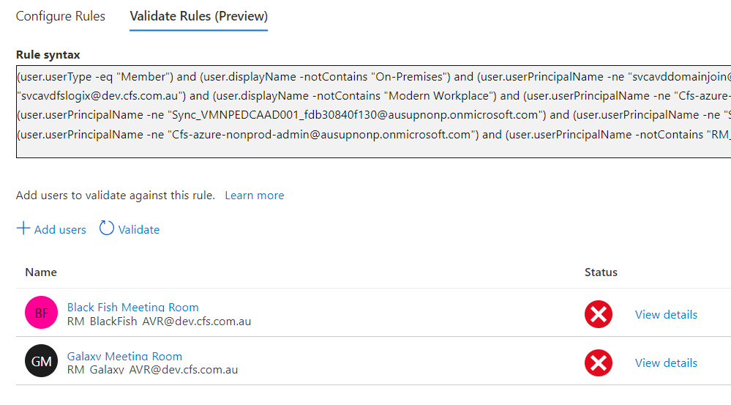

##### Excluding from Conditional Access Policies

During Team Rooms configuration and set up, CFS will need to exclude all Team Rooms resource accounts from multi-factor authentication challenges. This is required because those accounts are not registered for MFA or SSPR and nobody within CFS will be able to provide SMS or Microsoft Authenticator challenge 2-factor tokens to verify their identity.

|  |  |
| --- | --- |
|  | ***Important Note***  *At the time of writing this document, CFS did not have a physical location with IP Addresses which can be used to exclude from MFA. Because of this, the exclusion will be applied to the Team Rooms Account group* **SG-AA-OPS-TeamRoomsPremiumAccounts & SG-AA-OPS-TeamRoomsStandardAccounts***. It is recommended to exclude locations instead of user accounts.* |

Configure exclusions for the following Conditional Access Policies so they do not challenge any of the sign in attempts by the Team Rooms resource accounts:

* [*CA004: Require multi-factor authentication for all users*](https://portal.azure.com/#blade/Microsoft_AAD_IAM/PolicyBlade/policyId/39acb6bd-3a01-4b8d-9dc9-88888eea40c0/appId//policyName/)
* [*CA016 Require MFA for Device Registration*](https://portal.azure.com/#blade/Microsoft_AAD_IAM/PolicyBlade/policyId/776194ae-4041-4555-a91d-69c74f2fa94c/appId//policyName/)
* *CA011: CA011: Enforce Mobile MDM Policies*

#### Creating Intune Compliance Policies

To create compliance policies for the Team Rooms Premium devices, perform the steps below. Note the compliance policies will only check for encryption requirements (TPM), no other values will be checked. Microsoft Teams Premium does not support most of the policies at this stage.

1. Open Endpoint Manager, Locate Windows, Devices, Compliance Policies, click on Create Policy, Windows 10 Later
2. Provide the details for the policy
   1. Name: Team Rooms – Device Compliance Policy
   2. Description: Compliance policy for Team Rooms Premium devices, it checks for TPM encryption
3. Under **Device Health**, select all the encryption options

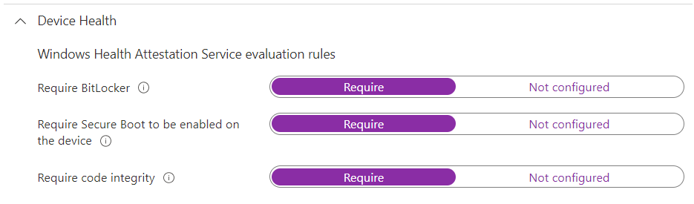

1. Under **Microsoft Defender for Endpoint**, select **Require the device to be at or under the machine risk score**: **Low**
2. Under **Actions for** **NonCompliance,** select 1 day
3. Under Assignments, assign this policy to the Team Device group **DG-AA-OPS-TeamRoomsDevices**

#### Creating Intune Device Configuration Policy

Create a Windows Configuration Profile with the following settings for all Team Devices.

1. Open Endpoint Manager, Devices, Windows, Configuration Profile, Click on Create Profile
2. Select Platform Windows 10 and later, profile type: templates
3. Select **Device Restrictions Windows 10 Team**
4. Provide the details
   1. Name: Team Rooms – Device Restrictions
   2. Description: Device restriction policy for Team Room devices
5. Select the following polices
   1. **Configuration Settings**
      1. Apps and Experience:
         1. Meeting information displayed on welcome screen: Organizer, time, and subject (subject hidden for private meetings)
         2. Maintenance: 8PM for 5 hours
6. Assign the policy to DG-AA-OPS-TeamRoomsDevices

#### Creating Intune Endpoint Configuration Policy

The only configuration policy supported for Microsoft Team Rooms devices at the time of writing this document is TPM and Bitlocker encryption policies. The following policy will configure these values and CFS can add any future settings once they are available for preview.

1. Open Endpoint Manager, Devices, Windows, Configuration Profiles, click on Create Profile
2. Select Platform Windows 10 and later, profile type: **Templates**
3. Select **Endpoint Protection** as template
4. Specify the details for the profile
   1. Name: Team Rooms – Device Endpoint Protection Profile
   2. Description: Configuration profile policy for Microsoft Team Rooms Premium devices. This policy only configures Encryption as it is the only policy supported by Team devices
   3. Under Windows Encryption, select **Encrypt Devices**

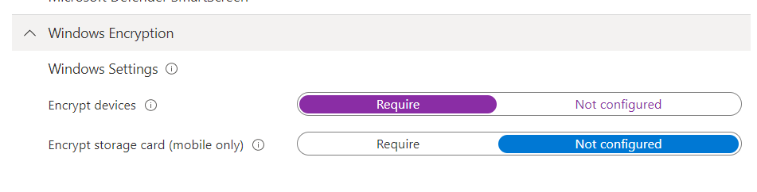

1. Under Assignment, select the Team Rooms Device group **DG-AA-OPS-TeamRoomsDevices**

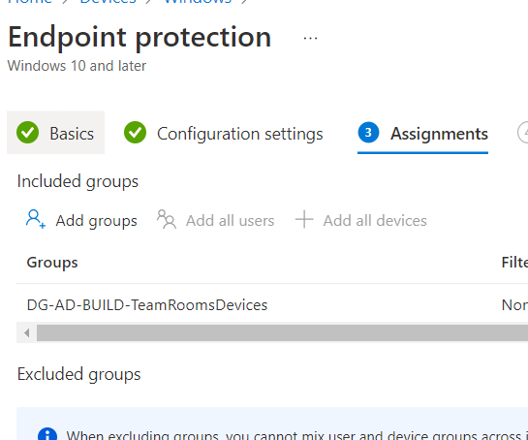

1. Under Application Rules, select Assign Profile if **OS Edition** is Windows 10/11 Enterprise and Professional
2. Review and create the policy

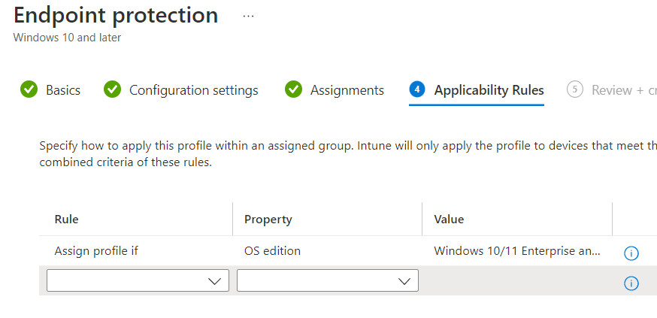

1. Create an additional policy of type **Device restrictions (Windows 10 Team)**
2. Provide the name and description
   1. Name: Team Rooms – Device restrictions for Team Rooms
   2. Description: Configuration policy to apply restrictions to Windows 10 Teams devices
3. Under **App and Experience,** change the value **Meeting Information displayed on welcome screen**
   1. Set to: Organizer, time, and Subject (subject hidden for private meetings)
4. Under **Maintenance,** set the maintenance time to 8 PM and duration to 5 hours.
5. All other settings must be left as default. CFS can adjust any of these policies later

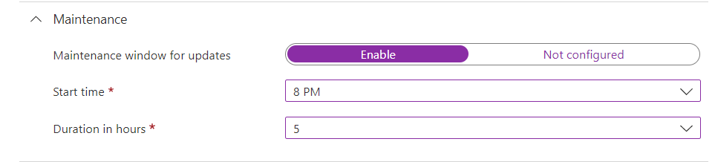

1. Assign the policy to the Team Device Group **DG-AA-OPS-TeamRoomsDevices**
2. Under Application Rules, apply to Windows 10/11 Enterprise and Professional.
3. Create the policy

#### Creating Defender for Endpoint policies

Each Microsoft Team Rooms Premium device will need to onboard on Defender for Endpoint. The following section describes the policy to enable automatic onboarding for Windows 10 Team devices.

1. Open Endpoint Manager, Locate Endpoint Security, Endpoint Detection and Response, Create Policy, Windows 10 and Later
2. Provide the details for the policy
   1. Name: Team Rooms – Defender for Endpoint
   2. Description: Defender for Endpoint onboarding policy for Team Rooms Premium devices
3. Under Endpoint Detection and Response, select all options
4. Under Assignments, assign the policy to the Team Rooms device group **DG-AA-OPS-TeamRoomsDevices**
5. Create the policy

## Cortana

|  |  |
| --- | --- |
|  | ***Note***  *For* ***Windows 11****, Cortana is no longer pinned to the taskbar by default. You can still pin the Cortana app to the taskbar as you would any other app. In addition, the keyboard shortcut that launched Cortana (Win+C) no longer opens Cortana.*  The MDM configurable settings for Cortana in an Organization are documented on <https://docs.microsoft.com/en-us/windows/configuration/cortana-at-work/cortana-at-work-policy-settings> |

## Microsoft Whiteboard

Microsoft Whiteboard is configured as part of the user licensing.

## Microsoft Stream

|  |  |  |
| --- | --- | --- |
| Step No. | Procedure | Screenshot |
|  | Open the Microsoft Stream Admin Center | <https://web.microsoftstream.com/admin> |
|  | Select Live Events |  |
|  | Under settings, turn on the toggle to restrict live events  and click Save |  |
|  | Select Content Creation |  |
|  | Turn on the Toggles for both **Restrict video uploads** and **Restrict companywide channel creation** and click Save |  |
|  | Select Comments |  |
|  | Turn the toggle on to Restrict comments on videos and click Save |  |

# Workplace

## Microsoft Managed Desktop

### Branding

|  |  |
| --- | --- |
|  | ***Important Note***  *Make sure the branding is set otherwise MMD Autopilot scripts will fail* |

Make sure all the branding has been configured prior running MMD onboarding scripts

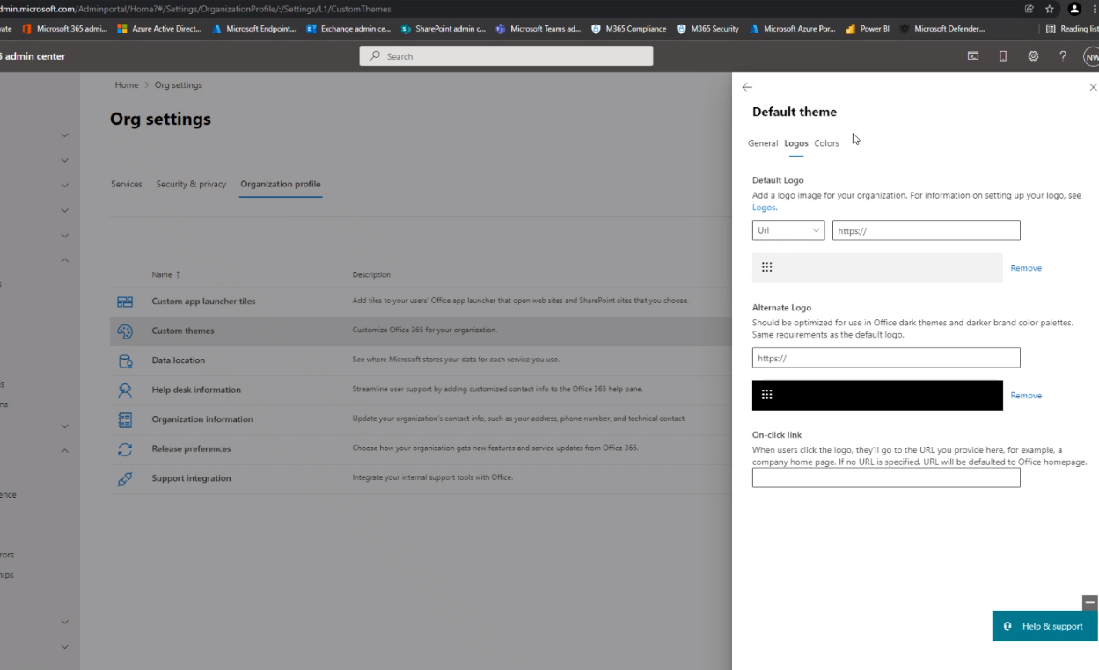

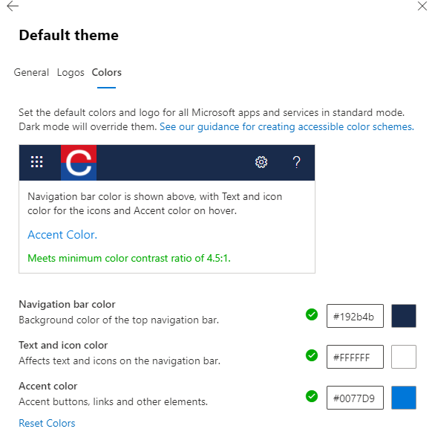

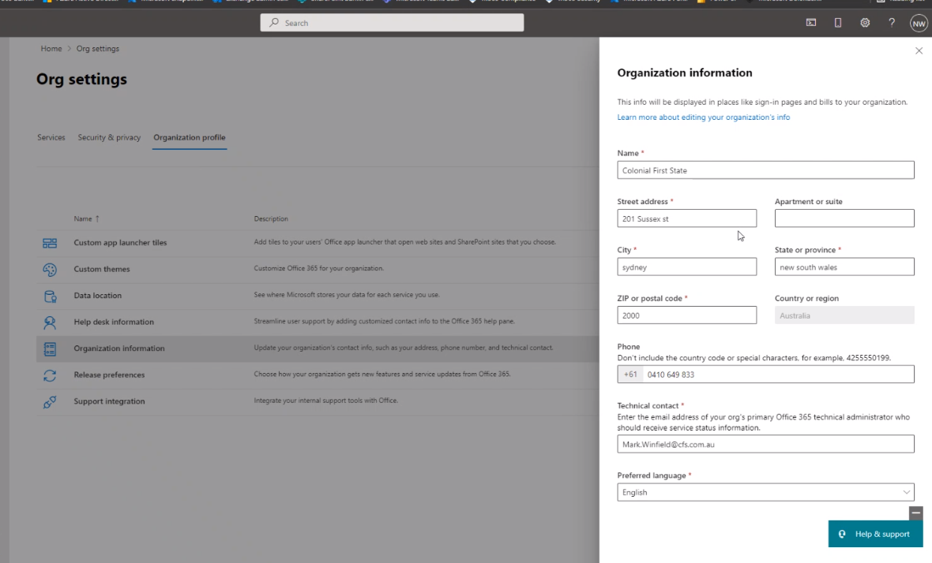

Set Company Branding on the Azure Portal, under Active Directory

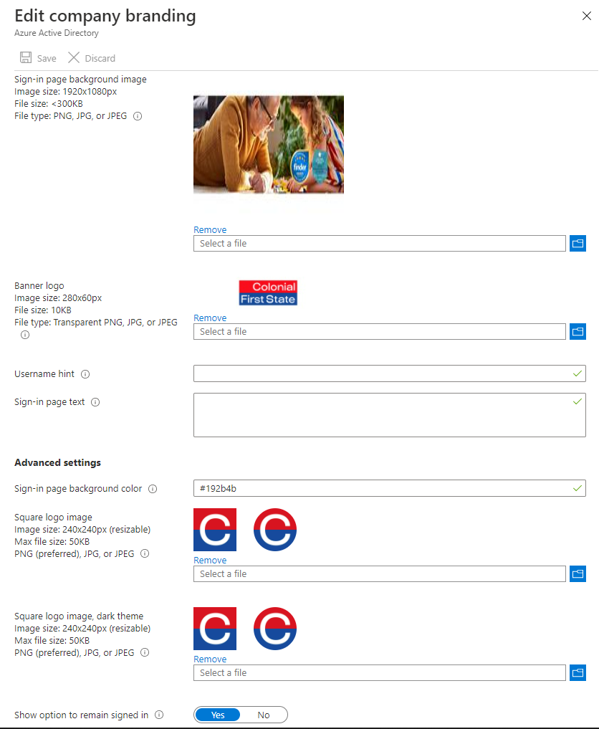

Under Tenant Admin in Endpoint Manager, populate the Company details

#### Desktop Wallpaper

Wallpaper are stored in the following Azure Storage Blobs. Wallpaper URLs must be publicly accessible (anonymous access)

NON-PROD - <https://stonpedcoper001.blob.core.windows.net/intune-np-desktop-wallpaper-images/>

PROD - <https://stoprdedcoper001.blob.core.windows.net/intune-prd-desktop-wallpaper-images/>

In Microsoft Endpoint Manager go to Microsoft Managed Desktop -> Settings -> Desktop background picture

Set URL as depicted:

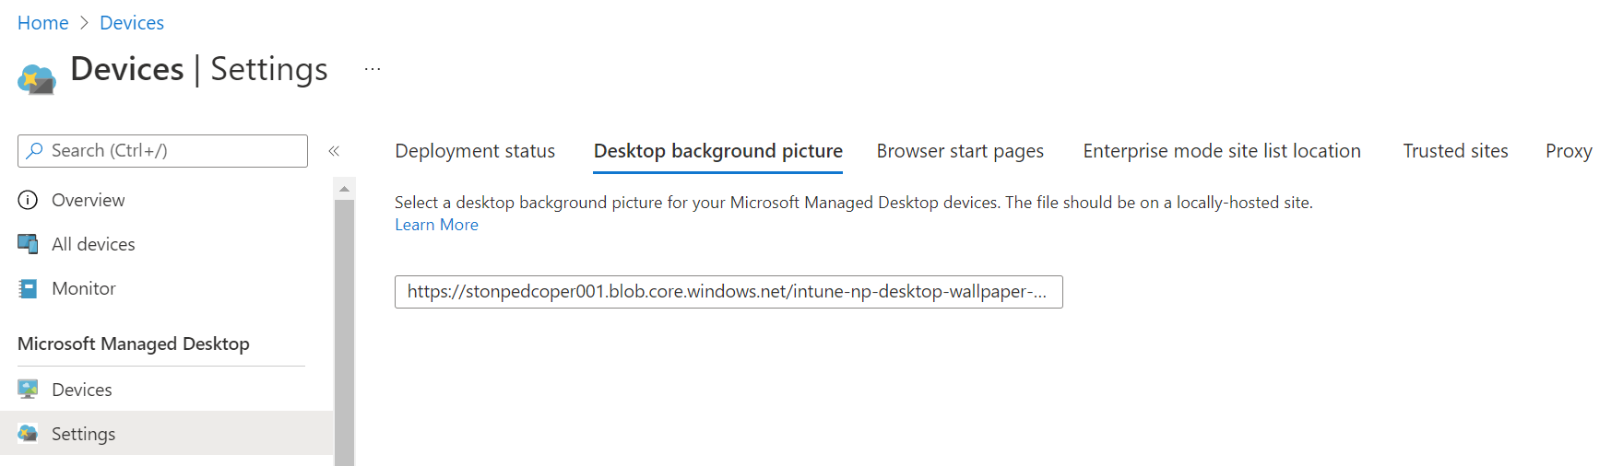

Full URL Non-Prod: <https://stonpedcoper001.blob.core.windows.net/intune-np-desktop-wallpaper-images/CFS_Background_2022.04.jpg>

Full URL Prod: <https://stoprdedcoper001.blob.core.windows.net/intune-prd-desktop-wallpaper-images/CFS_Background_2022.04.jpg>

Then Deploy the change to each Deployment Ring as required under Microsoft Managed Desktop -> Settings -> Deployment Status -> Desktop background picture -> Groups (test / first / fast / broad) -> Deploy

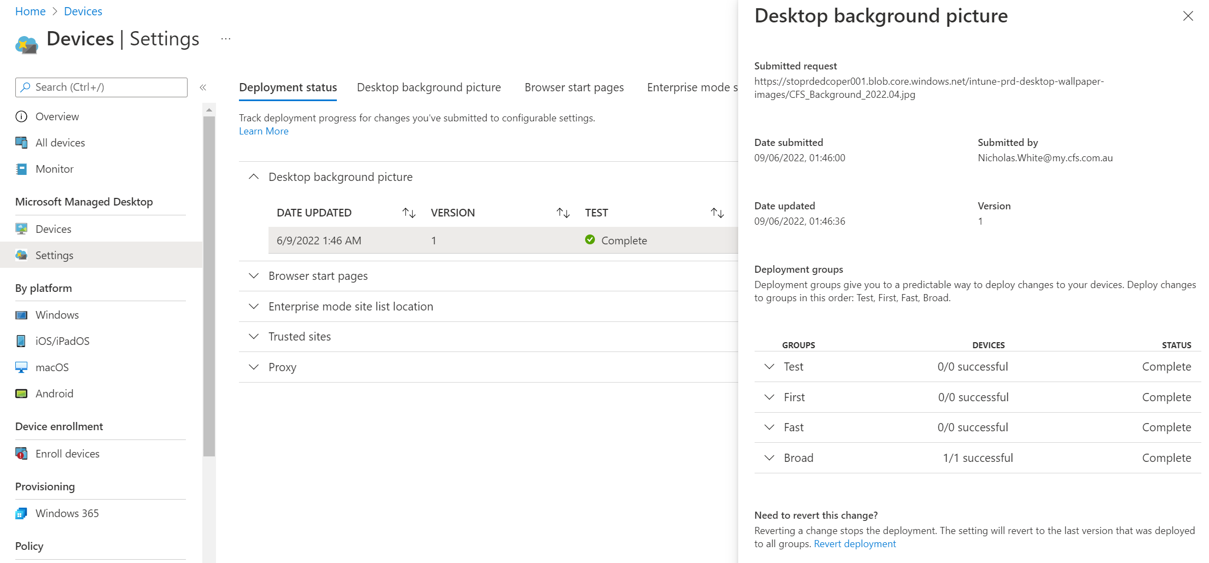

### Verify Licences for MMD

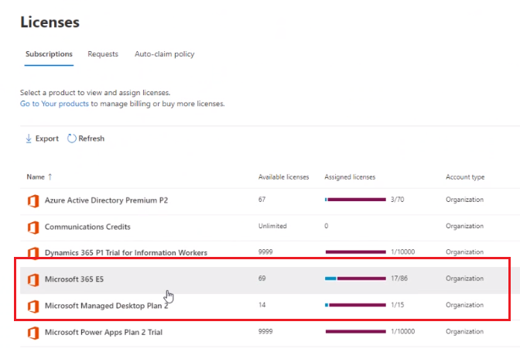

### Configure Windows Store

Require global admin

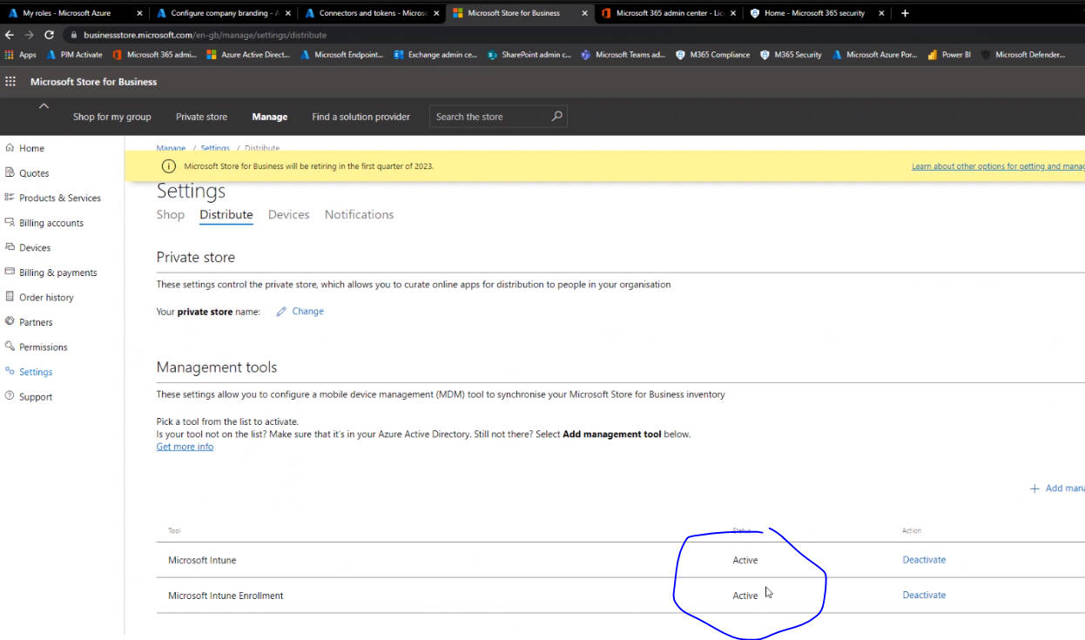

1. Click on Enable then on SYNC and wait 30 mins

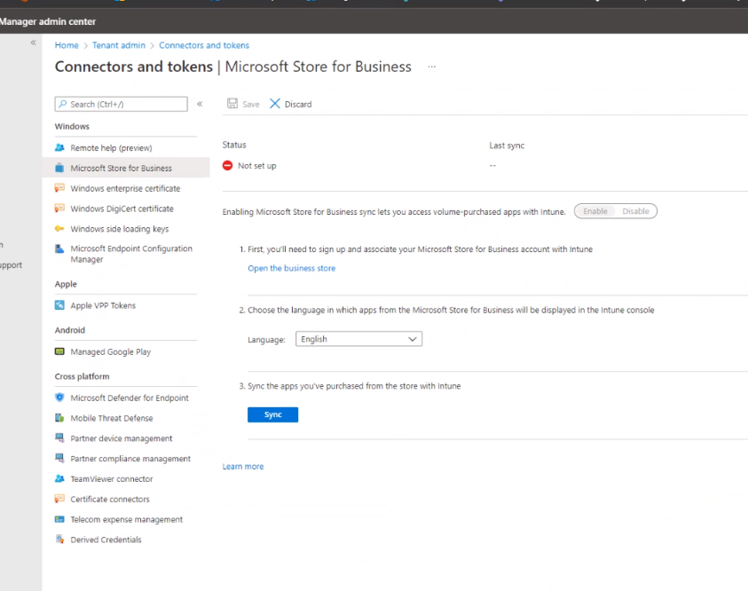

1. Windows store will appear enable after 30 mins average

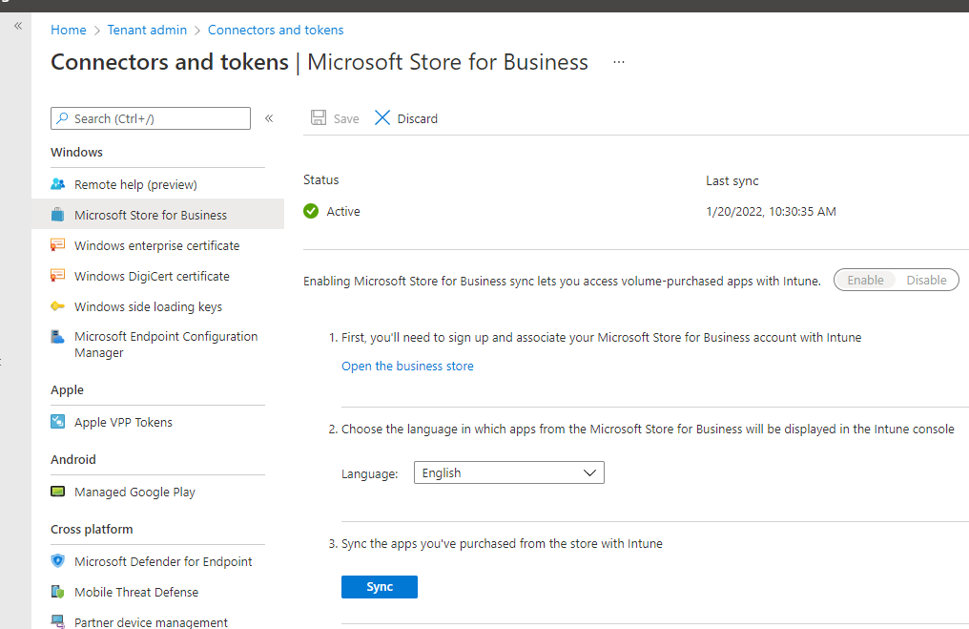

1. Go back to Business Store and purchase the Company Portal App

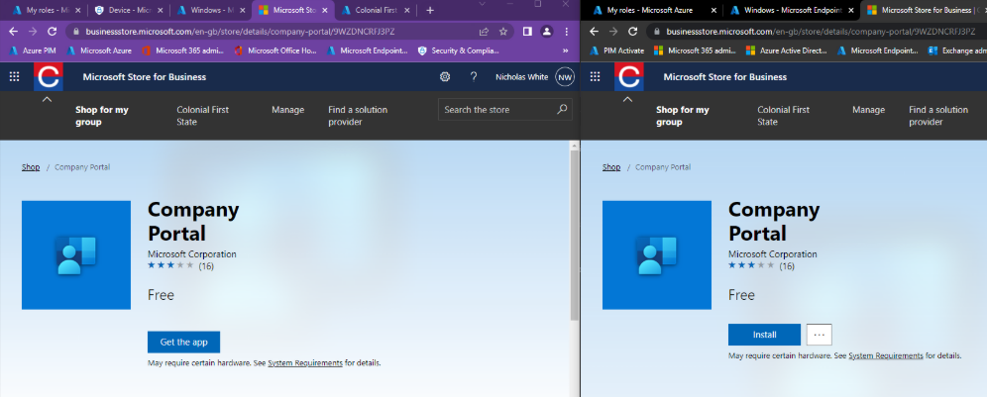

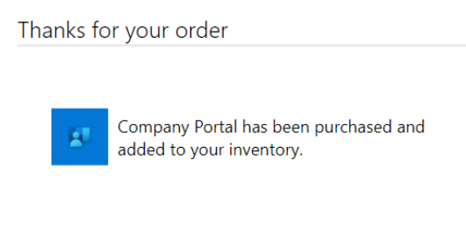

1. Once the store is Active, wait 30 mins and verify the Company portal app is published as an app in Intune

### Verify Defender for Endpoint Features

Check the following features are set to ON in the Defender for Endpoint portal (security Portal)

1. Open Security Portal
2. Click on Settings
3. Verify **Preview Features** are ON

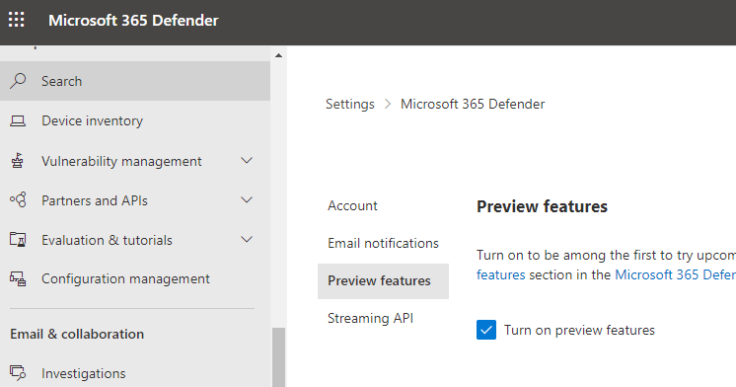

1. Click on Streaming API and verify no APIs are set

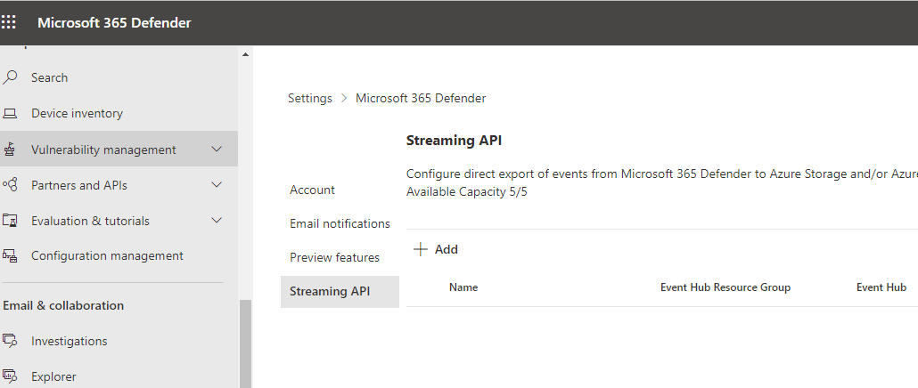

1. Click on Settings Again then **Endpoints**

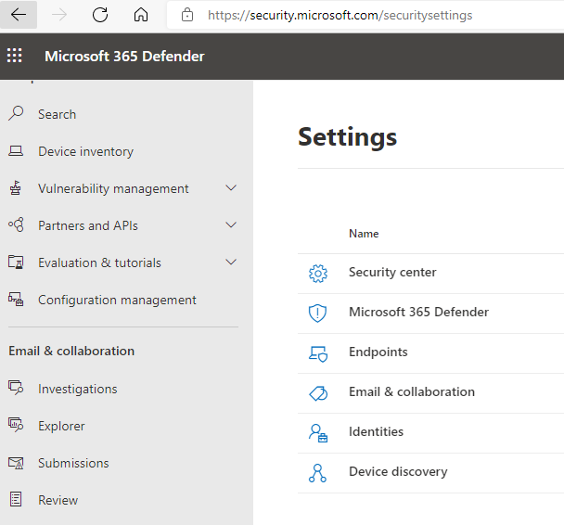

1. Verify the region of your tenant is correct

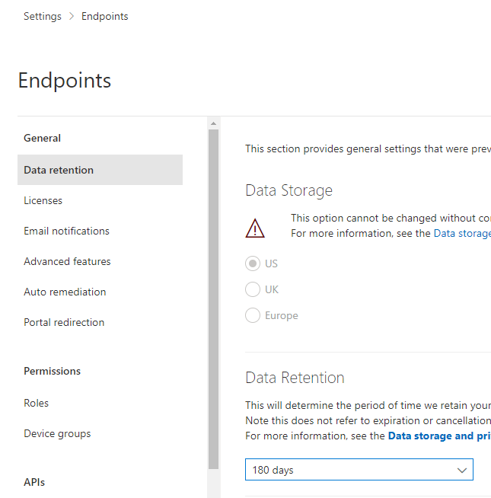

1. Click on **Advance Features** and verify the following settings are ON
   1. Live Response
   2. Automatically Resolve alerts
   3. Allow or block file
   4. Custom Network indicators
   5. Microsoft Defender for Cloud Apps
   6. Microsoft Secure Score
   7. Microsoft Intune Connection
2. Save Preferences

### Verify SSPR is not enforcing registration

If SSPR is set to enforce registration on sign-in and the target of the registration is set to ALL users, this will break MMD Autopilot

1. Check SSPR settings on the Azure Portal, Active Directory, Password Reset
2. If Self Service Password Reset is set to **ALL**, the registration must not be enforced

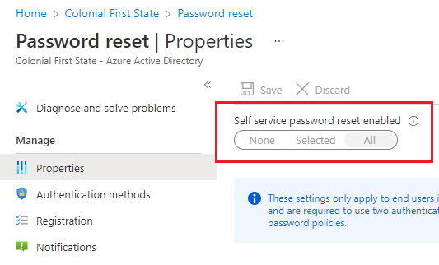

1. Under **Registration**, verify registration on sign-in is set to **NO. This will not** be enforced SSPR registration if the policy was set to ALL

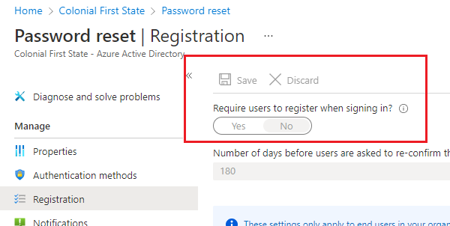

### Integrate MDE with MEM

1. Under Connectors and Tokens, Microsoft Defender for Endpoint, enable the integration and set Connect Windows devices to Microsoft Defender for Endpoint to ON

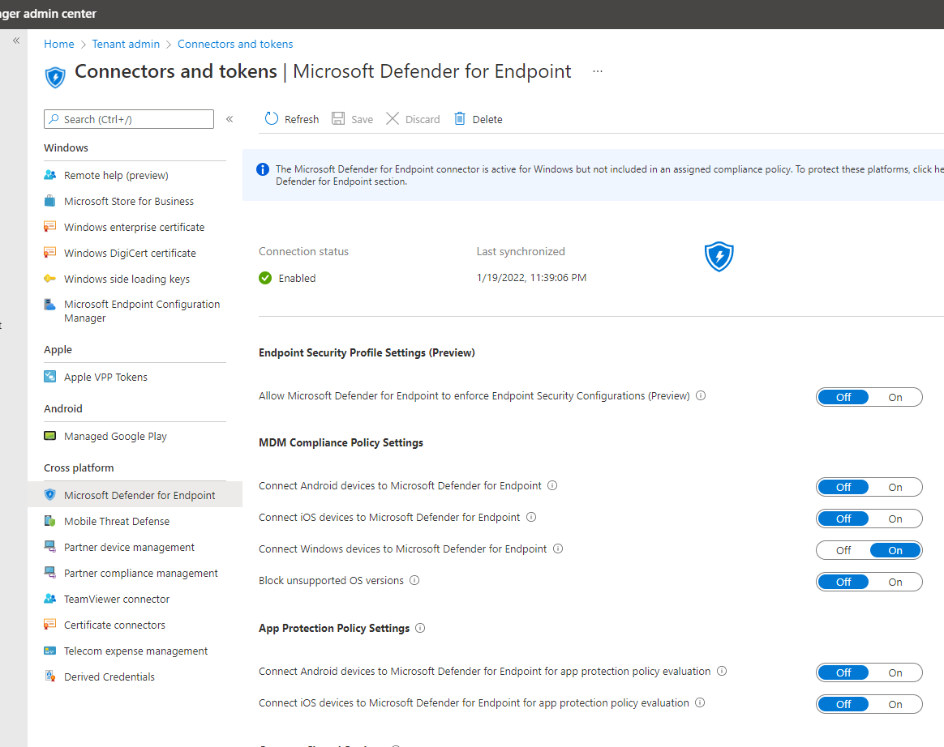

### Verify Device Settings

Under Azure AD, Devices, Verify the following settings are set

1. Under Device Settings, verify User may join devices to Azure AD is set to ALL

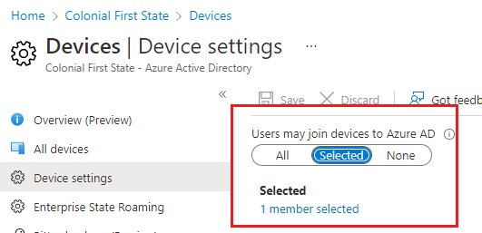

1. Under Enterprise State Roaming, verify it is set to ALL

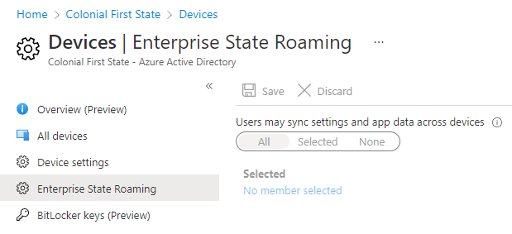

### Verify MEM is MDM Authority

Check Microsoft Intune is the MDM authority for the tenant

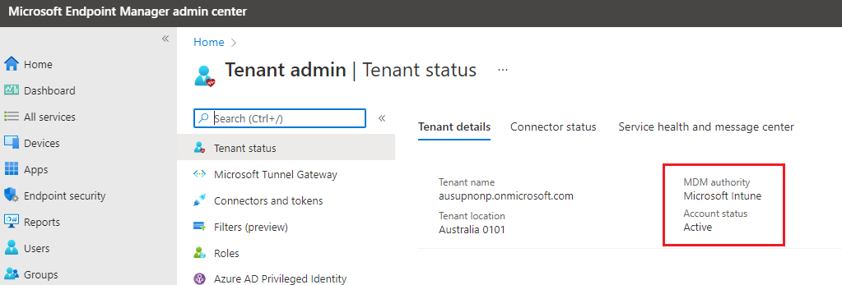

### Restrict Device Enrolment

To restrict who and what type of devices can be enrolled into Endpoint Manager (Intune), configure Device Restrictions under Endpoint Tenant settings.

1. Open Endpoint Manager
2. Devices, Enrolled Devices

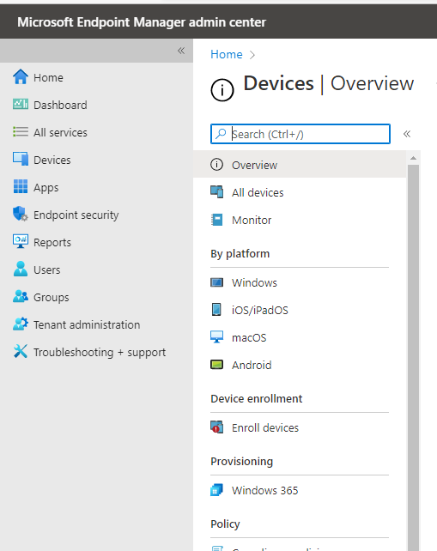

1. Select Enrolment Device Platform Restrictions

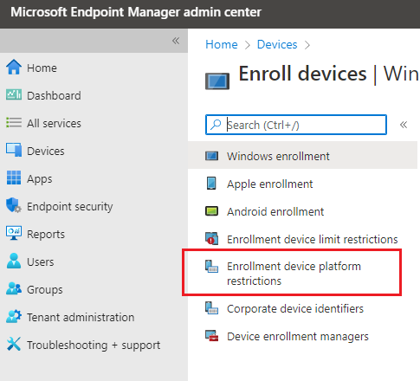

1. Prohibit Windows and MacOS personal enrolment into Intune

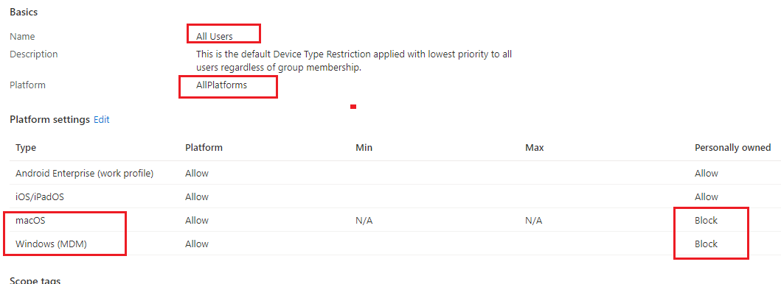

### Onboard MMD into MEM Tenant

Follow these steps to onboard the existing Intune tenant on MMD.

1. Verify the onboarding requests has been approved by Microsoft
2. Verify the domain has been verified

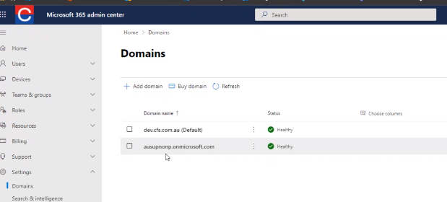

1. Verify Company Portal is published

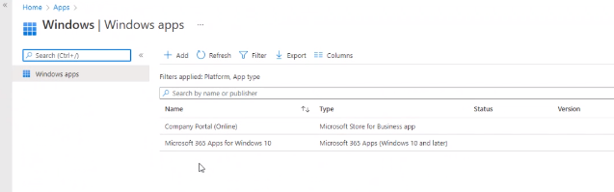

1. Click on tenant admin, Microsoft Managed Desktop

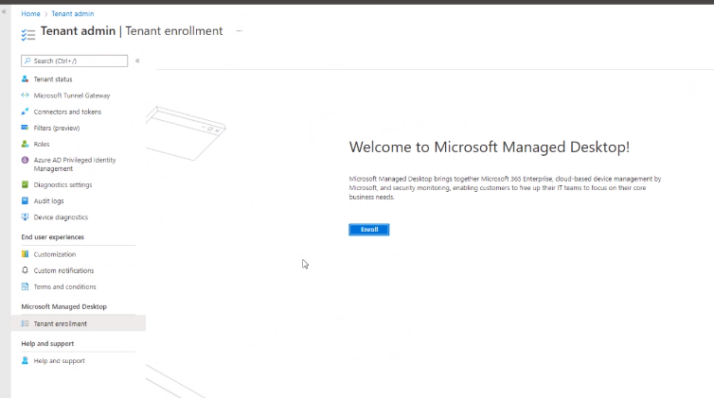

1. Click Enrol and accept terms
2. Select **all-Cloud managed devices**

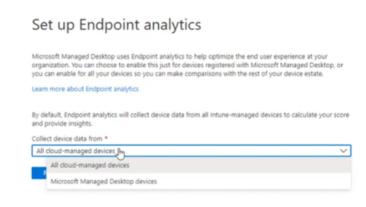

1. Wait for the process to complete

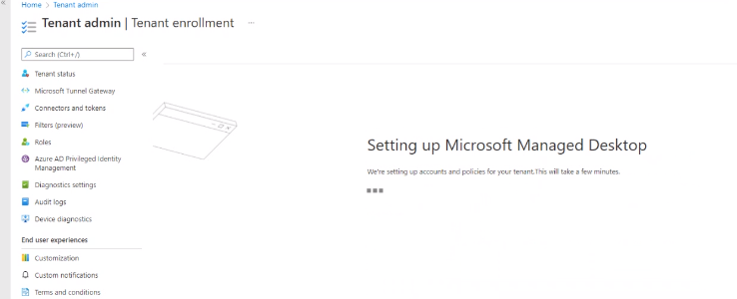

1. Provide the contact details

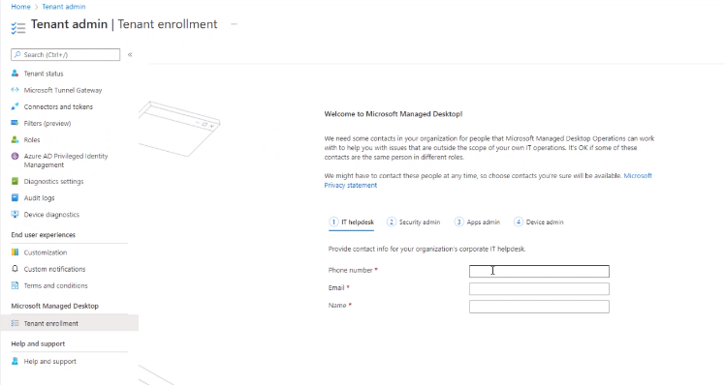

1. Provide App admin details

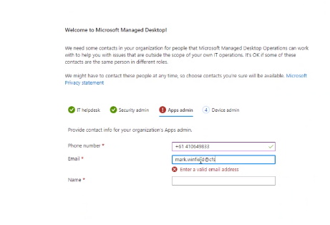

1. Wizard will continue

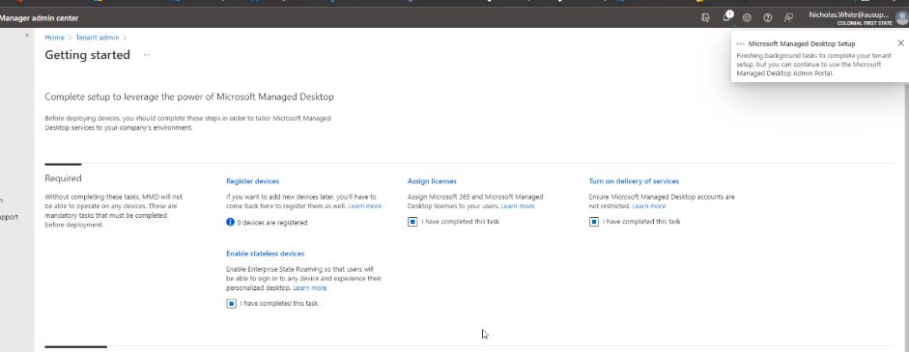

1. Wait for the process to complete

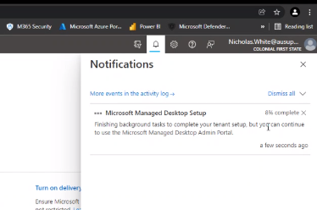

1. Check MMD users and groups are being created

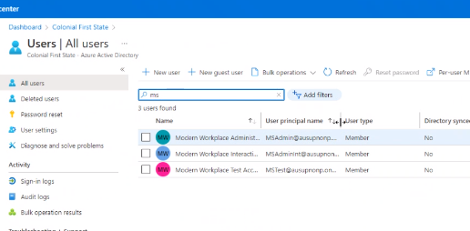

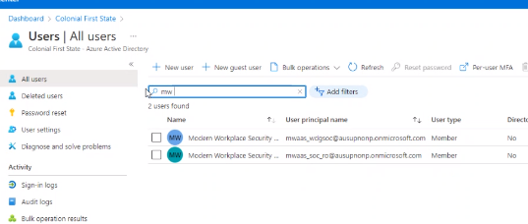

1. Verify Conditional Access Policies have been modified and exclude MMD groups, especially:
   1. Risky Sign In CA policy
   2. MFA for admins
   3. MFA for all users

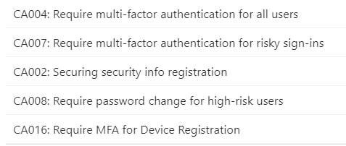

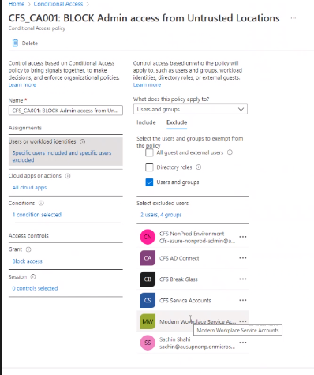

1. Verify the new **Modern Workplace - Secure Workstation** has been created. This blocks Microsoft from accessing the tenant EXCEPT from certain IP ranges across the world

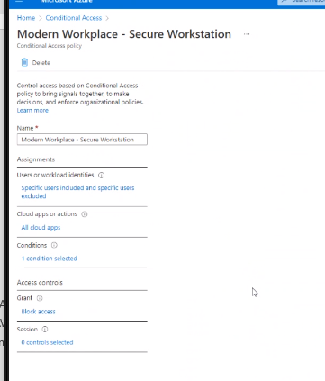

1. Wait until the wizard completes

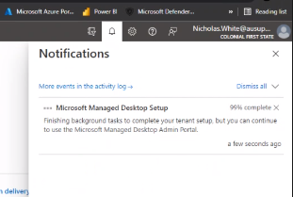

1. Verify all Compliance and Configuration Policies have been created with the name **Modern Workplace**

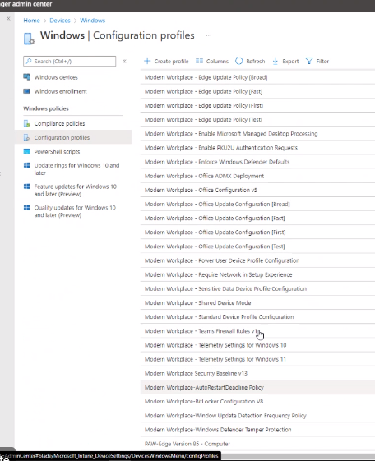

1. Verify all Powershell scripts have been created

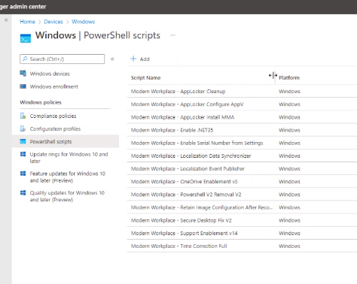

1. Verify the scripts have been assigned to Modern Workplace groups

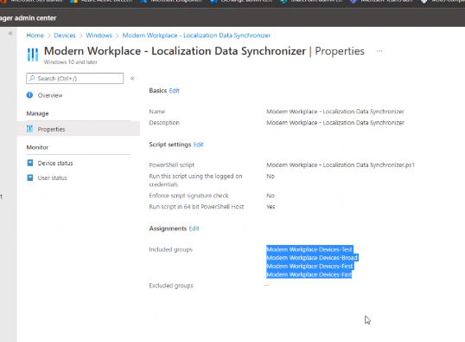

### Post Onboarding Tasks

Perform these post-configuration tasks to finalise the MMD onboarding for the tenant.

1. Make sure the test account (**testaccount.onshore1)** has been assigned MMD license
   1. This triggers the enterprise application assignment role impersonation
2. Click on Tenant Admin
3. Add additional admin contacts, specifically the person who will authorise to approve changes
4. Each role must have 2 contacts for emergency change and approvals **per role**

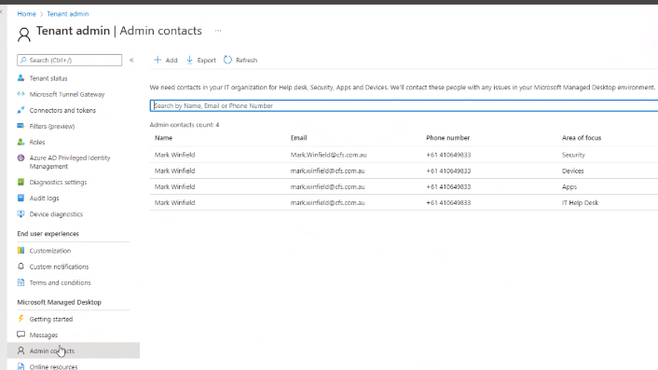

1. Click devices on the left

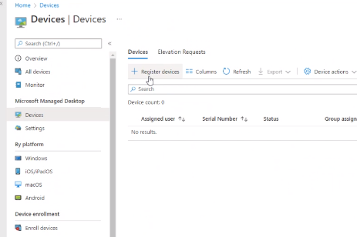

1. Assign the device profile type to a test device (when it is available). See section **Onboard Test Device**

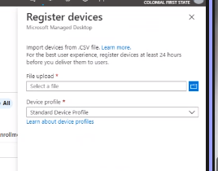

1. Configure Customer customisations

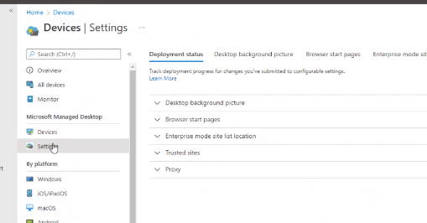

1. Configure the URL to the desktop pic

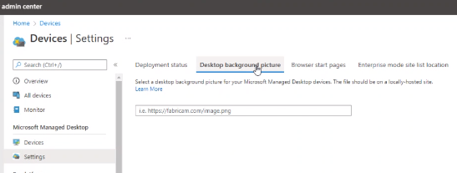

### Upload MMD Recovery Image

The test laptops may not have a non-compatible MMD Windows 10 version. To download the right version, perform these steps.

|  |  |
| --- | --- |
|  | ***Important Note***  *Microsoft will provide CFS with devices ready to enrol in MMD. The test laptop requires additional steps to install a compatible Windows 10 version.* |

1. Download image from <https://support.microsoft.com/en-us/surface-recovery-image>
2. Store it in a USB and run the steps on the test device **as an elevated administrator**
   1. Request the administrator username and password for the local test device
3. Follow the steps to replace the Windows image on the test device with a MMD Windows 11 compatible image.

### Onboard Devices

Obtain the autopilot hash from the surface Laptop

Store it in a USB

1. Open a PowerShell prompt with administrative rights.
2. Run Install-Script -Name Get-WindowsAutoPilotInfo
3. Run powershell -ExecutionPolicy Unrestricted Get-WindowsAutoPilotInfo -OutputFile <path>\hardwarehash.csv
4. Do not open the csv file

Open Endpoint Manager, Devices, Manage Desktop

Register devices

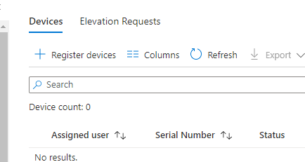

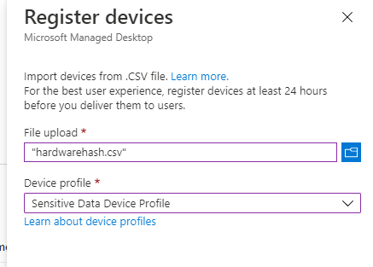

Click on Register Device

Wait for device to enrol

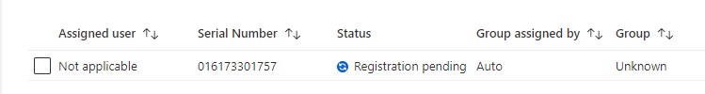

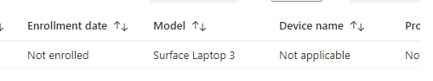

#### Raise a request to assign Sensitive Data as the default Device Profile Type

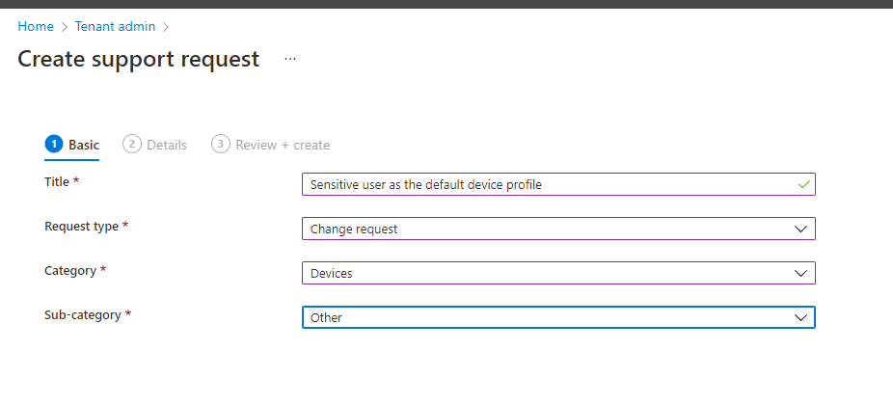

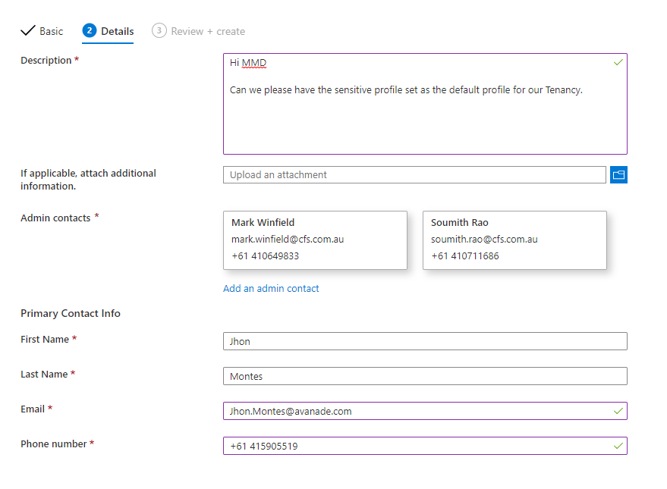

#### Request USB policies exception

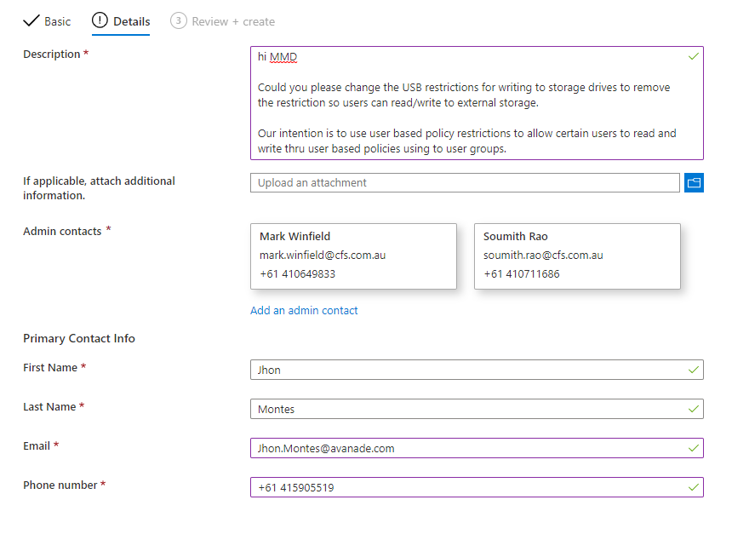

If device fails to enrol, perform these steps

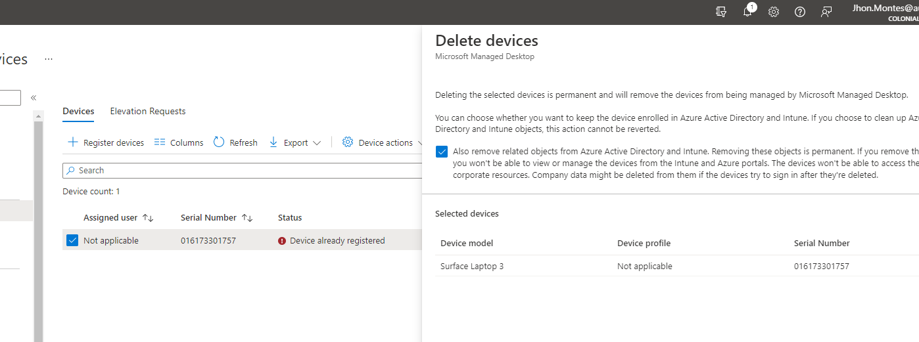

## Microsoft Endpoint Manager (Intune)

### Create device compliance message template

This message template is required to notify users their device is not compliance. Administrators will know the device is not compliance, but users will need notification to address any issues before 14 days passed until the device becomes NOT-COMPLIANT and it is blocked by Conditional Access Policies,

To create the message template, perform these steps

1. Open Endpoint Manager, Devices, Compliance Policies Notifications, Create Notifications

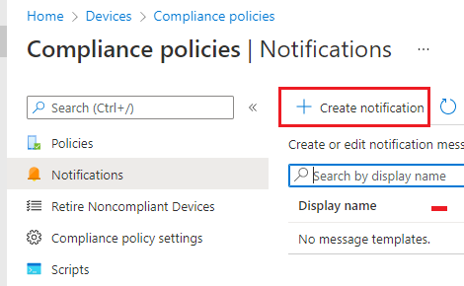

1. Enable all the options and provide a name for the notification
2. Specify Subject and details below
   1. **Subject:** Your CFS device has been marked as non-compliant
   2. **Message:** Microsoft Intune has identified your device as non-compliant. Please review the information below and address any issues highlighted which are making your device non-compliant. Your device will be set on grace period for 8 hours until the issues are resolved.

If you require assistance, please contact CFS Service Desk.

Your device will be marked as non-compliant in 8 hours from this email.

1. Select Default Template and save

### Configure Compliance Settings

Under Devices, compliance settings, change the following values and save

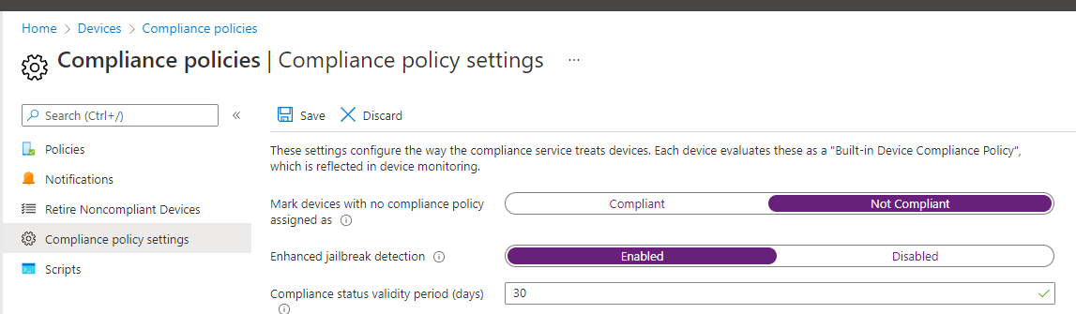

### Compliance Policies

#### iOS/iPadOS

1. Open Endpoint manager
2. Locate Devices, iOS/iPadOS
3. Click on Compliance Policies
4. Click on Create Policy

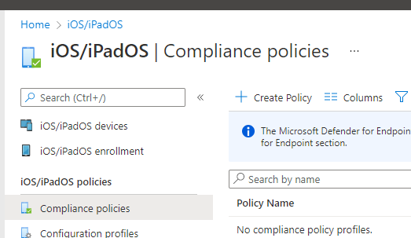

1. Provide the name and description
   1. Name: iOS - MDM Compliance Policy
   2. Description: MDM Compliance policy for all iOS devices. Applies to all corporate iOS/iPadOS devices. Does not apply to MacOS
2. Specify the following policies only as per Design requirements under **Compliance Settings**
   1. **Device Health:** Jailbroken devices: Block
   2. Under **System Security**
      1. Require a password to unlock mobile devices: **Require**
      2. Simple Password: **block**
      3. Minimum password length: **6**
      4. Require password type: **numeric**
      5. Number of non-alphanumeric character in password: **not configured**
      6. Maximum minutes after screen lock before password is required: **5 minutes**
      7. Maximum minutes of inactivity until screen lock: **5 minutes**
      8. Password expiration (days): **365**
      9. Number of previous passwords to prevent reuse: **15**

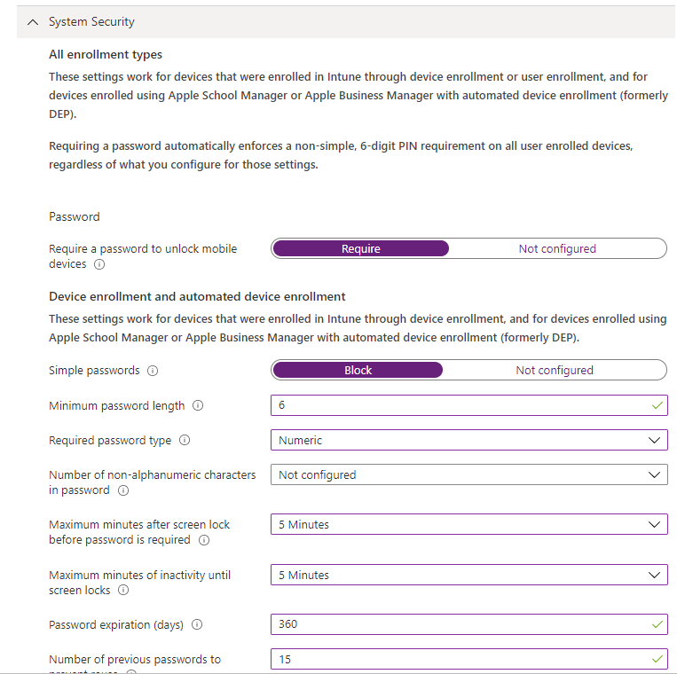

1. Under **Action for Non-compliance,** set
   1. Mark device as noncompliant to **14 days** to allow users 14 days to resolve non-compliance issues.
   2. Send email to end user: immediately notify of noncompliance, select the notification message template created above

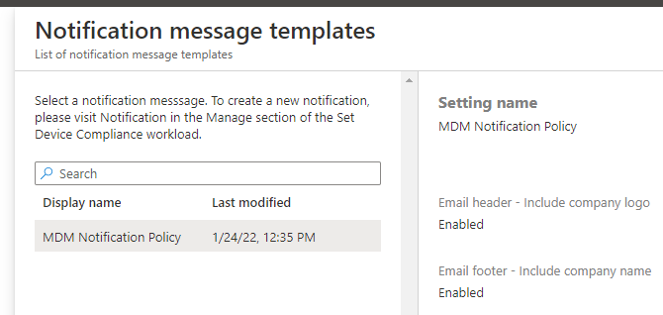

1. Under **additional recipients**, select the administrators for the tenant
2. Under **Assignment,** assign the policy to **ALL USERS.** Save and create the policy

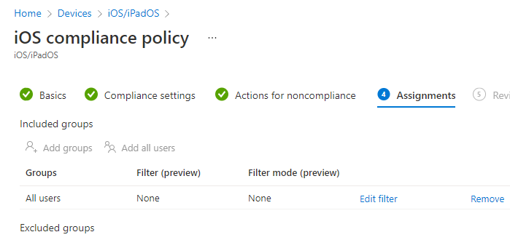

#### Android Enterprise Fully Managed

To create the Compliance policies for Android Enterprise, perform these steps

1. On devices, Android, click on Compliance Policies
2. Click on Create policy and Select
   1. Platform: **Android Enterprise**
   2. Profile Type: **Fully Managed, Dedicated, and corporate-owned work profile**
3. Provide name and description
   1. Name: Android - MDM Compliance Policy
   2. Description: MDM Compliance policy for all Android corporate devices. Applies to all corporate Android Enterprise devices (not Android Administrator).
4. Under **Compliance Settings**, configure the following values
   1. Device Health, Google Play Protection, SafetyNet Device Attestation
      1. Select Check basic integrity & certified devices

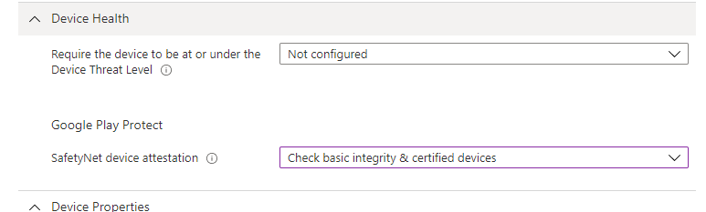

1. Under **System Security,** select the following options
   1. Require password to unlock mobile device: **Require**
   2. Require password type: **Numeric**
   3. Minimum password length: **6**
   4. Maximum minutes of inactivity before password is required: **5 minutes**
   5. Number of days until password expires: **360 days**
   6. Number of passwords before a user can reuse a password: **15**
   7. **Encryption**
      1. Require encryption of data storage on device: **Require**
   8. **Device Security:**
      1. Intune app runtime integrity: **Require**

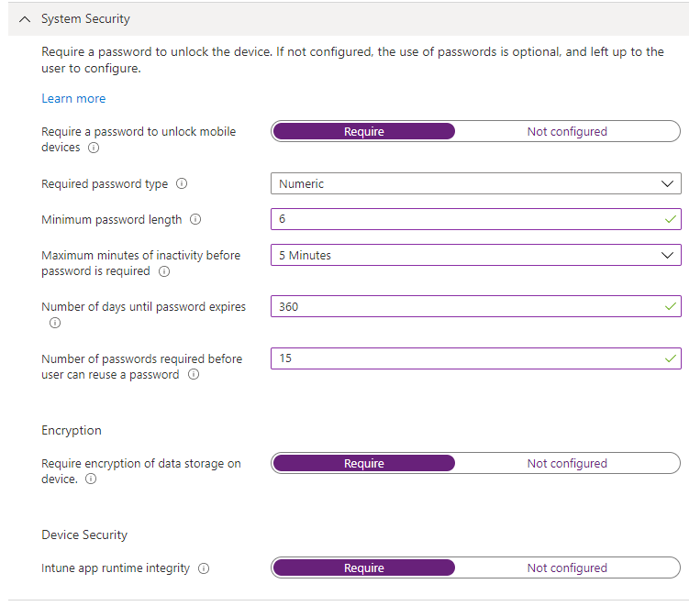

1. Under Actions for noncompliance, select the message template to notify users **immediately** of noncompliance. Select Mark device as noncompliant **after 14 days**

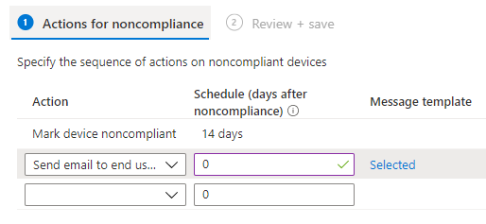

1. Assign to ALL USERS and create the policy

#### Android Enterprise – Personally Owned

To create the Compliance policies for Android Enterprise, perform these steps

1. On devices, Android, click on Compliance Policies
2. Click on Create policy and Select
   1. Platform: **Android Enterprise**
   2. Profile Type: **Personally-Owned Work Profile**
3. Provide name and description
   1. Name: Android - MDM Compliance Policy Personally Owned
   2. Description: MDM Compliance policy for all Android personal devices. Applies to all personally owned Android Enterprise devices (not Android Administrator).
4. Under **Compliance Settings**, configure the following values
   1. Device Health, Google Play Protection, SafetyNet Device Attestation
      1. Select Check basic integrity & certified devices



1. Under **System Security,** select the following options
   1. Require password to unlock mobile device: **Require**
   2. Require password type: **Numeric**
   3. Minimum password length: **6**
   4. Maximum minutes of inactivity before password is required: **5 minutes**
   5. Number of days until password expires: **360 days**
   6. Number of passwords before a user can reuse a password: **15**
   7. **Encryption**
      1. Require encryption of data storage on device: **Require**
   8. **Device Security:**
      1. Intune app runtime integrity: **Require**



1. Under Actions for noncompliance, select the message template to notify users **immediately** of noncompliance. Select Mark device as noncompliant **after 14 days**



1. Assign to ALL USERS and create the policy

#### MacOS

To create MacOS compliance policies, click on Devices, MacOS then click on Compliance policies. Click on Crate policy

* Provide the name and description for the policy
  1. Name: MacOS – MDM compliance policy
  2. Description: MDM policy to apply compliance policies to corporate Mac devices
* Under Compliance Settings, select the options
  1. Device Health, Require System integrity protection: **Require**
  2. Under **System security,** select
     1. Require password to unlock devices: **require**
     2. Simple passwords: **block**
     3. Minimum password length: **8 (same as Windows 11 devices)**
     4. Password type: **alphanumeric**
     5. Number of non-alphanumeric characters: **1 – this means special characters**
     6. Maximum minutes of inactivity before password is required: **5 minutes**
     7. Password expiration (in days): **365 days**
     8. Number of previous passwords to prevent reuse: **15 (same as Windows 11)**

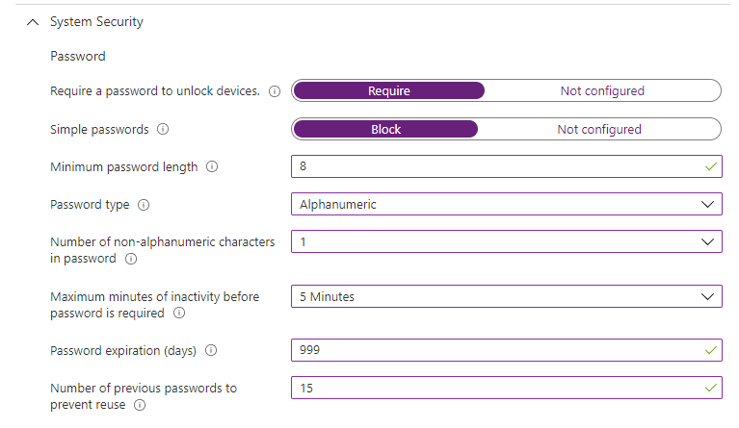

* Under encryption, select the following options
  1. Require encryption of storage on device: **Require**
  2. Device Security:
     1. Firewall: **Enable**
     2. Incoming Connections**: Block**
     3. Stealth mode: **Enable**
  3. Under Gatekeeper:
     1. Allow apps downloaded from the location: Set to NOT CONFIGURED

|  |  |
| --- | --- |
|  | ***Important Note***  *If you don’t set Gatekeeper to Not Configure for App downloads, Company Portal app will not download on the macOS device during enrolment, blocking you from enrolling the device.* |

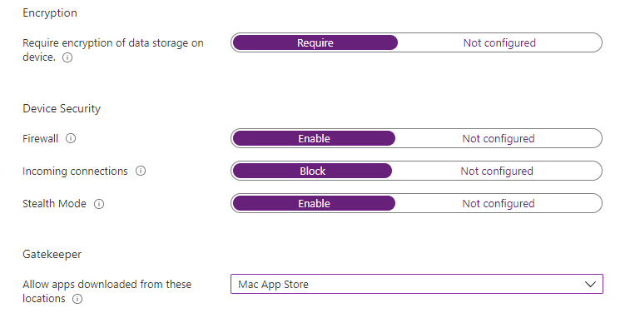

* Under Actions for noncompliance, select the notification template created above and mark device as noncompliance **after 1 day.** Note mobile devices have 14 days to address noncompliance

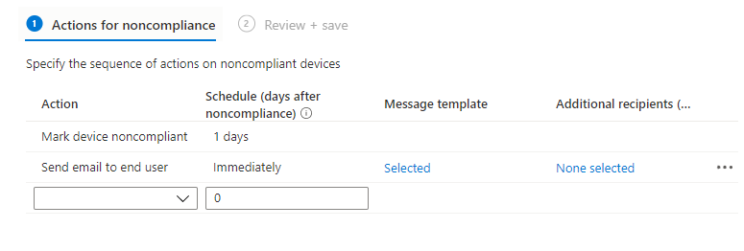

* Under Assignments, assign to **the MacOS device group** and create the policy

### Configuration Policies

#### iOS/iPadOS

##### Create Dynamic group

Create a dynamic group which will be used to assign all iOS/iPadOS policies

Group name: DG-AA-OPS-Intune-iOSDevices

Dynamic filter: DeviceOSType

Operator: Equals

Value: iPhone

Value: iPad

##### Device Restrictions

To create iOS configuration profiles policies, perform these steps

1. Open Endpoint Manager and locate Devices, iOS, Configuration Profiles then click on Create policy
2. Select **Device Restrictions**

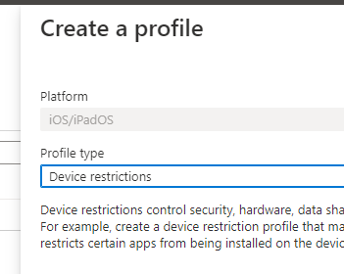

1. Provide the details for the policy
   1. Name: iOS – MDM Configuration Profile policy
   2. Description: Policy to set configuration settings on iOS/iPadOS devices. This policy sets password, security, and other device hardware-level settings to meet CFS design requirements.
2. Under Configuration Settings, configure the following items
   1. Under App Store, Doc viewing; Gaming
      1. Set all policies to YES
   2. Under **Automated Device Enrolment**, set all policies to YES

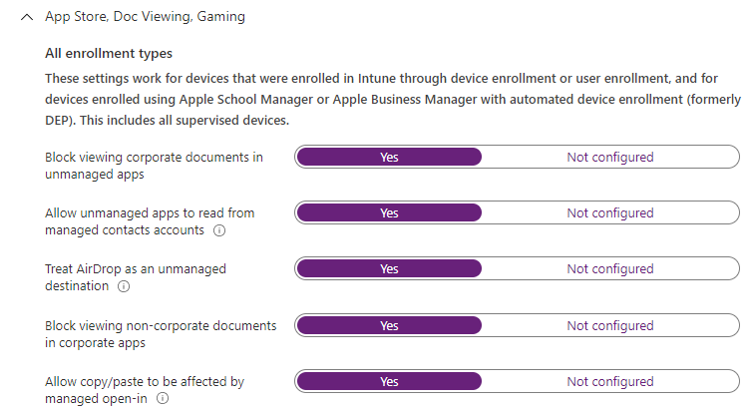

* 1. Under Built-in Apps, set the following policies
     1. Require Safari Fraud warning: **YES**
     2. Block Internet Search results from Spotlight: **YES**
     3. Block Safari JavaScript: YES
     4. Block Safari pop-ups: YES
     5. Block Siri for dictation: YES
     6. Block Siri for translation: YES

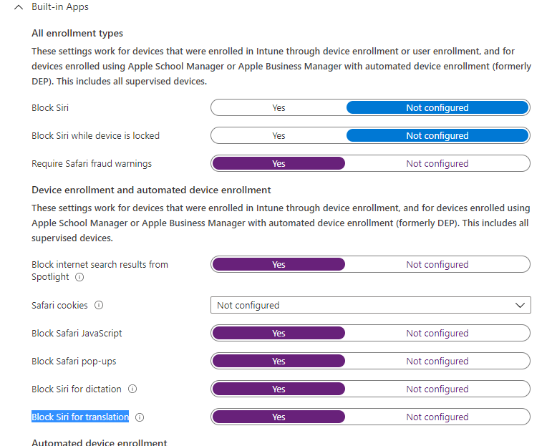

* 1. Under Cloud and Storage, select the policies
     1. Force Encrypted backups: **YES**
     2. Block managed apps from storing data in iCloud: **YES**
     3. Block notes and highlights sync for enterprise books: **YES**
     4. Block iCloud document and data sync: **YES**
     5. Block iCloud Keychain sync: **YES**
  2. Under **Connected Devices**, select the options
     1. Require AirPlay outgoing requests pairing password**: YES**
     2. Block Apple Watch auto unlock: **YES**
     3. Block AirDrop**: YES**
     4. Block pairing with non-Configurator hosts**: YES**
     5. Require AirPrint to destinations with trusted certificates**: YES**
     6. Block iBeacon discovery of AirPrint printers**: YES**
     7. Block setting up new nearby devices**: YES**
     8. Block access to USB drive in Files app**: YES**

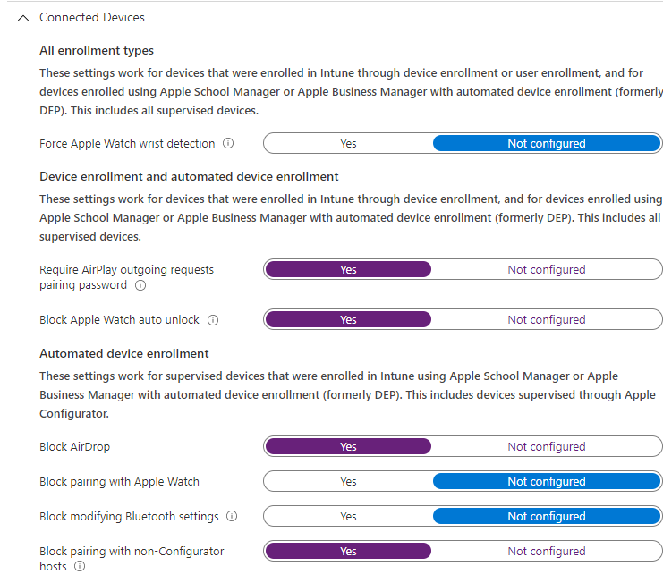

* 1. Under **General**, select the options below
     1. Block sending diagnostic and usage data to Apple**: YES**
     2. Block untrusted TLS certificates**: YES**
     3. Block over-the-air PKI updates**: YES**
     4. Force limited ad tracking**: YES**
     5. Block trusting new enterprise app authors**: YES**
     6. Limit Apple personalized advertising**: YES**
     7. Block remote Airplay, view screen by Classroom app, and screen sharing**: YES**
     8. Block users from erasing all content and settings on device**: YES**
     9. Block modification of device name**: YES**
     10. Block modification of notifications settings**: YES**
     11. Allow activation lock**: YES**
     12. Block removing apps**: YES**
     13. Block app clips**: YES**
  2. Under **Password**, set the policies below
     1. Require Password**: YES**
     2. Block Simple password: **YES**
     3. Required Password Type**: Numeric**
     4. Number of non-alphanumeric characters in password**: Not configured**
     5. Minimum password length**: 6 digits**
     6. Number of sign-in failures before wiping device**: 10**
     7. Maximum Minutes after screen lock before password is required**: 5 minutes**
     8. Maximum minutes of inactivity until screen lock**: 5 minutes**
     9. Password expiration (days)**: 365 days**
     10. Prevent reuse of previous passwords**: 15**
     11. Block password sharing**: YES**

1. Leave all remaining settings as default values
2. Assign the policy to **ALL DEVICES**
3. Create the policy

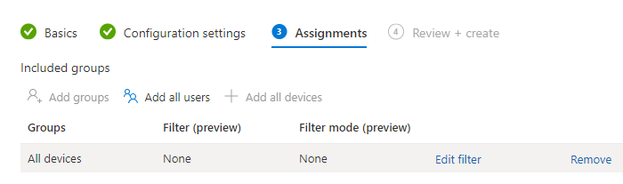

1. Policy will be created

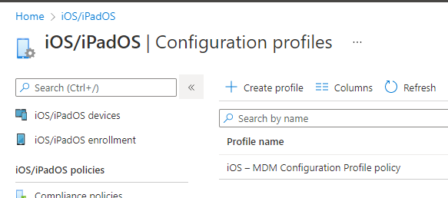

##### Device Features

1. Click on Create Profile to create a **Device Features** policy

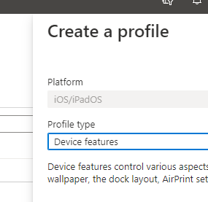

1. Provide the details for the policy
   1. Name: **iOS - MDM Device Features Policy**
   2. Description: This policy controls certain features on Apple Business Manager enrolled devices like docking station, apple start menu icons position, SSO settings, etc
2. Under **Home Screen Layout**, specify the options below

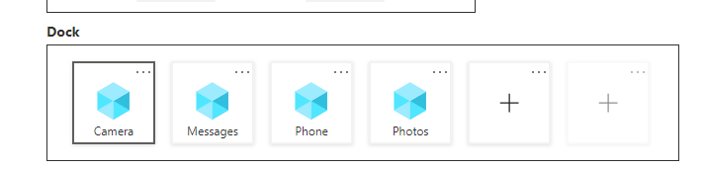

1. Under **Lock Screen Message,** provide the details for CFS building return address should the device needs to be return to their location

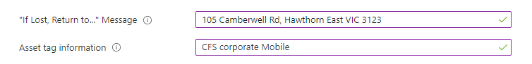

1. Under Single Sign-ON, specify the options below
   1. Azure AD username attribute: **User principal name**
   2. Realm: **DEV.CFS.COM.AU**
   3. URL: https://*.dev.cfs.com.au, <https://dev.cfs.com.au>

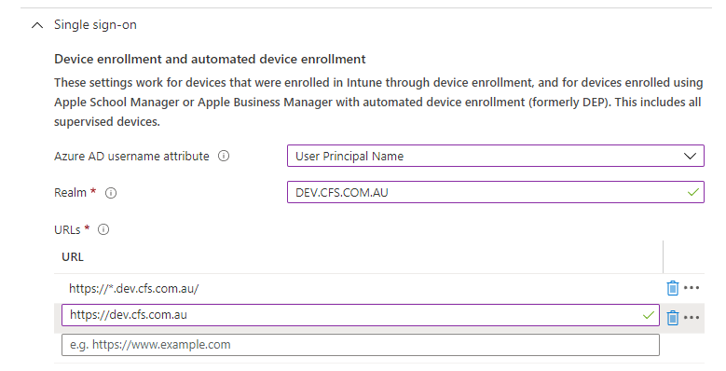

1. Under Single Sign-on app extension, select
   1. SSO app extension type**: Microsoft Azure AD**
   2. Enable shared device mode**: NOT CONFIGURED**
2. Under **Wallpaper,** select the CFS wallpaper

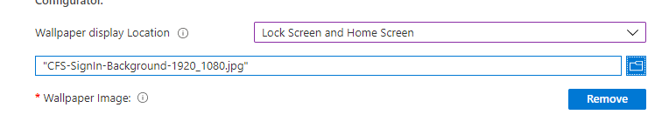

1. Under Assignments, assign to **ALL DEVICES**; save and create the policy

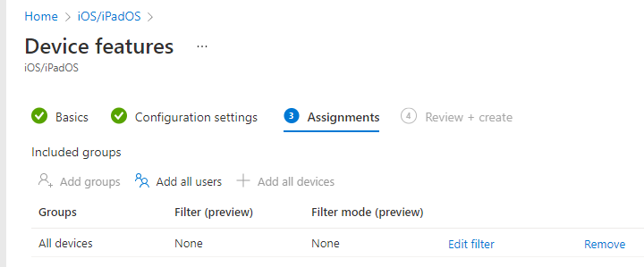

##### Configuring Apple Business Manager Tokens

To configure Intune ABM (Apple business Manager tokens) perform the steps below. This token is used to enrol the devices into Apple Business Manager and make a connection between Intune and ABM.

###### Pre-requisites

1. CFS must had enrolled into ABM and obtained the DUNS numbers for both Production and TST environments (as explained on section **Configure Apple Business Manager enrolment**)
2. The following 2 accounts are used to enrol and configure the environment
3. To connect Federated identities, you will require GLOBAL ADMINISTRATOR permissions on the Azure Tenant when running the Federation connection wizard below

|  |  |
| --- | --- |
| Account Name | Purpose |
| [CFSITCoreTeam@cfs.com.au](mailto:CFSITCoreTeam@cfs.com.au)  Or (if domain verification does not happen during the first 14 days of enrolment)  [cfsitcoreteam@cfscomau.appleid.com](mailto:cfsitcoreteam@cfscomau.appleid.com) | ABM account for production environment. |
| Mark E Winfield - [Mark.Winfield@cfs.com.au](mailto:Mark.Winfield@cfs.com.au)  Or  mark.winfield@cfscomau1.appleid.com | ABM account for development environment. This account will be changed later once CFS is ready for rollout of test devices |

###### Configure Apple Enrolment

To configure Apple Enrolment certificate and enrolment settings, perform these steps

|  |  |
| --- | --- |
|  | ***Important Note***  Apple enrolment certificate must be renewed every 365 days. This is a critical certificate require for all apple enrolment. |

1. Open Endpoint Manager, click on Devices, iOS/iPadOS, iOS/iPad OS enrolment. Click on **I agree**

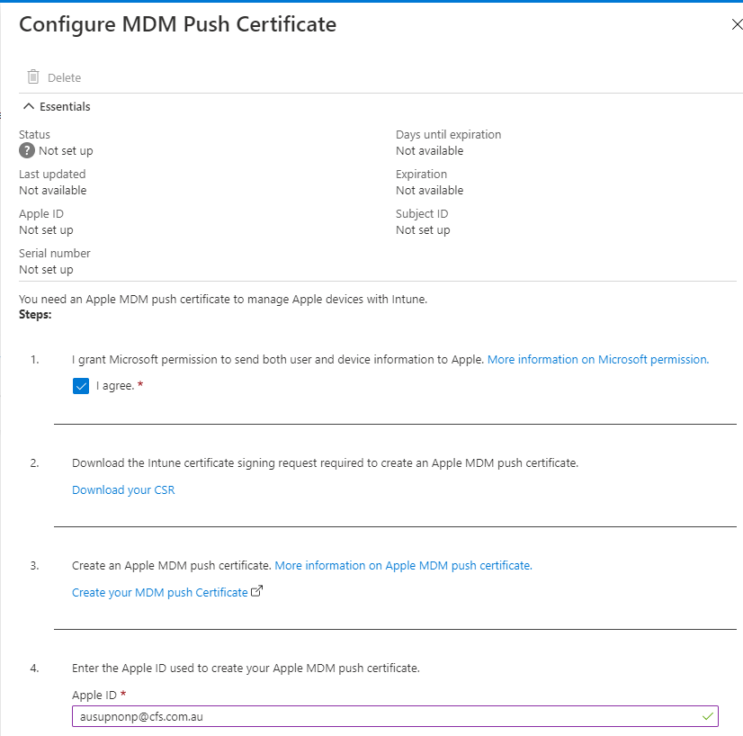

1. Click on Download your CSR

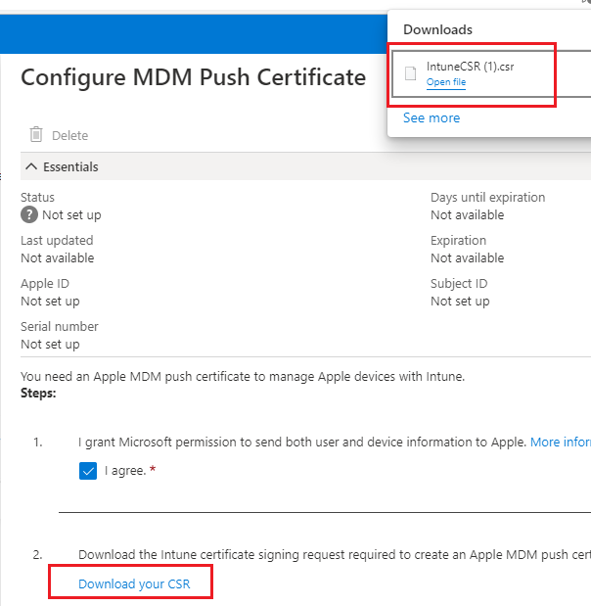

1. Click on **Create your MDMD push certificate**
2. Provide the CFS Apple ID for the environment you are building
3. Provide the MFA for the account passcode sent to CFS device. You will need to request CFS for this passcode for phone ending on XXXXXXXXX33

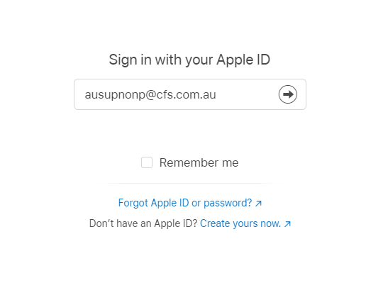

1. Click on **Create a certificate**

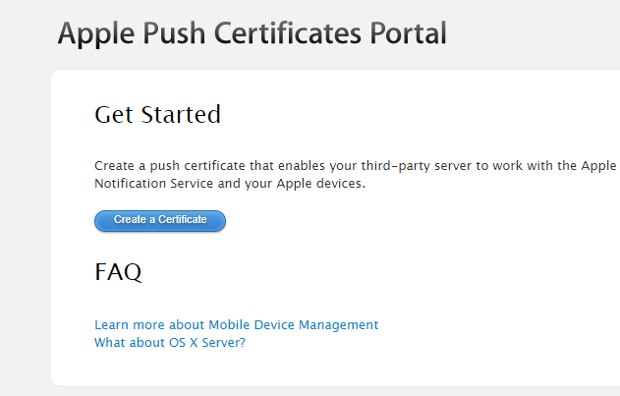

1. Click on Choose file and locate the CSR file downloaded above

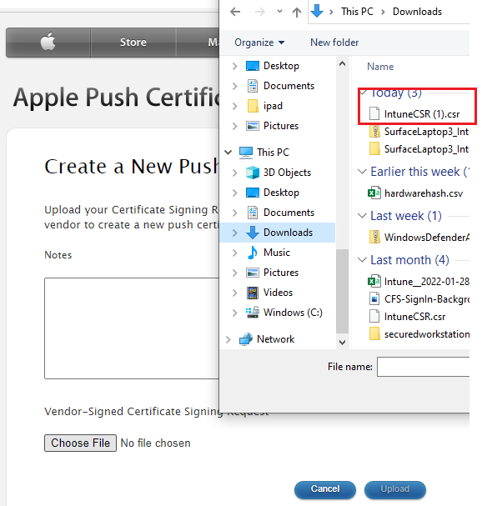

1. Click on **Download** Certificate

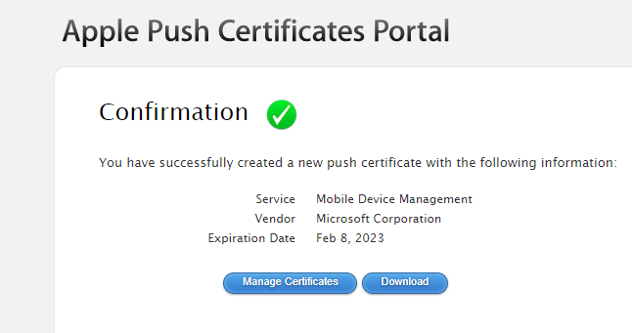

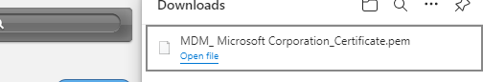

1. Navigate back to Endpoint Manager and click on Step 5, Browse to your MDM push certificate
2. Locate the certificate downloaded on step 8 and click on **UPLOAD**

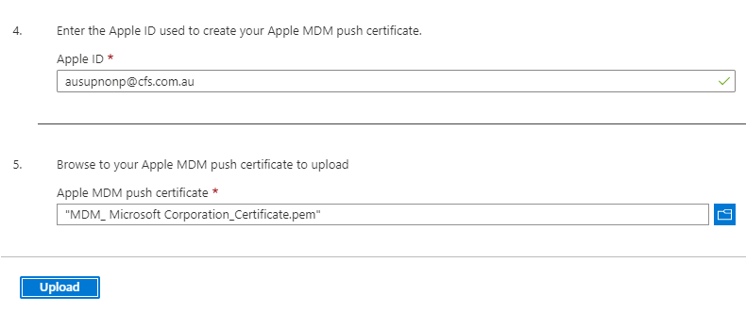

1. Certificate will appear as Active

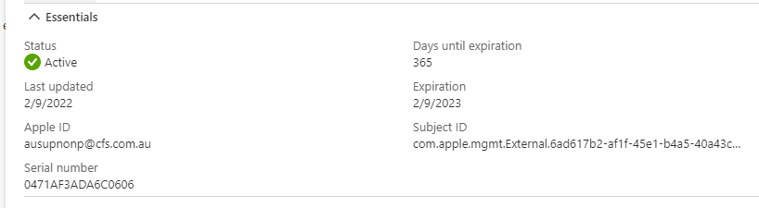

###### Configure Apple Business Manager enrolment

To configure the Apple business manager token program, perform these steps

1. On Endpoint Manager, click on Devices, iOS/iPadOS, iOS/iPadOS enrolment
2. Click on **Enrolment** **Program Tokens**
3. Click on ADD

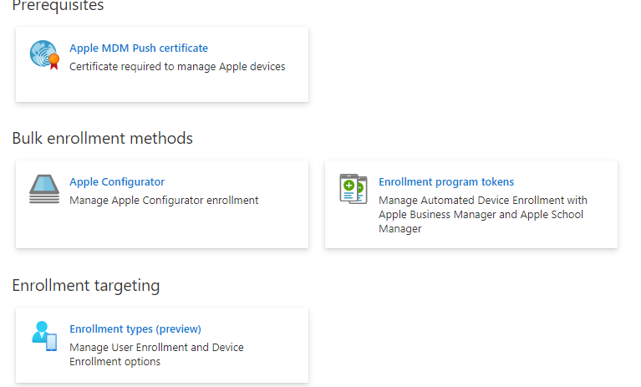

1. Select I agree and click on **Download your public key** and then click on Create a token via the **Apple Business Manager**

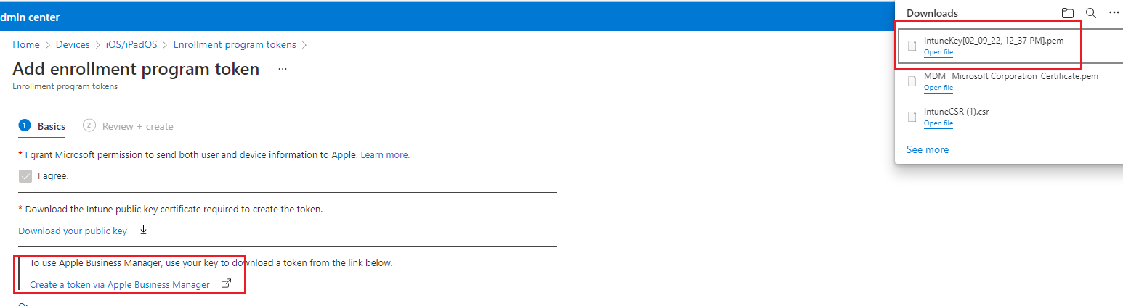

1. Request CFS for the DUNS number, or query the database if one exist

[Look up your D-U-N-S Number - Enroll - Apple Developer](https://developer.apple.com/enroll/duns-lookup/#!/search)

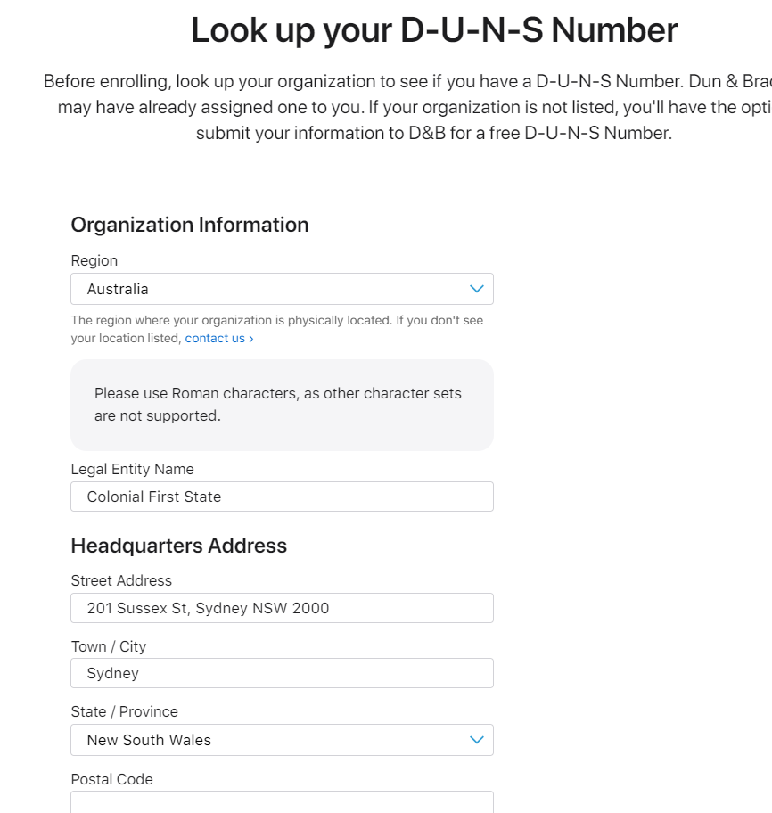

1. Locate the DUNS

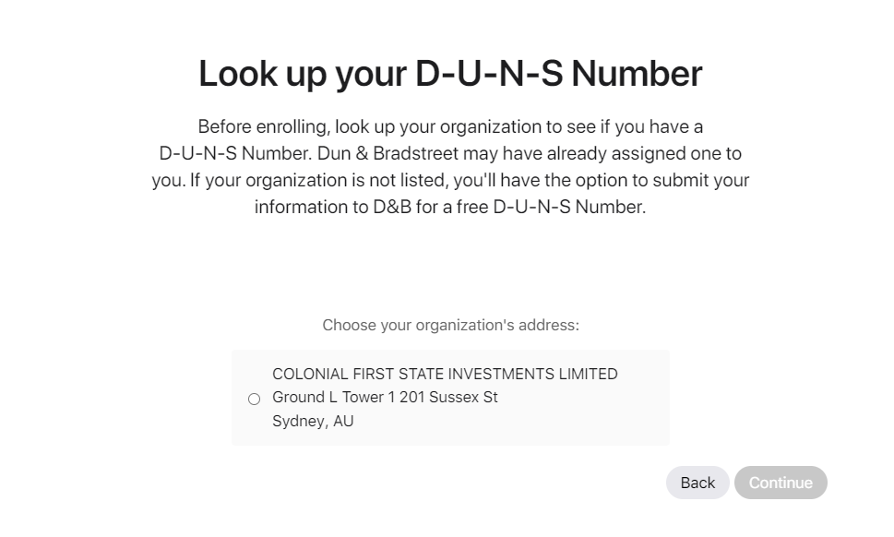

1. An Email will be sent to the CFS representative with the DUNS number

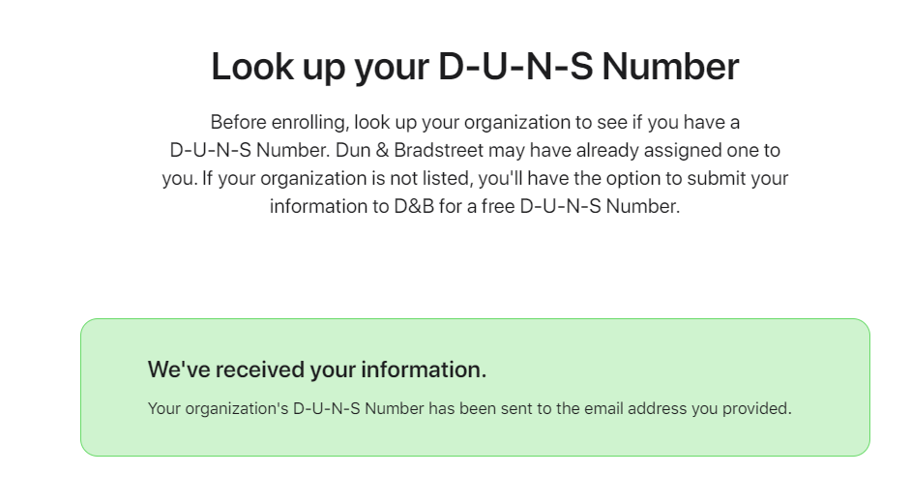

1. Review the DUNS number received by the CFS representative.
   1. There will be 2 DUNS numbers, one for TST and one for PRD

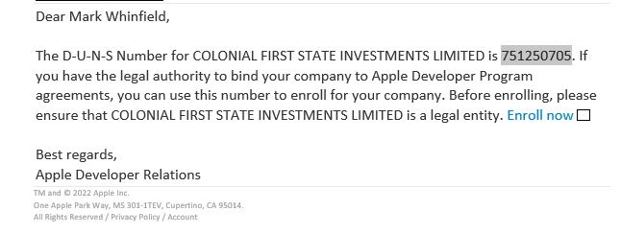

1. Navigate back to Endpoint Manager on the Add enrolment program token screen
2. Click on **Create Token via Apple Business Manager**

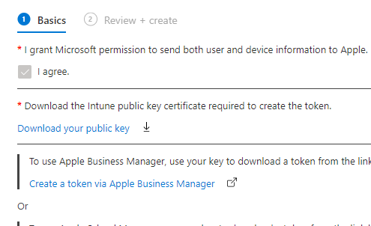

1. Sign in with the Apple ID provided by CFS and click on Enrol now

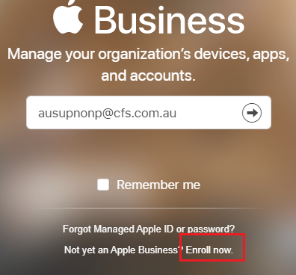

1. Provide CFS details

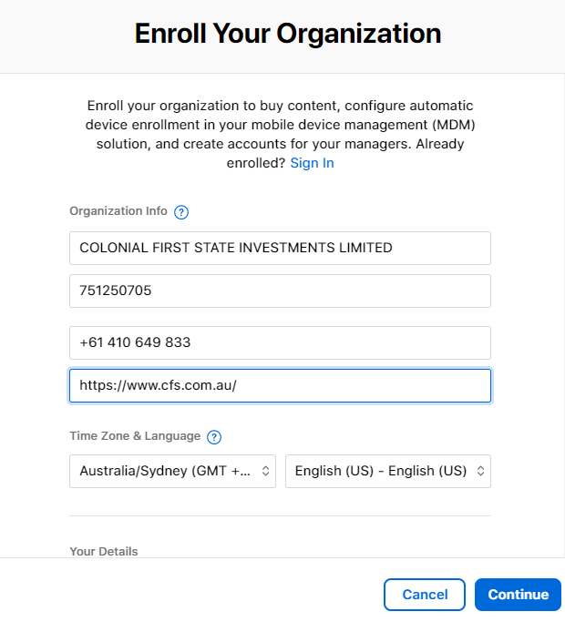

1. Click on Submit

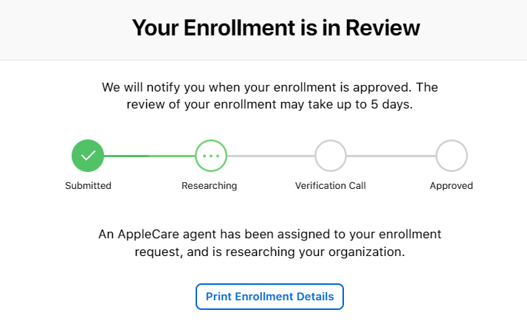

###### Create Apple Enrolment Types

To create the apple enrolment device types, perform these steps

1. On Endpoint Manager console, click on Devices, iOS/iPadOS Enrolment,
2. Click on Enrolment Targeting, Create Profile, iOS/iPadOS
3. Provide the name and description
   1. Name: Corporate iOS device enrolment profile type
   2. Description: Enrolment profile for corporate ABM apple devices
4. Under Settings, select Device Enrolment
5. Under Assignments, assign to SG-AA-OPS-IntunePolicies and save the policy

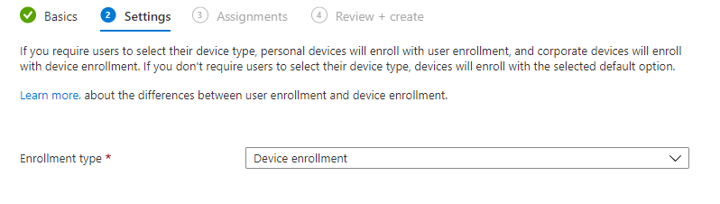

###### Configuring Tokens

Once the DUNs numbers and accounts have been configured with ABM, which is a process performed by CFS and Apple, perform the steps below to connect Intune and ABM.

1. Open Endpoint Manger, Devices, iOS/iPadOS, click on iOS/iPadOS enrolment
2. Click on **Enrolment Program Tokens** and click on ADD
3. Click on **Download your public key**. You will need this later during ABM connection to Intune
   1. File name: **ABM Token.pem**
4. Click on Agree and select **Create a token via Apple Business Manager**

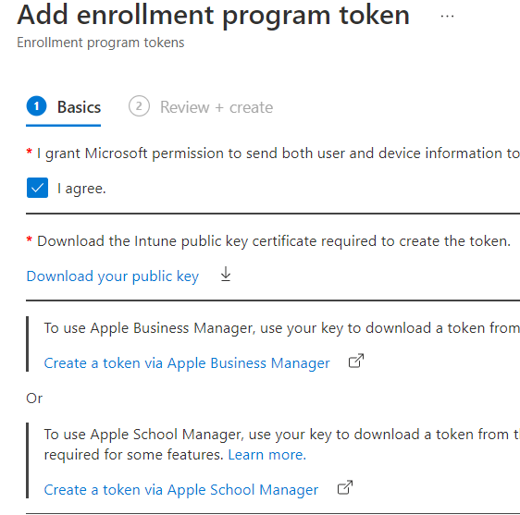

1. Sign in with the Apple Business Manager account on the table above depending on the environment you are configuring and perform MFA. **CFS will provide the MFA token when you are configuring this step**

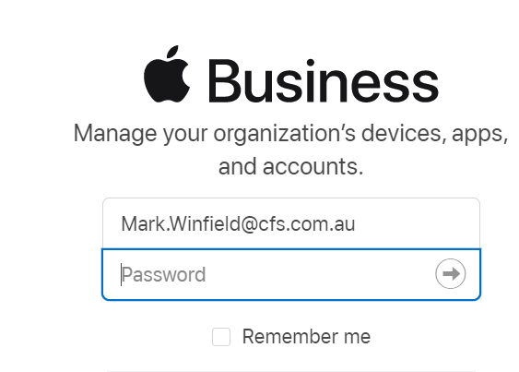

1. Click on trust this browser

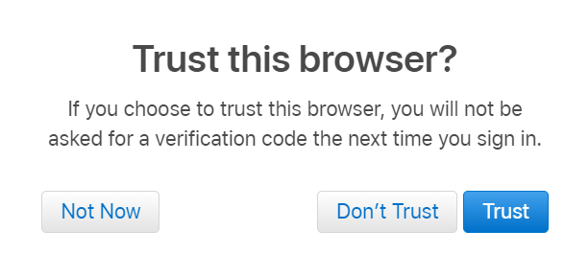

1. You can now configure Federation once logged in.
2. Click on Roles, Device Enrolment to verify you have the right DUNS for the environment being configured. In this walk-thru we can verify **testing** corresponding to the DUNS number above.

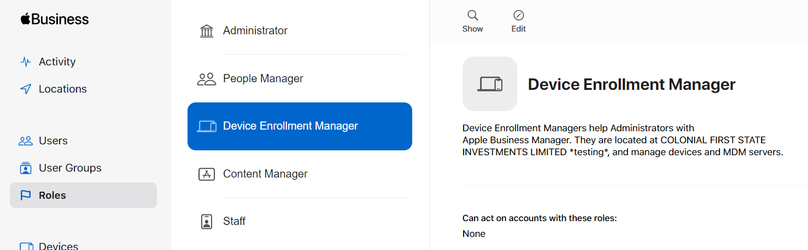

1. Click on the user name on the bottom left corner, click on Preferences, then click on Accounts then Domains and add the domains that need to be verified as part of the deployment. My and Tech are only for Production environment
   1. Dev.cfs.com.au
   2. My.cfs.com.au (only for PRD)
   3. Tech.cfs.com.au (only fort PRD)
2. Provide the TXT-record to the DNS team to verify the domain for TST and PRD domains

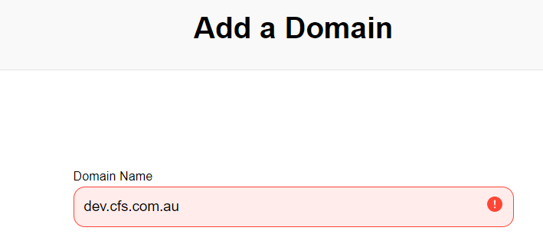

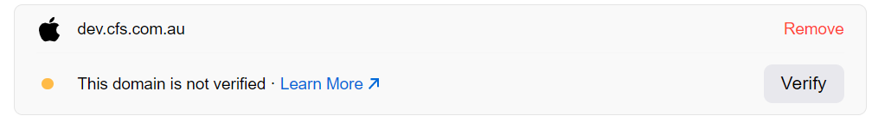

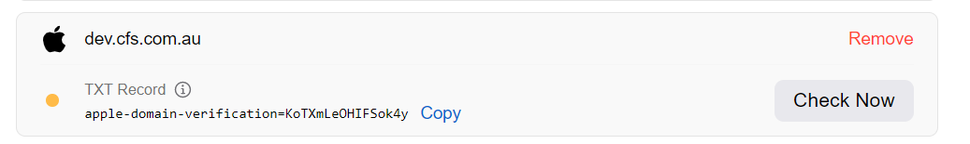

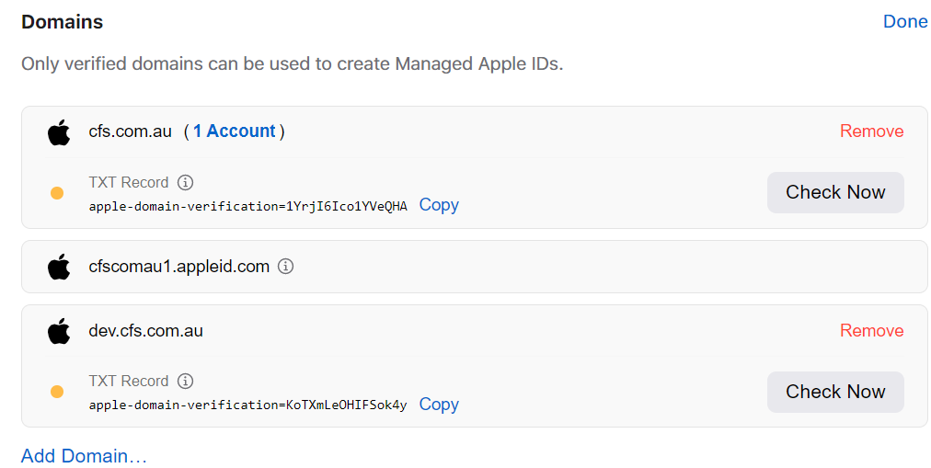

1. Once the domain TXT-record is added, click on Check now to verify that domain.
   1. The domain status will change to VERIFIED OWNERSHIP

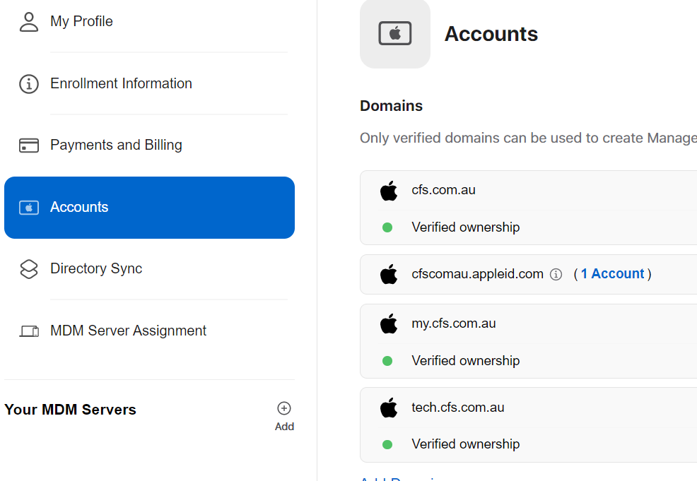

1. Click on Accounts, locate your MDM Servers option and click on Add
2. Provide the MDM server name title:
   1. CFS Development MDM connector

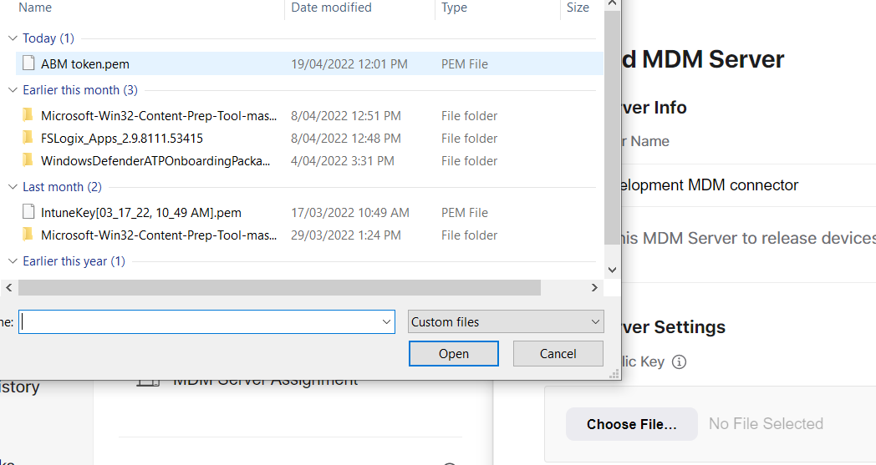

1. Click on Save and then click on Download Token

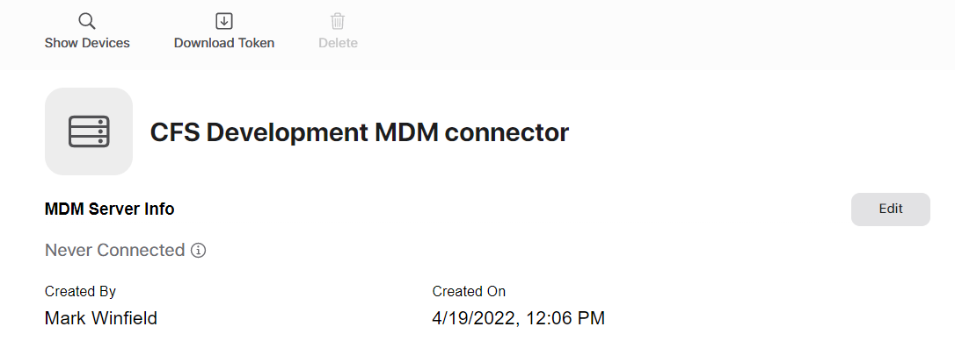

1. Download the token to a safe location and navigate back to Endpoint Manager
2. Click on Upload token and locate the file

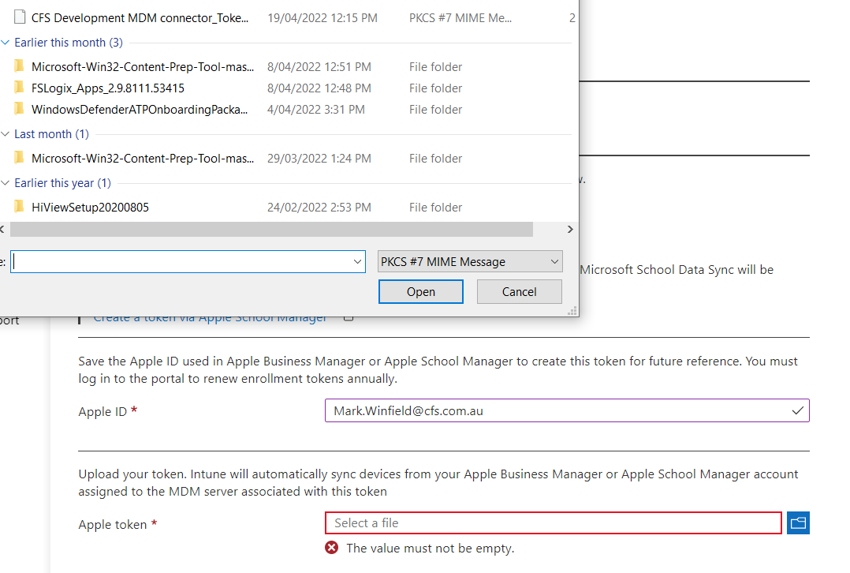

1. Upload the file and configuration

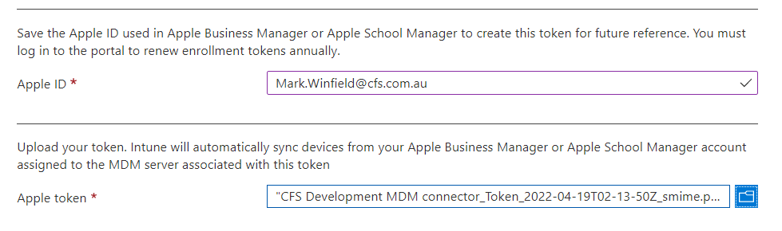

1. Verify the connection is active and ready



###### Configuring Apple Business Manager Federation

|  |  |
| --- | --- |
|  | ***Important Note***  *Only configure federation if the domain has been verified, not before* |

Once you have verified and configure the Connector for MDM identities in Apple Business Manager, perform the steps below to configure federation of identities. This will enable Azure AD users to use their UPN as an apple id.

1. Open Apple Business Manager for TST/PRD using the accounts listed in the pre-requisites section for ABM above
2. Click on the account name on the bottom left corner then click on Preferences

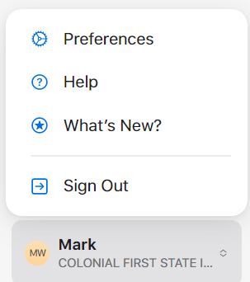

1. Click on Accounts, then under Federated Authentication, click on EDIT
2. Select Microsoft Azure AD and click Connect

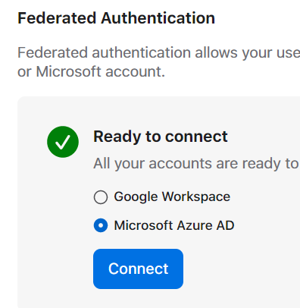

1. Sign in with a GLOBAL ADMIN to the Azure Tenant for CFS and perform MFA

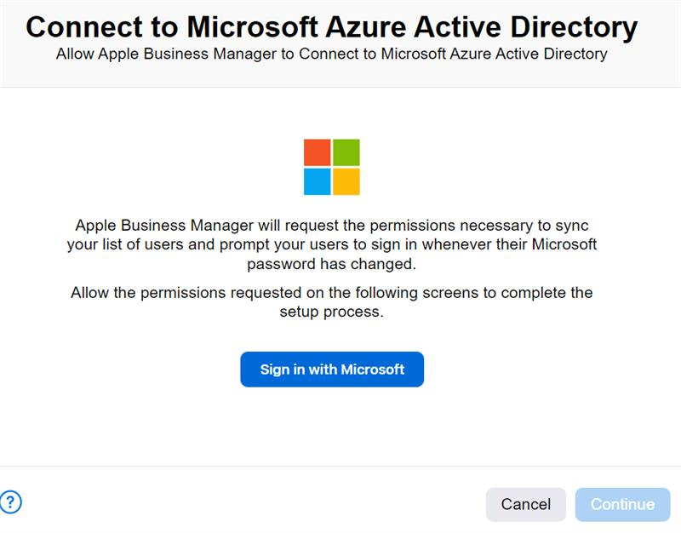

1. Grant apple.com the require permissions

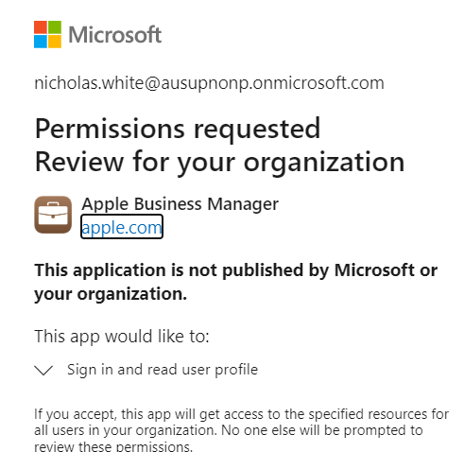

1. The wizard will connect the tenant to apple.com for identity management

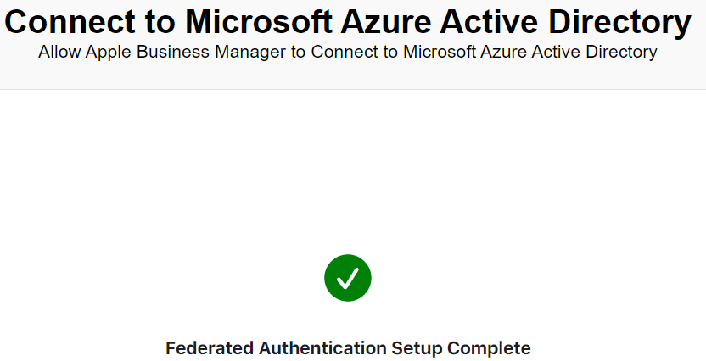

1. Click on **Enable Directory Sync** to enable synchronisation of Azure identities to Apple Business Manager. This will synchronise users from Azure AD to ABM and enable each account as an apple id using Azure AD UPNs automatically (@dev.cfs.com.au, my.cfs.com.au and tech.cfs.com.au)
2. Locate the Apple Business Manager Enterprise App

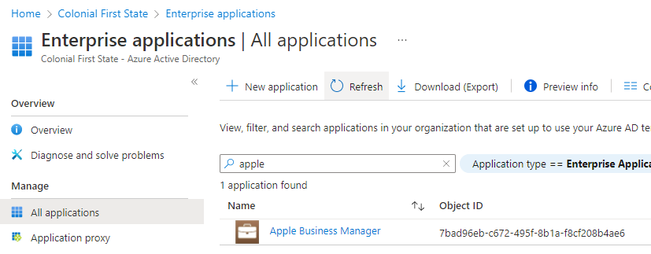

1. On the Apple Business Manager, copy the URL and token to the Apple Business Manager app in Azure AD

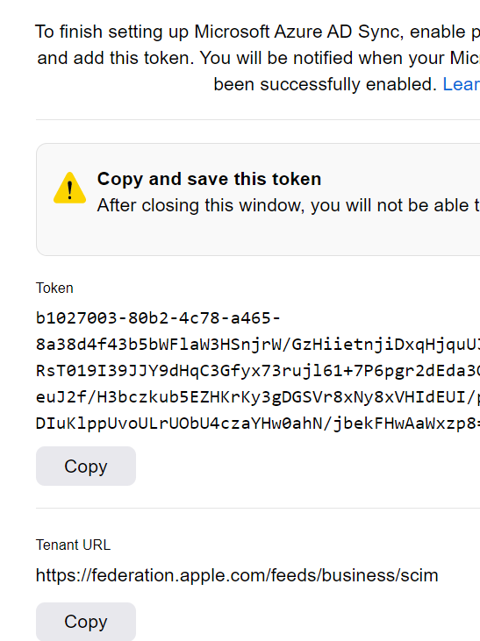

1. Provide the values and click in Test Connection
2. Select Scope: Sync all users and groups
3. Select Provisioning Status: ON
4. Wait until accounts are synchronised to Apple Business Manager

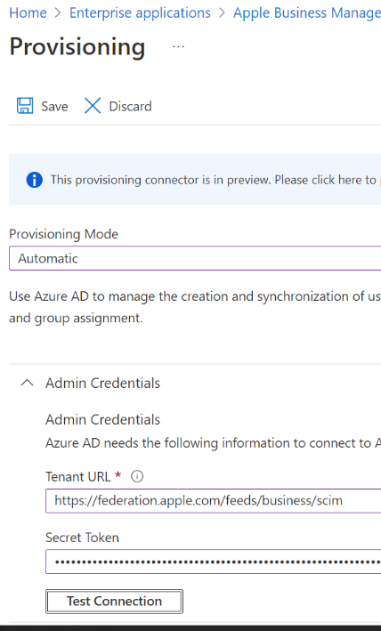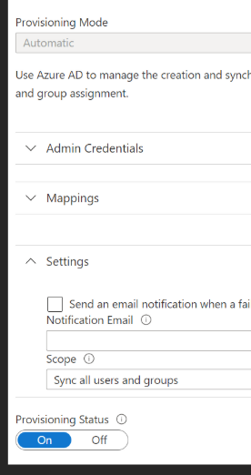

###### Configure Federation for Each verified domains

Click on Federate and provide a CFS DEV/PRD Global admin account to connect to the domain.

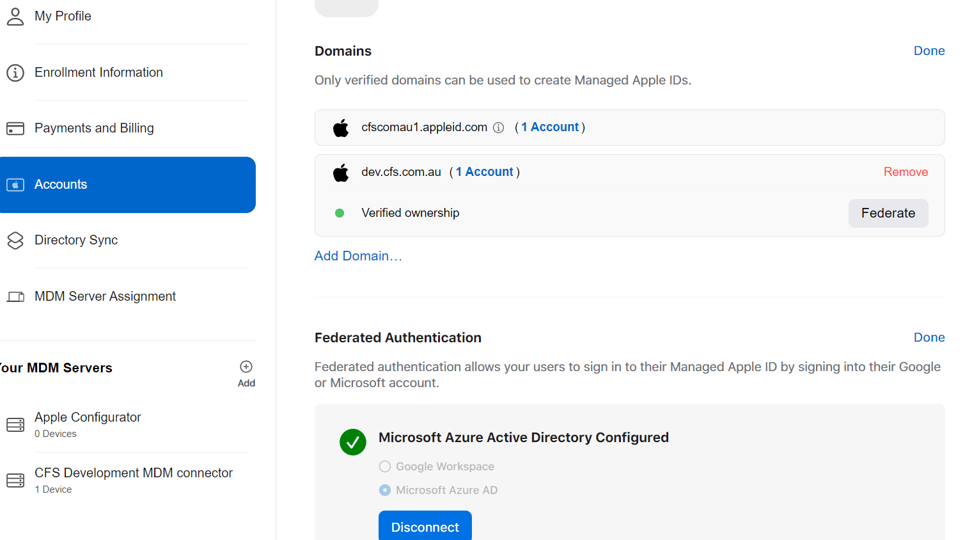

Sign in with a Global admin

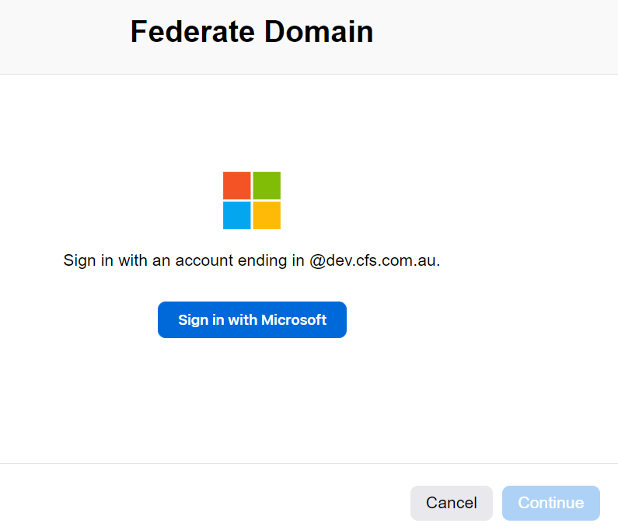

Click on Enable Federation

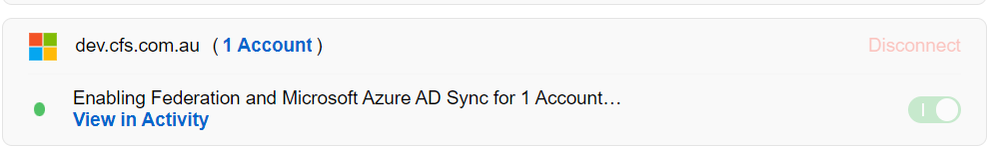

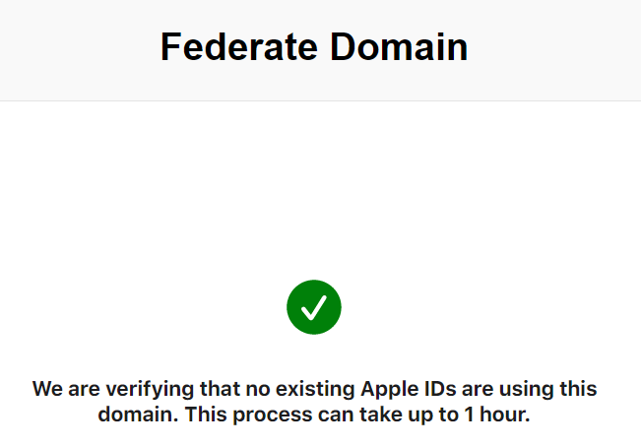

Accounts will SYNC from Azure AD to Apple ABM.

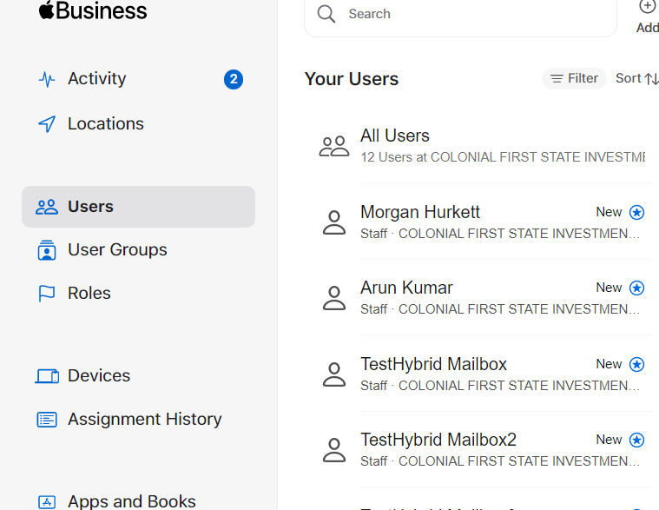

Repeat Federation for MY.CFS.COM.AU and TECH.CFS.COM.AU

###### Add VPP Token for App purchases

On Apple Business Manager, download the App and Books token. You will find the token in Preferences, Payment and Billing, then select the Location under Server Tokens.

Save this file to a secure Location, you will import it in Intune later on.

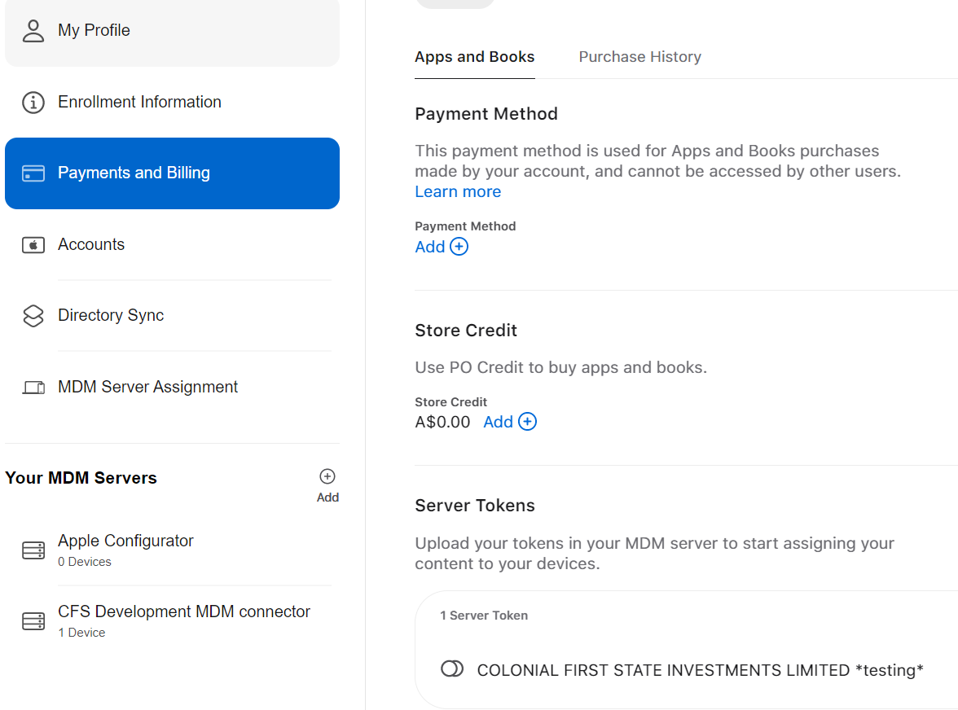

1. Open Endpoint Manager, Tenant Administration, then select Apple VPP tokens

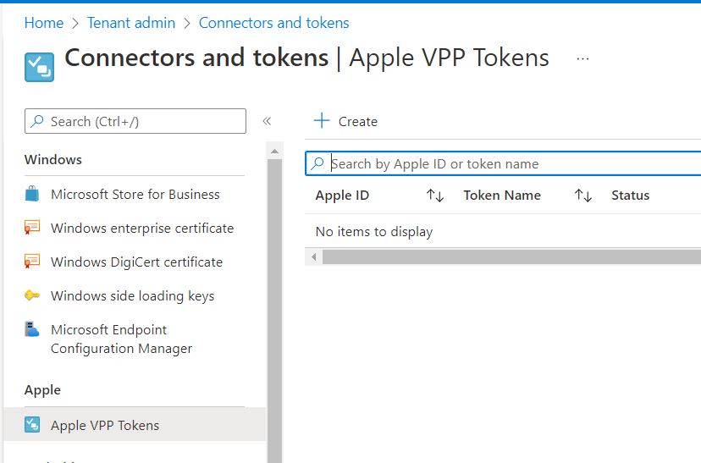

1. Click on Create and provide the details for the connector

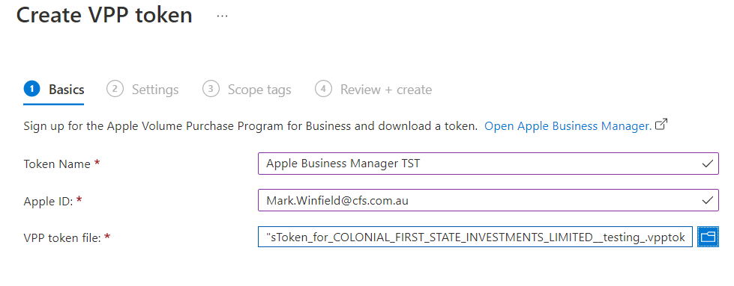

1. Provide the details under Settings

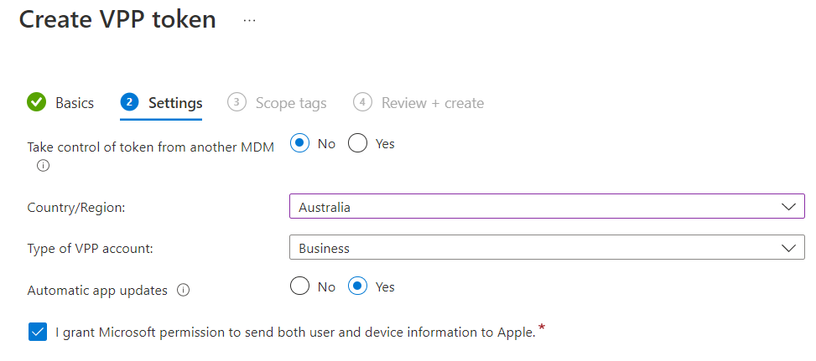

1. The token will be uploaded and appear as Active

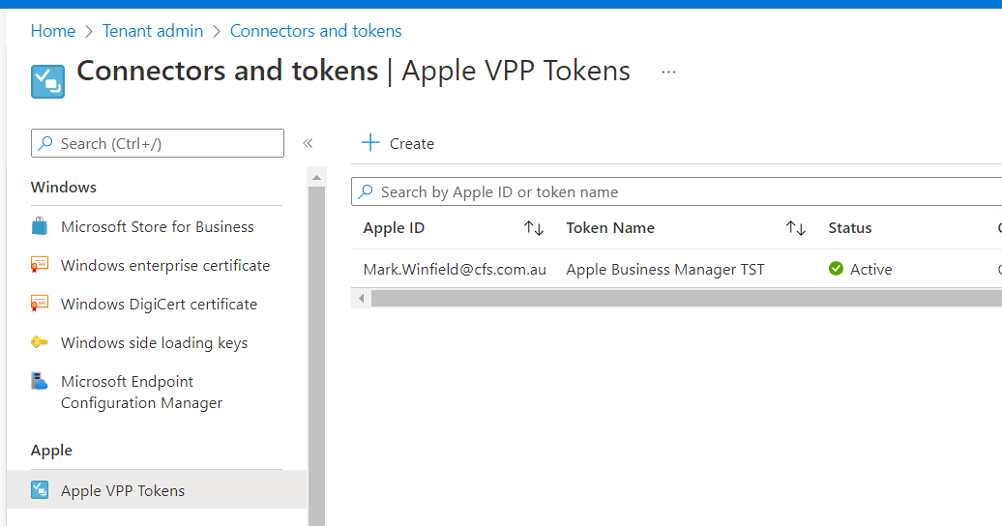

1. Once you have configured the Token, any apps purchased on Apple Business Manager will appear in Intune

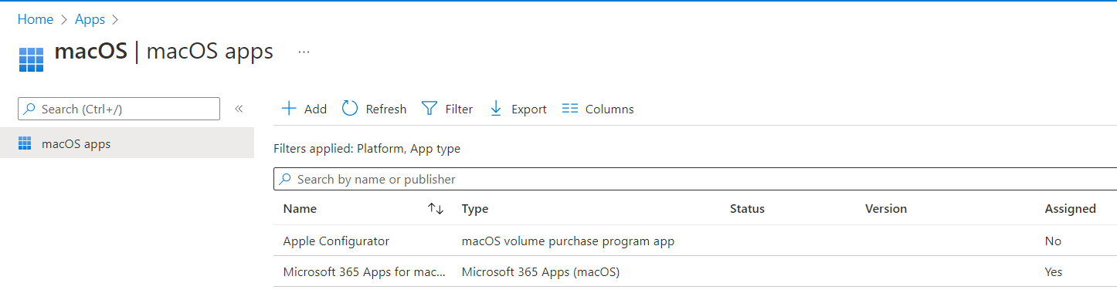

###### Configure Company Portal Licensing

In order to enable VPP tolens, the Company portal app needs to be assigned as an APP on Apple Business Manager.

Perform these steps to assign the app licenses require for production and test

1. Open Apple Business manager for the environment (TST Or PRD)
2. Click on App and Books, locate the Company portal app and click on Assing to Location
   1. Assign to TST or PRD location
3. Select 500 licenses to start with for Wrap users in Melbourne then click on GET

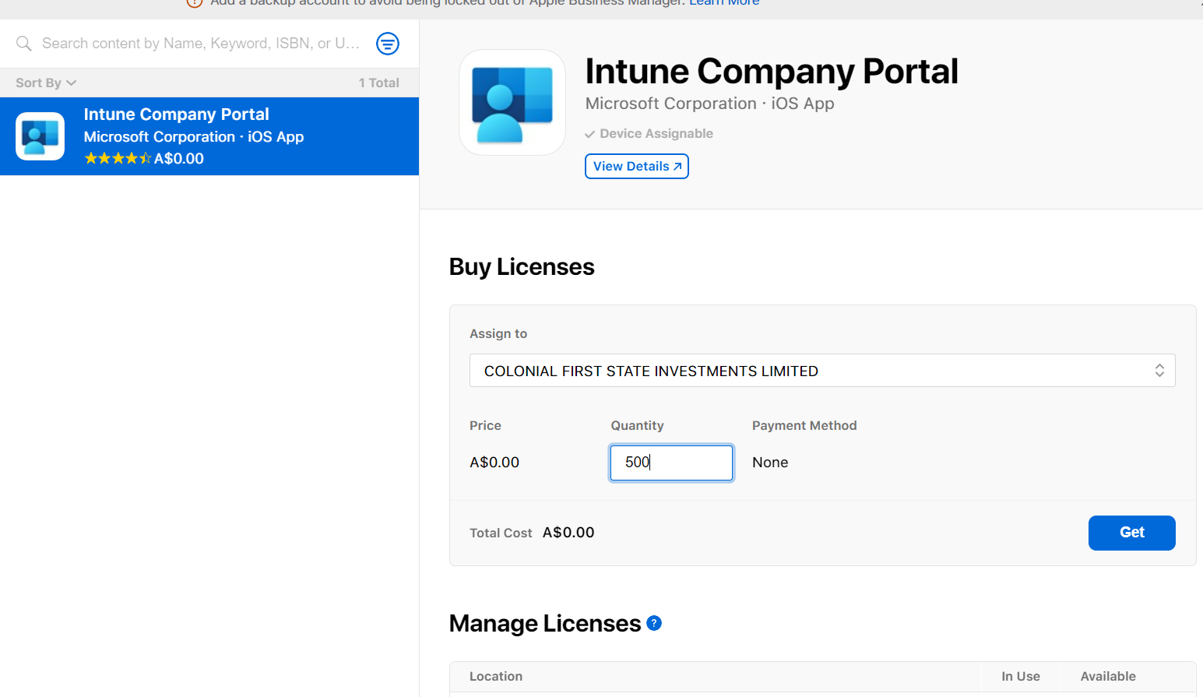

1. On Endpoint Manager, Tenant Administration, Connectors and Tokens, locate the Apple VPP token. Right click on the VPP token and click SYN

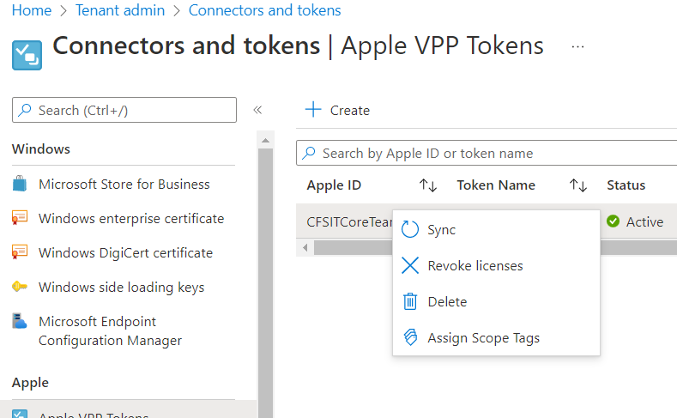

1. Verify the iOS/iPadOS app Company portal volume app license is now deployed



###### Configure ABM enrolment profile

Once the connection between ABM and MDM Intune has been set, click on Endpoint manager, iOS/iPadOS Enrolment then Enrolment Program Tokens, select the token previously configure and perform these steps

1. Click on Profiles, New Profile. iOS/iPadOS
2. Provide the name and description for the profile
   1. Name: iOS/iPadOS - Enrolment Profile
   2. Description: Enrolment profile for corporate iOS/iPadOS
3. Under Management Settings, select the options below
   1. **User Affinity:** enrol with user affinity
   2. **Authenticatioin Method:** Company Portal
   3. **Install Company Portal with VPP:** select the troken for the environment (TST or PRD)
   4. **Supervised:** YES
   5. **Locked enrolment:** YES
   6. **Shared iPad:** YES
   7. **Maximum cache users:** 10
   8. **Maxim seconds after screen lock before password is required:** 300 (5 mins)
   9. **Maximum seconds of inactivity until user session logs out:** 0
   10. **Sync with computers:** Deny all
   11. **Apply device name template:** YES
   12. **Device name template: {{DEVICETYPE}}-{{SERIAL}}**
4. Under Setup assistant, select the options below
   1. Department: CFS IT
   2. Phone number: +61 410649833
   3. Toggle All
   4. Create the policy
5. Click on a new Profile for MacOS and repeat the process
   1. **Select User Affinity:** Enrol with User Affinity
   2. **Authentication method:** Setup Assistant with modern Authentication
   3. **Lock enrolment:** Yes
6. Once both profiles are created, click on **set default profile and** allocate each iOS profile and MacOS respectively.

###### Add Reseller Numbers

To add Telstra and other resellers to Apple business Manager, perform the steps below.

1. Open Apple Business manager for TST/PRD, then under preferences, devices, MDM Server Assigment:
2. Click on Add and provide the reseller ID for Telstra: **1A586DA0**
3. Save the changes

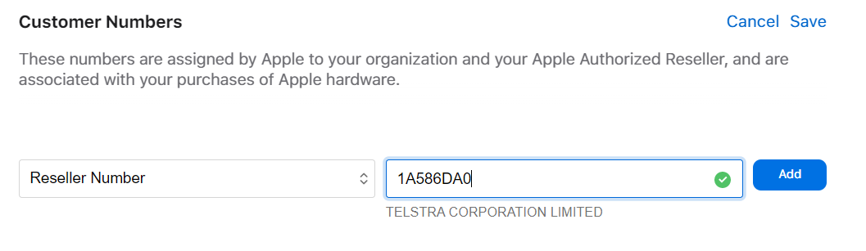

###### Configure Apple Configurator

Apple Configurator can be used to manually enrolled Apple devices which are not purchased from an authorise retailer

To configure Intune and Apple Configurator integration, perform these steps

1. Open Endpoint manager, devices, enrolled devices, Apple enrolment, Apple Configurator
2. Click on Profile, create profile
   1. Name: Apple Configurator Profile
   2. Description: Profile to allow manual enrolment of apple devices using Apple Configurator
3. Under Settings, select User Affinity: **Enrol with user affinity**
4. **Select where users must authenticate:** company portal
5. Create the profile
6. Under profile, click on export profile and copy the URL to Notepad. This URL will be used later on the Mac device to enrol other apple devices

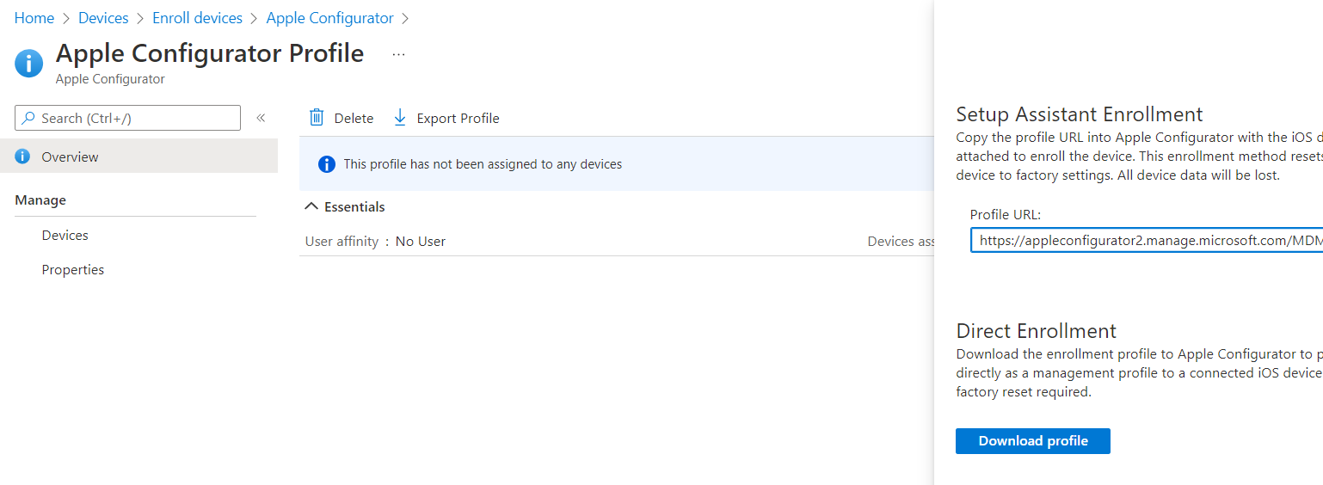

###### Manual Enrolment of a device

To manually enrol iPhone/MacOS devices, follow this document: [How to manually add devices in Apple Business Manager (ABM) or Apple School Manager (ASM) - Microsoft Tech Community](https://techcommunity.microsoft.com/t5/intune-customer-success/how-to-manually-add-devices-in-apple-business-manager-abm-or/ba-p/2328462)

1. Apple steps on how to enroll an iPhone device manually using an iPhone and Mac device: [Apple Configurator User Guide – Apple Support (AU)](https://support.apple.com/en-au/guide/apple-configurator/welcome/ios)
2. Copy the Apple Configurator URL above into the profile in Apple configurator as per instructions

|  |  |
| --- | --- |
|  | ***Important Note***  *Make sure to plug the iPhone directly to the Mac device where you are using Apple Configurator using USB cable.*  To enrol an iPhone, you will need Apple Configurator in a Mac device to push the profile to the phone; and to enrol a Mac you will need an iPhone with apple configurator installed then you will need to sign into the configurator using the Apple Business Manager account to enrol the Mac into ABM before you continue with Intune enrolment. |

1. Once you have enrolled the Mac into Apple Business Manager using the iPhone, install Company Portal on the device and follow the steps in the wizard to finalise enrolment.

###### Automatic Enrolment of a device

Follow the enrolment videos for the platform of your device below accordingly. The videos can be found here

[CFS Device Enrolment | Microsoft Stream](https://web.microsoftstream.com/channel/353c5d75-a6b3-4d22-9350-8140632d909b)

##### Trusted Certificate Profile Policy

To create the Trusted Root ca policy for iOS, perform these steps below

1. On Endpoint Manager, click on Devices, iOS/iPadOS, Configuration Profiles,
2. Create a new profile, Templates, select Trusted Certificate
3. Provide the details for the policy
   1. Name: iOS - Trusted Root CA
   2. Description: Trusted Root CA Policy for on premise CA
4. Upload the Root CA from the on premise CA and assign to DG-AA-OPS-Intune-iOSDevices

##### Trusted Intermediate Certificate Profile Policy

Create another Trusted Certificate and specify the SubCA intermediate certificate from the on premise Certificate Authority (CA)

Policy name: iOS - Trusted Intermediate Certificate Sub CA01

Assignment: DG-AA-OPS-Intune-iOSDevices

|  |  |
| --- | --- |
|  | ***Important Note***  *You will need to create 2 intermediate certificate policies for Production. One for Sub CA 01 and another for Sub CA 02* |

You will need 2 Intermediate policies for production

##### PKCS User certificate Profile

Once you have created the Root CA and SubCA policies, create a PKCS User Certificate Configuration Policy. Perform these steps:

1. Create a new Configuration Policy for iOS/iPadOS, provide the policy details
   1. Name: iOS – PKCS User Certificate
   2. Description: PKCS User Certificate for iOS/IPadOS
2. Provide the details for the certificate policy:
   1. Certification authority:
      1. **Dev server:** VMNPEDCPKI001.dev.cfs.com.au
      2. **Prod servers:** VMPRDEDCPKI001.cfs.com.au for user certificates
      3. **Prod servers:** VMPRDSDCPKI001.cfs.com.au for device certificates
   2. Certificate Authority Name:
      1. **Dev:** DEVCFS Sub CA 01
      2. **Production:** CFS Sub CA 01 for users
      3. **Production:** CFS Sub CA 02 for devices
   3. Certificate Template: **CFSIntuneUserAuth**
   4. Subject Name format: CN={{UserName}},E={{EmailAddress}}
   5. Subject Alternative Name:
      1. Attribute: User Principal Name
      2. Value: {{UserPrincipalName}}
   6. Assign to DG-AA-OPS-Intune-iOSDevices

##### PKCS Device certificate Profile

Create a PKCS Certificate Configuration Profile and specify the values for Device PKCS certificate:

1. Create a new Configuration Policy for iOS/iPadOS, provide the policy details
   1. Name: iOS – PKCS Device Certificate
   2. Description: PKCS Device Certificate for iOS/IPadOS
2. Provide the details for the certificate policy:
   1. Certification authority:
      1. **Dev server:** VMNPEDCPKI001.dev.cfs.com.au
      2. **Prod servers:** VMPRDEDCPKI001.cfs.com.au for user certificates
      3. **Prod servers:** VMPRDSDCPKI002.cfs.com.au for device certificates
   2. Certificate Authority Name:
      1. **Dev:** DEVCFS Sub CA 01
      2. **Production:** CFS Sub CA 01 for users
      3. **Production:** CFS Sub CA 02 for devices
   3. Certificate Template: **CFSIntuneDeviceAuth**
   4. Subject Name format: **CN={{AAD_Device_ID}}**
   5. Subject Alternative Name:
      1. Attribute: Custom Azure AD Attribute
      2. Value: **CN={{DeviceName}}**
   6. Assign to DG-AA-OPS-Intune-iOSDevices

##### Defender for Endpoint Integration

To integrate iOS devices (MacOS and iOS), the compliance policy will need to evaluate the risk level of the endpoint. Modify the compliance policy for iOS to include this check:

1. Open Endpoint manager, click on Devices, iOS, Configuration Profiles
2. Locate iOS – MDM Compliance Policy and click on properties
3. Under Compliance Settings, change the value of Microsoft Defender for Endpoint to
   1. Require the device to be at or under the machine risk score: **CLEAR**
4. Save the compliance policy

#### Android Enterprise Fully Managed and Personally Owned

##### Device Restrictions – Fully Managed devices

To create Android Enterprise Configuration profiles, perform these steps

1. Open Endpoint Manager, Devices, Android, then click on Configuration Profiles
2. Create a new profile policy
3. Select Android Enterprise and Device restrictions, Fully Managed Corporate - owned

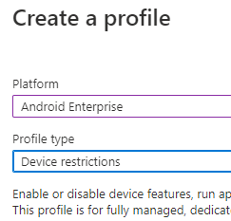

1. Provide the name and description for the policy
   1. Name: **Android - MDM Configuration Profile policy**
   2. Description: Policy to set configuration settings on Android Enterprise devices. This policy sets password, security, and other device hardware-level settings to meet CFS design requirements.
2. Under **Configuration Settings, then** General select the options below
   1. **USB File transfer** and **External Media** set to **BLOCK**
   2. Factory reset protection emails: **Google account email addresses**
   3. List of email addresses (Google account email addresses option only): [ausupnonp@gmail.com](mailto:ausupnonp@gmail.com)
   4. Data sharing between work and personal profiles: **Block all sharing between profiles**

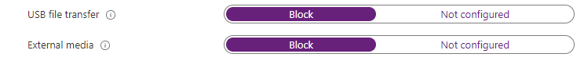

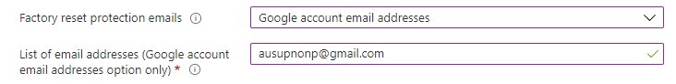



1. Under **System Security**, leave defaults as REQUIRED
2. Under **Device experience**, select
   1. Enrolment profile type: **Fully managed**
   2. Configure custom wallpaper: **Enable**
   3. Enter URL of wallpaper image: <https://www.cfs.com.au/content/dam/colonial-first-state/icons/27509-CFS-logo-94x40.svg>

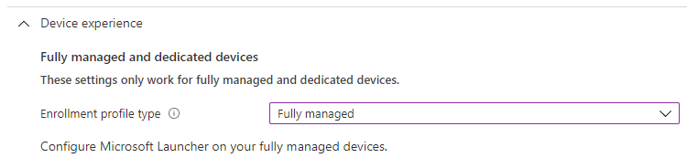

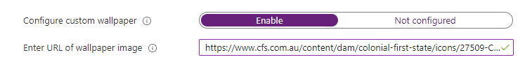

1. Under **Device Password,** select the following options
   1. Require password type: **Numeric**
   2. Minimum password length: **6**
   3. Number of days until password expires: **365 days**
   4. Number of passwords required before user can reuse a password: **15**
   5. Number of sign-in failures before wiping device: 10
   6. Disable lock screen features: **0 selected** – all options will be available on the lock screen

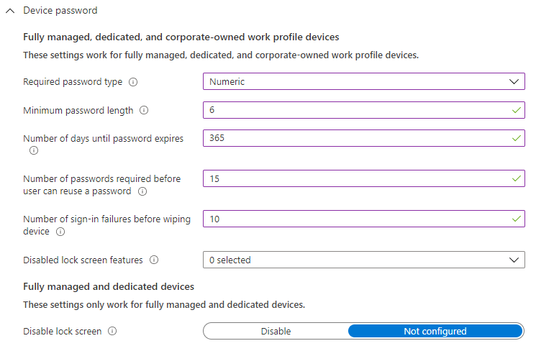

1. Under **Work-profile password**, select the options below
   1. Required password type: **Numeric**
   2. Minimum password length: **6**
   3. Number of days until password expires: **365**
   4. Number of password required before user can reused a password: **15**
   5. Number of sign-in failures before wiping device: **10**

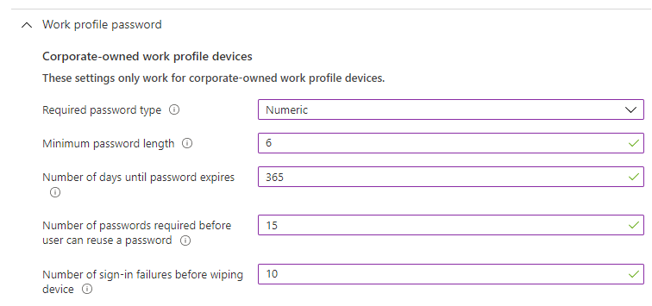

* 1. Under **Assignments**, assign the policy to **ALL DEVICES** and create the policy

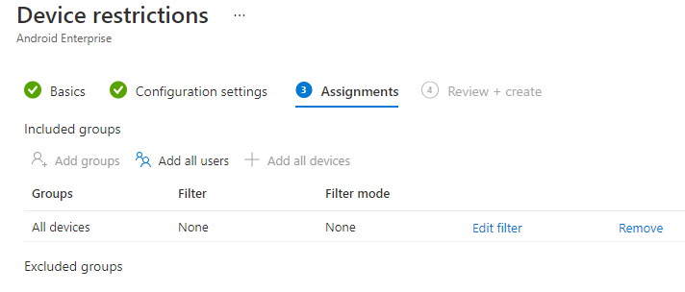

##### Device Restrictions – Personally Owned

Create an identical Device restriction policy but for Personally Owned Android Enterprise. Settings will be identical to the section immediately above.

1. Under **Work profile settings**, select the options below
   1. Copy and paste between work and personal profiles: **ON**
   2. All other settings default
2. Under Work profile password, select the same options as **Device Restrictions** above
   1. Require Work profile password: Require
   2. Minimum password length: 6
   3. Maximum minutes inactivity: 5 mins
   4. Number sign in failures: 10
   5. Password expire: 365 days
   6. Password type: at least numeric
   7. Prevent reuse of passwords: 15
3. Under Password, set the policies the same as Work Profile password
4. Under **system security,** select the options below
   1. Threat scan on apps: Require
   2. Prevent app installation from unknown sources in the personal profile: BLOCK
5. Under **Connectivity**, leave defaults. This section can configure the VPN client where require
6. Under **Assignments,** assign to ALL DEVICES

##### Configure Google Play

To configure Android Enterprise and Google Play account integration with Intune, perform the steps below

1. Open Endpoint Manager, Devices, Android, click on **Android Enrolment**
2. Click on **Managed Google Play**
3. Click on I Grant Microsoft permission to send both user and device information to Google

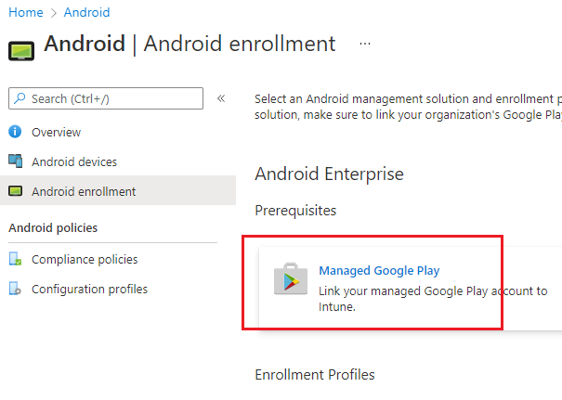

1. Click on Launch Google to connect now

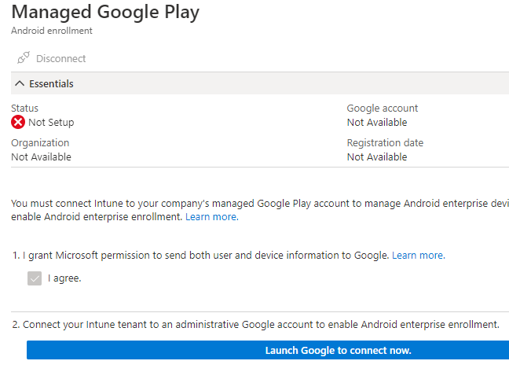

1. Click on SIGN IN

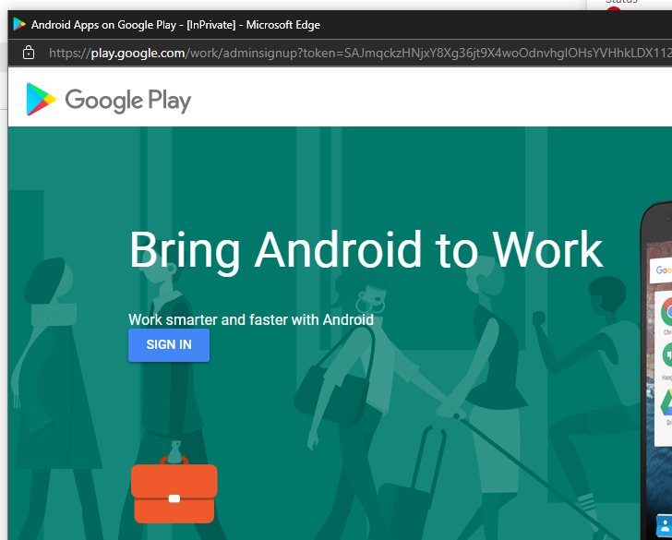

1. Provide the CFS Google Dev account (or production) details
   1. Account Name: [ausupnonp@gmail.com](mailto:ausupnonp@gmail.com) or ausupprod@gmail.com
   2. Password: request CFS to provide the password
   3. Click on NEXT

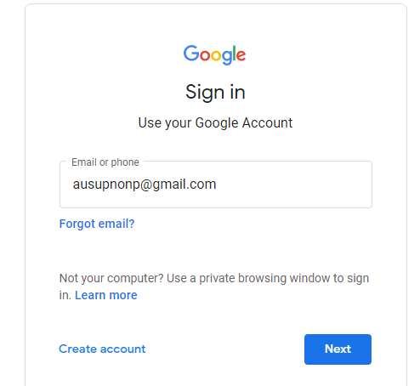

1. The account will sign in onto the device, click on the right top corner icon to verify the account is now signed in
2. Click on **Get Started**

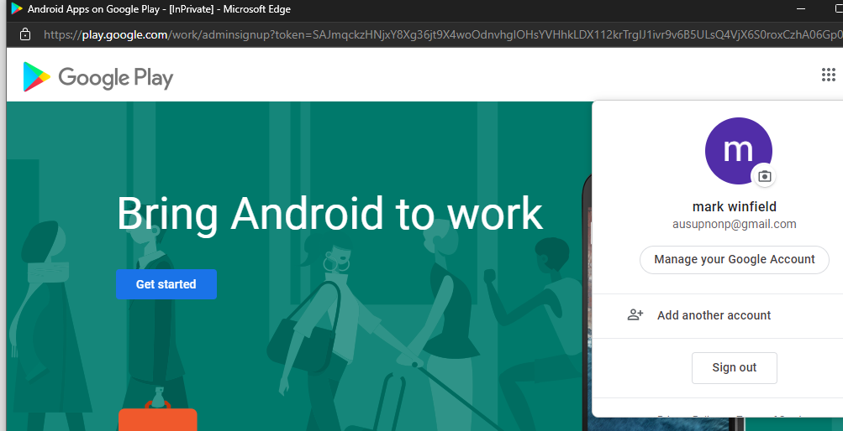

1. Provide the Business Name
   1. Name: Colonial First State
2. Provide the details of both the Data Information Officer and EU Representative then click on **I have read and agree to the Manage Google play agreement**
   1. Name: Mark Winfield
   2. Email: [Mark.Winfield@cfs.com.au](mailto:Mark.Winfield@cfs.com.au)
   3. Phone: Request the user for their mobile

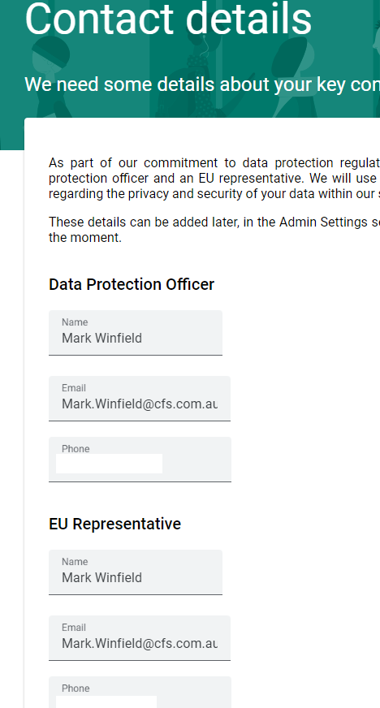

1. Click on **Complete Registration**

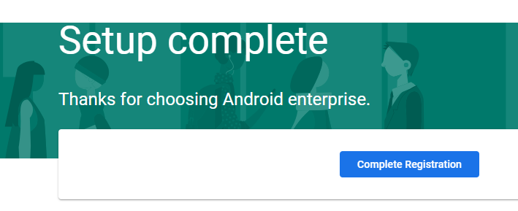

1. Verify the connection is now appearing as Setup and the user details correspond to the DEV account or PRD account respectively.

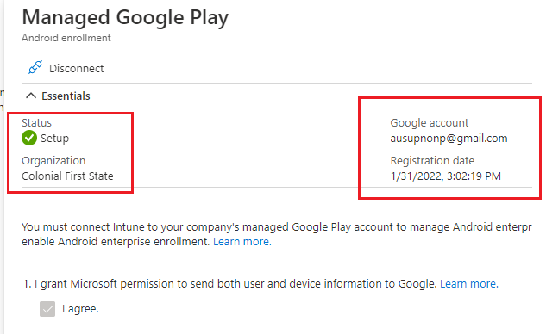

1. Click on **Corporate-owned, fully managed user devices**
2. Enable the option to allow users to enrolled fully managed Android devices using tokens
3. Select yes to the option **Allow users to enrol corporate-owned user devices**

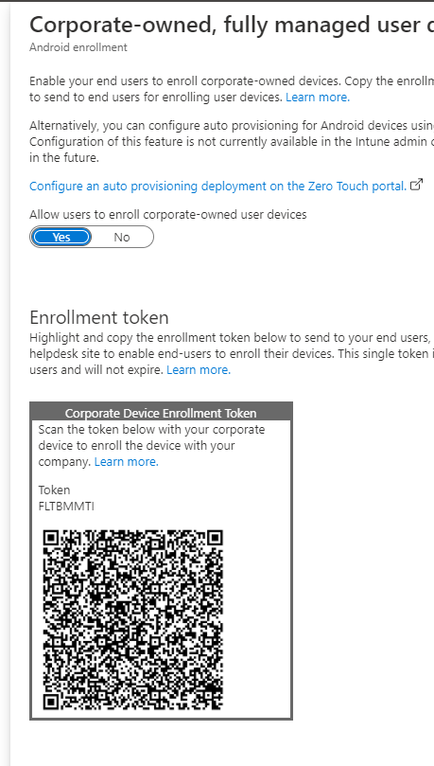

|  |  |
| --- | --- |
|  | ***Important Note***  *CFS can provide this token to users when they receive a brand-new Android Corporate device to enrol it onto Intune automatically as a Corporate Android Fully Managed Device. This type of device will not have personal apps installed, only fully corporate usage.* |

1. Click on **Corporate-owned devices with work profile**

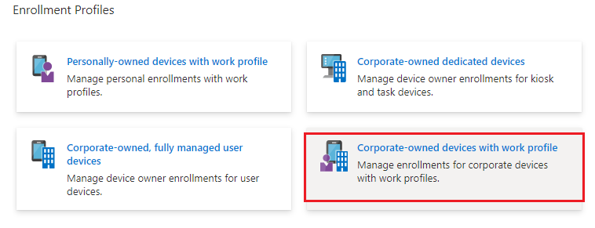

|  |  |
| --- | --- |
|  | ***Important Note***  *Creating a* ***corporate-owned work profile*** *will enable users to enrol their CFS owned device using a different token. This is basically enabling the user to enrol the device and create 2 containers in the device: PERSONAL and CORPORATE,*  The containers have the apps for each profile (personal apps in the personal container and corporate apps from Intune in the Corporate one), |

1. Provide the name and description then click on **Create.**
   1. Name :**Android - Corporate owned work profile**
   2. Description: Profile to enable users to enrol corporate-owned android devices using work profile.

##### Configure Trusted Root CA – Fully Managed

To create the Root Certificate Authority Configuration Profile policy for Fully managed Android devices, perform the steps below

1. Open Endpoint Manager, Locate Devices, Android then click on Configuration Profiles
2. Create a new profile for Android Enterprise, Fully Managed, Corporate Owned work-profile
3. Select Trusted Certificate as the template
4. Provide the name and description
   1. Name: Android – Root CA certificate Fully managed devices
   2. Description: Profile to deploy CFS ROOT CA to fully managed and corporate owned work-profile devices
5. Provide the ROOT CA which has been provided to you by the security Team.

|  |  |
| --- | --- |
|  | ***Important Note***  The Root CA may contain both Root CA and Subsidiary CA certificates mixed in one file. |

1. Assign the policy to **All Devices.** The policy will only apply to Fully managed or corporate-owned work-profile, not personal Androids

##### Configure Trusted Intermediate CA – Fully Managed

To create the Intermediate certificate Authority Configuration Profile policy for Fully managed Android devices, perform the steps below

1. Open Endpoint Manager, Locate Devices, Android then click on Configuration Profiles
2. Create a new profile for Android Enterprise, Fully Managed, Corporate Owned work-profile
3. Select Trusted Certificate as the template
4. Provide the name and description
   1. Name: Android – Intermediate CFS Sub CA 01 certificate Fully managed devices
   2. Description: Profile to deploy CFS Sub CA 01 to fully managed and corporate owned work-profile devices
5. Provide the CFS Sub CA 01 certififcate which has been provided to you by the security Team.

|  |  |
| --- | --- |
|  | ***Important Note***  You will need to create only 1 intermediate for TST but 2 Sub CA policies for Production |

1. Assign the policy to **All Devices.** The policy will only apply to Fully managed or corporate-owned work-profile, not personal Androids
2. Repeat for the Sub CA 2 certificate

##### Configure Trusted Root CA – Personally Owned

To create the ROOT CA profile for personally owned android devices, repeat the steps above but choose **Personally Owned work-profile** during the Platform options.

1. Provide the name of the profile and description
   1. Name: Android – Root CA certificate personally owned work-profile devices
   2. Description: Profile to deploy CFS ROOT CA to personally owned work-profile devices

##### Configure Trusted Intermediate CA – Personally Owned

To create the Intermediate certificate Authority Configuration Profile policy for Fully managed Android devices, perform the steps below

1. Open Endpoint Manager, Locate Devices, Android then click on Configuration Profiles
2. Create a new profile for Android Enterprise, Personally-Owned
3. Select Trusted Certificate as the template
4. Provide the name and description
   1. Name: Android – Intermediate CFS Sub CA 01 certificate personally-owned managed devices
   2. Description: Profile to deploy CFS Sub CA 01 to personally-owned work profile
5. Provide the CFS Sub CA 01 certififcate which has been provided to you by the security Team.

|  |  |
| --- | --- |
|  | ***Important Note***  You will need to create only 1 intermediate for TST but 2 Sub CA policies for Production |

1. Assign the policy to **All Devices.** The policy will only apply to personally owned work profile
2. Repeat for the Sub CA 2 certificate

##### PKCS User Certificate profile – Fully Managed

To create a PKCS user certificate profile for fully managed devices, perform these steps. The steps are the same for personally owned devices on the section below.

1. Under Configuration Profiles in Endpoint Manager, click on new profile
2. Choose Android Enterprise, Fully Managed, corporate work-profile
3. Choose PKCS User as the template
4. Provide the name and description
   1. Name: Android - PKCS User Certificate Fully Managed
   2. Description: Android Fully Managed PKCS User certificate
5. Provide the PKCS User Certificate template details.

|  |  |
| --- | --- |
|  | ***Important Note***  The certificate template MUST not contain spaces |

1. Change the Certification Authority to Production servers where required.

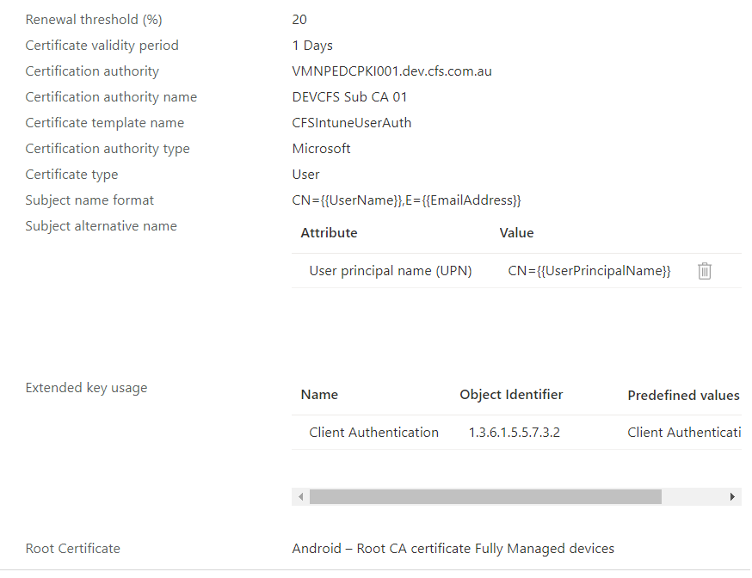

##### PKCS User Certificate profile – Personally Owned

Perform the same steps as PKCS User certificate fully manged but select **Personally owned** under platform. Assign the policy to ALL DEVICES, which will include all personally owned work-profile devices.

##### PKCS Device certificate profile – Fully Managed

1. Create a new Configuration Profile policy, click on new, Android Enterprise and select Fully Manged, corporate owned work-profile.
2. Under Template, select PKCS Certificate
3. Provide the details of the policy
   1. Name: Android – PKCS Device Certificate Fully Managed
   2. Description: Android Fully managed PKCS device Certificate policy
4. Provide the details of the certificate request below

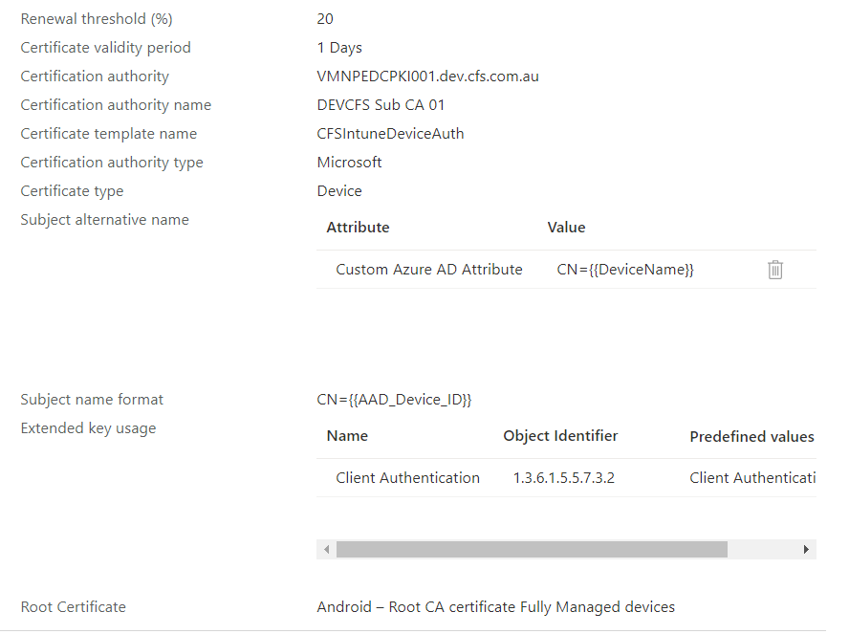

* + 1. **Prod servers:** VMPRDEDCPKI001.cfs.com.au for user certificates
    2. **Prod servers:** VMPRDSDCPKI001.cfs.com.au for device certificates
    3. **Production:** CFS Sub CA 01 for users
    4. **Production:** CFS Sub CA 02 for devices
    5. **Template:** CFSIntuneDeviceAuth
    6. **Subject Alternate name:** CN={{DeviceName}}

1. Assign the policy to ALL DEVICES (only fully managed devices will get this policy)

##### PKCS Device certificate profile – Personally Owned

Repeat the same steps as PKCS device certificate but select Personally owned work-profile on the platform option. Assign this policy to ALL DEVICES, which will only cover personally owned work-profile devices.

##### Defender for Endpoint Integration

To integrate Android devices with Defender, the compliance policy will need to evaluate the risk level of the endpoint. Modify the compliance policy for Android to include this check:

1. Open Endpoint manager, click on Devices, Android, Configuration Profiles
2. Locate Android – MDM Compliance Policy and click on properties
3. Under Compliance Settings, change the value of Microsoft Defender for Endpoint to
   1. Require the device to be at or under the machine risk score: **CLEAR**
4. Save the compliance policy
5. Repeat for the Personally Owned Compliance Policy

#### MacOS

##### Create Mac device dynamic group

Create a dynamic group called **DG-AA-OPS-Intune-MacDevices**

Dynamic rule: device OS type

Operator: Equals

Value: macmdm

You will use this group to assign all policies below

##### Device Restrictions

To create MacOS configuration profile policies, perform these steps

1. On Endpoint Manager, Locate Devices, MacOS, Configuration Profiles
2. Click on Create Profile
3. Select **Device Restrictions**

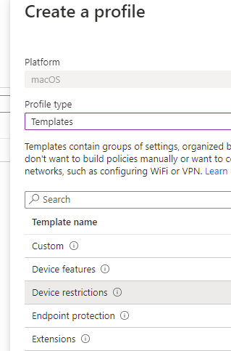

1. Provide the policy name and description
   1. Name: **MacOS – MDM Device Restrictions policy**
   2. Description: Policy to set device restrictions to all corporate Mac devices. This includes configuring password length, encryption settings and other hardware level settings
2. Under **App Store, Doc Viewing, Gaming** block all settings

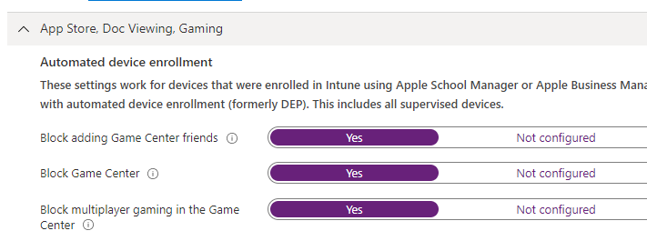

1. Under **Built-in Apps**, leave default
2. Under **Cloud & Storage**, block all settings except Block iCloud Private Relay

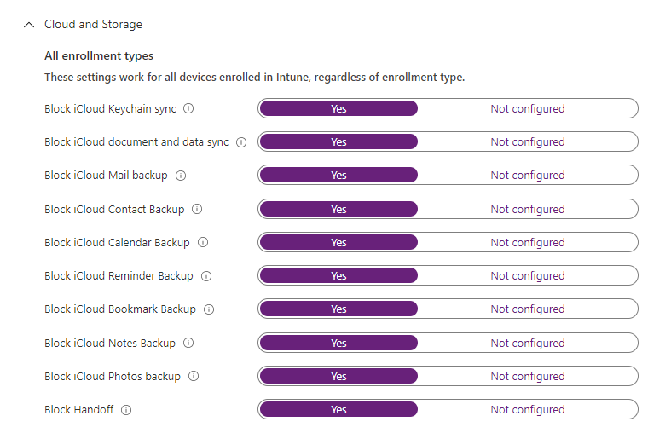

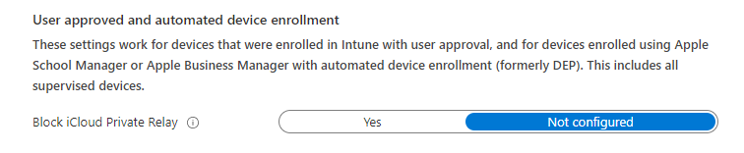

1. Under **Connected Devices,** block all settings

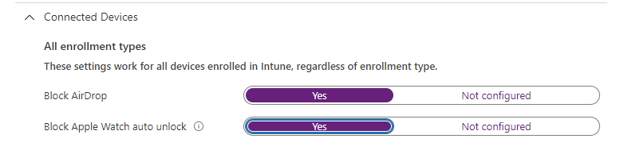

1. Under **General,** only enable the two policies below
   1. Block modification of wallpaper**: YES**
   2. Block users from erasing all content and settings on device**: YES**

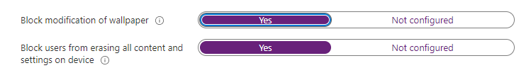

1. Under **Password**, select the following options
   1. Require Password**: YES**
   2. Required Password Type: alphanumeric
   3. Number of non-alphanumeric characters in password: 1 – this means 1 special character
   4. Minimum Password Length: 8 digits
   5. Block Simple Password**: YES**
   6. Maximum minutes after screen lock before password is required: 5 minutes
   7. Maximum minutes of inactivity until screen lock: 5 minutes
   8. Password Expiration in days**: 365**
   9. Prevent reuse of previous passwords: 15
   10. Maximum allowed sign-in attempts: 10
   11. Lockout duration: 30 minutes
   12. Block password sharing: YES
   13. Timeout (hours of inactivity): 48

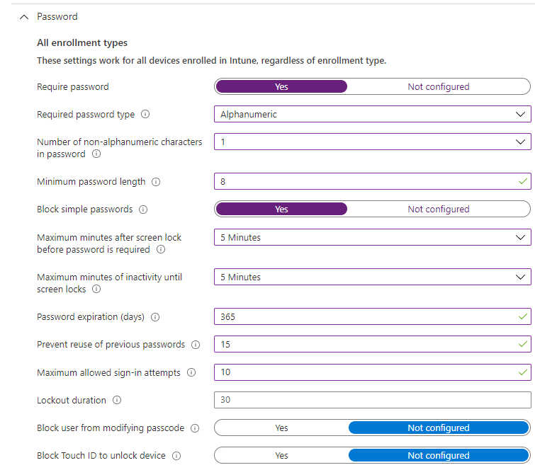

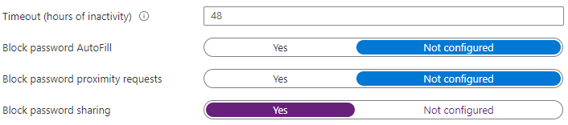

1. Click on NEXT
2. Under **Assignments**, assign to **DG-AA-OPS-Intune-MacDevices**

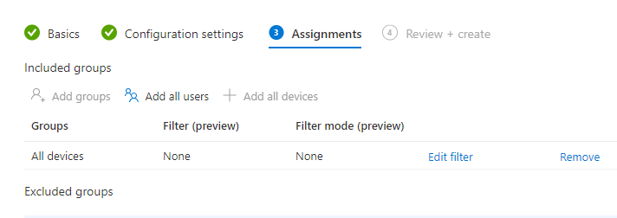

1. Save the policy

##### Endpoint Policy

This policy will enable File Vault, Gatekeeper and the mac Firewall for all Mac devices.

To create an Endpoint policy for MacOS, click on MacOS on Endpoint manager console and click on Create Profile, select Endpoint Protection

1. Select Templates, Endpoint Protection

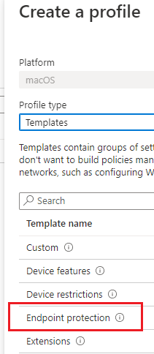

1. Provide the name and description for the policy
   1. Name: **MacOS – Endpoint Protection Policy**
   2. Description: Policy to enable encryption for all disks, firewall and Gatekeeper features for all corporate Macs
2. Under **Configuration Settings,** select the options below
   1. Enable Fire Vault: **YES**
   2. Escrow location description of personal recovery key: You can retrieve the personal recovery for your MacOS device from the Microsoft Intune App, Company Portal Website, or Company Portal Apps for android and iOS/iPadOS. CFS support can’t access recovery keys that belong to personal devices.
   3. Personal Recovery rotation: **6 months**
   4. Hide recovery key: YES
   5. Disable Prompt at sign-out: YES
   6. Number of times allowed to bypass: **5** (users can sign out 5 times before Fire Vault is enforced to be enable)

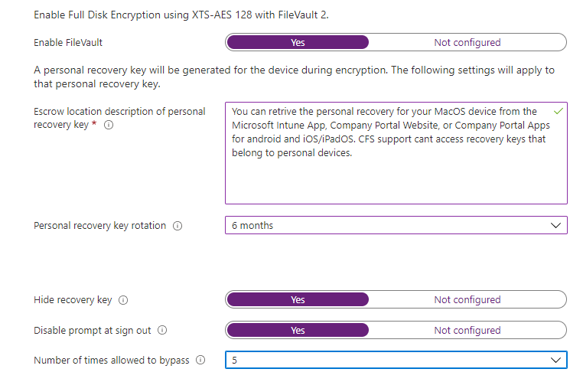

1. Under **Firewall,** select the following options
   1. Enable Firewall**: YES**
   2. Block all incoming connections: **YES**
   3. **No specific Apps to bypass firewall at this stage**

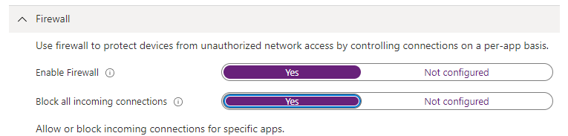

1. Under Gatekeeper, select the options below
   1. Allow app downloads from this location: **Mac App Store**
   2. Do not allow users to overwrite gatekeeper**: YES**

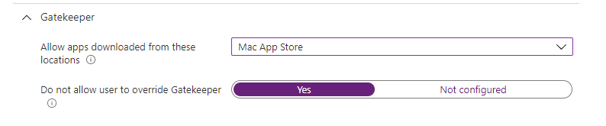

1. Under **Assignments**, assign to **DG-AA-OPS-Intune-MacDevices** and create the policy

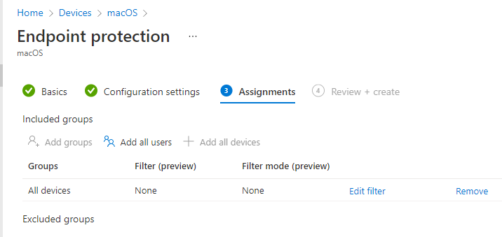

##### USB Policies

|  |  |
| --- | --- |
|  | ***Important Note***  *Before you create the USB policies, request the Azure identity team to create an on premise AD group with name* **SG-AA-OPS-Intune-USB-ReadWriteMacOS***if it doesn’t exist* |

To restrict USB storage devices on MacOS, perform the steps below to create a policy.

* This policy will set all USB devices to read-only for ALL users except **the ReadWrite group**

1. Open Endpoint Manager, Devices, MacOS, Configuring Profile
2. Create a new policy of type Custom
3. Provide the details
   1. Name: MacOS - Block USB for all Users
   2. Description: policy to block all USB peripherals in Mac devices. This policy excludes the group **SG-AD-OPS-Intune-USB-ReadWriteMacOS** *which is allowed to write to USB devices*
4. Open a note pad and paste the following script, save as .XML.

Source: [Examples of device control policies for Intune | Microsoft Docs](https://docs.microsoft.com/en-us/microsoft-365/security/defender-endpoint/mac-device-control-intune?view=o365-worldwide)



1. Return to Endpoint manager and locate the XML file, set Device Channel and Name the policy

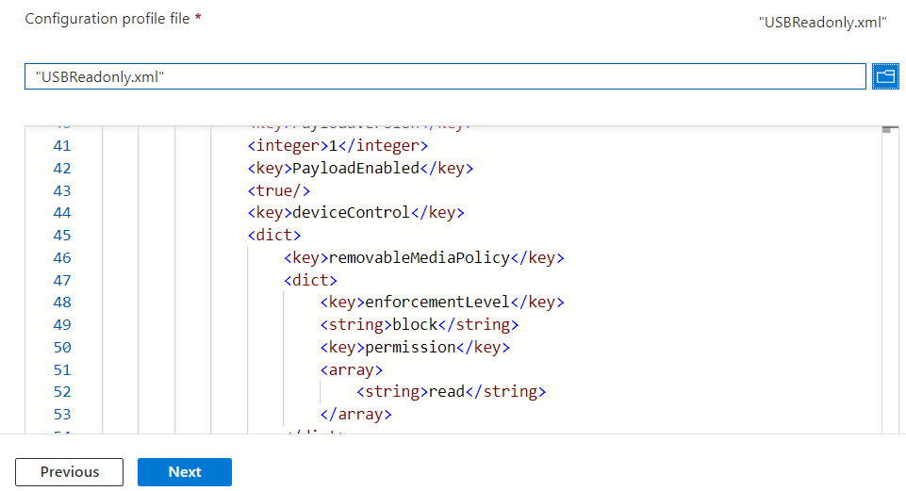

1. Under Assignments, assign to all the Intune users **SG-AA-OPS-IntunePolicies.** This group contains all users in the tenant
2. Under exclusions, add the Read-Write group
3. Save the policy

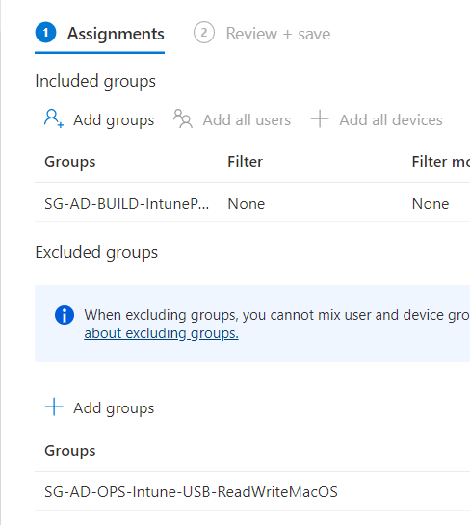

##### Defender for Endpoint Integration

To integrate MacOS with Defender for Endpoint, push the Defender for Endpoint app using an Intune App policy

1. Open Endpoint Manager
2. Locate MacOS, apps, then click on add new app, app type Microsoft Defender for Endpoint – MacOS
3. Select yes Show in Company Portal

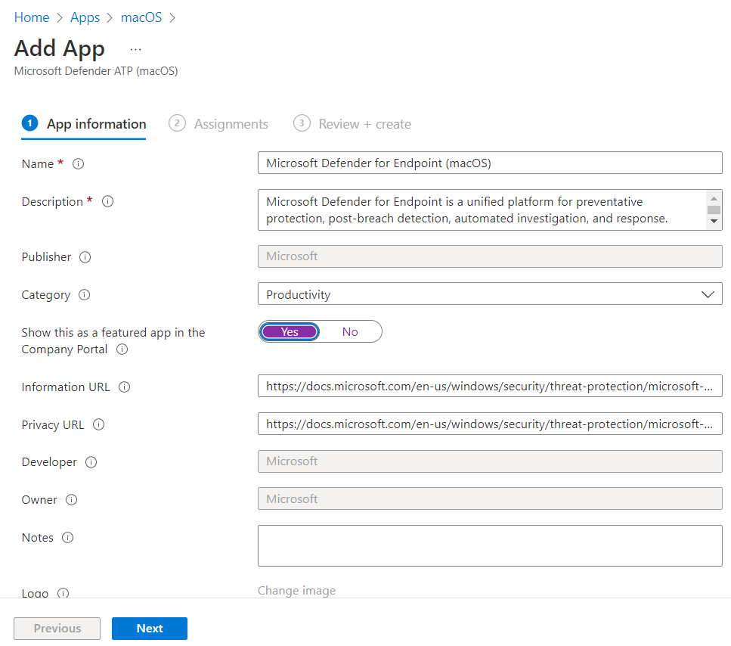

1. Assign the policy to all mac OS devices group DG-AA-OPS-Intune-MacDevices
2. Wait until the package and app is deployed to the MacOS device

Download XML file for Defender for Endpoint

Follow this article for more information [Intune-based deployment for Microsoft Defender for Endpoint on Mac | Microsoft Docs](https://docs.microsoft.com/en-us/microsoft-365/security/defender-endpoint/mac-install-with-intune?view=o365-worldwide#approve-system-extensions)

To download the XML config file, open Security Centre console [Security & Compliance (microsoft.com)](https://security.microsoft.com/)

1. Locate Settings, Endpoints
2. Locate onboarding
3. Select MacOS then Select Mobile Device Management/Microsoft Intune
4. Download the onboarding package and unzip the files to a known location

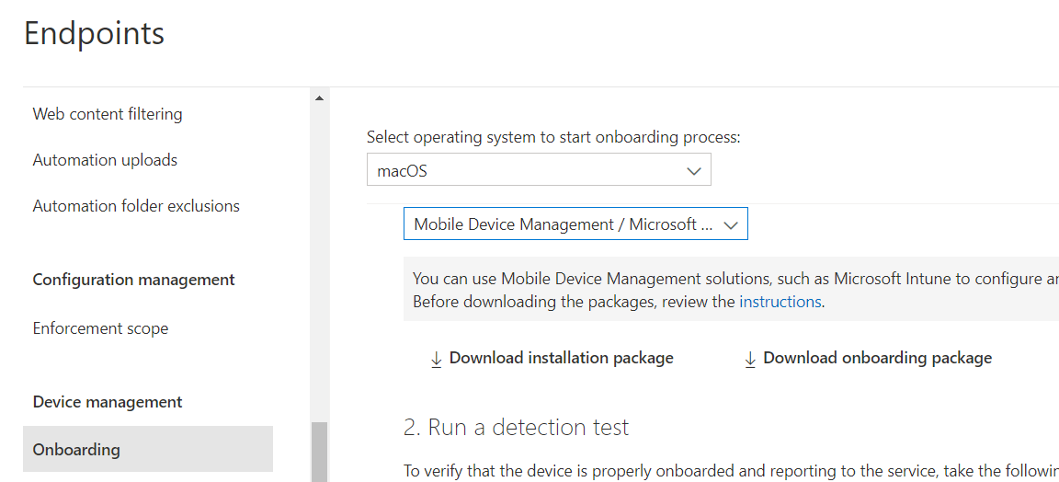

Onboarding Policy

1. Navigate back to Endpoint Manager, Devices, macOS, create a new Custom Profile policy
2. Provide the details for the policy
   1. Name: MacOS - Onboarding to Defender for Endpoint
   2. Description: Policy to onboard devices to Defender for Endpoint
   3. Device Channel
   4. Select the Onboarding XML file download from Defender for ATP

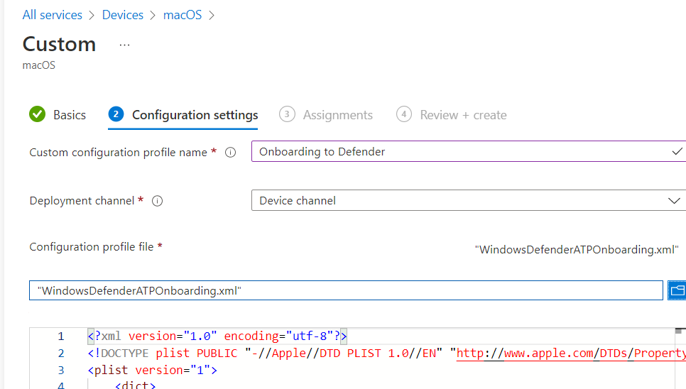

1. Assign the policy to the MacOS device group DG-AA-OPS-Intune-MacDevices

Approve System Extensions Policy

Create another profile settings of type Template, Extensions with the following settings

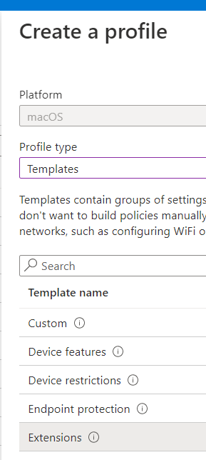

1. Provide name and description
   1. Name: MacOS - MDATP System Extension
   2. Description: profile setting to configure system extensions for MacOS to allow system extensions for defender
2. Under Configuration Settings, add the **system extensions** below and assign to **DG-AA-OPS-Intune-MacDevices**

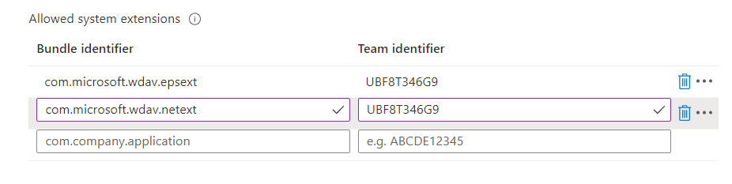

Kernel Extension Policy

Create another template, extension policy below

Name: MacOS - MDATP Kernel Extensions

Description: kernel extensions policy for MacOS Defender policies

Assign to : **DG-AA-OPS-Intune-MacDevices**

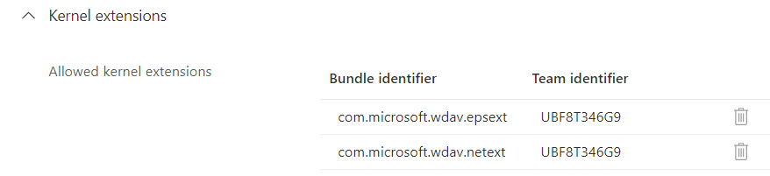

Full disk policy

Follow the article above on how to create the full disk access policy and assign to **DG-AA-OPS-Intune-MacDevices**

Name: MacOS - Full Disk Access Policy

Description: Policy to grant Defender for Endpoint Full disk access on MacOS Policy to grant Defender for Endpoint Full disk access on MacOS

Assignment: **DG-AA-OPS-Intune-MacDevices**

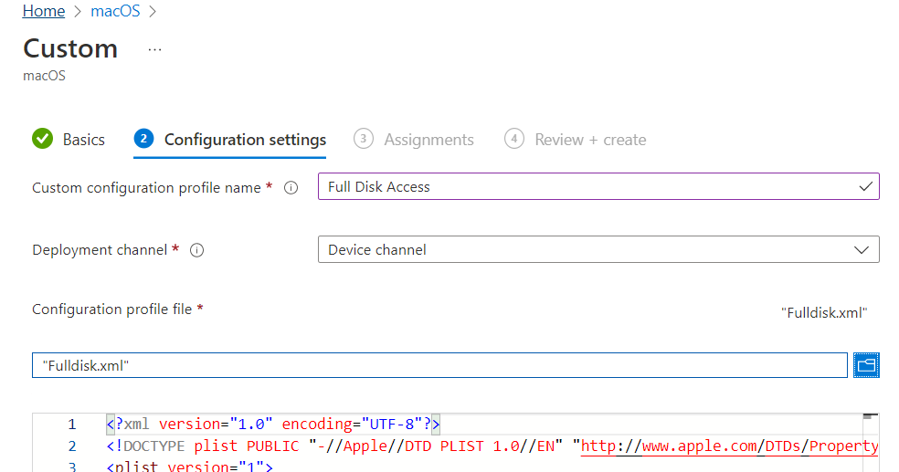

Network Filter Policy

Repeat the procedure to create another custom template policy for the Network filter and assign to the MacOS device group.

Name: MacOS - Network Filter Policy

Description: As part of the Endpoint Detection and Response capabilities, Microsoft Defender for Endpoint on macOS inspects socket traffic and reports this information to the Microsoft 365 Defender portal. The following policy allows the network extension to perform this functionality.

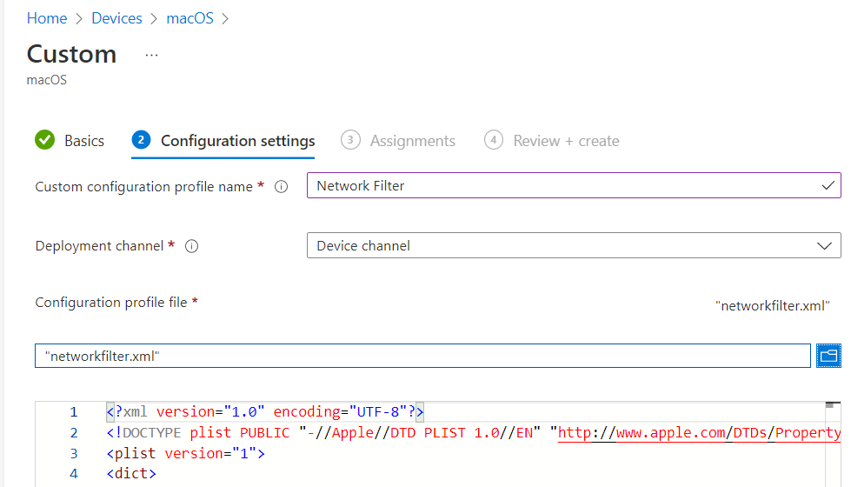

Defender Notifications Policy

Create another custom template policy to enable Defender for Endpoint to notify users in their MacOS devices

Name: MacOS - Notifications Policy

Description: This profile is used to allow Microsoft Defender for Endpoint on macOS and Microsoft Auto Update to display notifications in UI on macOS 10.15 (Catalina) or newer.

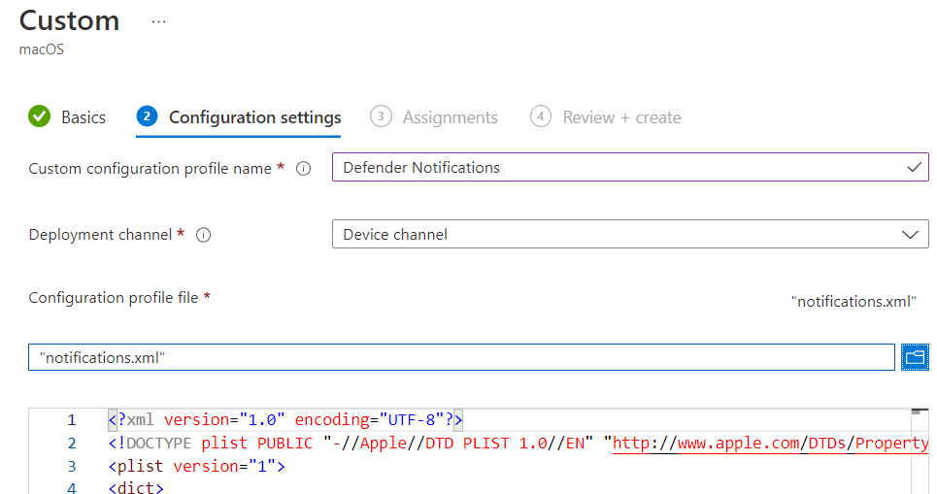

Create Endpoint Antivirus Policy

Navigate to Endpoint manager, Endpoint Security and Antivius, create a MacOS Activirus profile

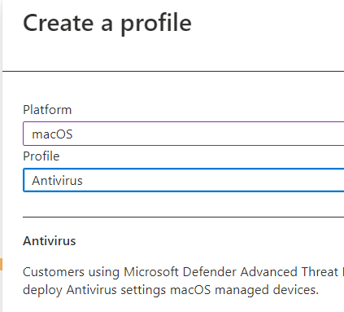

1. Provide the details for the policy
   1. Name: MacOS - Defender Profile
   2. Description: Defender Antivirus policy to specify Defender settings
2. Enable the policies below and assign to the Mac OS device group **DG-AA-OPS-Intune-MacDevices**

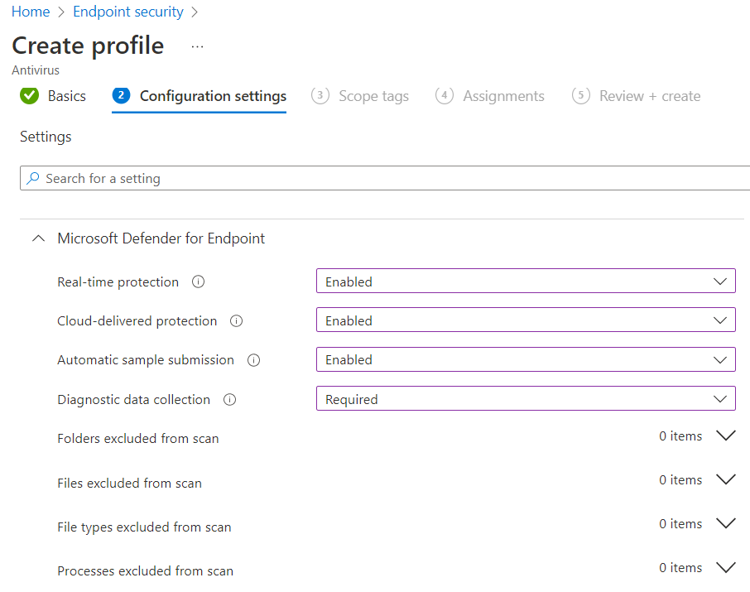

##### Trusted Root CA Policy

Create a Trusted Root CA policy for MacOS and assign the policy to MacOS device group. The Root CA must be obtained from the CA authority team.

Name: MacOS - Trusted Root CA

Description: Root CA policy

##### Trusted Intermediate Certificate

Repeat the process to create the SUBCA certificate policy for MacOS. Request the SUBCA certificate from the security team. You will need 2 Sub CA certificates for Production.

Name: MacOS – Intermediate Certificate Sub Ca01

Description: Intermediate certificate for Sub Ca 01

Name: MacOS – Intermediate Certificate Sub Ca02

Description: Intermediate certificate for Sub Ca 02

##### PKCS User Certificate Policy

Create the User PKCS policies below

Name: MacOS - PKCS User Certificate

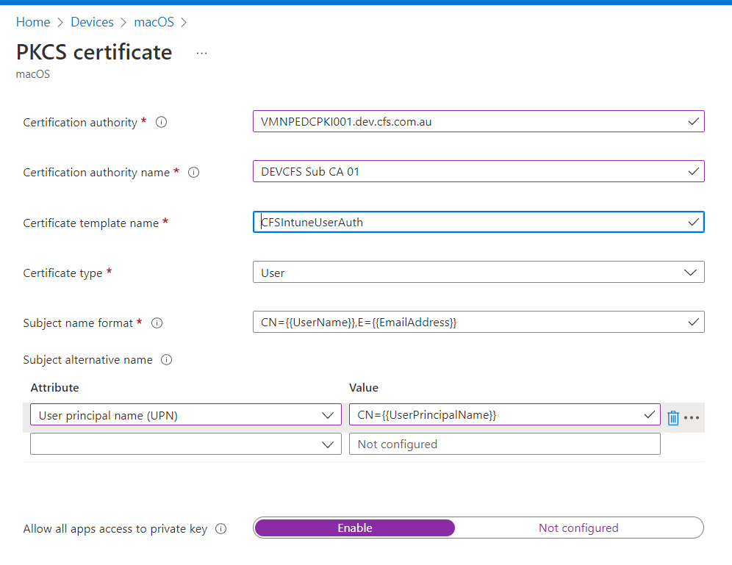

* 1. Certification authority:
     1. **Dev server:** VMNPEDCPKI001.dev.cfs.com.au
     2. **Prod servers:** VMPRDEDCPKI001.cfs.com.au for user certificates
     3. **Prod servers:** VMPRDSDCPKI001.cfs.com.au for device certificates
  2. Certificate Authority Name:
     1. **Dev:** DEVCFS Sub CA 01
     2. **Production:** CFS Sub CA 01 for users
     3. **Production:** CFS Sub CA 02 for devices
  3. Certificate Template: **CFSIntuneUserAuth**
  4. Subject Name format: CN={{UserName}},E={{EmailAddress}}
  5. Subject Alternative Name:
     1. Attribute: User Principal Name
     2. Value: CN={{UserPrincipalName}}

##### PKCS Device Certificate Policy

Create a PKCS Device Certificate for MacOS

Name: MacOS - PKCS Device Certificate

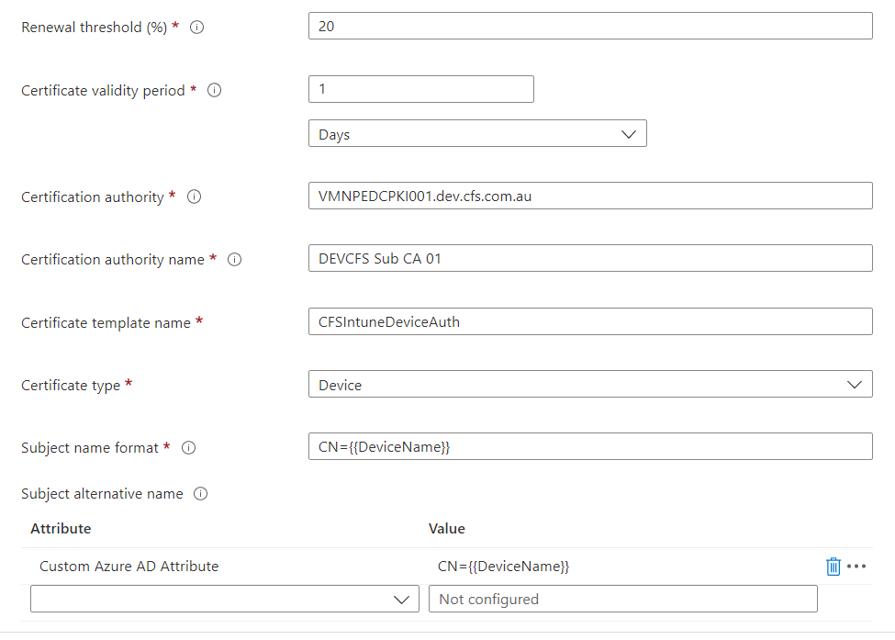

1. Certification authority:
   * 1. **Dev server:** VMNPEDCPKI001.dev.cfs.com.au
     2. **Prod servers:** VMPRDEDCPKI001.cfs.com.au for user certificates
     3. **Prod servers:** VMPRDSDCPKI001.cfs.com.au for device certificates
2. Certificate Authority Name:
   * 1. **Dev:** DEVCFS Sub CA 01
     2. **Production:** CFS Sub CA 01 for users
     3. **Production:** CFS Sub CA 02 for devices
3. Certificate Template: **CFSIntuneDeviceAuth**
4. Subject Name format: **CN={{AAD_Device_ID}}**
5. Subject Alternative Name:
   * 1. Attribute: Custom Azure AD Attribute
     2. Value: **CN={{DeviceName}}**

#### Windows

This section covers all policies for Windows 11 devices which are part of MMD, AVD or PAWS related. All MMD policies are automatically created by Microsoft.

##### Configure Windows 10 USB policies

To create the USB policies as per design requirements, create two policies in Endpoint Security, category

|  |  |
| --- | --- |
|  | ***Important Note***  *Before you create the USB policies, request the Azure identity team to create an AZURE AD group with name* ***SG-AA-OPS-Intune-USB-ReadWrite*** |

1. Open Endpoint Manager, Endpoint security, then click on **Attack surface reduction**
2. Create 2 policies of type **Device Control**

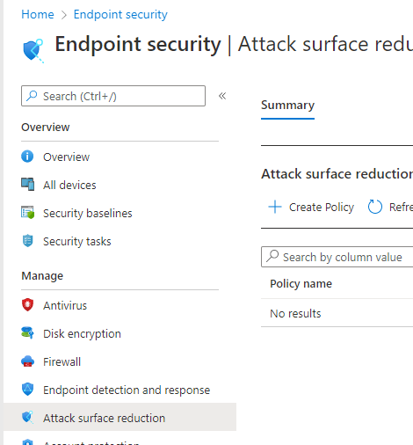

1. Provide the details for the first policy
   1. Name: Windows 11 – USB Read-only policy for all users
   2. Description: blocks USB write access to all users and excludes the Azure AD group of users who will have read-write permissions
2. Under **Device Control**, provide the following options
   1. Scan removable drives during full scan: **YES**
   2. Block USB connection (HoloLens only): **YES**
   3. Block write access to removable storage: **YES**

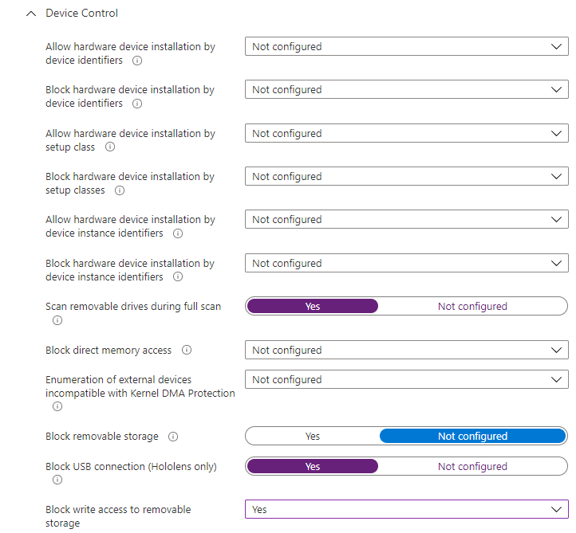

1. Under assignments, assign the policy to **the Intune Policy group** and exclude the Readwrite USB allow group in the exclusion section

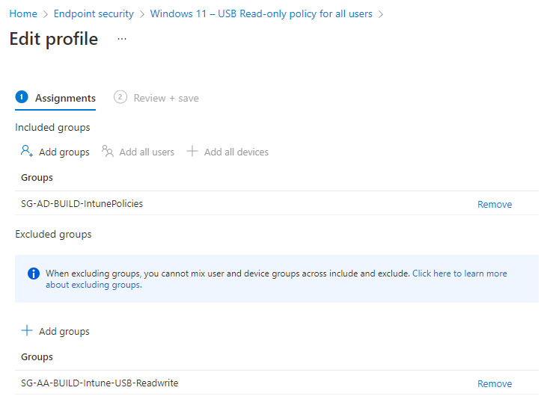

1. Create a second policy with the details below to allow USB ReadWrite to the specific group
2. Provide the policy details
   1. Name: Windows 11 – Allow Read & Write to USB policy for certain users
   2. Description: Policy to allow certain group members to be able to write to USB devices. This policy is assigned to the group SG-AA-OPS-Intune-USB-ReadWrite
3. Under Device Control, provide the options below
   1. Scan removable drives during full scan: **YES**
   2. Block USB connection (HoloLens only): **YES**
   3. Block write access to removable storage: **NO**

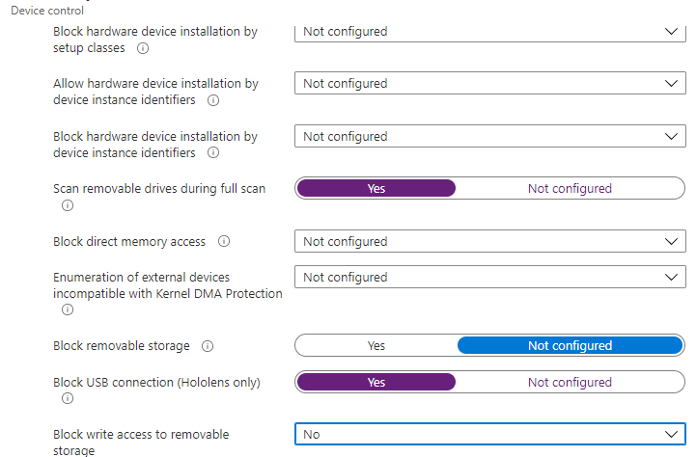

1. Under Assignments, assign this policy to **SG-AA-OPS-Intune-USB-ReadWrite** and save the policy

##### Configuring Trusted Root Certificate Profile

To create the trusted certificate profile policy for Windows 11, perform the steps below

1. Open Endpoint
2. Click on Devices, iOS, Configuration Profiles, create a new profile of Type: Windows 11, Template, Trusted Certificate
3. Specify the name of the profile
   1. Name: Windows - Windows Trusted Root Certificate
   2. Description: CFS dev certificate from on premise CA
4. Under Configuring Settings, click and upload the Root Certificate **provided by the security Team** as a Computer certificate container for both **root and subCAs**

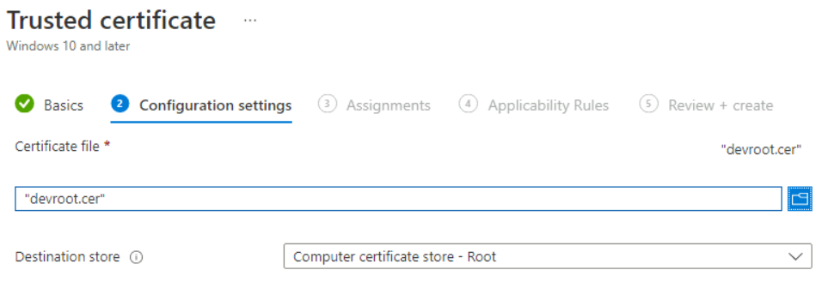

1. Under **Assignments**, assign the certificate to all MMD devices or other devices as required
   1. MMD Group name: DG-AA-OPS-MMDDevices
2. Save and create the policy

##### Configuring Trusted Intermediate Certificate

Create a policy to deploy the intermediate certificates in the intermediate folder. **Production will have 2 intermediate certificate authorities which you will need to create as separate policies for.**

1. On Endpoint Manager, Devices, Windows, Click on Configuration Profiles
2. Create new profile, trusted certificate
3. Locate the intermediate certificate and store it in the intermediate folder
4. Profile details
   1. name: Windows - Windows Trusted Intermediate Certificate
   2. Description: Intermediate certificate SUBCA 01
5. Assign this policy to DG-AA-OPS-MMDDevices

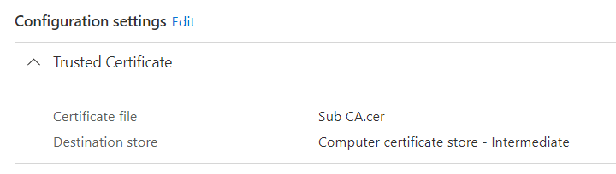

##### PKCS User Certificate Policy

**Pre-requisites**:

1. Check the following endpoints can accept outbound connections from the PKCS Intune connector servers to:

login.microsoftonline.com  
*.officeconfig.msocdn.com  
config.office.com  
graph.windows.net  
enterpriseregistration.windows.net  
*.manage.microsoft.com

1. Certificate Connector for PKCS must already been installed in 1 or more machines in the network

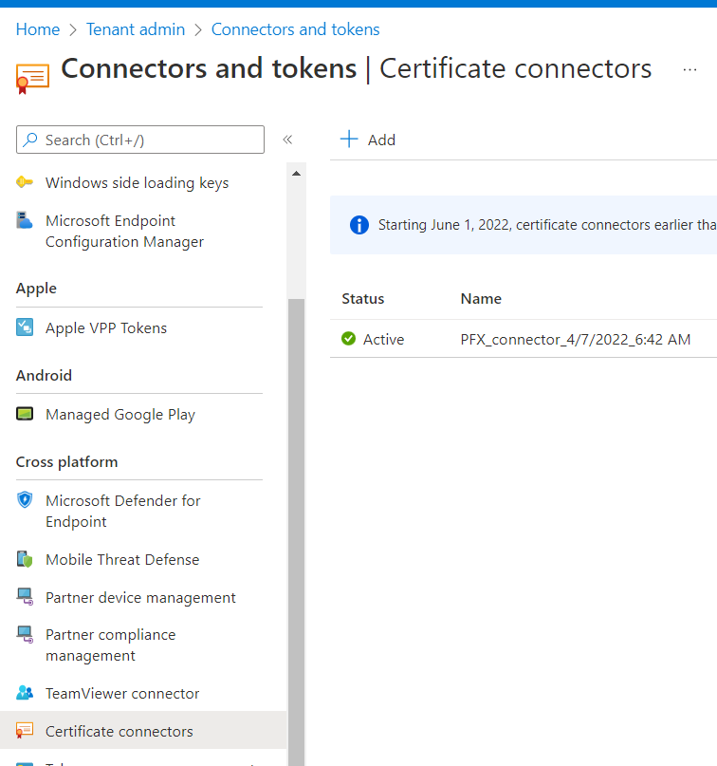

1. The root certificate and all other subCA certificates must be exported as CER files
2. Once you have checked pre-requisities, open Endpoint Manager, Devices, Windows, Configuration Policies and click on Create new policy
3. Provide the details for the policy
   1. Name: Windows - PKCS User Certificate Request
   2. Description: Windows certificate of type user. It requests a certificate to Intune Connector for the user identity and stores it in the User Certificate Personal container
4. Under **Configuration Settings**, specify the following attributes
   1. **Certificate Validity Period:** any period from 1 day to multiple years
   2. **Key Storage Provider:** Enrol to trusted TPM
   3. **Certificate Authority:** PKCS connector in the environment: VMNPEDCPKI001.dev.cfs.com.au
      1. **Prod servers:** VMPRDEDCPKI001.cfs.com.au for user certificates
      2. **Prod servers:** VMPRDSDCPKI002.cfs.com.au for device certificates
   4. **Certification Authority Name:** DEVCFS Sub CA 01
      1. **Production:** CFS Sub CA 01 for users
      2. **Production:** CFS Sub CA 02 for devices
   5. **Certificate template name:** CFSIntuneUserAuth

|  |  |
| --- | --- |
|  | ***Important Note***  *The certificate template name MUST not contain spaces and must be the one provided by your CA administrator* |

* 1. **Certificate Type:** User
  2. **Subject name format:** CN={{UserName}},E={{EmailAddress}}
  3. **Subject alternative name:**
     1. **Attribute:** User Principal Name (UPN)
     2. **Value:** CN={{UserPrincipalName}}

1. Assign the policy to a User Group containing ONLY users, in this case
   1. **SG-AA-OPS-IntunePolicies**
   2. Exclude group:
      1. SG-AD-OPS-EDC-AVDPersonalUsers
      2. SG-AD-OPS-EDC-AVDSharedUsers
      3. SG-AD-OPS-SDC-AVDPersonalUsers
      4. SG-AD-OPS-SDC-AVDSharedUsers
      5. SG-AA-OPS-TeamRoomsPremiumAccounts
      6. SG-AA-OPS-TeamRoomsStandardAccounts
2. Save the policy and run a SYNC from the test device to verify the certificate is provisioned and allocated to the user. To verify the certificate was provisioned, open the User Certificate Console in the test device and verify there is a certificate allocated for the user account under the PERSONAL Container issued by DEVCFS or CFS (PRD) Certificate Authority

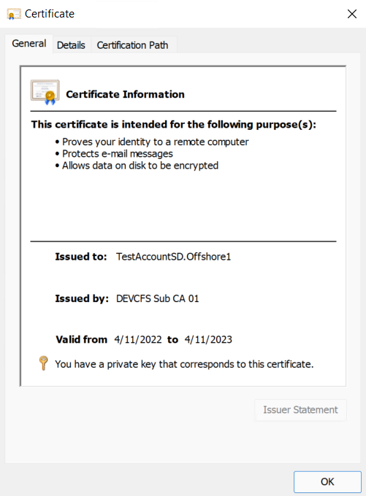

##### PKCS Device Certificate Policy

Device certificates differ from User Certificates in the attributes populated and passed to the Certificate Authority. These certificates must be assigned to a device group.

To create the PKCS Device certificate policy, perform these steps:

1. Open Endpoint manager, Devices, Windows, Configuration Profiles, create a new profile
2. Select Windows 10 or later, Template, PKCS Certificate
3. Provide the details for the template

TST

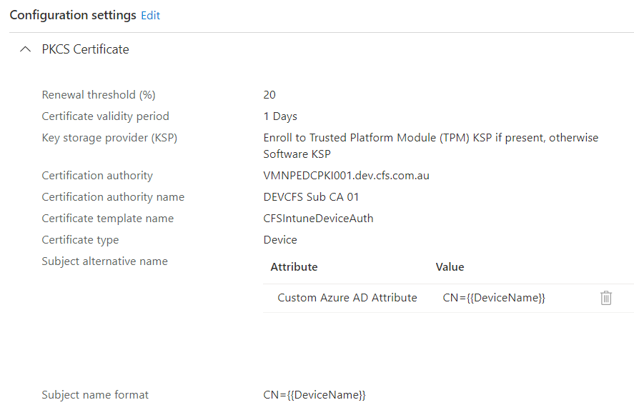

Production

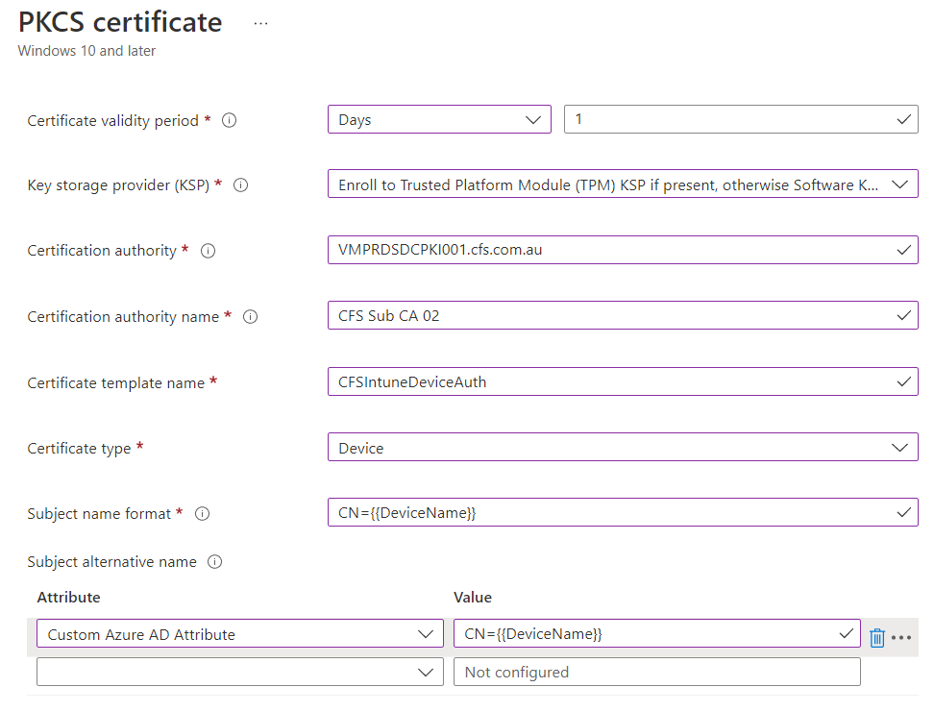

1. Assign this policy to the respective groups which will deploy this certificate. Either all devices, all users or groups.

### Publishing apps

This section covers adding mobile apps to Intune, so all corporate devices get deployed with a set of required mobile applications

##### Windows

To deploy an application, you will need to use the Intune Wapping tool. Follow the steps below to publish a Windows 32 bits app (or 64) to Windows store.

The following example wraps Acrobat Reader on an Intune Package. This package is then deployed to a User Group on the section immediately after this one.

1. Download Acrobat Reader installer.
2. Save the file to any location
3. Download the Intune Wrapping Tool from GitHub website [Intune Wrapping Tool](https://github.com/Microsoft/Intune-Win32-App-Packaging-Tool)
4. Open powershell and locate the path to the wrapping tool

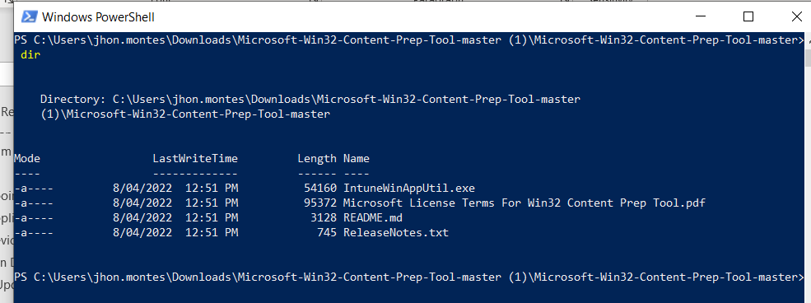

1. Run IntuneWInAppUtil.exe
2. Specify the source folder where the Acrobat Download file is
3. Specify the setup file name
4. Specify the output folder (C:\temp)
5. Don’t specify Catalog folder

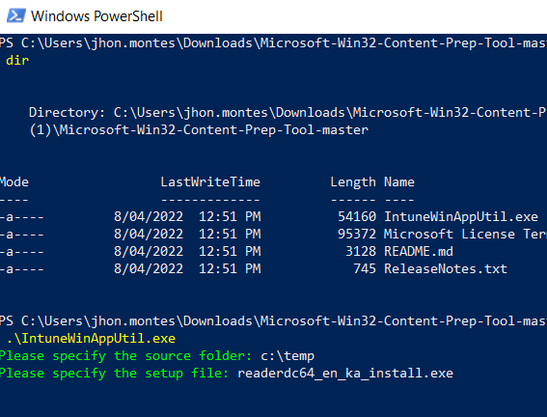

1. The installer will be wrapped and be located in the C:\temp

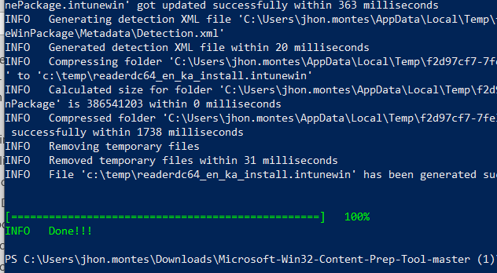

1. Check the package has been wrapped



1. Once the app appears on Intune, assign the app to the respective group or ALL DEVICES/ALL USERS.

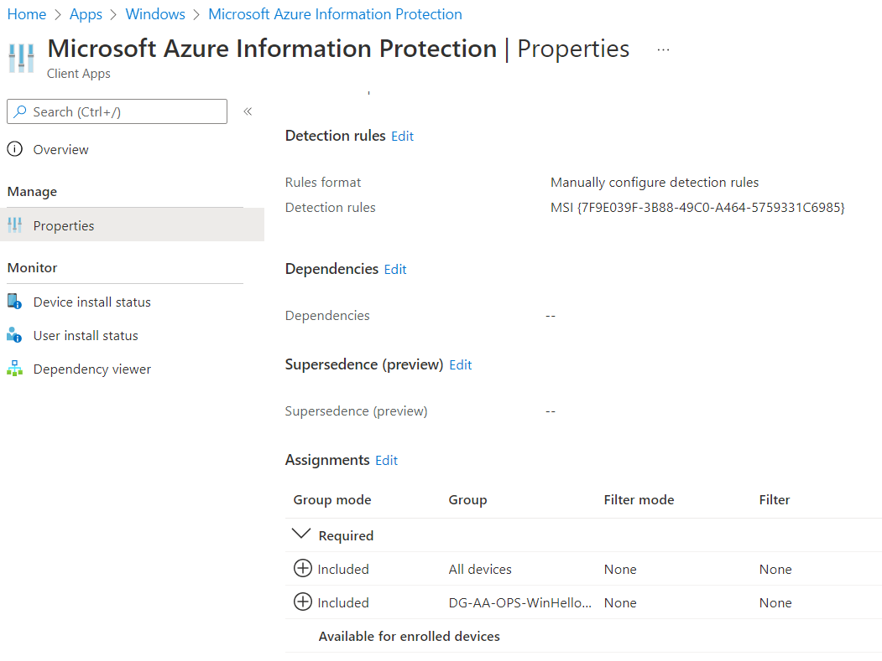

##### iOS

To publish iOS mobile apps, repeat the steps below for the following apps using Apple Business Manager

* Microsoft Outlook
* Microsoft Word
* Microsoft Excel
* Microsoft PowerPoint
* Microsoft OneDrive for Business
* Microsoft Teams
* Microsoft OneNote
* Microsoft Authenticator
* Microsoft Edge: Web Browser
* Microsoft To Do
* Google Chrome
* Yammer
* Sharepoint
* Microsoft Defender for Endpoint
* Intune Company Portal (for iOS and MacOS)

1. Open Apple Business Manager for TST or PRD
2. Locate Apps and Books
3. Locate the app to be deployed to all corporate devices, select the location for the TST or PRD environment
4. Select the **number of licenses** required and click on GET

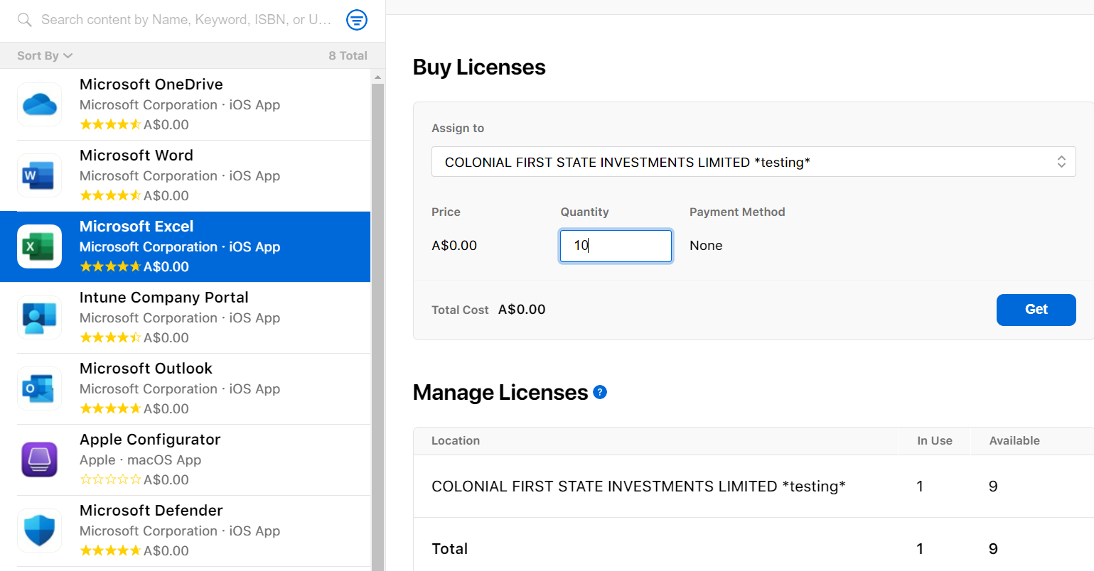

1. Repeat for each App above
2. Navigate to Endpoint manager, Tenant Administration, Connectors and tokens – Apple VPP tokens
3. Right click on the token and click SYNC

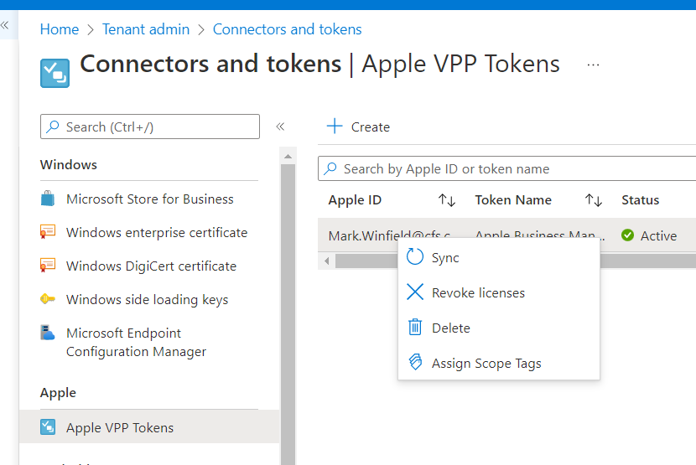

1. Wait for the app to appear on the list of apps

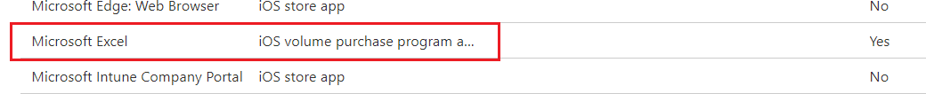

1. Open the app and Under Assignments, assign the app to **ALL DEVICES** and set **Uninstalled on device removal** to **YES**
2. Repeat the steps for the remaining apps listed above

##### Android

To publish apps to Android Enterprise devices, perform these steps

1. Locate Apps, Android, then assign the existing apps to **ALL DEVICES**

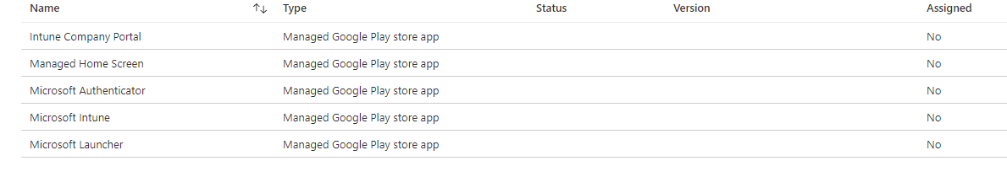

1. Add the following apps to the Android store

* Microsoft Outlook
* Microsoft Word
* Microsoft Excel
* Microsoft PowerPoint
* Microsoft OneDrive for Business
* Microsoft Teams
* Microsoft OneNote
* Microsoft Edge: Web Browser
* Google Chrome
* Microsoft To Do
* Yammer
* Sharepoint
* Microsoft Defender for Endpoint (ATP)

1. Click on ADD app then select from GOOGLE PLAY STORE.

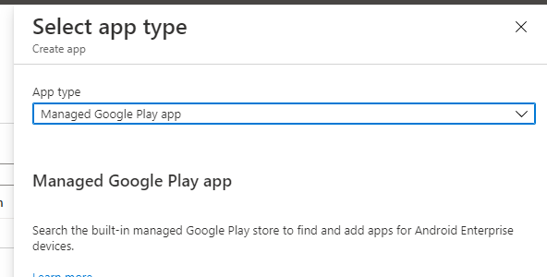

1. Search for **Microsoft Outlook**

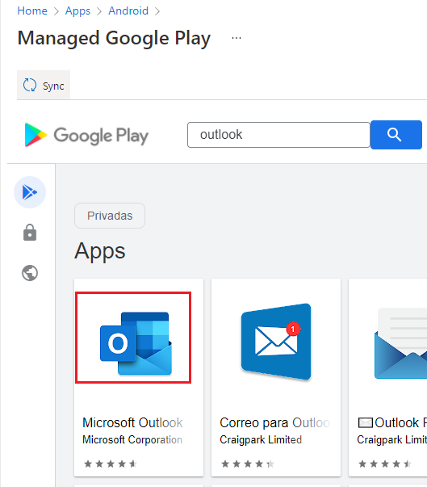

1. Click on **Approve**

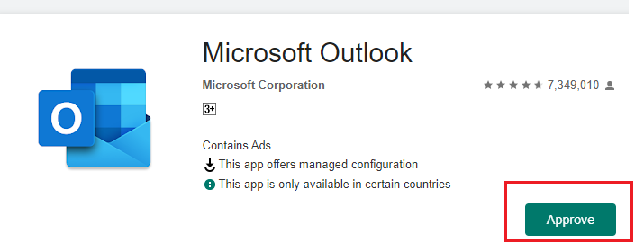

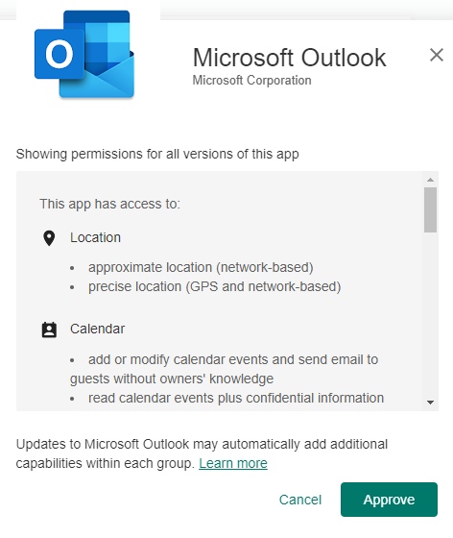

1. Leave default options and click DONE

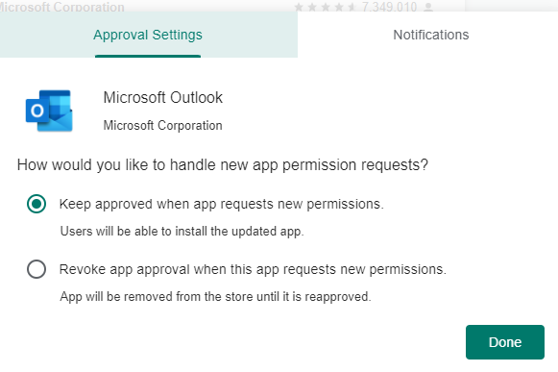

1. Once outlook has been approved, click on SYNC

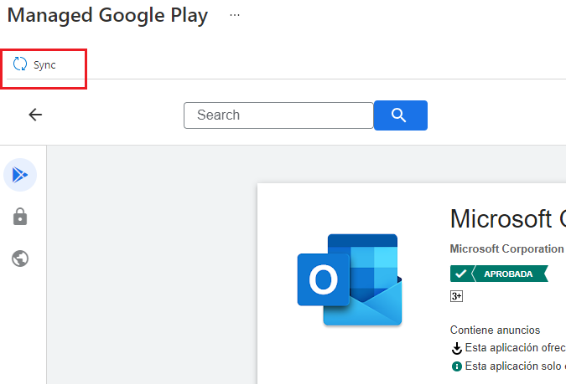

1. Wait until Outlook appears as a published APP
2. Once the app is visible, assign the app to **ALL DEVICES**
3. Repeat the process **for all apps** described above on step 2

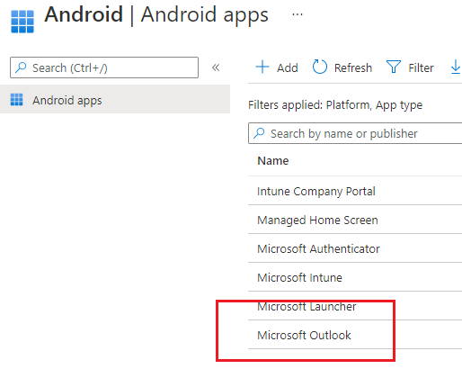

##### MacOS

To publish Microsoft Office 365 apps to MacOS, perform these steps

1. Open Endpoint Manager, click on Apps, MacOS then click on New App
2. Type: Microsoft 365 Apps
3. Provide the details for the app if you desire to change the details
4. Assign the app to a group or to the Mac device group

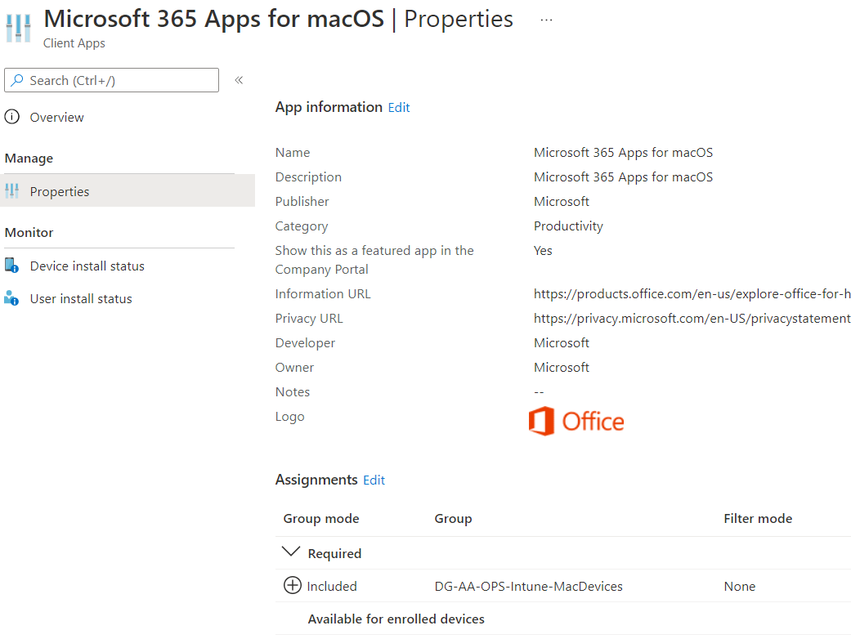

### Create App Configuration Policies

This section only applies to iOS devices. A manage app protection policy is required for each Microsoft mobile app that has been published from the VPP token. This policy is required so the application can identify if it is running on a corporate iOS device. This does not apply to Android devices.

The Configuration policy will pass the parameter **IntuneMAMUPN** for each manage app below

* Microsoft Outlook
* Microsoft Word
* Microsoft Excel
* Microsoft PowerPoint
* Microsoft OneDrive for Business
* Microsoft Teams
* Microsoft OneNote
* Microsoft Authenticator
* Microsoft Edge: Web Browser
* Microsoft To Do
* Google Chrome
* Yammer
* Sharepoint

To create **app configuration policies,** perform these steps

1. Open Endpoint Manager, Locate Apps then click on **App Configuration Policies**
2. Click on Add then **Managed devices**

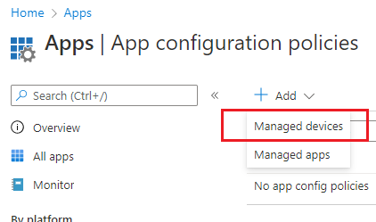

1. Provide the name and description for the policy, app target and the OS version
   1. Name: **iOS – MDM App Configuration Policy for Outlook**
   2. Description: This policy passes parameter IntuneMAMMUPN for the app. The parameter will tell the device if it is a corporate or a personal device.
   3. Platform iOS/iPadOS, target app: **OUTLOOK**

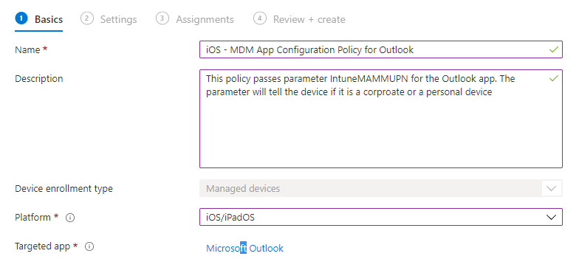

1. Under **Settings,** select the options below (**this only applies to OUTLOOK app**)
   1. Configuration settings format: Use configuration designer
   2. Email account configuration, Configure email account settings**: YES**
   3. Authentication type: **Modern Authentication**
   4. Username attribute from AAD: **User Principal Name**
   5. Email address attribute from AAD: **User principal name**
   6. Allow only work or school account: **Enabled**
   7. Focus inbox: **ON**
   8. Require Biometrics to access app: **ON**
      1. Allow user to change setting: **YES**
   9. Save Contacts: **ON**
      1. Allow user to change setting: **YES**

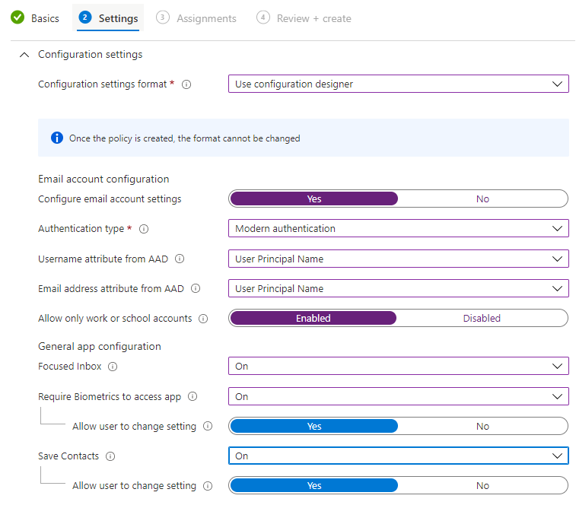

1. Verify **IntuneMAMUPN** key has been properly set to **{{userprincipalname}}**

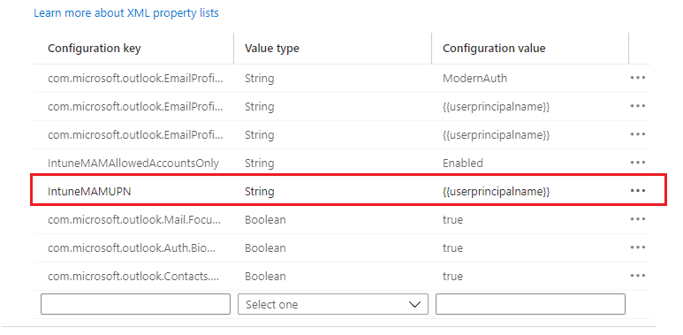

1. Assign the policy to **ALL DEVICES** and repeat the process for each the apps mentioned above
2. Repeat the steps for all apps as per the app list above on this section

### Corporate App Protection Policies

App protection policies are required for corporate devices to manage copy paste restrictions, saving corporate data to external clouds and other corporate protections required on each device. App protection policies for corporate devices only differ from MAM protection policies regarding printing capabilities**. Printing on corporate mobiles is enabled on all corporate** apps (both Android Enterprise and iOS/iPadOS)

To create corporate app protection policies, perform these steps

#### iOS/iPadOS

To create the corporate APP protection policies to restrict copy pasting and printing on corporate devices, perform the steps below. The app protection policies for corporate devices differs from the App protection policies for personal devices only on the PRINTING options. All personal devices are not allowed to PRINT while corporate mobiles are allowed to print on any Bluetooth or AirPrint device.

1. Open Endpoint Manager console, locate the option Apps, then App Protection Polices
2. Click on Create Policy, select iOS/iPadOS
3. Provide the name and description
   1. Name: iOS – Corporate mobile device policy
   2. Description: MDM policy for iOS corporate mobile devices to restrict copy pasting, saving to other cloud storage/local storage and to enable printing only for corporate devices
4. Under **Apps,** select the options
   1. Target to apps on all device types: **NO**
   2. Device Types: **Managed**
   3. Target policy to: **All Microsoft Apps**

#### Android Enterprise

To create the Android Enterprise corporate app protection policies, perform the steps below

1. Open Endpoint Manager, locate apps, app protection policies and click on Create Policy
2. Select Android
3. Provide the name and description for the policy
   1. Name: **Android - Corporate Mobile device policy**
   2. Description: MDM policy for Android corporate mobile devices to restrict copy pasting, saving to other cloud storage/local storage and to enable printing only for corporate devices
4. Under **Apps,** select the options below
   1. Target to apps on all device types: **NO**
   2. Device types: **Android Enterprise**
   3. Target policy to: **All Microsoft Apps**

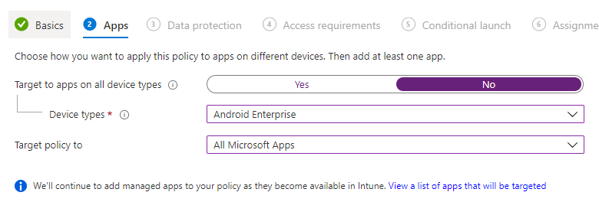

1. Under **Data Protection**, select the options below
   1. Backup org data to Android backup services: **Block**
   2. Send or data to other apps: **Policy managed apps**
   3. Save copies of org data: **Block**
   4. Allow user to save copies to selected services: **OneDrive For Business and Sharepoint**
   5. Receive data from other apps: **All apps**
   6. Restrict cut, copy, and paste between other apps: **Policy managed apps with paste-in**
   7. Screen capture and Google Assistant: **Allow**
   8. Encrypt org data: **REQUIRE**
      1. Encrypt org data on enrolled devices: **Require**
   9. Sync policy managed app data with native apps or add-ins: **Allow** – this permits to save contacts on the native app
   10. Printing org data: **Allow**
   11. Restrict web content transfer with other apps: **Microsoft Edge**
   12. Org data notifications: **Allow –** this permits Apple watches to show notifications

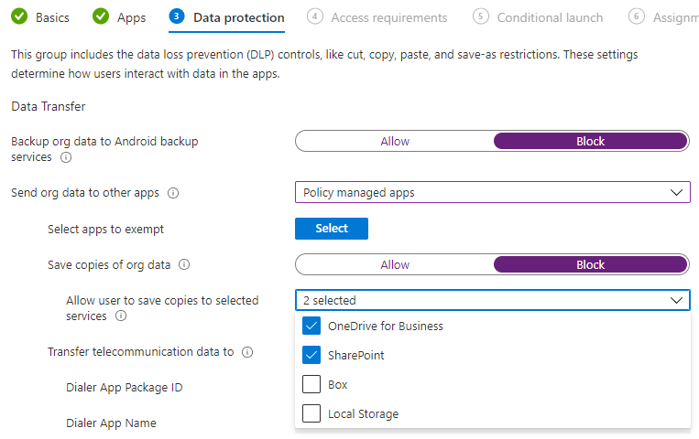

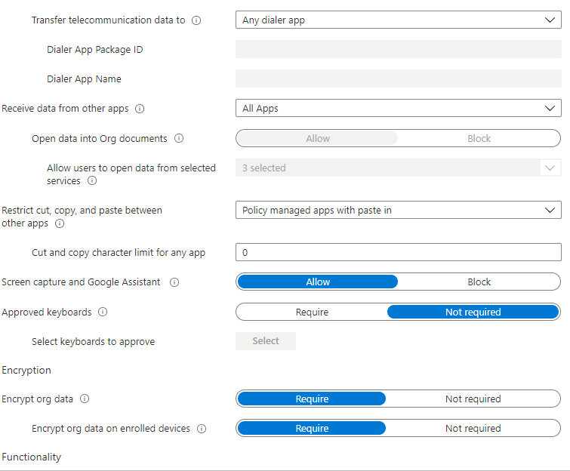

1. Under **Access Requirements,** select the options below
   1. PIN for access: **Require**
   2. PIN Type: **Numeric**
   3. Simple PIN: **Block**
   4. Select minimum PIN length: **6**
   5. Fingerprint instead of PIN for access: **Allow**
   6. Override fingerprint with PIN after timeout: **Not required**
   7. Biometrics instead of PIN for access: **Allow**
   8. PIN reset after number of days: **365**
   9. Select number of previous PIN values to maintain: **15**
   10. App PIN when device PIN is set: **Require**
   11. Work or school account credentials for access: **Require**
   12. Recheck the access requirements after (minutes of inactivity): **1440 minutes – 24 hours**

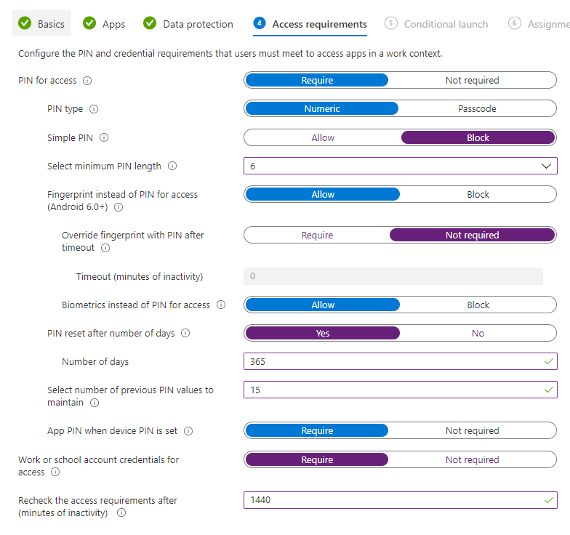

1. Under **Conditional Launch,** set the options below

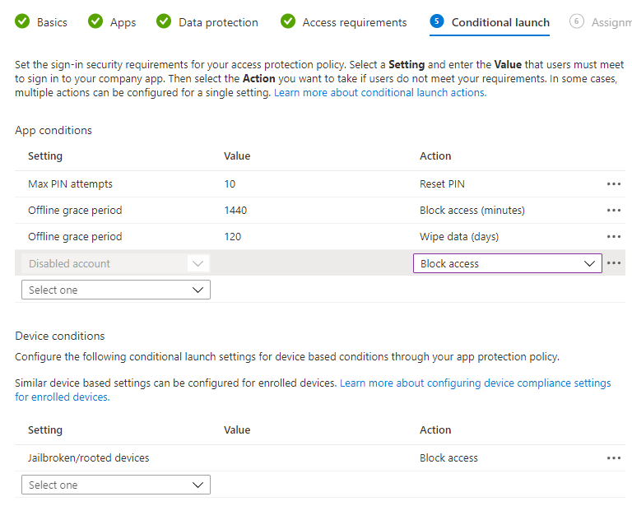

Under **Assignments,** assign the policy to the Intune group **SG-AD-BUILD-IntunePilotGroup** and create the policy

### Personal - MAM app protection policies

To create the Mobile application management policies to control personal mobile phones, perform the steps below depending on the platform.

#### iOS/iPadOS

To create Apple iOS policies for personal devices, perform these steps

1. Open Endpoint Manager console
2. Select Apps on the left menu and click on iOS/iPadOS
3. Click on App Protection Policies

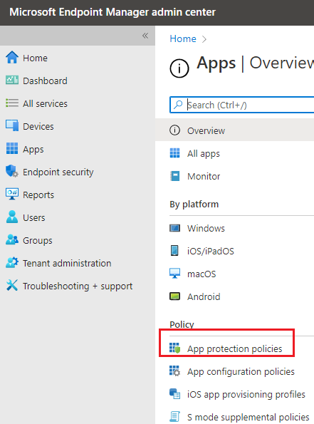

1. Click on New then click on iOS/iPadOS

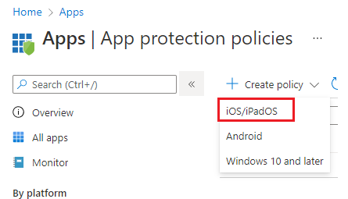

1. Provide the details of the policy below
   1. **Name:** iOS MAM - Personal Mobile device policy
   2. **Description:** Intune policy for personal mobile devices. This policy restricts printing and other settings on personal mobile devices with iOS to protect corporate CFS data being access on personal mobile phones. Phones will not be allowed to store local data or save to cloud apps other than O365

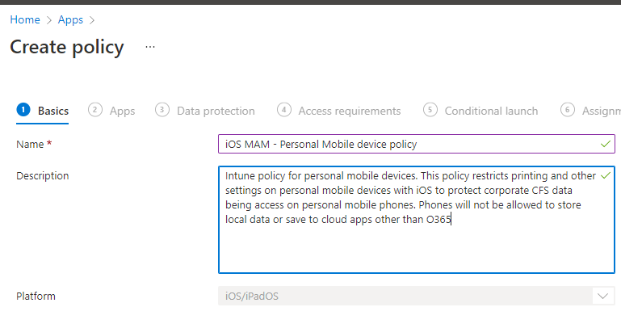

1. Under Apps select this policy only applies to Unmanaged (personal phones) and select Applies to **All Microsoft Apps**

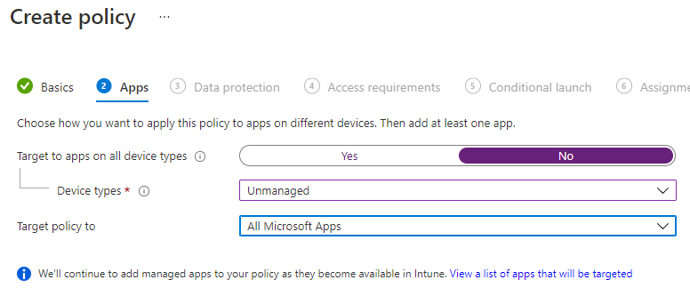

1. Under Data Protection, select the options
   1. **Backup org data:** Block
   2. **Send org data to other apps:** Only to policy managed apps (corporate apps with a policy managed app)
   3. **Save copies of org data:** OneDrive For Business and SharePoint only

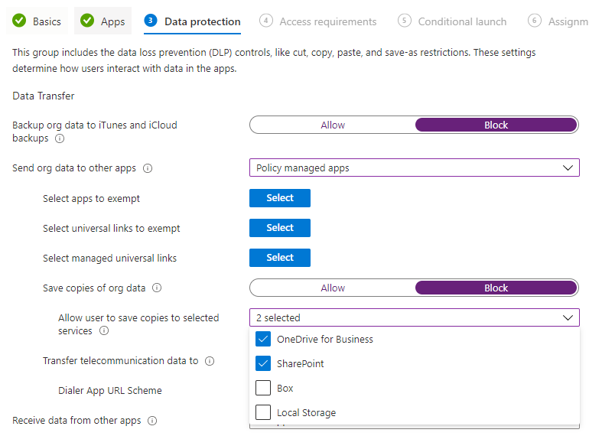

1. Select the remaining policies as per the screenshot below

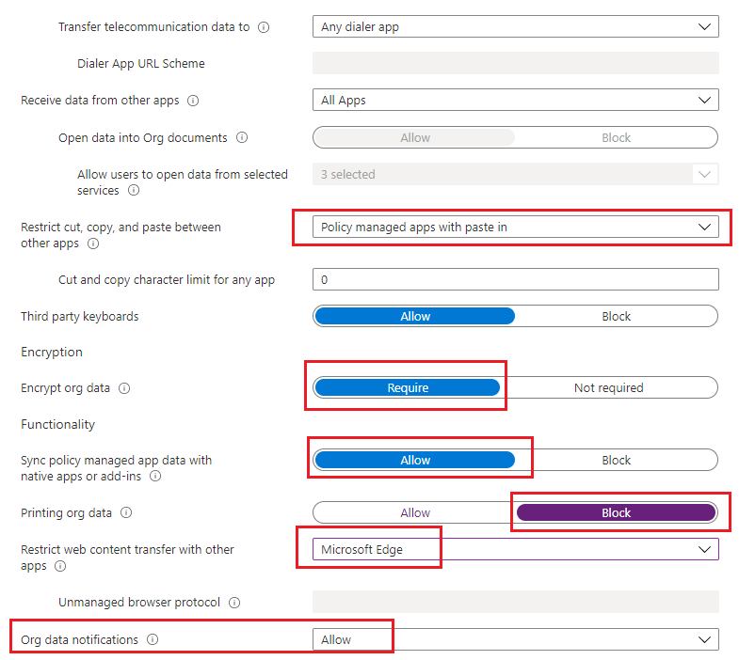

1. Under Access Requirements, select all the options below

* 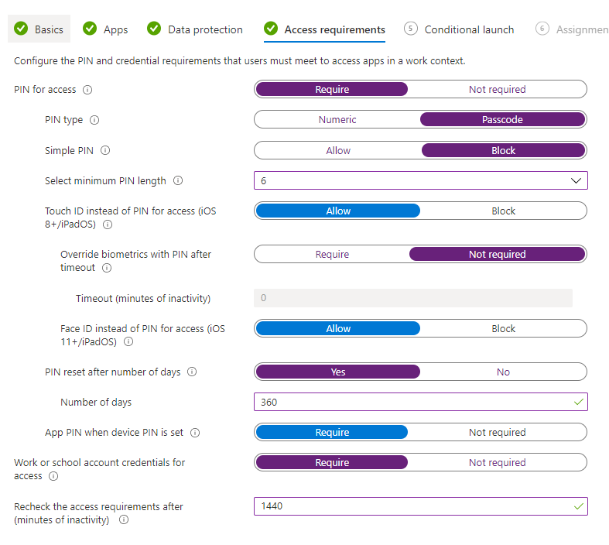

1. Under Conditional Launch, select the options below

* 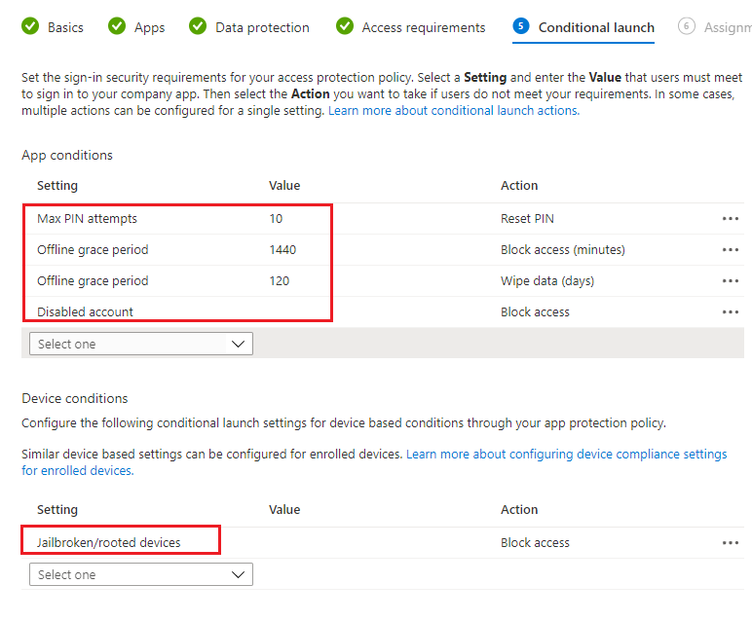

1. Under Assignment, select the Intune Pilot group. This group will contain all active users in the tenant

#### Android Enterprise

Once you have created the policy for iOS, perform the steps below to create the same policy for Android OS.

1. On the Apps section, click on New Policy and Choose **Android**
2. Provide the details of the policy

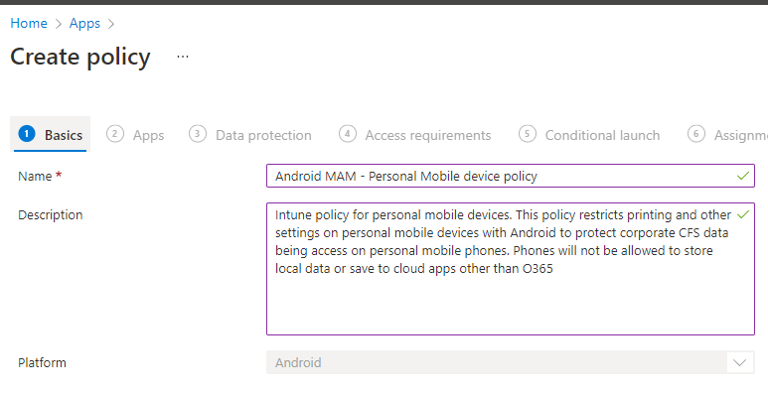

1. Under Apps, select the options below
   1. Target to apps on all device types: **NO**
   2. Device types: **Unmanaged (personal)**
   3. Target policy to: **All Microsoft apps**

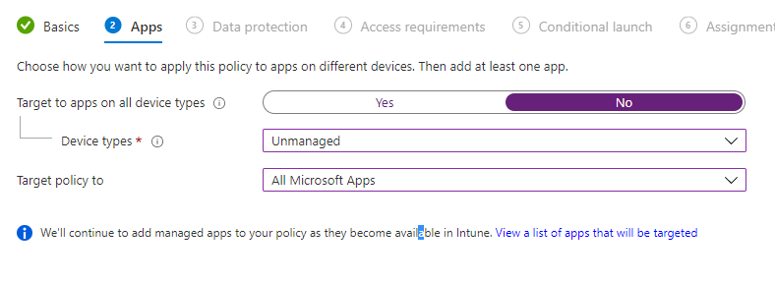

1. Under **Data Protection,** select the same options as the ones provided for iOS devices below
   1. Backup org data to Android backup services: **Block**
   2. Save copies of org data: Block
   3. Allow user to save copies to selected services: Choose only **OneDrive for Business and Sharepoint**

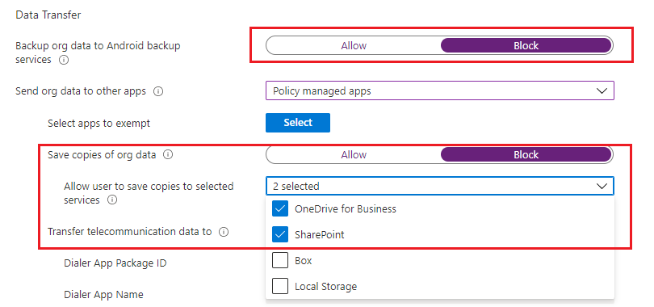

1. Leave the defaults for all the other options or change as per Design Requirements, specifically the option **Sync policy managed app data with native apps or add-ins.** This option allows contacts and calendar to sync to the native Android OS apps.

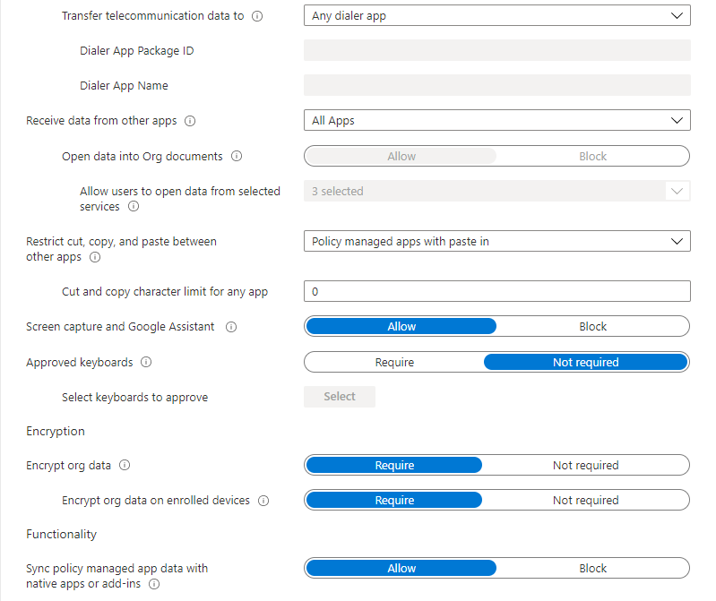

1. Select the remaining options to configure the policies as below
   1. Printing org data: **Block**
   2. Restrict web content transfer with other apps: **Microsoft Edge**
   3. Org data notifications: **Allow** – This will allow Android watch on screen notifications

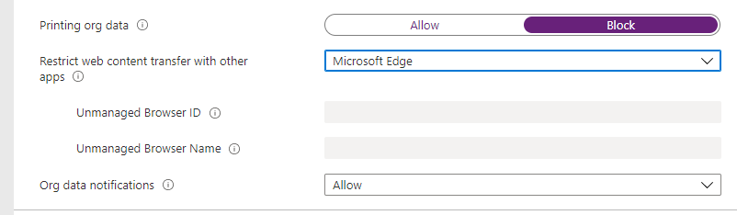

1. Under Access requirements, select the options below
   1. Pin for Access: **Require**
   2. Pin Type: **Numeric**
   3. Simple PIN: **Block**
   4. Select minimum PIN length: **6 digits**
   5. Fingerprint instead of PIN for access: **Allow**
   6. Override fingerprint with PIN after timeout: **Not required**
   7. Biometrics instead of PIN to access: **Allow**
   8. Pin reset after number of days: **360**
   9. Select number of PIN values to maintain: **4**
   10. App PIN when device PIN is set**: require**
   11. Work or school credentials for access: **require**
   12. Recheck the access requirements after (minutes of inactivity): **1440 (24 hours)**

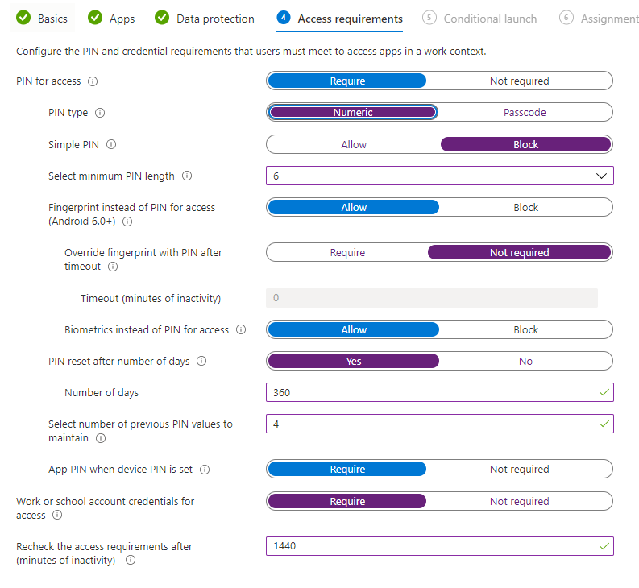

1. Under Conditional Launch, select the options below
   1. Max PIN attempts: **10**
   2. Offline grace period: **1440** (block access and require re-authentication after 24 hours)
   3. Offline grace period: **120 days** (wipe data if device has been offline for 120 days)
   4. Disabled Account: **block access**
   5. Jailbroken/Rooted devices: **block access**

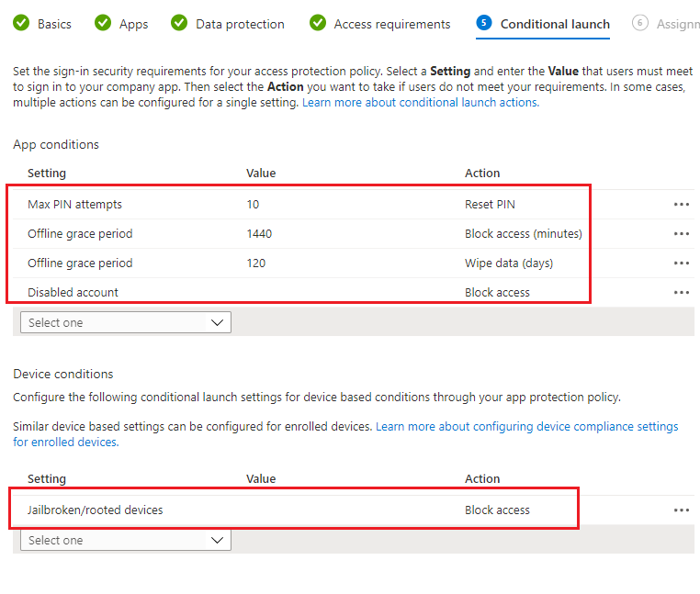

1. Under Assignment, assign to the Pilot group initially. This group will be changed to a DYNAMIC group containing all users as the policy must apply to all users.

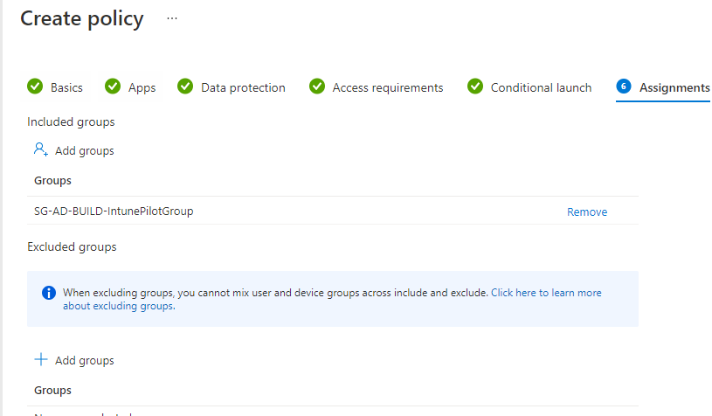

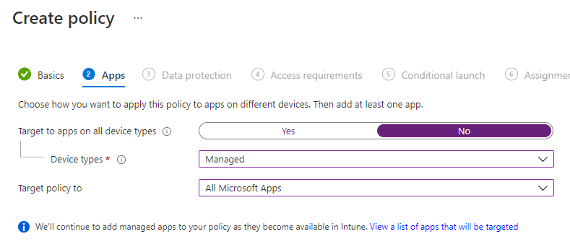

1. Under **Data Protection,** select
   1. Backup org data to iTunes and iCloud backups: **Block**
   2. Send org data to other apps: **Policy Managed apps**
   3. Save copies of org data: **Block**
   4. Allow user to save copies to selected services: **OneDrive for Business and SharePoint**
   5. Receive data from other apps: **All apps**
   6. Restrict cut, copy, and paste between other apps: **Policy managed apps with paste-in**
   7. Encrypt org data: **REQUIRE**
   8. Sync policy managed app data with native apps or add-ins: **Allow** – this permits to save contacts on the native app
   9. Printing org data: **Allow**
   10. Restrict web content transfer with other apps: **Microsoft Edge**
   11. Org data notifications: **Allow –** this permits Apple watches to show notifications

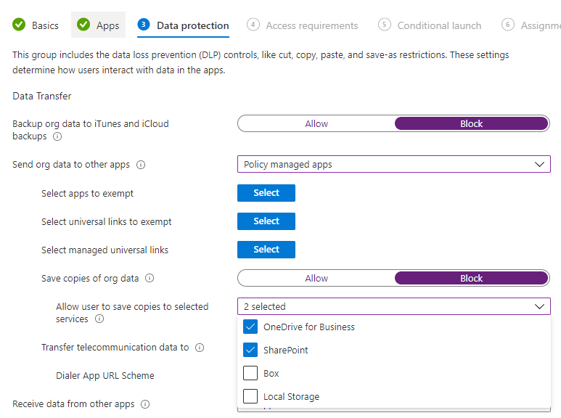

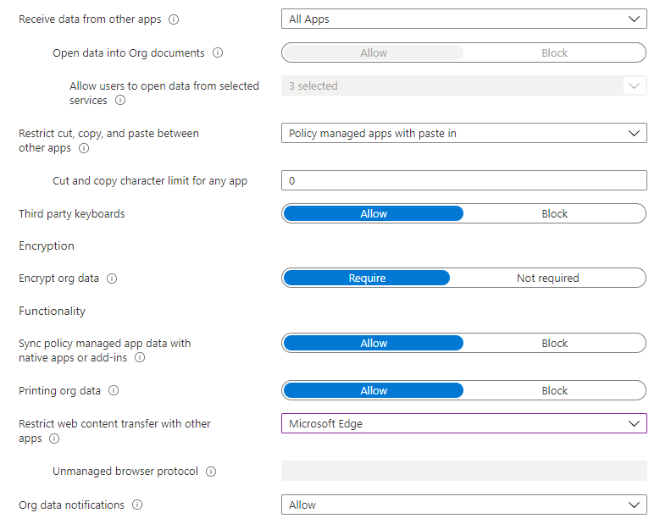

1. Under **Access requirements**, select the following options
   1. PIN for access: **Require**
   2. PIN type: **Numeric**
   3. Simple PIN: **Block**
   4. Select minimum PIN length: **6**
   5. Touch ID instead of PIN for access: **Allow**
   6. Override biometrics with PIN after timeout **Not required**
   7. Face ID instead of PIN for access: **Allow**
   8. PIN reset after number of days: **365**
   9. App PIN when device PIN is set: **Require**
   10. Work or school account credentials for access: **Require**
   11. Recheck the access requirements after (minutes of inactivity): **1440 minutes** – 24 hours

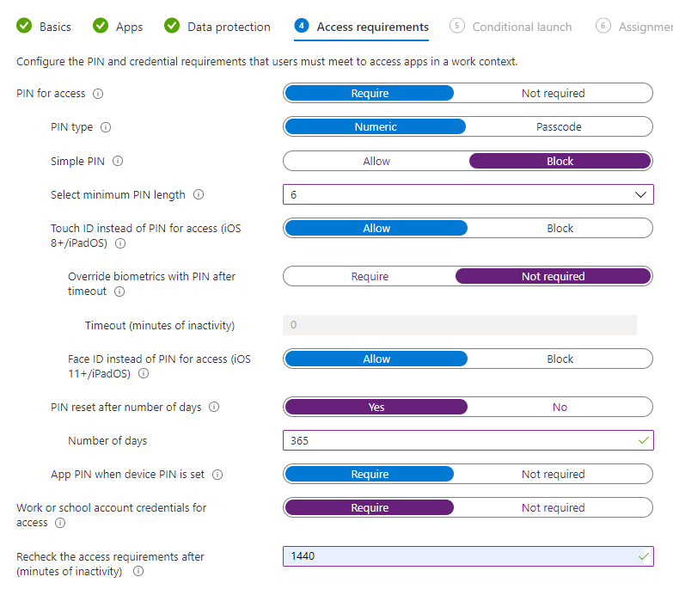

1. Under **Conditional Launch,** select the options below

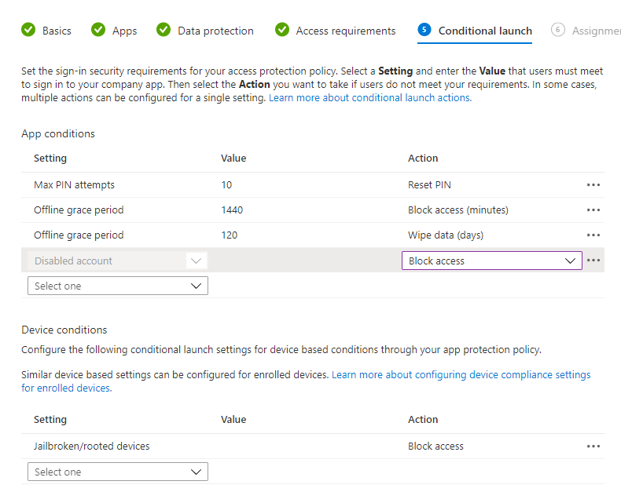

1. Under **Assignments,** assign the policy to group **SG-BUILD-INTUNEGROUP** and create the policy

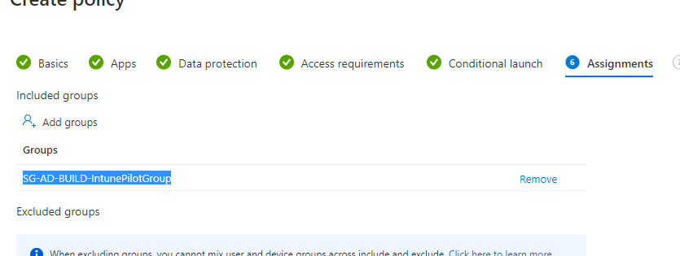

### Configuring Intune PAW policies

#### Pre-requisites

Download the scripts from Microsoft repository labelled **Privilege Profile Configuration** and make sure to unlock the scripts (repeat for each script)

[Deploying a privileged access solution | Microsoft Docs](https://docs.microsoft.com/en-us/security/compass/privileged-access-deployment)

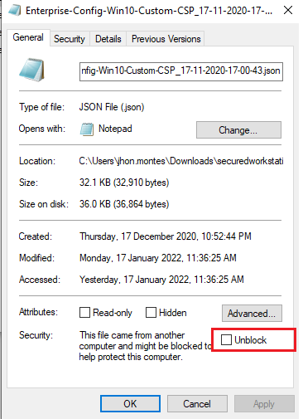

1. Download the GitHub project for **PAW privilege work stations**
2. Run the Master script Master Script PAW.PS1
3. Specify an Intune Administrator or Global Admin account, example **jhon.montes@ausupnonp.onmicrosoft.com**

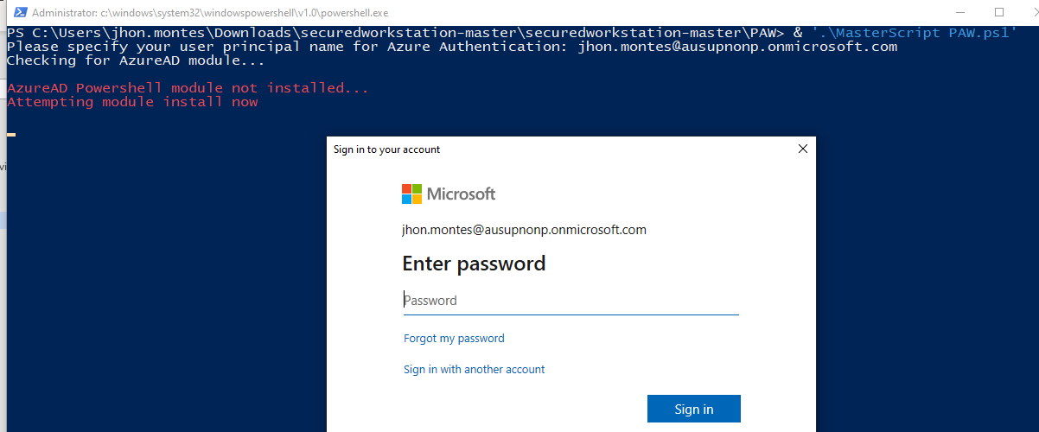

1. Authenticate and MFA with the Intune Administrator. You may face the message below if the Global Admin role is not assigned to the user authenticating

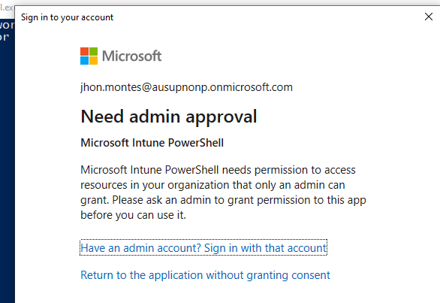

1. If you face this error, run the script with a Global admin or assign Global Admin to the user running the script
2. Grant access to the Intune Powershell scripts

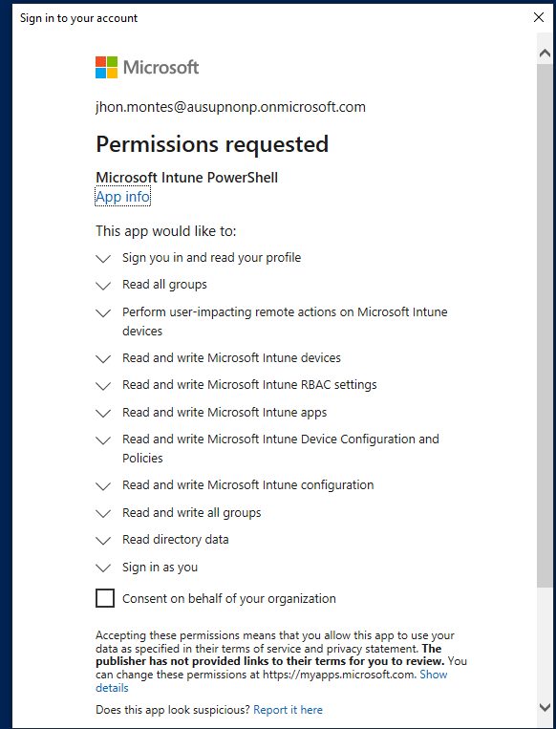

1. If the scripts fail, rerun the Master script again
2. If any individual script fails, rerun the individual PS1 file as per the error by changing the group names in the JSON files for all Compliance and ADMX files.
3. Once all scripts have run successfully, you will have **3 compliance polices and 8 Configuration Policies** as shown below

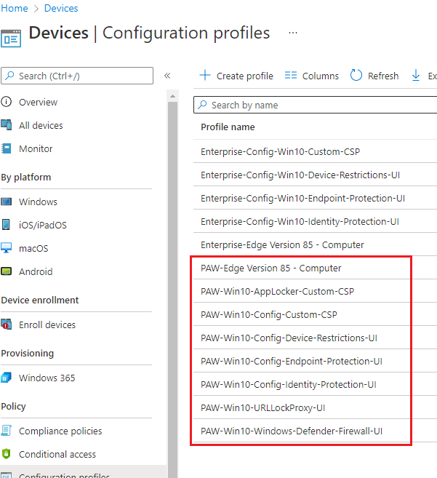

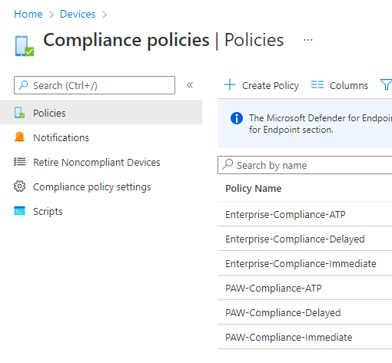

1. Assign each policy to the respective PAWs group containing **all the privilege Workstations**
2. Create an Endpoint Detection and response policy. Assign this policy to the PAWS workstation device group

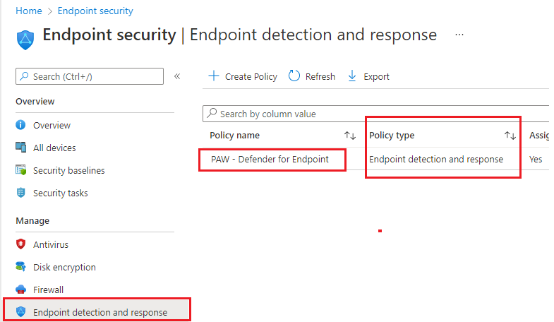

1. Create an Endpoint Detection and response policy. Assign this policy to the PAWS workstation device group

#### Policy changes

Make the following updates to the policies once they are created and assigned.

**PAW-Win10-URLLockProxy-UI** | General | DMA – Not configured

**PAW-Windows-Defender-Firewall-UI** | Microsoft Defender Security Center | Family Options – Not configured

**PAW-Windows-Defender-Firewall-UI** | Microsoft Defender Security Center | Clear TPM button – Not configured

**PAW-Windows-Defender-Firewall-UI** | Microsoft Defender Security Center | TPM firmware update warning – Not configured

**PAW-Windows-Defender-Firewall-UI** | Microsoft Defender Security Center | Microsoft Defender Exploit Guard |Network Protection – Not configured

**PAW-Win10-Windows-Defender-Firewall-UI** | Default action for outbound connections (Domain networks) - Block

**PAW-Win10-Config-Device-Restrictions-UI** | Passwords | Require password when device returns from idle state (Mobile and Holographic) – Not configured

**PAW-Win10-Config-Endpoint-Protection-UI** | Microsoft Defender Exploit Guard | List of apps that have access to protected folders - added C:\Windows\System32\omadmclient.exe & C:\windows\System32\svchost.exe

**PAW-Win10-Config-Endpoint-Protection-UI** | Local Device Security Options | Accounts | Add new Microsoft accounts | Not-Configured

**PAW-Win10-Config-Endpoint-Protection-UI** | Local Device Security Options | Accounts | Admin | Local Admin Accounts | Not-Configured

#### Assign Local Admins

Create an **Endpoint Security Account protection policy** to assign Administrators group to the PAW administrator Azure AD team group.

1. Open Endpoint Manager, Endpoint Security, Account Protection, click on Create Policy, Platform Windows 10 and Later
2. Choose **Local user group membership** and provide the name and description for the policy
   1. Name: PAWS - Local administrators
   2. Description: Adds the PAWS Azure AD group to the local administrators of each PAW machine

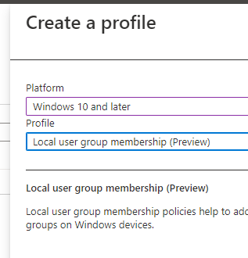

1. Under **Configuration Settings,** add **Emergency BreakGlass PAW** and other groups as per requirements:
   1. SG-AA-OPS-PAWSAdmins

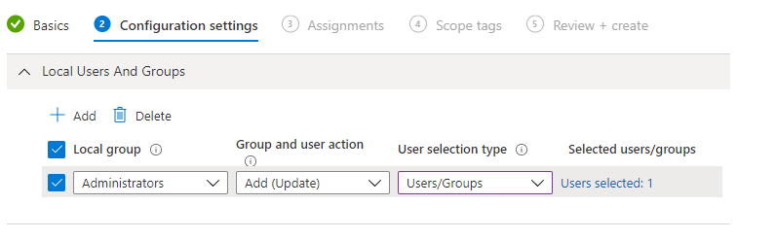

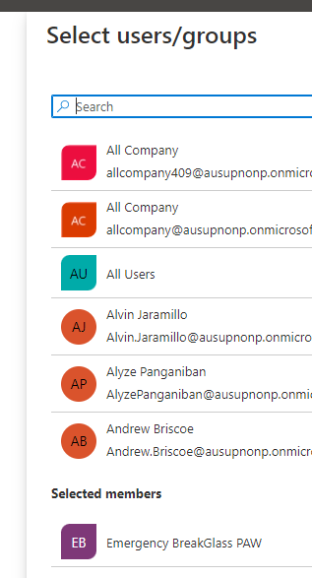

1. Under Assignments, assign this policy to all PAWS devices. Save and create the policy

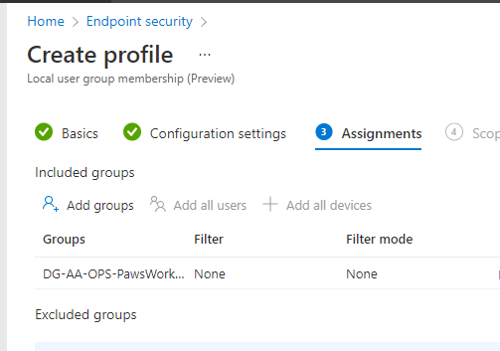

#### Configure Roles in Defender for Endpoint

Create a Role in Defender for Endpoint, role name **Windows Servers Admins,** assign this role to the on premise group **SG-AD-OPS-ServerATPAdmin**

Create a role in Defender for Endpoint, role name **PAWS administrators**, assign this role to the group **SG-AA-OPS-PAWSAdmins**

#### Configure device group for Defender for Endpoint

Create a device group in Defender for Endpoint called **Windows Servers,** assign permissions to the group **SG-AD-OPS-ServerATPAdmin**

**Filter: OS in Windows Server 2022**

Create a device group for **PAWS Workstations**, assign permissions to the group **SG-AA-OPS-PAWSAdmins**

**Filter: Name contains PAWS**

#### Configure Update rings

Configure update rings for PAW machines as per screen below

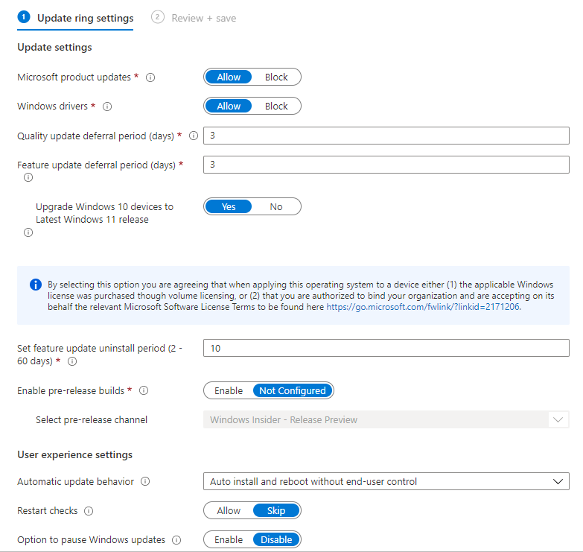

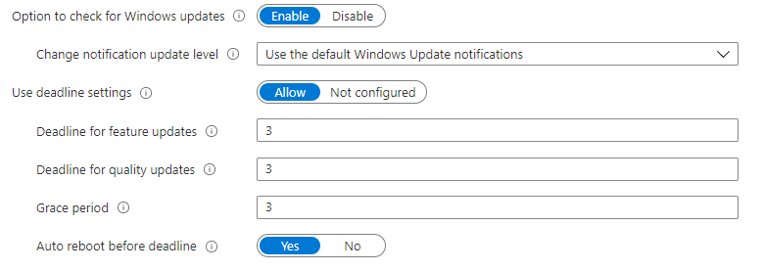

1. Assign the policy to the PAWS workstations group **DG-AA-OPS-PawsWorkstations**

### Configuring AVD Intune Policies

#### Pre-requisites

Download the scripts from Microsoft repository labelled as **Enterprise Profile Configuration** and make sure to unlock the scripts (repeat for each script)

[Deploying a privileged access solution | Microsoft Docs](https://docs.microsoft.com/en-us/security/compass/privileged-access-deployment)



1. Open an elevated PowerShell and locate the folder where the scripts are located
2. Run the Master Script with a Global Admin account and perform MFA



1. Rerun the scripts if the master scripts shows any errors
2. Once the scripts have run successfully, you will get the policies below 5 Configuration Policies and 3 compliance policies (each identified by either PAW or ENT depending on the policy allocation type)

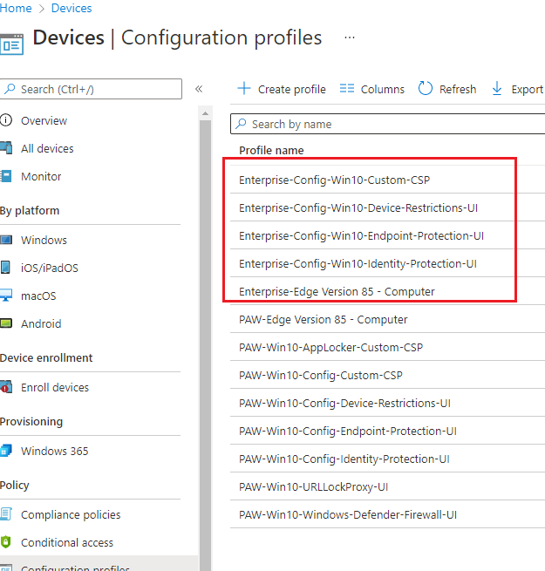



1. Assign each policy to the respective Azure Virtual Desktop device group containing the devices to be enrolled into MDM

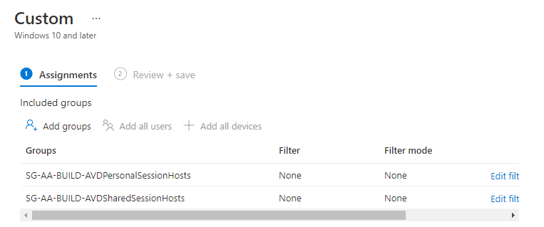

1. Create an Endpoint Detection and response policy. Assign this policy to the Enterprise Workstations (AVD) workstation device group
2. This policy will onboard AVD Windows 11 devices to Defender for Endpoint

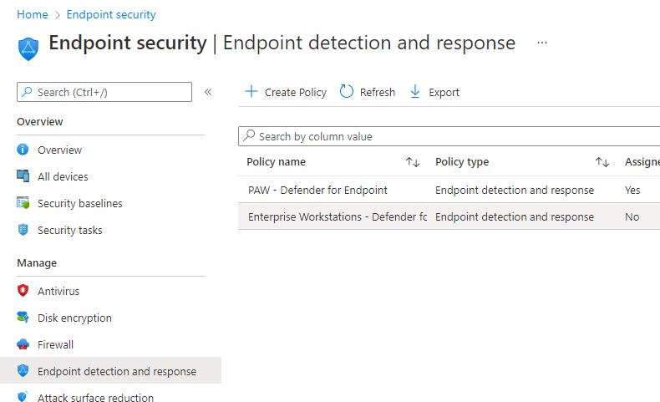

1. Create OneDrive for Business known folder redirection
2. On Configuration Profiles, create a new profile, type **Administrative Template**

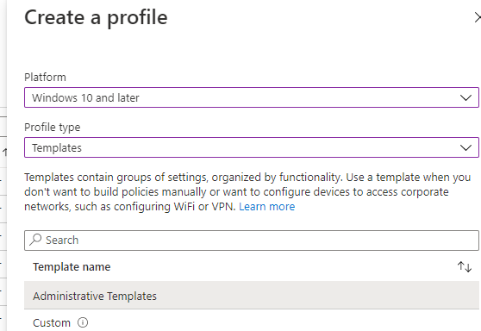

1. Provide name and description
   1. Name: Enterprise AVD OneDrive folder redirection
   2. Description: Configures OneDrive system settings for automatic sign-in, known folder redirection and move
2. Under **Configuration Settings,** select the option Silently move Windows known folders to OneDrive (2.0). Choose all Options and no notification

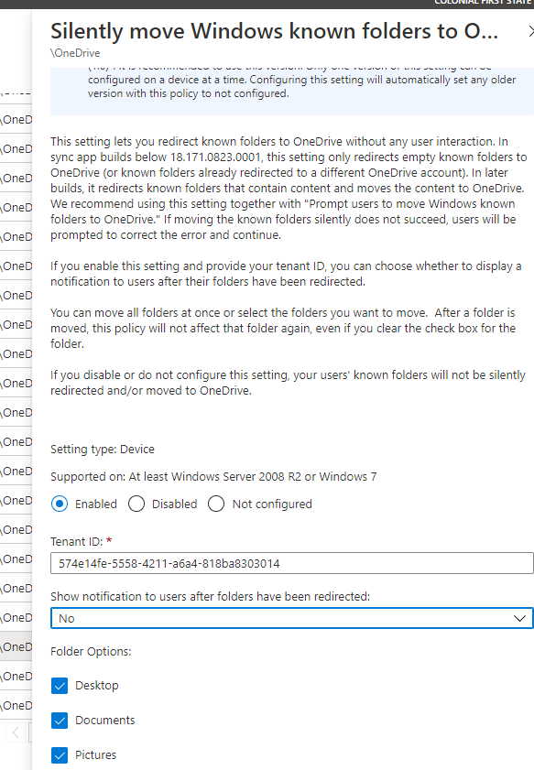

1. Enable the policy **Silently sign in users to the OneDrive sync app with their Windows credentials**

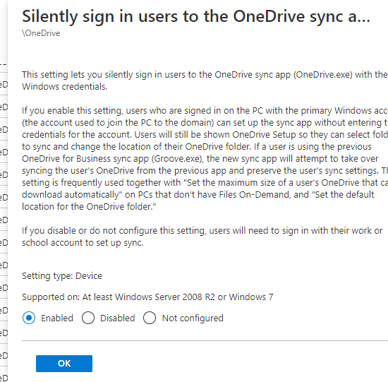

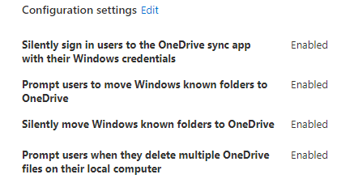

1. Under Assignments, select the AVD groups and create the policy

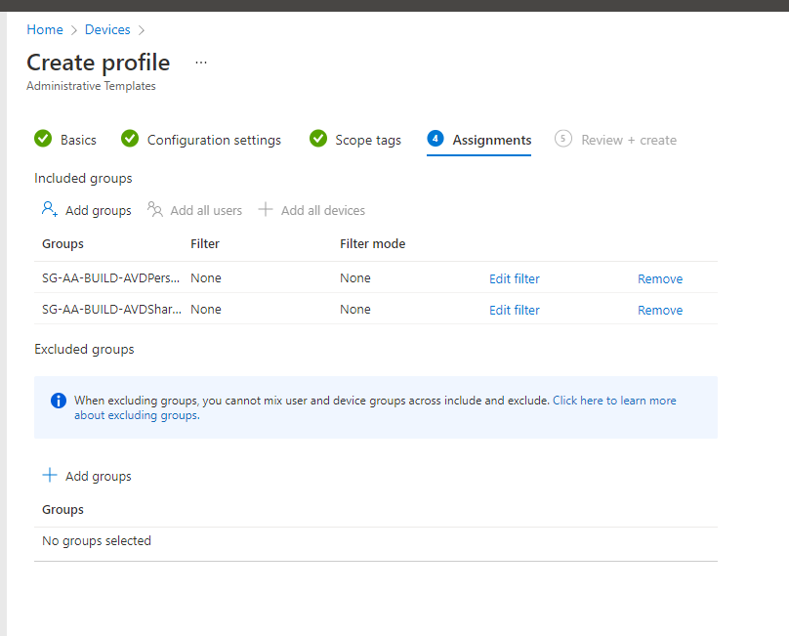

#### Multi-Session Policies

Create a Configuration Policy of type system catalog for all the Azure Virtual Desktop Multi-session Windows 11 machines. This is required because Configuration Policies of Device Configuration type are not compatible with Multi-session Windows 11 OS.

1. Open Endpoint Manager, Devices, Configuration Profiles, Create Profile, Setting Catalog

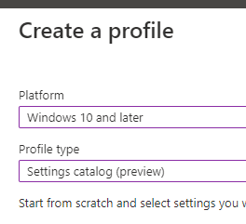

1. Provide the name and description
   1. Name: MDM – Windows 11 Multi-session Configuration Policies
   2. Description: Configuration Policy for Multi-session Windows 11 Azure Virtual Desktop devices
2. Under Configuration Settings, select the options below

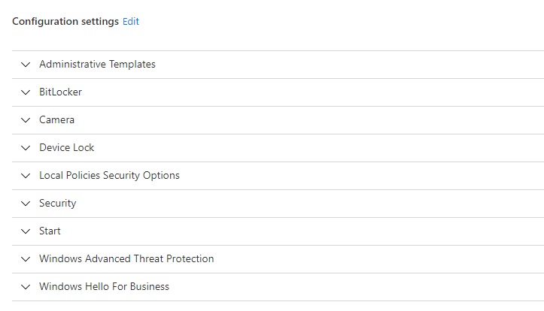

* 1. Administrative templates

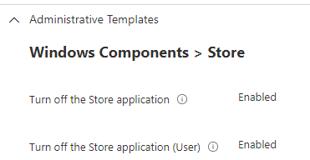

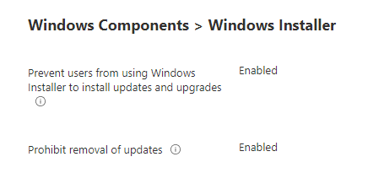

* 1. Bitlocker

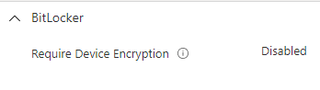

* 1. Camera

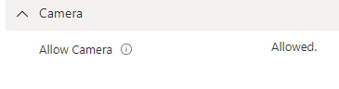

* 1. Device Lock

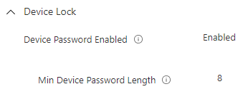

* 1. Local policies security options

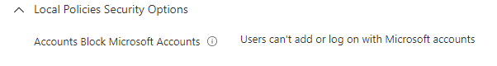

* 1. Security

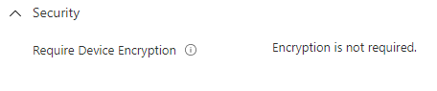

* 1. Start

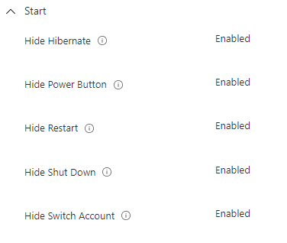

* 1. Windows Advance Threat Protection

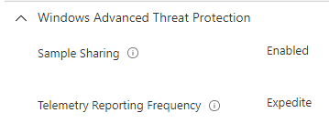

* 1. Windows Hello for Business

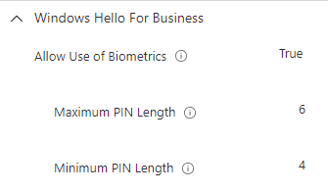

1. Under Windows Update for Business, select the options below

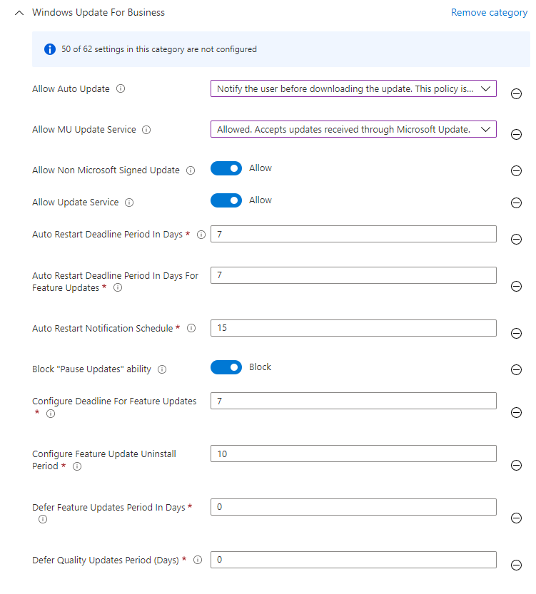

1. Under Windows Components > File Explorer

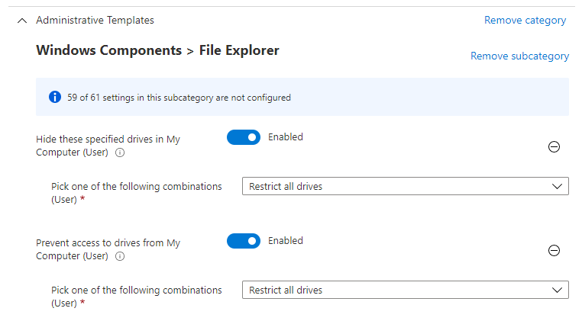

1. Under **OneDrive,** select the options below

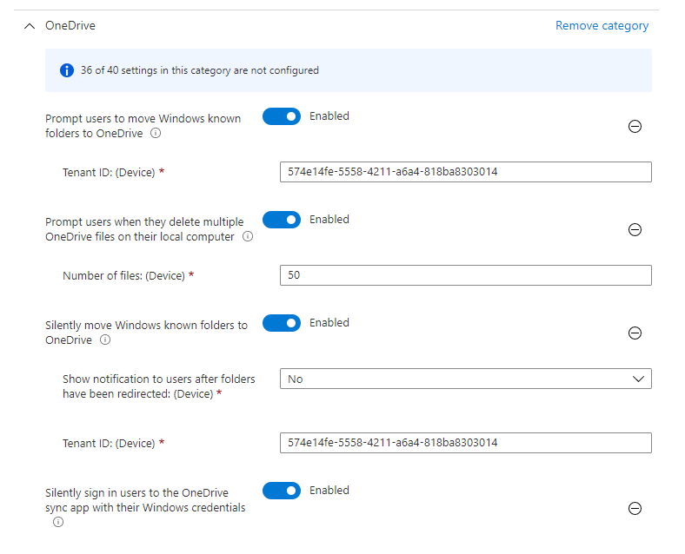

1. Under Time Language settings, set the policy to

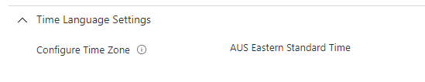

1. Under **Assignments**, assign this policy to the AVD Share Pool device group

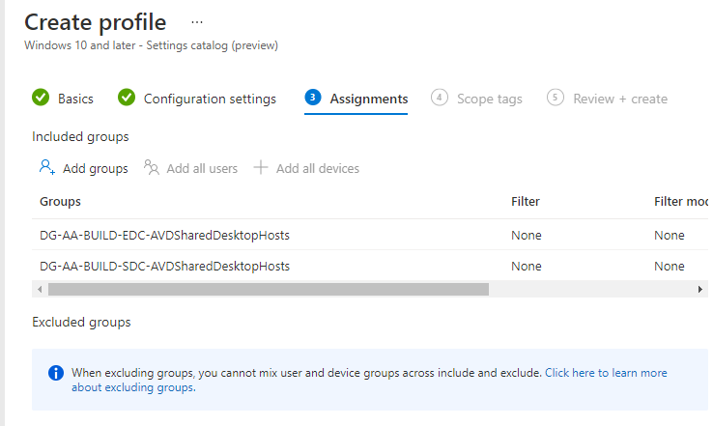

#### Configure AVD Roles in Endpoint Defender

Create a Role for AVD admins and assign to **AVD Administrators**

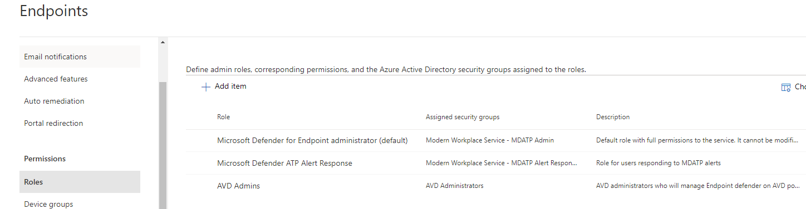

#### Configure Device Group in Endpoint Defender

Assign the device group to the Role created above

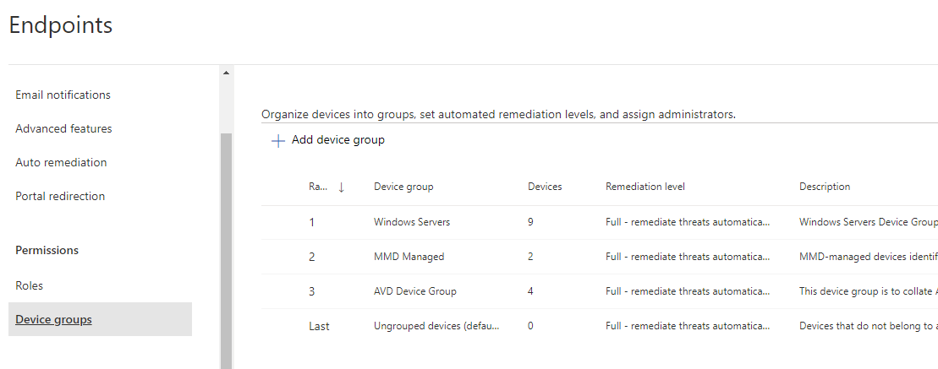

#### Disable Microsoft Store

Modify the existing Custom CSP policy for Enterprise AVD and add the option below

./User/Vendor/MSFT/Policy/Config/ApplicationManagement/RequirePrivateStoreOnly

Value 1 (integer)

#### Configure Update Rings for Personal AVDs

|  |  |
| --- | --- |
|  | ***Important Note***  *Refer to AVD Update procedures for AVD devices for more information. That document outlines the GREEN and BLUE patching strategy for both Feature and Update rings* |

To configure the Update rings for AVD machines, perform these steps

1. Open Endpoint Manager, Devices, Update Rings for Windows 10 and Later, click on Create new profile
2. Provide the name and description
   1. Name: Enterprise AVD Machines Update Rings
   2. Description: Update rings for AVD machines
3. Select the options below

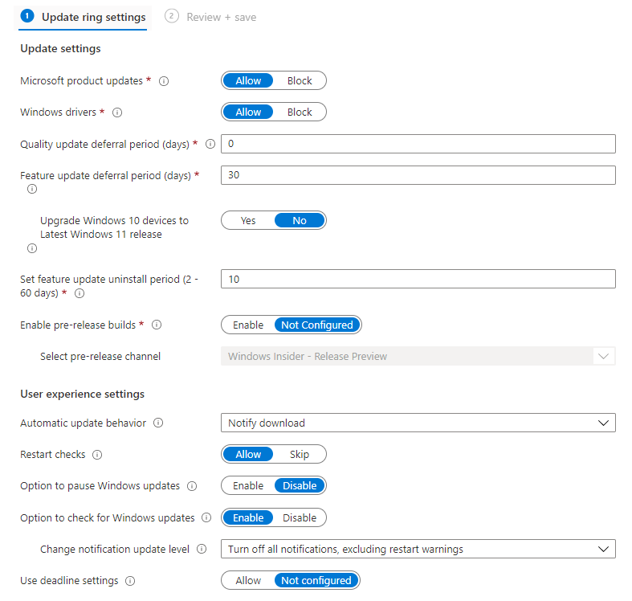

1. Under Assignments, Assign to the AVD personal and shared pools. Note share pools don’t support Update rings.
2. Save the policy

#### Deploy O365 app to Personal AVDs

To deploy Office 365 Apps to all Personal session Azure Virtual desktop devices, create an Intune App for Windows.

Create an app package name: Microsoft 365 Apps for Windows 10 and later – AVDs

**Deploy it** to SG-AAOPSAVDPersonalSessionHosts

**Require: Yes**

#### Time Zone Policy for Personal AVD

Create a Setting Catalog policy to change the Time Zone for all Personal AVD devices

1. Click on New Configuration Profile, Select Setting Catalog type
2. Provide the details for the policy below
   1. Name: Enterprise AVD - Configure Time Zone for Personal AVD
   2. Description: Configures time zone to AU Eastern Time

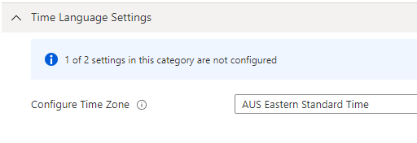

1. Assign the policy to all the Personal AVD device groups

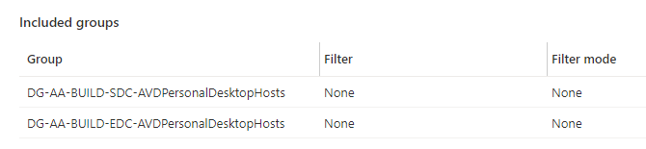

#### Configure Defender Antivirus Exclusions Personal AVDs

Modify the Device Restriction Configuration Policy **Enterprise AVD -Config-Win10-Device-Restrictions-UI** to include the paths of any program or AVD requirements so the Defender antivirus excludes these paths and processes from the scan policy:

|  |  |
| --- | --- |
|  | ***Important Note***  *Replace NP value for production servers where applicable so vmnpsdcfs001 becomes vmprdsdcfs001 and the share storage becomes fs-prd-sdc-XXXX* |

Excluded files:

%ProgramFiles%\FSLogix\Apps\frxdrv.sys

%ProgramFiles%\FSLogix\Apps\frxdrvvt.sys

%ProgramFiles%\FSLogix\Apps\frxccd.sys

%TEMP%\*.VHD

%TEMP%\*.VHDX

%Windir%\TEMP\*.VHD

%Windir%\TEMP\*.VHDX

\\vmnpedcfs001.file.core.windows.net\fs-np-edc-avdsd-01\*.VHD

\\vmnpedcfs001.file.core.windows.net\fs-np-edc-avdpd-01\*.VHD

\\vmnpedcfs001.file.core.windows.net\fs-np-edc-avdsd-01\*.VHDX

\\vmnpedcfs001.file.core.windows.net\fs-np-edc-avdpd-01\*.VHDX

\\vmnpsdcfs001.file.core.windows.net\fs-np-sdc-avdsd-01\*.VHD

\\vmnpsdcfs001.file.core.windows.net\fs-np-sdc-avdpd-01\*.VHD

\\vmnpsdcfs001.file.core.windows.net\fs-np-sdc-avdsd-01\*.VHDX

\\vmnpsdcfs001.file.core.windows.net\fs-np-sdc-avdpd-01\*.VHDX

Excluded processes:

%ProgramFiles%\FSLogix\Apps\frxccd.exe

%ProgramFiles%\FSLogix\Apps\frxccds.exe

%ProgramFiles%\FSLogix\Apps\frxsvc.exe

1. Open Endpoint Manager, click on Devices, Windows, Configuration Policies, locte Enterprise AVD – Device Restriction policy above. Save the changes.
2. Under configuration settings, configure the excluded paths and processes as above

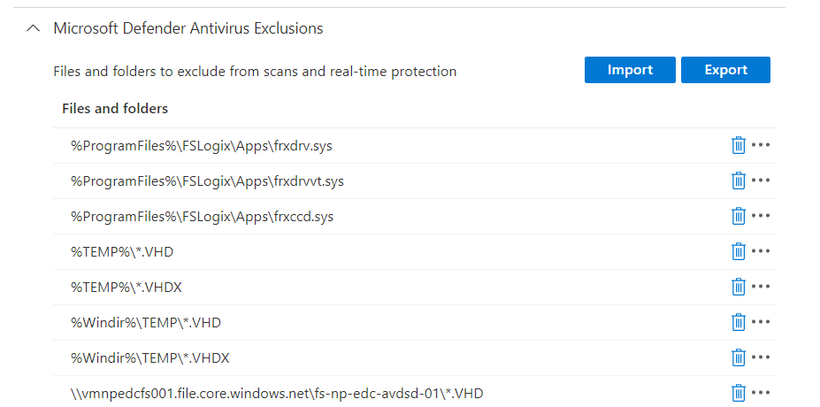

#### Configure Defender Antivirus Exclusions Shared AVDs

Modify the Device Restriction Configuration Policy **Enterprise AVD – Windows 11 Multi-session Configuration Policies** to include the paths of any program or AVD requirements so the Defender antivirus excludes these paths and processes from the scan policy:

Excluded files:

%ProgramFiles%\FSLogix\Apps\frxdrv.sys

%ProgramFiles%\FSLogix\Apps\frxdrvvt.sys

%ProgramFiles%\FSLogix\Apps\frxccd.sys

%TEMP%\*.VHD

%TEMP%\*.VHDX

%Windir%\TEMP\*.VHD

%Windir%\TEMP\*.VHDX

\\vmnpedcfs001.file.core.windows.net\fs-np-edc-avdsd-01\*.VHD

\\vmnpedcfs001.file.core.windows.net\fs-np-edc-avdpd-01\*.VHD

\\vmnpedcfs001.file.core.windows.net\fs-np-edc-avdsd-01\*.VHDX

\\vmnpedcfs001.file.core.windows.net\fs-np-edc-avdpd-01\*.VHDX

\\vmnpsdcfs001.file.core.windows.net\fs-np-sdc-avdsd-01\*.VHD

\\vmnpsdcfs001.file.core.windows.net\fs-np-sdc-avdpd-01\*.VHD

\\vmnpsdcfs001.file.core.windows.net\fs-np-sdc-avdsd-01\*.VHDX

\\vmnpsdcfs001.file.core.windows.net\fs-np-sdc-avdpd-01\*.VHDX

Excluded processes:

%ProgramFiles%\FSLogix\Apps\frxccd.exe

%ProgramFiles%\FSLogix\Apps\frxccds.exe

%ProgramFiles%\FSLogix\Apps\frxsvc.exe

1. Open Endpoint Manager, click on Devices, Windows, Configuration Policies, locate Enterprise AVD – Windows 11 Multi-session Configuration Policies policy above.
2. Click on Add Setting Under Configuration Settings, locate the Antivirus exclusions administrative template, then select Path Exclusions and Process Exclusions. Replace the values of NONPROD with PROduction values where applicable.

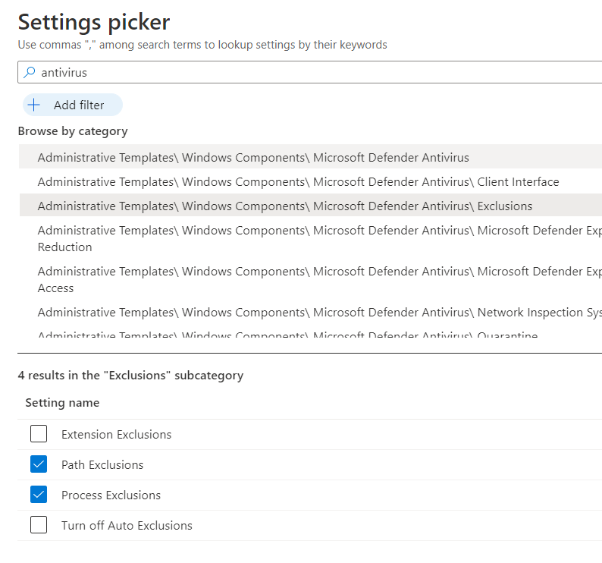

1. Configure the exclusions as the paths and process above

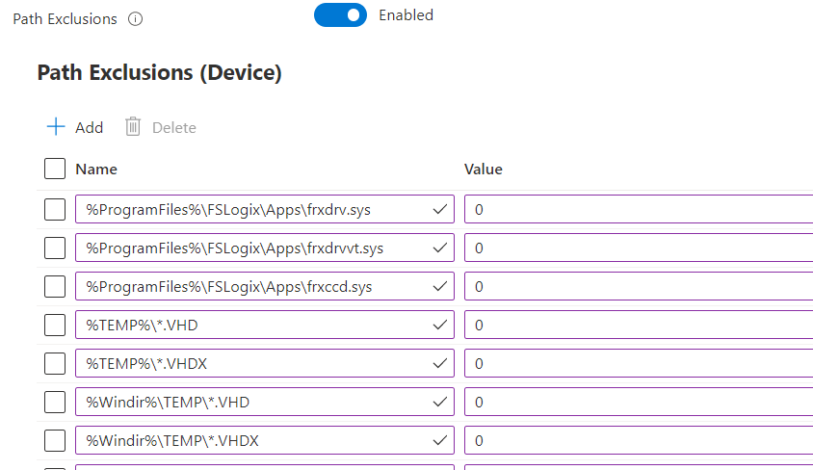

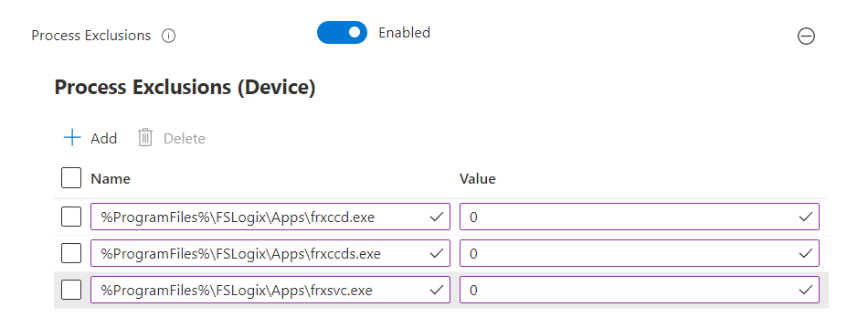

#### Desktop Wallpaper

Personal and Shared AVD session host VMs are configured to get the desktop wallpaper image via Intune policies. The desktop wallpaper image files are hosted in Storage Accounts, for more information on the configuration of these storage accounts, refer the Storage Accounts section in Azure Virtual Desktop section further in this document.

The following policy settings are applied. These policy settings are identical in production and non-production environment except the storage accounts. Each environment has its own storage account.

**Personal AVDs:**

The following screenshot contains the policy setting for desktop wallpaper image:

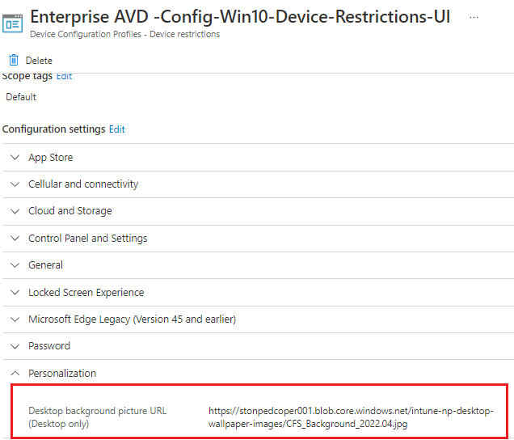

The following screenshot contains the policy settings for lock screen wallpaper image:

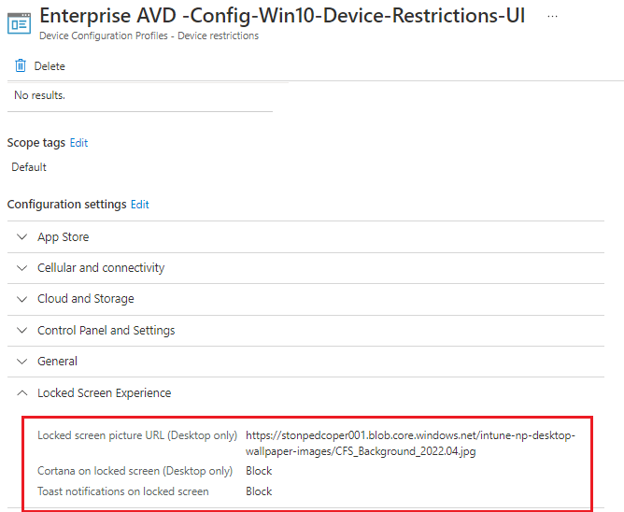

**Multi-session AVDs:**

The following screenshot contains the policy settings for lock screen and desktop wallpaper images:

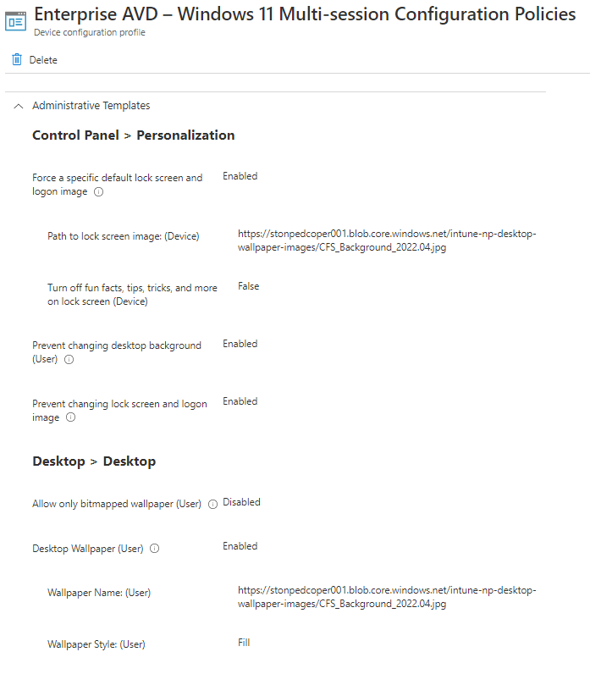

### Defender for Endpoint Integration with mobiles

Configure the options below to integrate endpoint devices (Devices that are onboarded on Defender for Endpoint) with Endpoint Manager (Intune). These options will enable mobile phone integration

1. Under Endpoint Manager, Tenant Administration, click on Connectors and Tokens
2. Click on Cross Platform, Microsoft Defender for Endpoint
3. Enable the options below
   1. Allow Microsoft Defender for Endpoint to enforce Endpoint Security Configurations: ON
   2. Connect Android Devices to Microsoft Defender for Endpoint: ON
   3. Connect iOS devices to Microsoft Defender for Endpoint: ON
4. Under App protection policy settings, enable the options
   1. Connect Android devices to Microsoft Defender for Endpoint for app protection policy evaluation: ON
   2. Connect iOS devices to Microsoft Defender for Endpoint for app protection policy evaluation: ON

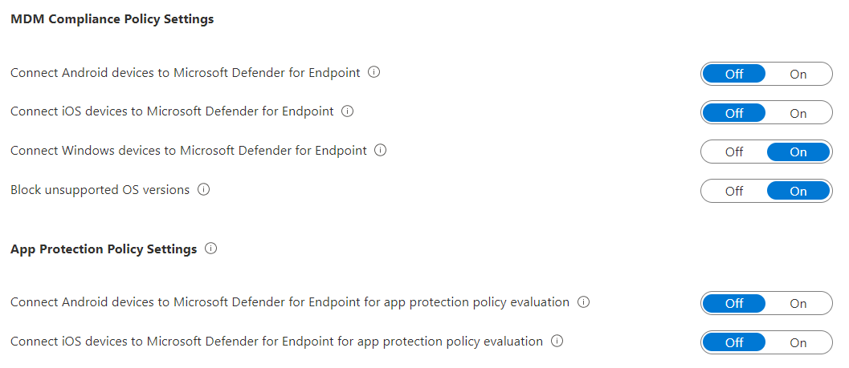

### Configuring Remote Help App

To configure Microsoft Remote Help and its components, perform the steps below

##### Check Premium Add-on

Under Premium Add-Ons, verify Remote Help Add-on is Active

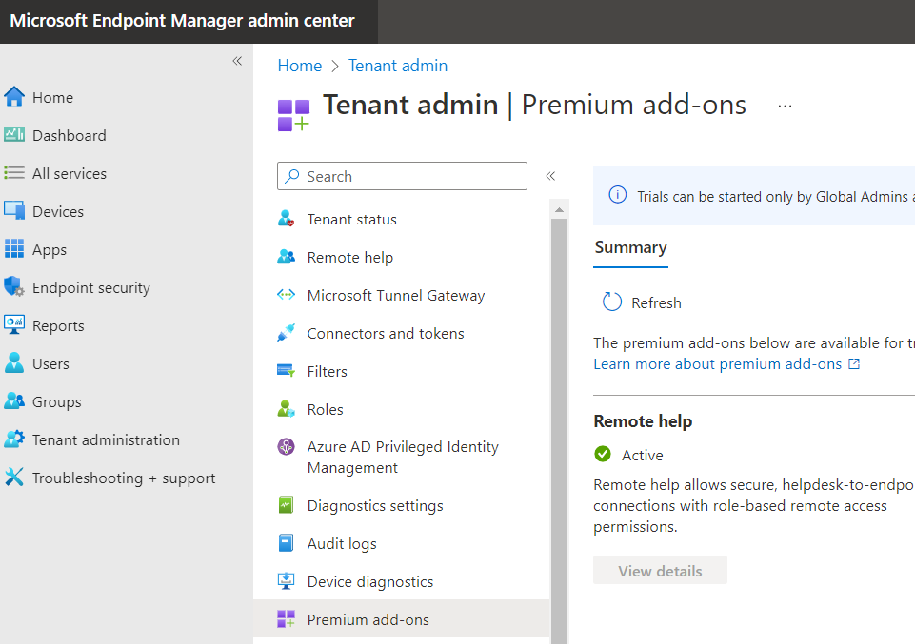

##### Deploy Remote Help App

1. Download Remote app https://aka.ms/downloadremotehelp
2. Wrap remote help app using Wrap Tool
3. Create Intune Remote help Win32 app. For more details, see App Deployment Guide or Operations Guide documentation

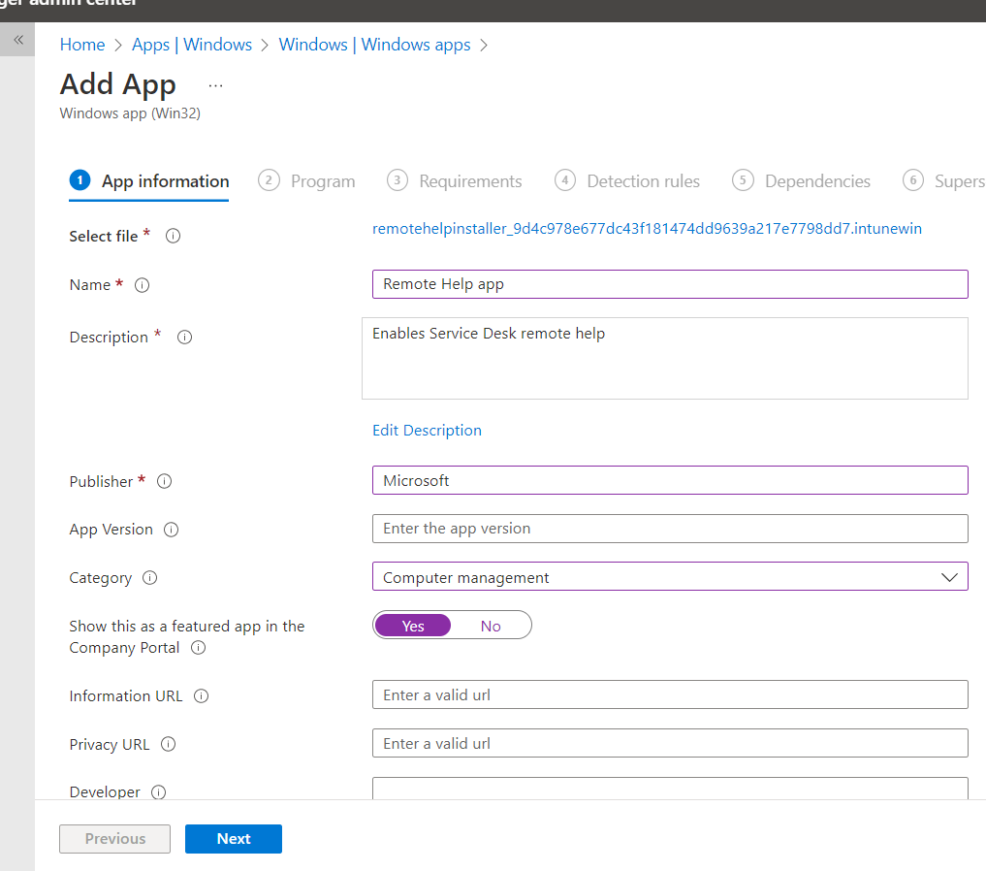

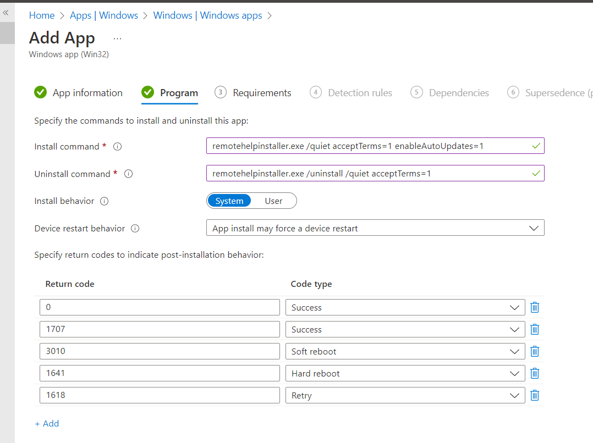

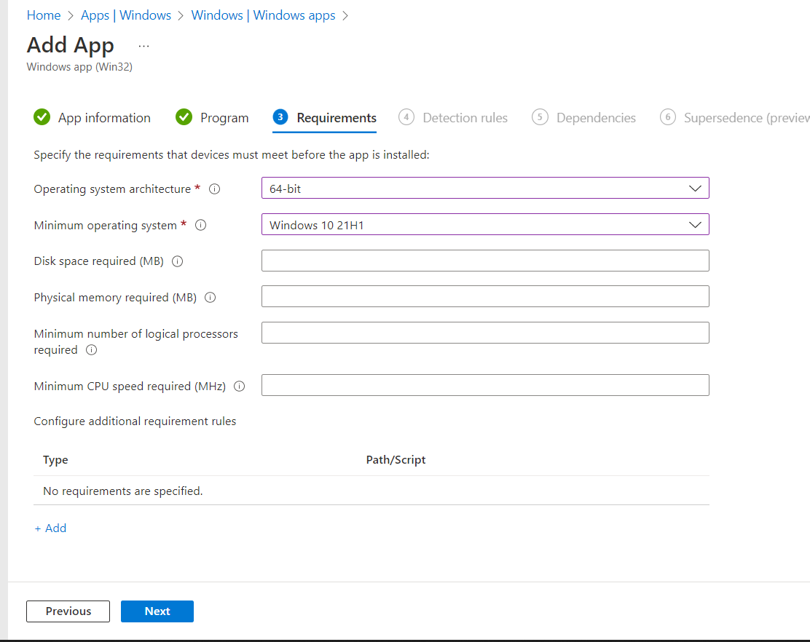

1. Configure detection rules

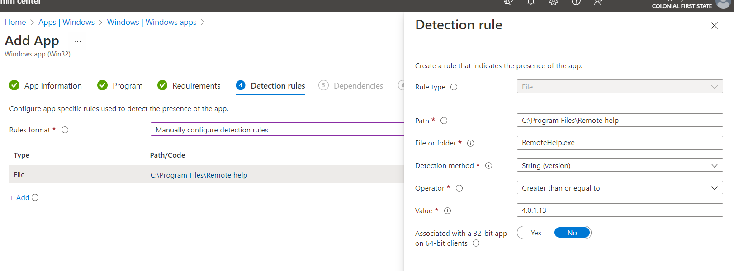

1. Deploy it to a DG group containing test device only. Once ready for production rollout, deploy to all MMD devices and AVD devices.
   1. **DG-AA-OPS-MMDDevices**

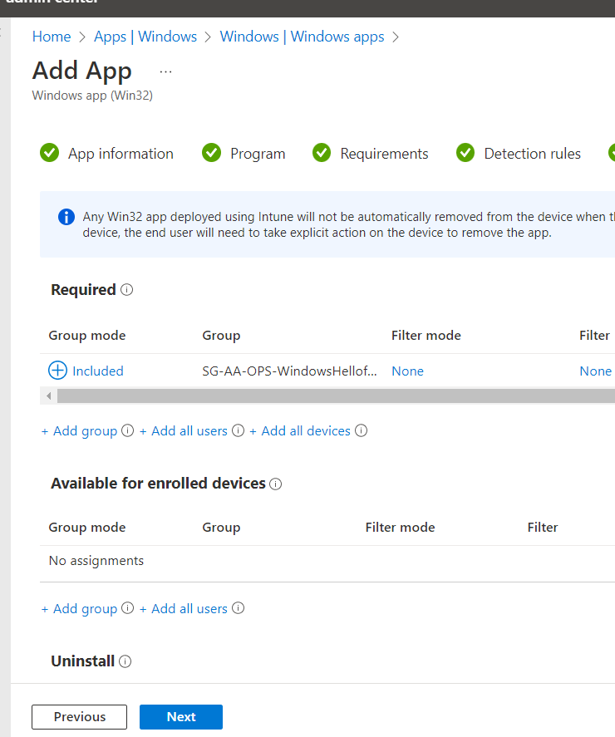

1. Create the app

##### Configuring CFS Tenant Remote Help settings

|  |  |
| --- | --- |
|  | ***Important Note***  *Remote help will not be configured in the development environment due to the current device allocation to the environment (very few devices) and licensing constraints allocation* |

Configure the following settings to enable Remote help capabilities in the tenant for CFS Production Only.

1. Click on tenant Administration
2. Click on Remote Help

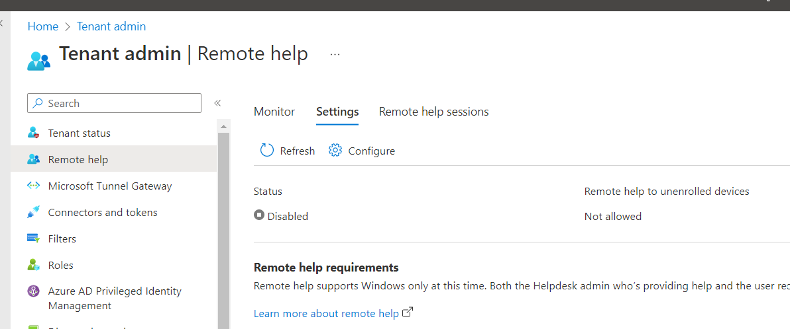

1. Click on Configure and Enable the service

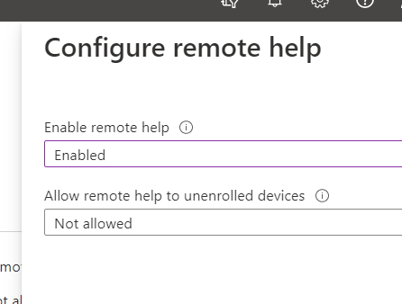

1. Settings must be like below

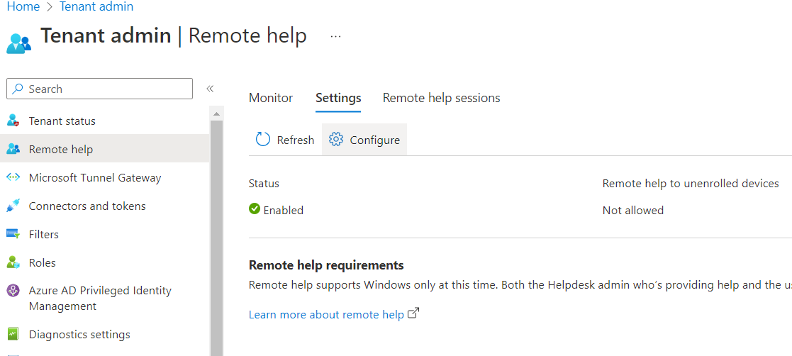

##### Configure Service Desk Remote Help Role

To leverage Role base access control (RBAC), Remote help allows role allocation. Anybody who is assigned this role will be able to provide helping codes to end users. If a user is not in this group (role) then they will not be able to provide remote help assistance. This guarantees only service desk and specific users are allowed to remotely help users in addition to Netskope protection and Defender for Endpoint.

1. Click on Tenant Administration
2. Roles then click on Create a new role

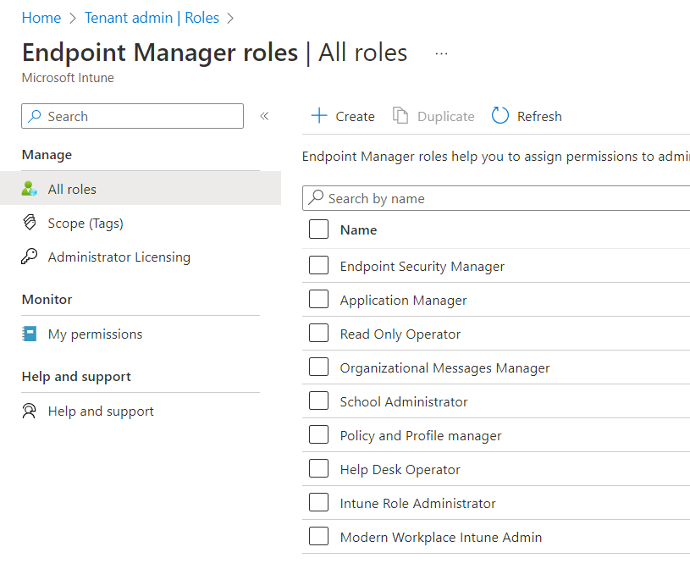

1. Provide the details of the role as follow
   1. Name: MDM - Remote Help Assist role
   2. Description: Role for people who can provide a helping code in order to take control of devices via Remote Help App
2. Under Custom Role, select the options below

* 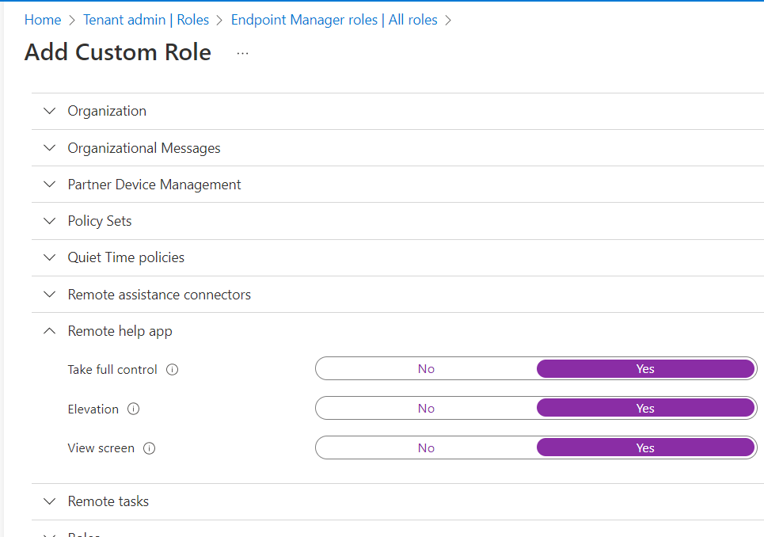

1. Click on the newly create role and under assignments,

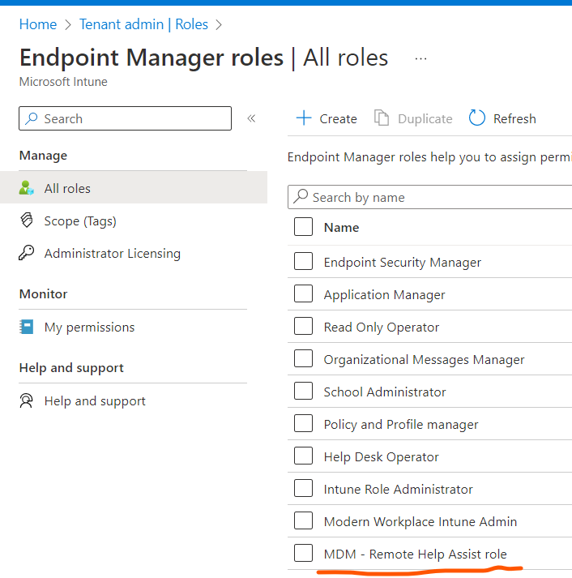

1. Under assignments, click on Assign

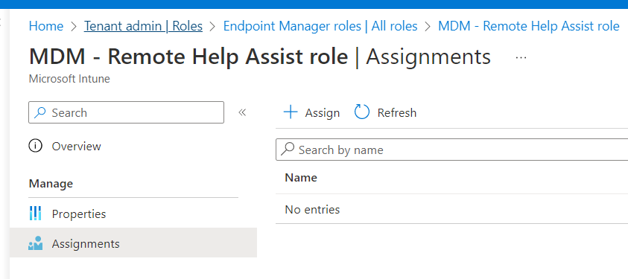

1. Provide the details of the assignment below
   1. Name: Remote Help app
   2. Description: Remote help app assignment to service desk to provide them Remote Help app permissions
2. Under Admin groups, select the Remote Assist Azure group
   1. For rollout to production, this group will be renamed to SG-AA-OPS-RemoteAssistTeam

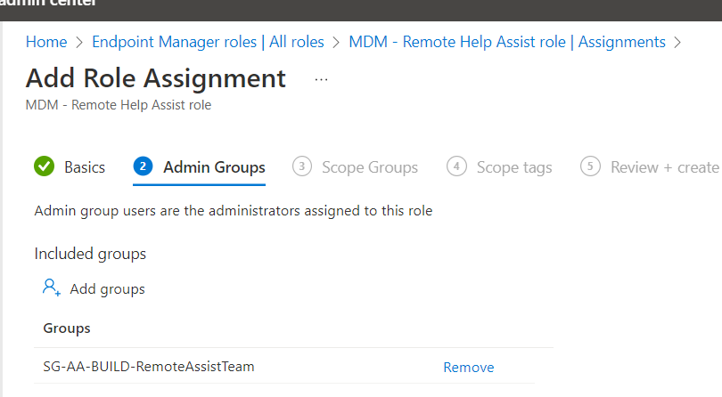

1. Scope this role to ALL DEVICES and create the role

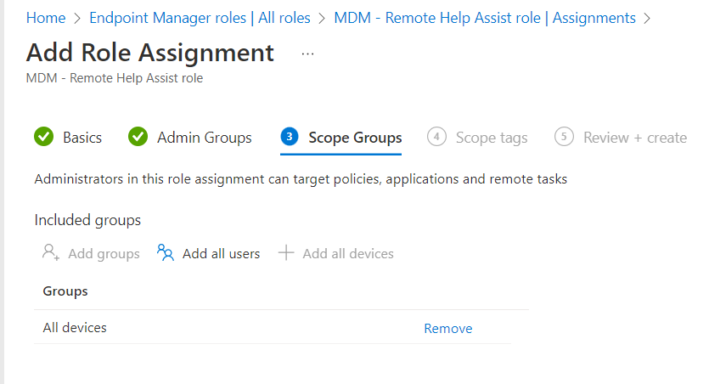

##### Allocating Licensing

To allocate licenses for Remote Help Add-on, assign the license to the Intune Policies group **SG-AA-OPS-IntunePolicies**. This group contains all users who can potentially require remote help assistance.

|  |  |
| --- | --- |
|  | ***Important Note***  *Remote help assistance to Team Room and Team Room premium accounts is not permitted* |

Allocate Remote Help Add-on Licenses to all users using the group **SG-AA-OPS-IntunePolicies**. This group contain all Office 365 users to be provided support.

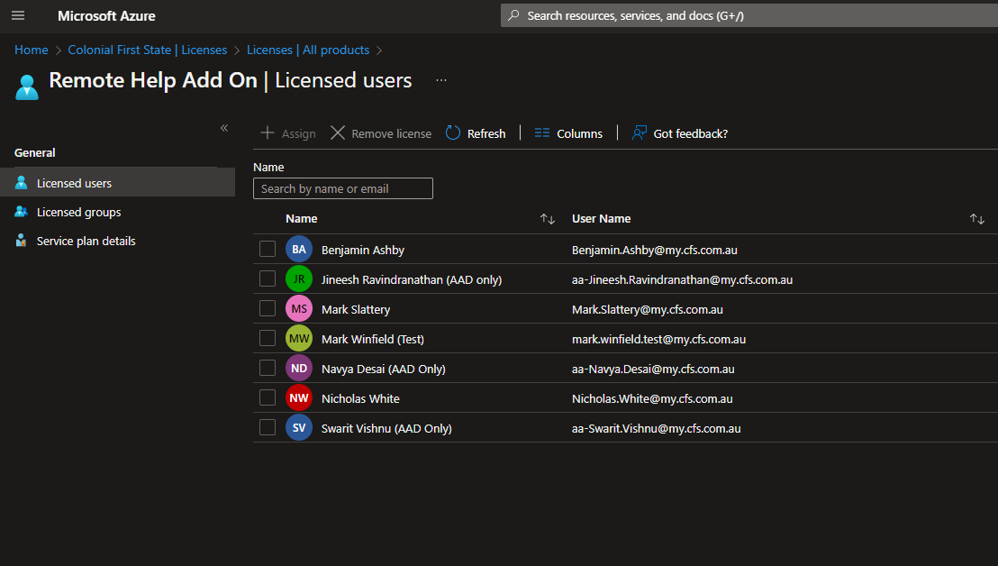

##### Network Requirements

The following are the network requirements to enable remote help connectivity between devices. Note Remote help can only connect between Microsoft Managed Desktop devices (MMD) or Azure Virtual Desktop Devices. The table below shows the connection paths possible

|  |  |  |
| --- | --- | --- |
| Device | Can remote help connect to this device | Scenario |
| MMD to MMD | Yes, Netskope will allow this connectivity.  Even if Netskope is down, the connection is still over 443 | Tech Hub supporting Melbourne or Sydney CFS users |
| AVD to MMD | Yes, Netskope will allow this connectivity.  Even if Netskope is down, the connection is still over 443 | Offshore or Onshore support providing remote help assistance to an MMD user in Melbourne or Sydney |
| AVD to AVD in the same data centre | Only connections between SDC to SDC or EDC to EDC are possible. This means machines must be in the same data centre for remote help to connect.  No connectivity is possible if Netskope is down | Offshore support supporting an AVD user.  Machines must be in the same data centre. |

Request TCS to enable the following endpoints over 443 via Netskope. There is no need to enable or open these endpoints on the firewall or Fortinet. All devices including AVD and MMD must be enabled to reach these endpoints.

Remote help communicates over port 443 (https) and connects to the Remote Assistance Service at https://remoteassistance.support.services.microsoft.com by using the Remote Desktop Protocol (RDP). The traffic is encrypted with TLS 1.2.

Both the helper and sharer must be able to reach these endpoints over port 443:

|  |  |
| --- | --- |
|  | ***Important Note***  *MMDs can still remotely connect even if Netskope agent is down. This is still secure via 443, only available to RBAC role users and protected by Defender for Endpoint.*  *AVD machines will not be able to connect to each other if Netskope is down.* |

|  |  |
| --- | --- |
| Domain/Name | Description |
| *.aria.microsoft.com | Used for accessibility features within the app |
| *.events.data.microsoft.com | Microsoft Telemetry Service |
| *.monitor.azure.com | Required for telemetry and remote service initialization |
| *.support.services.microsoft.com | Primary endpoint used for the remote help application |
| *.trouter.skype.com | Used for Azure Communication Service for chat and connection between parties |
| *.aadcdn.msauth.net | Required for logging in to the application (AAD) |
| *.aadcdn.msftauth.net | Required for logging in to the application (AAD) |
| *.edge.skype.com | Used for Azure Communication Service for chat and connection between parties |
| *.graph.microsoft.com | Used for connecting to the Microsoft Graph service |
| *.login.microsoftonline.com | Required for Microsoft login service. Might not be available in preview in all markets or for all localizations |
| *.remoteassistanceprodacs.communication.azure.com | Used for Azure Communication Service for chat and connection between parties |
| [Allow list for Microsoft Edge endpoints](https://learn.microsoft.com/en-us/deployedge/microsoft-edge-security-endpoints) | The app uses Edge WebView2 browser control. This article identifies the domain URLs that you need to add to the allow list to ensure communications through firewalls and other security mechanisms |

## Azure Virtual Desktop (AVD)

This section details the as-built configuration of Azure Virtual Desktop environment in CFS and applies to both non-production and production environment.

### Role Based Access Control

The following permissions are required to setup Azure Virtual Desktop solution in CFS environment:

|  |  |  |  |  |
| --- | --- | --- | --- | --- |
| * Role ID | * Environment | * Resources | * Role | * Comments |
| * 1 | * Azure | * Subscription | * Contributor | * This will be required to deploy Azure resources related to Azure Virtual Desktop. |
| * 2 | * NA | * User Access Administrator | * This will be required to publish/ assign app groups to user or groups. |
| * 3 | * Azure Virtual Desktop (AVD) | * Desktop Virtualization Contributor | * This will be required to manage AVD deployment and other aspects within the AVD environment. |
| * 4 | * Endpoint Manager (Intune) | * NA | * Read Only Operator | * This will be required to view AVD session host enrolments within Microsoft Intune. |
| * 5 | * Azure AD | * NA | * Service Support Administrator | * This will be required to access the service dashboard and message center to monitor the service breakdowns. |
| * User Administrator | * This will be required to access user information for testing purposes. |
| * Groups Administrator | * This will be required to create dynamic groups in Azure AD as a part of build process. |

### Personas

Azure Virtual Desktop environment can have multiple personas. As of November 2022, only two personas exist in the CFS AVD environment. The following table contains the persona names and resources associated with it:

|  |  |  |  |  |
| --- | --- | --- | --- | --- |
| * ID | * Persona | * Persona Specific resources | * Common AVD resources/ settings | * Purpose |
| 1 | Partner Operate Teams | * Host Pools * Azure VMs * Application Groups * Workspaces * Scaling Plans * Applications * Workloads * AD Groups (user-based) | * Resource Groups * Log Analytics Workspace * Virtual Network * Network Security Groups * Identity and Identity Protection * AD Groups (device-based) * VM Naming Convention * Azure Files Shares for User Profiles * User profiles using FSLogix * Group Policies * Azure Backup * Service Accounts * Device Management * Endpoint Protection * Windows Updates * Host Pool RDP Settings | Each persona leverages the resources from underlying Azure architecture of AVD as described in Persona Design Framework. However, some of the Azure resources are persona specific due to various business requirements mainly around applications and workloads.  For e.g.,  Partner Operate Teams persona has its own set of host pools and VMs, but these host pools reside in the same resource groups that contains host pools from other personas. Similarly, this persona has its own set of VMs, but these VMs share the standard naming convention used by all the personas in the AVD environment and reside in the same resource groups as other persona VMs.  Partner Operate Teams persona has different applications and tooling requirements than that of CFS Offshore Users persona. Hence, those specific apps are only deployed to Partner Operate Teams persona VMs. |
| * 2 | CFS Offshore Users |

AD Groups and AVD resources such as Host Pools, Workspaces, Application Groups and Scaling Plans that are associated with CFS Offshore Users persona will have ‘CFS’ in their naming convention except names of virtual machines as VM naming standard is same across the AVD environment regardless of persona.

### Active Directory

Active Directory is be used as an identity provider in CFS environment.

##### Identities

User identities are created in on-premises Active Directory and synchronised to Azure AD via Azure AD Connect. The sync is configured to be executed after every 30 mins. Hence, any changes made to the user objects or associated computer objects will be automatically synchronised.

##### Organizational Units

The following Organizational Units in non-prod and prod are created to host the Azure Virtual Desktop related objects in Active Directory:

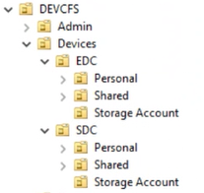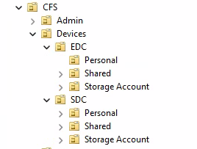

##### Service Accounts

The following is the configuration of service account created for use in Azure Virtual Desktop environment:

**Non-production**

|  |  |  |  |
| --- | --- | --- | --- |
| ID | Service Account | Source | Purpose |
| 1 | [svcavddomainjoin@dev.cfs.com.au](mailto:svcavddomainjoin@dev.cfs.com.au) | Active Directory | Used for joining AVD session host VMs to dev.cfs.com.au domain. Equipped with delegated access on the DEVCFS OU. |

**Production**

|  |  |  |  |
| --- | --- | --- | --- |
| ID | Service Account | Source | Purpose |
| 1 | svcavddomainjoin@cfs.com.au | Active Directory | Used for joining AVD session host VMs to cfs.com.au domain. Equipped with delegated access on the CFS OU. |

**Steps to assign delegated access**

The following are the steps involved in assigning the delegated access to above mentioned service account in Active Directory. These permissions will be required to enable this service account for VMs domain-joining purposes:

|  |  |
| --- | --- |
|  | ***Important Note***  *These steps apply to both non-production and production environments as the process to delegate access is identical regardless of environment.* |

|  |  |  |
| --- | --- | --- |
| ID | Steps | Screenshot |
| 1 | From **Active Directory Users and Computers**, go to **‘Devices’** OU à right click and click on **‘Delegate Control’** à follow the wizard, add the user **‘svcavddomainjoin’** à select the **‘create a custom task to delegate’** à click **‘Next’** |  |
| 2 | Select the highlighted options and click **‘Next’** |  |
| 3 | Select the **highlighted permissions** and complete the process |  |

##### Groups

###### Naming Convention

The following naming convention is followed to create the AD groups for Azure Virtual Desktop environment:

|  |  |  |
| --- | --- | --- |
| Attribute | Value | Definition |
| Group Type | DG or SG | Device Group or Security Group |
| Separator | - | |
| Source | AA or AD | Azure AD or Active Directory |
| Separator | - | |
| Business Unit or Function | OPS | Operations for on-going maintenance |
| Separator | - | |
| Function | <function> | Function or purpose (57 characters max) |
| Example 2 (user-based AD groups in Partner Operate Teams persona) | SG-AD-OPS-EDC-AVDPersonalUsers | |
| Example 3 (user-based AD groups in CFS Offshore User persona) | SG-AD-OPS-SDC-CFS-AVDSharedUsers | |

###### Active Directory Groups

**Steps:**

The following are the example steps to create a Security group in Active Directory. This is the sequence of steps that were followed to create the Security groups in Azure AD mentioned further in this section:

|  |  |
| --- | --- |
|  | ***Important Note***  *These steps apply to both non-production and production environments as the process to create a security group in AD is identical regardless of environment.* |

|  |  |  |
| --- | --- | --- |
| ID | Group Details | Screenshot |
| 1 | From the Active Directory Users and Computers, navigate to ‘**Security Groups’** OUunder DEVCFS > Groups  In production environment, the ‘Security Groups’ OU exist under CFS > Groups OU. |  |
| 2 | Right click on the **Security Groups** OU > select ‘**New’** and click on ‘**Group’** > Enter the **Group name** and click on ‘**OK’**  Once the security group is created, wait for the Azure AD Sync to take place or run it manually for faster synchronisation as required. |  |

**Active Directory Groups (Non-production and Production):**

The following groups are created in Active Directory for use in the Azure Virtual Desktop’s non-production and production environments:

|  |  |  |
| --- | --- | --- |
| ID | Group Details | Screenshot |
| 1 | **Name**: SG-AD-OPS-EDC-AVDSharedUsers  **Purpose**: This group is used for assigning users to Sydney Shared host pool in Partner Operate Teams persona.  **Members**: Partner Operate Team users that will access Sydney Shared session desktops. |  |
| 2 | **Name**: SG-AD-OPS-SDC-AVDSharedUsers  **Purpose**: This group is used for assigning users to Melbourne Shared host pool in Partner Operate Teams persona.  **Members**: Partner Operate Team users that will access Melbourne Shared session desktops. |  |
| 3 | **Name**: SG-AD-OPS-EDC-AVDPersonalUsers  **Purpose**: This group is used for assigning users to Sydney Personal host pool in Partner Operate Teams persona.  **Members**: Partner Operate Team users that will access Sydney Personal session desktops. |  |
| 4 | **Name**: SG-AD-OPS-SDC-AVDPersonalUsers  **Purpose**: This group is used for assigning users to Melbourne Personal host pool in Partner Operate Teams persona.  **Members**: Partner Operate Team users that will access Melbourne Personal session desktops. |  |
| 5 | **Name**: SG-AD-OPS-AVDAdministrators  **Purpose**: Group for administrating AVD environment  **Members**: Administrative Accounts and avdadmin@dev.cfs.com.au |  |
| 6 | **Name**: SG-AD-OPS-AVDFSLogixShareContributorGroup  **Purpose**: Group for AVD users to access their FSLogix profiles.  **Members:** All AVD users |  |
| 7 | **Name**: SG-AD-OPS-AVDFSLogixShareElevatedContributorGroup  **Purpose**: Group for AVD administrator for NTFS permissions on FSLogix shares.  **Members**: Administrative Accounts and avdadmin@dev.cfs.com.au |  |
| 8 | SG-AD-OPS-EDC-CFS-AVDPersonalUsers  **Purpose**: This group is used for assigning users to Sydney personal host pool in CFS Offshore Users persona.  **Members**: CFS Offshore users that will access Sydney personal session desktops. |  |
| 9 | SG-AD-OPS-EDC-CFS-AVDSharedUsers  **Purpose**: This group is used for assigning users to Sydney shared host pool in CFS Offshore Users persona.  **Members**: CFS Offshore users that will access Sydney shared session desktops. |  |
| 10 | SG-AD-OPS-SDC-CFS-AVDPersonalUsers  **Purpose**: This group is used for assigning users to Melbourne personal host pool in CFS Offshore Users persona.  **Members**: CFS Offshore users that will access Melbourne personal session desktops. |  |
| 11 | SG-AD-OPS-SDC-CFS-AVDSharedUsers  **Purpose**: This group is used for assigning users to Melbourne shared host pool in CFS Offshore Users persona.  **Members**: CFS Offshore users that will access Melbourne shared session desktops. |  |

##### Group Policy

Majority of device settings and restrictions are configured to be deployed via Microsoft Intune. However, there are some settings that cannot be delivered by Microsoft Intune due to product limitations as of April 2022, therefore such settings are deployed via AD Group Policy Objects.

To configure group policies for FSLogix, download the administrative template and import it into the domain.

* Refer the instructions [here](https://docs.microsoft.com/en-us/fslogix/use-group-policy-templates-ht#prerequisites) to download and extract the template files.
* Refer the instructions [here](https://docs.microsoft.com/en-us/fslogix/use-group-policy-templates-ht#central-store) to import the template files into the domain.
* Refer the instructions [here](https://docs.microsoft.com/en-us/fslogix/use-group-policy-templates-ht#template-edit) to use and edit the template files

GPO inheritance is blocked on OUs containing domain joined storage accounts. This will prevent the storage accounts from adopting any password expiration or any other policies applied in the domain, as this will impact the overall functionality of the FSLogix user profile containers.

The following screenshot shows the Block Inheritance configuration in production, same configuration exists in non-production environment:

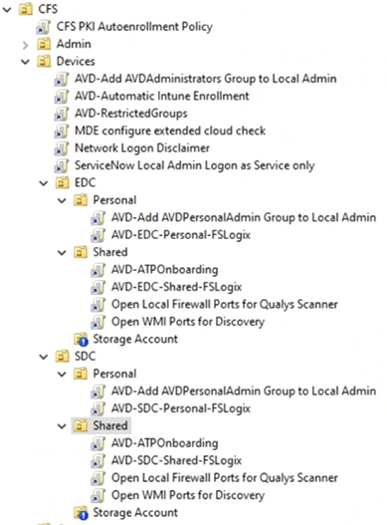

**Non-production**

The following group policy objects (GPO) are created in on-premises Active Directory non-production environment. These GPOs are assigned to Organizational OUs containing the AVD session host VM computer objects:

|  |  |  |  |
| --- | --- | --- | --- |
| ID | GPO Name | Linked OU | Purpose |
| 1 | AVD-Automatic Intune Enrollment | DEVCFS > Devices | Enable automatic Intune enrolment of AVD Shared session host VMs. Note that Personal AVD VMs enrol in Intune via Automatic Enrolment MDM scope configured in Azure AD. |
| 2 | AVD-Add AVDAdministrators Group to Local Admin | DEVCFS > Devices | Add ‘SG-AD-OPS-AVDAdministrators’ to local ‘Administrators’ group of shared AVD Session Host VMs. |
| 3 | AVD-ATP-Onboarding | DEVCFS > Devices > EDC > Shared  DEVCFS > Devices > SDC > Shared | ATP onboarding of AVD Shared Session Host VMs. |
| 4 | AVD-Restricted Groups | DEVCFS > Devices | 1. Add the ‘SG-AD-OPS-AVDAdministrators’ group to local group ‘FSLogix Profile Exclude List’ 2. Add ‘Everyone’ to local group ‘FSLogix Profile Include List’ |
| 5 | AVD-EDC-Shared-FSLogix | DEVCFS > Devices > EDC > Shared | Deployment of FSLogix profile container registry keys for Sydney pooled session host VMs. |
| 6 | AVD-SDC-Shared-FSLogix | DEVCFS > Devices > SDC > Shared | Deployment of FSLogix profile container registry keys for Melbourne pooled session host VMs. |
| 7 | AVD-EDC-Personal-FSLogix | DEVCFS > Devices > EDC > Personal | Deployment of FSLogix profile container registry keys for Sydney personal session host VMs. |
| 8 | AVD-SDC- Personal-FSLogix | DEVCFS > Devices > SDC > Personal | Deployment of FSLogix profile container registry keys for Melbourne personal session host VMs. |
| 9 | AVD-Add AVDPersonalAdmin Group to Local Admin | DEVCFS > Devices > EDC > Personal  DEVCFS > Devices > SDC > Personal | Add ‘SG-AD-OPS-AVDPersonalLocalAdmins’ AD group to local ‘Administrators’ group of personal AVD Session Host VMs. |

**Production**

The following group policy objects (GPO) are created in on-premises Active Directory production environment. These GPOs are assigned to Organizational OUs containing the AVD session host VM computer objects:

|  |  |  |  |
| --- | --- | --- | --- |
| ID | GPO Name | Linked OU | Purpose |
| 1 | AVD-Automatic Intune Enrollment | CFS > Devices | Enable automatic Intune enrolment of AVD Session Host VMs. |
| 2 | AVD-Add AVDAdministrators Group to Local Admin | CFS > Devices | Add ‘SG-AD-OPS-AVDAdministrators’ to local ‘Administrators’ group of shared AVD Session Host VMs. |
| 3 | AVD-ATP-Onboarding | CFS > Devices > EDC > Shared  CFS > Devices > SDC > Shared | ATP onboarding of AVD Shared Session Host VMs. |
| 4 | AVD-RestrictedGroups | CFS > Devices | 1. Add the ‘SG-AD-OPS-AVDAdministrators’ group to local group ‘FSLogix Profile Exclude List’ 2. Add ‘Everyone’ to local group ‘FSLogix Profile Include List’ |
| 5 | AVD-EDC-Shared-FSLogix | CFS > Devices > EDC > Shared | Deployment of FSLogix profile container registry keys for Sydney pooled session host VMs. |
| 6 | AVD-SDC-Shared-FSLogix | CFS > Devices > SDC > Shared | Deployment of FSLogix profile container registry keys for Melbourne pooled session host VMs. |
| 7 | AVD-EDC-Personal-FSLogix | CFS > Devices > EDC > Personal | Deployment of FSLogix profile container registry keys for Sydney personal session host VMs. |
| 8 | AVD-SDC- Personal-FSLogix | CFS > Devices > SDC > Personal | Deployment of FSLogix profile container registry keys for Melbourne pooled session host VMs. |
| 9 | AVD-Add AVDPersonalAdmin Group to Local Admin | CFS > Devices > EDC > Personal  CFS > Devices > SDC > Personal | Add ‘SG-AD-OPS-AVDPersonalLocalAdmins’ AD group to local ‘Administrators’ group of personal AVD Session Host VMs. |

###### Configuration

This section contains the configuration of above policies.

|  |  |
| --- | --- |
|  | ***Important Note***  *The configuration shown below is taken from either production or non-production environments, the process of configuring these GPOs is similar in each environment (make sure to change the storage account names and shares while creating these GPOs)* |

|  |  |  |
| --- | --- | --- |
| ID | GPO | Screenshot |
| 1 | **AVD-Automatic Intune Enrollment** |  |
| 2 | **AVD-Add AVDAdministrators Group to Local Admin** |  |
| 3 | **AVD-ATP-Onboarding** |  |
| 4 | **AVD-Restricted Groups** |  |
| 5 | **AVD-EDC-Shared-FSLogix** |  |
| 6 | **AVD-EDC-Personal-FSLogix** |  |
| 7 | **AVD-SDC-Shared-FSLogix** |  |
| 8 | **AVD-SDC-Personal-FSLogix** |  |
| 9 | **AVD-Add AVDPersonalAdmin Group to Local Admin** |  |

##### DNS

###### Active Directory DNS

Virtual networks of AVD session host VMs are configured to use Azure Firewall as their DNS. Azure Firewall forwards the DNS queries to on-premises Active Directory DNS or to internet as required.

The following is the DNS configuration of VNETs in AVD environment:

**Non-production**

|  |  |  |  |
| --- | --- | --- | --- |
| ID | Virtual Network | DNS IP Address | Location |
| 1 | vnet-np-edc-oper-001 | 10.40.1.68 | Australia East |
| 2 | vnet-np-sdc-oper-001 | 10.60.1.68 | Australia Southeast |

**Production**

|  |  |  |  |
| --- | --- | --- | --- |
| ID | Virtual Network | DNS IP Address | Location |
| 1 | vnet-prd-edc-operations-001 | 10.20.0.68 | Australia East |
| 2 | vnet-prd-sdc-operations-001 | 10.30.0.68 | Australia Southeast |

###### Azure Private DNS zone

Azure Files storage accounts are configured with Active Directory authentication and has private endpoints integrated with Azure Private DNS zone to allow VMs to connect to the storage accounts privately through the private endpoint names. The following namespace in Azure is used by default for this purpose:

**privatelink.file.core.windows.net**

On-premises DNS servers are configured to resolve the private endpoints to above namespace. Forward lookup zone with above namespace has been created hosting DNS ‘A’ records of storage accounts.

The following screenshot shows the on-premises DNS configuration:

**Non-production**

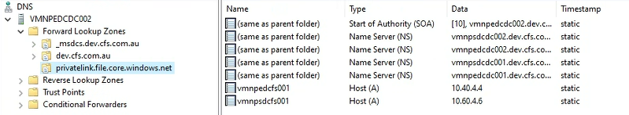

**Production**

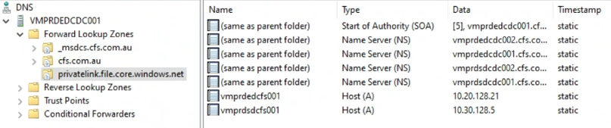

The configuration and steps involved in setting storage account’s private end are described in the Storage section.

### Azure Active Directory

##### Groups

###### Naming Convention

The following naming convention is followed to create the Azure AD groups for Azure Virtual Desktop environment:

|  |  |  |
| --- | --- | --- |
| Attribute | Value | Definition |
| Group Type | DG or SG | Device Group or Security Group |
| Separator | - | |
| Source | AA | Azure AD or Active Directory |
| Separator | - | |
| Business Unit or Function | OPS | Operations for on-going maintenance |
| Separator | - | |
| Function | AVD<function> | Function or purpose (57 characters max) |
| Example | DG-AA-OPS-AVDSharedSessionHosts | |

###### Azure AD Groups

**Steps:**

The following are the example steps to create a Dynamic Device group in Azure AD and applies to both non-production and production environments. This is the sequence of steps that were followed to create the Dynamic Device groups in Azure AD mentioned further in this section:

|  |  |  |
| --- | --- | --- |
| ID | Group Details | Screenshot |
| 1 | From the Azure portal, navigate to **Azure Active Directory** à **Groups** à **All Groups** and click on **‘New Group’** |  |
| 2 | Select **‘Security’** as a **Group type** from the drop-down menu à Enter the **Group name** following the naming standard à Enter the **Group description** à Select ‘**Dynamic Device’** as a **Membership type** from drop-down menu à find and select the **Group owner(s)** à finally click on ‘**Add dynamic query’** |  |
| 3 | Click **‘Edit’** and enter the rule syntax or use the Rule builder to create the dynamic query à click **‘OK’** once editing is done |  |
| 4 | Click n **‘Save’**  Note: The newly created group may take sometime to process and update the group memberships based on the dynamic query. |  |

**Azure AD Groups (Non-Production):**

The following groups are created in Azure AD for use in the Azure Virtual Desktop’s non-production environment:

|  |  |  |
| --- | --- | --- |
| ID | Group Details | Screenshot |
| 1 | **Name**: DG-AA-OPS-AVDSharedSessionHosts  **Purpose**: This group is used for assignments of policies or settings to AVD Shared Desktop Session Host VMs in system context. |  |
| 2 | **Name**: DG-AA-OPS-AVDPersonalSessionHosts  **Purpose**: This group is used for assignments of policies or settings to AVD Personal Desktop Session Host VMs in system context. |  |
| 3 | **Name:** DG-AA-OPS-AVDSharedBlueSessionHosts  **Purpose**: This group is used for assignment of Windows Updates policy to shared session host VMs in Blue lane. |  |
| 4 | **Name:** DG-AA-OPS-AVDSharedGreenSessionHosts  **Purpose**: This group is used for assignment of Windows Updates policy to shared session host VMs in Green lane. |  |
| 5 | **Name:** DG-AA-OPS-AVDPersonalBlueSessionHosts  **Purpose**: This group is used for assignment of Windows Updates policy to personal session host VMs in Blue lane. |  |
| 6 | **Name:** DG-AA-OPS-AVDPersonalGreenSessionHosts  **Purpose**: This group is used for assignment of Windows Updates policy to personal session host VMs in Green lane. |  |

**Azure AD Groups (Production):**

The following groups are created in Azure AD for use in the Azure Virtual Desktop’s production environment:

|  |  |  |
| --- | --- | --- |
| ID | Group Details | Screenshot |
| 1 | **Name**: DG-AA-OPS-AVDSharedSessionHosts  **Purpose**: This group is used for assignments of policies or settings to AVD Shared Desktop Session Host VMs in system context. |  |
| 2 | **Name**: DG-AA-OPS-AVDPersonalSessionHosts  **Purpose**: This group is used for assignments of policies or settings to AVD Personal Desktop Session Host VMs in system context. |  |
| 3 | **Name:** DG-AA-OPS-AVDSharedBlueSessionHosts  **Purpose**: This group is used for assignment of Windows Updates policy to ‘shared’ session host VMs in Blue lane. |  |
| 4 | **Name:** DG-AA-OPS-AVDSharedGreenSessionHosts  **Purpose**: This group is used for assignment of Windows Updates policy to ‘shared’ session host VMs in Green lane. |  |
| 5 | **Name:** DG-AA-OPS-AVDPersonalBlueSessionHosts  **Purpose**: This group is used for assignment of Windows Updates policy to ‘personal’ session host VMs in Blue lane. |  |
| 6 | **Name:** DG-AA-OPS-AVDPersonalGreenSessionHosts  **Purpose**: This group is used for assignment of Windows Updates policy to ‘personal’ session host VMs in Green lane. |  |

##### Hybrid Azure AD Join

All the AVD session host VMs are configured to join on-premises domain. Hybrid AD Join configuration is enabled in Active Directory domain in both the environment production and non-production.

Refer the Identity and Access Management documentation for more information on the configuration of Hybrid AD Join.

##### Multi-factor authentication

Users accessing Azure Virtual Desktop will be required to perform successful multi-factor authentication.

Refer section 7.2 for more information on the MFA configuration.

##### Conditional Access

Access to Azure Virtual Desktop environment is protected by Conditional Access.

The following are the two CA policies configured in both non-production and production environments to gate the AVD accessibility:

|  |  |  |
| --- | --- | --- |
| ID | CA Policy | Assignments |
| 1 | CA014: Block AVD Access to non-AVD users | **Excluded Groups**  SG-AD-OPS-EDC-AVDPersonalUsers  SG-AD-OPS-EDC-AVDSharedUsers  SG-AD-OPS-SDC-AVDPersonalUsers  SG-AD-OPS-SDC-AVDSharedUsers  SG-AD-OPS-EDC-CFS-AVDPersonalUsers  SG-AD-OPS-EDC-CFS-AVDSharedUsers  SG-AD-OPS-SDC-CFS-AVDPersonalUsers  SG-AD-OPS-SDC-CFS-AVDSharedUsers |
| 2 | CA015: Allow AVD Access to AVD users only | **Included Groups**  SG-AD-OPS-EDC-AVDPersonalUsers  SG-AD-OPS-EDC-AVDSharedUsers  SG-AD-OPS-SDC-AVDPersonalUsers  SG-AD-OPS-SDC-AVDSharedUsers  SG-AD-OPS-EDC-CFS-AVDPersonalUsers  SG-AD-OPS-EDC-CFS-AVDSharedUsers  SG-AD-OPS-SDC-CFS-AVDPersonalUsers  SG-AD-OPS-SDC-CFS-AVDSharedUsers |

The following table contains the configuration of these CA policies in production environment. Configuration of these policies in non-production is same and not captured in the following table:

|  |  |
| --- | --- |
| CA Policy | Screenshot |
| **CA014: Block AVD Access to non-AVD users** |  |
| **CA015: Allow AVD Access to AVD users only** |  |

### Azure Infrastructure

Azure Virtual Desktop entirely depends on the resources in CFS Azure environment. Each AVD environment have its own Azure infrastructure such as production and non-production.

The following Azure infrastructure/ resources required by Azure Virtual Desktop are deployed using Azure DevOps:

1. Resource Groups
2. Virtual Networks
3. Subnets
4. NSGs
5. Route Tables
6. Storage Accounts

#### Subscriptions

Azure Virtual Desktop resources are provisioned in the following subscriptions:

|  |  |  |  |
| --- | --- | --- | --- |
| ID | Environment | Subscription Name | Region |
| 1 | Non-production | subsc-np-operations-001 | Australia East and Australia Southeast |
| 2 | Production | subsc-prd-operations-001 | Australia East and Australia Southeast |

#### Resource Groups

##### Deployment

Resource Groups for Azure Virtual Desktop environment are configured to be deployed using Infrastructure-as-Code (IaC) tools such as Azure DevOps. Refer the CDS as-built document for more information on the configuration to deploy Azure resources.

##### Resource Group Mapping

Azure Virtual Desktop resources in Azure are created in the Resource Groups. Resource Group mapping of each AVD related resource is mentioned in the following table.

Some specific AVD resource types share the same Resource Groups with AVD Session Host VMs. These resources are as follows:

1. AVD Host Pool
2. AVD Application Group
3. AVD Workspace

These specific resources must be maintained in the same Resource Groups on the on-going basis as there are no separate or dedicated resource groups were designed for these resources to minimise the number of resource groups to maintain.

|  |  |
| --- | --- |
|  | ***Important Note***  *The resource group mapping applies to both non-production and production environments.* |

|  |  |  |  |
| --- | --- | --- | --- |
| ID | Resource Group Name | Mapped Resources | Mapping Purpose |
| 1 | rg-xx-xxx-oper-comp-001 | * AVD Shared Host pools * AVD Shared Application Groups * AVD Shared Workspaces * AVD Shared Session Host VMs – Blue * Availability Set | Resource group for shared session host VMs in Blue lane.  Along with above session VMs, this resource group also host the specific components of AVD such as host pool, application group and workspace. |
| 2 | rg-xx-xxx-oper-comp-003 | * AVD Shared Session Host VMs – Green * Availability Set | Resource group for shared session VMs in Green lane.  This resource group will not host any other resource except Azure virtual machines, VM related resources such as network card or disk and lastly, an availability set. |
| 3 | rg-xx-xxx-oper-comp-002 | * AVD Personal Host pools * AVD Personal Application Groups * AVD Personal Workspaces * AVD Personal Session Host VMs – Blue * Availability Set | Resource group for personal session host VMs in Blue lane.  Along with above session VMs, this resource group also host the specific components of AVD such as host pool, application group and workspace. |
| 4 | rg-xx-xxx-oper-comp-004 | * AVD Personal Session Host VMs – Green * Availability Set | Resource group for personal session VMs in Green lane.  This resource group will not host any other resource except Azure virtual machines, VM related resources such as network card or disk and lastly, an availability set. |
| 5 | rg-xx-xxx-oper-stor-001 | * Azure Files Storage Account | Resource group for Azure Files storage accounts containing the file shares for FSLogix user profile containers. |
| 6 | rg-xx-xxx-oper-sec-001 | * AVD Scaling Plans | Resource group for AVD scaling plans.  Initially, this resource group was created to host the log analytics workspace for AVD Insights as well but later it was decided to ship the monitoring logs to a centralised log analytics workspace in ‘subsc-np-security-001’ Azure subscription. Hence, this resource group will only contain the AVD scaling plans. |
| 7 | rg-xx-xxx-oper-netw-001 | * Virtual Networks * Network Security Groups * Route Tables * Private DNS Zone (Global) * Private Endpoint for Azure Files Storage Account | Resource group for networking components of AVD. |
| 8 | rg-xx-xxx-oper-rsv-001 | * Recovery Services Vault | Resource group for Recovery Services Vault for backup purposes of file shares in Azure File Storage Account. |

#### Availability Sets

The following table contains the Availability Sets configuration for VMs:

**Non-production**

|  |  |  |  |
| --- | --- | --- | --- |
| Availability Set | VMs to be Associated | Resource Groups | Location |
| avail-np-edc-avd-001 | VMNPEDCVDSBXX | rg-np-edc-oper-comp-001 | Australia East |
| avail-np-edc-avd-002 | VMNPEDCVDPBXX | rg-np-edc-oper-comp-002 |
| avail-np-edc-avd-003 | VMNPEDCVDSGXX | rg-np-edc-oper-comp-003 |
| avail-np-edc-avd-004 | VMNPEDCVDPGXX | rg-np-edc-oper-comp-004 |
| avail-np-sdc-avd-001 | VMNPSDCVDSBXX | rg-np-sdc-oper-comp-001 | Australia Southeast |
| avail-np-sdc-avd-002 | VMNPSDCVDPBXX | rg-np-sdc-oper-comp-002 |
| avail-np-sdc-avd-003 | VMNPSDCVDSGXX | rg-np-sdc-oper-comp-003 |
| avail-np-sdc-avd-004 | VMNPSDCVDPGXX | rg-np-sdc-oper-comp-004 |

**Production**

|  |  |  |  |
| --- | --- | --- | --- |
| Availability Set | VMs to be Associated | Resource Groups | Location |
| avail-prd-edc-avd-001 | VMPREDCVDSBXX | rg-prd-edc-oper-comp-001 | Australia East |
| avail-prd-edc-avd-002 | VMPREDCVDPBXX | rg-prd-edc-oper-comp-002 |
| avail-prd-edc-avd-003 | VMPREDCVDSGXX | rg-prd-edc-oper-comp-003 |
| avail-prd-edc-avd-004 | VMPREDCVDPGXX | rg-prd-edc-oper-comp-004 |
| avail-prd-sdc-avd-001 | VMPRSDCVDSBXX | rg-prd-sdc-oper-comp-001 | Australia Southeast |
| avail-prd-sdc-avd-002 | VMPRSDCVDPBXX | rg-prd-sdc-oper-comp-002 |
| avail-prd-sdc-avd-003 | VMPRSDCVDSGXX | rg-prd-sdc-oper-comp-003 |
| avail-prd-sdc-avd-004 | VMPRSDCVDPGXX | rg-prd-sdc-oper-comp-004 |

##### Deployment

|  |  |
| --- | --- |
|  | ***Important Note***  *The deployment steps mentioned this section are taken from non-production environment. However, the steps to deploy the Availability Sets in production are same.* |

###### Australia East

avail-np-edc-avd-001

| **Availability Set Name – avail-np-edc-avd-001**  **Purpose – Availability Set for Shared Desktop Blue VMs** | |
| --- | --- |
| Navigate to Azure portal 🡪 enter **‘Availability Sets’** in the search bar at the top blue ribbon of the portal 🡪 Click on Availability Sets and click ‘**Create’**  Basic configuration |  |
| Advanced |  |
| Tags |  |
| Validate |  |

avail-np-edc-avd-002

| **Availability Set Name – avail-np-edc-avd-002**  **Purpose – Availability Set for Personal Desktop Blue VMs** | |
| --- | --- |
| Navigate to Azure portal 🡪 enter **‘Availability Sets’** in the search bar at the top blue ribbon of the portal 🡪 Click on Availability Sets and click ‘**Create’**  Basic configuration |  |
| Advanced |  |
| Tags |  |
| Validate |  |

avail-np-edc-avd-003

| **Availability Set Name – avail-np-edc-avd-003**  **Purpose – Availability Set for Shared Desktop Green VMs** | |
| --- | --- |
| Navigate to Azure portal 🡪 enter **‘Availability Sets’** in the search bar at the top blue ribbon of the portal 🡪 Click on Availability Sets and click ‘**Create’**  Basic configuration |  |
| Advanced |  |
| Tags |  |
| Validate |  |

avail-np-edc-avd-004

| **Availability Set Name – avail-np-edc-avd-004**  **Purpose – Availability Set for Personal Desktop Green VMs** | |
| --- | --- |
| Navigate to Azure portal 🡪 enter **‘Availability Sets’** in the search bar at the top blue ribbon of the portal 🡪 Click on Availability Sets and click ‘**Create’**  Basic configuration |  |
| Advanced |  |
| Tags |  |
| Validate |  |

###### Australia Southeast

avail-np-sdc-avd-001

| **Availability Set Name – avail-np-sdc-avd-001**  **Purpose – Availability Set for Shared Desktop Blue VMs** | |
| --- | --- |
| Navigate to Azure portal 🡪 enter **‘Availability Sets’** in the search bar at the top blue ribbon of the portal 🡪 Click on Availability Sets and click ‘**Create’**  Basic configuration |  |
| Advanced |  |
| Tags |  |
| Validate |  |

avail-np-sdc-avd-002

| **Availability Set Name – avail-np-sdc-avd-002**  **Purpose – Availability Set for Personal Desktop Blue VMs** | |
| --- | --- |
| Navigate to Azure portal 🡪 enter **‘Availability Sets’** in the search bar at the top blue ribbon of the portal 🡪 Click on Availability Sets and click ‘**Create’**  Basic configuration |  |
| Advanced |  |
| Tags |  |
| Validate |  |

avail-np-sdc-avd-003

| **Availability Set Name – avail-np-sdc-avd-003**  **Purpose – Availability Set for Shared Desktop Green VMs** | |
| --- | --- |
| Navigate to Azure portal 🡪 enter **‘Availability Sets’** in the search bar at the top blue ribbon of the portal 🡪 Click on Availability Sets and click ‘**Create’**  Basic configuration |  |
| Advanced |  |
| Tags |  |
| Validate |  |

avail-np-sdc-avd-004

| **Availability Set Name – avail-np-sdc-avd-004**  **Purpose – Availability Set for Personal Desktop Green VMs** | |
| --- | --- |
| Navigate to Azure portal 🡪 enter **‘Availability Sets’** in the search bar at the top blue ribbon of the portal 🡪 Click on Availability Sets and click ‘**Create’**  Basic configuration |  |
| Advanced |  |
| Tags |  |
| Validate |  |

#### Network

##### Deployment

Network resources described in this section are configured to be deployed using Infrastructure-as-Code (IaC) tools such as Azure DevOps. Some of the configuration such as inbound and outbound access rules are added manually by separate team. Refer the CDS as-built document for more information on the configuration to deploy Azure resources.

##### Virtual Networks

The following virtual networks are configured in the AVD environment:

**Non-production**

|  |  |  |  |
| --- | --- | --- | --- |
| ID | Virtual Network Name | Address Space | Resource Group |
| 1 | vnet-np-edc-oper-001 | 10.40.4.0/24 | rg-np-edc-oper-netw-001 |
| 2 | vnet-np-sdc-oper-001 | 10.60.4.0/24 | rg-np-sdc-oper-netw-001 |

**Production**

|  |  |  |  |
| --- | --- | --- | --- |
| ID | Virtual Network Name | Address Space | Resource Group |
| 1 | vnet-prd-edc-operations-001 | 10.20.128.0/17 | rg-prd-edc-oper-netw-001 |
| 2 | vnet-prd-sdc-operations-001 | 10.30.128.0/17 | rg-prd-sdc-oper-netw-001 |

##### Subnets

The following subnets are configured in the AVD environment:

**Non-production**

|  |  |  |  |
| --- | --- | --- | --- |
| ID | Subnet | Address Space | Virtual Network |
| 1 | sub-np-edc-operations-001 | 10.40.4.0/25 | vnet-np-edc-oper-001 |
| 2 | sub-np-sdc-operations-001 | 10.60.4.0/25 | vnet-np-sdc-oper-001 |

**Production**

|  |  |  |  |
| --- | --- | --- | --- |
| ID | Subnet | Address Space | Virtual Network |
| 1 | sub-prd-edc-operations-001 | 10.20.128.0/23 | vnet-prd-edc-operations-001 |
| 2 | sub-prd-sdc-operations-001 | 10.30.128.0/23 | vnet-prd-sdc-operations-001 |

Note that the following subnets are not used by AVD, but they are part of operations subscription:

**Non-production**

* sub-np-edc-operations-002
* sub-np-sdc-operations-002

**Production**

* sub-prd-edc-operations-002
* sub-prd-sdc-operations-002

##### Network Security Groups

Network Security Groups (NSG) must be associated with subnet only. NSGs must not be associated to VM network adapter.

The following NSGs are configured in the AVD environment:

**Non-production**

|  |  |  |
| --- | --- | --- |
| ID | NSG | Subnet |
| 1 | nsg-np-edc-operations-001 | sub-np-edc-operations-001 |
| 2 | nsg-np-sdc-operations-001 | sub-np-sdc-operations-001 |

**Production**

|  |  |  |
| --- | --- | --- |
| ID | NSG | Subnet |
| 1 | nsg-prd-edc-operations-001 | sub-prd-edc-operations-001 |
| 2 | nsg-prd-sdc-operations-001 | sub-prd-sdc-operations-001 |

Note that the following NSGs are not used by AVD, but they are part of operations subscription:

**Non-production**

* nsg-np-edc-operations-002
* nsg-np-sdc-operations-002

**Production**

* nsg-prd-edc-operations-002
* nsg-prd-sdc-operations-002

###### Security Rules

Inbound access is designed to be managed at the NSG level. Hence all the AVD inbound access rules are configured on the NSGs. AVD communication with Active Directory domain controllers is managed at the NSGs level within the identity subscription.

The following is the configuration of inbound security rules on NSGs associated with AVD subnets:

**Non-production**

|  |  |
| --- | --- |
| NSG | nsg-np-edc-operations-001 |
|  | |

|  |  |
| --- | --- |
| NSG | nsg-np-sdc-operations-001 |
|  | |

**Production**

|  |  |
| --- | --- |
| NSG | nsg-prd-edc-operations-001 |
|  | |

|  |  |
| --- | --- |
| NSG | nsg-prd-sdc-operations-001 |
|  | |

|  |  |
| --- | --- |
|  | ***Important Note***  *Applications or 3rd party related network access is out of scope of this build. Hence, the screenshots added here in this section may not reflect the current state of security rules.* |

##### Firewall

Outbound access is designed to be managed in the Azure Firewall. Hence all the AVD outbound access rules are configured on the Azure Firewall.

|  |  |
| --- | --- |
|  | ***Important Note***   1. *Azure Virtual Desktop does not have a list of IP Address ranges that can be blocked to allow traffic. Only specific URLs are supported as of April 2022.* 2. *Applications or 3rd party related network access is out of scope of this build. Hence, the screenshots added here in this section may not reflect the current state of security rules.* |

The required URL [list](https://docs.microsoft.com/en-us/azure/virtual-desktop/safe-url-list) and outbound access described in this [document](https://docs.microsoft.com/en-us/azure/firewall/protect-azure-virtual-desktop#host-pool-outbound-access-to-the-internet) are configured in the Azure Firewall rules and Azure Virtual Desktop resources have outbound access allowed.

Network connectivity to Office 365 has also been allowed in accordance to the guidelines described in this [document](https://docs.microsoft.com/en-us/microsoft-365/enterprise/microsoft-365-ip-web-service?view=o365-worldwide).

The following screenshot is taken from an AVD session host VM with a list of URLs that VM is able to access from AVD vnets:

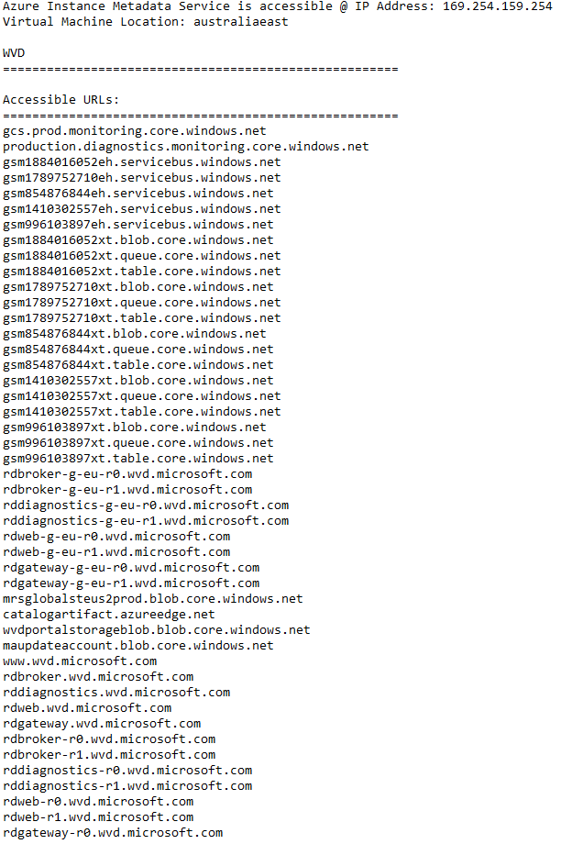

###### FQDNs

The following FQDNs are allowed for outbound access in Azure Firewall:

|  |  |  |  |
| --- | --- | --- | --- |
| ID | Source | Port | Destination FQDN |
| 1 | **Non-production:**  sub-np-edc-operations-001  sub-np-sdc-operations-001  **Production:**  sub-prd-edc-operations-001  sub-prd-sdc-operations-001 | 443 | * *.notify.live.net * *.do.dsp.mp.microsoft.com * *.dl.delivery.mp.microsoft.com * *.notify.windows.com * query.prod.cms.rt.microsoft.com * *.servicebus.windows.net * *.azure-dns.com,*.azure-dns.net * privacy.microsoft.com * *.store.core.windows.net * www.msftconnecttest.com * *.events.data.microsoft.com * *.sfx.ms * *.digicert.com |
| 2 | 80 | * www.msftconnecttest.com |
| 2 | 5671 | * global.azure-devices-provisioning.net * azure-devices.net |

###### FQDN Tags

The following FQDN Tags are allowed for outbound access in Azure Firewall:

|  |  |  |  |
| --- | --- | --- | --- |
| ID | Source | Port | Destination FQDN Tags |
| 1 | **Non-production:**  sub-np-edc-operations-001  sub-np-sdc-operations-001  **Production:**  sub-prd-edc-operations-001  sub-prd-sdc-operations-001 | 443 | * WindowsVirtualDesktop * WindowsDiagnostics * MicrosoftActiveProtectionService * WindowsUpdate |

###### Service Tags

The following Service Tags are allowed for outbound access in Azure Firewall:

|  |  |  |  |
| --- | --- | --- | --- |
| ID | Source | Port | Destination FQDN Tag |
| 1 | **Non-production:**  sub-np-edc-operations-001  sub-np-sdc-operations-001  **Production:**  sub-prd-edc-operations-001  sub-prd-sdc-operations-001 | 443 | * WindowsVirtualDesktop * AzureCloud * AzureActiveDirectory * AzureBackup * AzureConnectors * AzureKeyVault * AzureSiteRecovery * AzureTrafficManager * AzurePortal |

###### IP Addresses

The following IP Addresses are allowed for outbound access in Azure Firewall:

|  |  |  |  |
| --- | --- | --- | --- |
| ID | Source | Port | Destination FQDN Tag |
| 1 | **Non-production:**  sub-np-edc-operations-001  sub-np-sdc-operations-001  **Production:**  sub-prd-edc-operations-001  sub-prd-sdc-operations-001 | 80 | * 169.254.169.254 (Azure Instance Metadata Service Endpoint) * 168.63.129.16 (Session Host Health Monitoring) |

#### Storage

##### Deployment

Storage accounts described in this section are configured to be deployed using Infrastructure-as-Code (IaC) tools such as Azure DevOps. Refer the CDS as-built document for more information on the configuration to deploy Azure resources.

However, private endpoints are created manually and are not part of IaC.

###### Private Endpoints

The following is the configuration of private endpoints:

**Non-production**

|  |  |  |  |  |
| --- | --- | --- | --- | --- |
| Private Endpoint | DNS Namespace | IP Address | Associated Storage Account | Resource Group |
| pvte-vmnpedcfs001 | vmnpedcfs001.privatelink.file.core.windows.net | 10.40.4.4 | vmnpedcfs001 | rg-np-edc-oper-netw-001 |
| pvte-vmnpsdcfs001 | vmnpsdcfs001.privatelink.file.core.windows.net | 10.60.4.4 | vmnpsdcfs001 | rg-np-sdc-oper-netw-001 |

**Production**

|  |  |  |  |  |
| --- | --- | --- | --- | --- |
| Private Endpoint | DNS Namespace | IP Address | Associated Storage Account | Resource Group |
| pvte-vmprdedcfs001 | vmprdedcfs001.privatelink.file.core.windows.net | 10.20.128.21 | vmprdedcfs001 | rg-prd-edc-oper-netw-001 |
| pvte-vmprdsdcfs001 | vmprdsdcfs001.privatelink.file.core.windows.net | 10.30.128.5 | vmprdsdcfs001 | rg-prd-sdc-oper-netw-001 |

Naming standards are strictly followed while creating these private endpoints in the environment. The following naming standard is followed:

|  |  |  |
| --- | --- | --- |
| Attribute | Value | Definition |
| Resource type | pvte | Private endpoint |
| Separator | - | |
| Storage Account name | Vmxxxxxxx | Associated storage account name |
| Example | pvte-vmnpedcfs001 | |

The steps followed to create the Private Endpoints are mentioned below.

|  |  |
| --- | --- |
|  | ***Important Note***  *The deployment steps mentioned this section are taken from non-production environment. However, the steps to create the Private Endpoints in production are same.* |

pvte-vmnpedcfs001

|  |  |
| --- | --- |
| Steps | Screenshot |
| Navigate to Azure portal 🡪 go to **‘Storage Accounts’** 🡪 click on **‘vmnpedcfs001’** from the list 🡪 click on **‘Networking’** 🡪 click on **‘Private endpoint connections’**  Make sure the network that is being used to make any changes or access the storage accounts, is allowed to access the storage accounts. | |  |
| Click on **‘+ private endpoint’**  à select the appropriate resource group, enter the **name,** and select the required region and click **Next** | |  |
| In the **‘Target sub-resource’**, select **'file'** and click **Next** | |  |
| Select the virtual network and subnet 🡪 select **‘Yes’** to **‘Integrate with private DNS zone’** 🡪 make the sure the resource group and subscription is appropriate 🡪 click **Next** 🡪 add the required **Tags** and **Create** the private endpoint.  **Note:**  This step will create the global Azure Private DNS zone privatelink.file.core.windows.net (configuration described in the previous section). | |  |

Once the private endpoint is created successfully, the IP address of the newly created private endpoint must be resolvable from on-premises DNS servers. Hence, create the Host ‘A’ records of storage accounts with private IP Addresses as shown in section 6.3.2.1.6.2.

##### Storage Accounts

The following storage accounts are created for Azure Virtual Desktop environment:

**Non-production**

|  |  |  |  |
| --- | --- | --- | --- |
| Storage Accounts | Region | Storage Account Type | Purpose |
| vmnpedcfs001 | Australia East | Azure Files Premium | Used by FSLogix user profile containers |
| vmnpsdcfs001 | Australia Southeast | Azure Files Premium |
| stonpedcoper001 | Australia East | StorageV2 | Hosting desktop wallpaper images for Intune |

**Production**

|  |  |  |  |
| --- | --- | --- | --- |
| Storage Accounts | Region | Storage Account Type | Purpose |
| vmprdedcfs001 | Australia East | Azure Files Premium | Used by FSLogix user profile containers |
| vmprdsdcfs001 | Australia Southeast | Azure Files Premium |
| stoprdedcoper001 | Australia East | StorageV2 | Hosting desktop wallpaper images for Intune |

As the storage accounts are deployed using IaC, the following section contains the steps to refer the configuration of deployed storage accounts:

**Non-Production**

###### Non-production

Australia East

vmnpedcfs001

|  |  |
| --- | --- |
| Steps | Screenshot |
| Navigate to Azure portal 🡪 enter **‘Storage Accounts’** in the search bar at the top blue ribbon of the portal 🡪 click on **Storage Accounts** 🡪 click on **‘vmnpedcfs001’** from the list, refer the configuration in the **Overview** page.  While in the storage account blade, click on ‘**Configuration**‘ under **Settings** to refer the configuration | **Overview:**    **Configuration**: |
| Navigate to Azure portal à enter **‘Storage Accounts’** in the search bar at the top blue ribbon of the portal à click on **Storage Accounts** à click on **‘stonpedcoper001’**  from the list, refer the configuration in the **Overview** page.  While in the storage account blade, click on ‘**Configuration**‘ under **Settings** to refer the configuration | **Overview:**    **Configuration:** |

Australia Southeast

vmnpsdcfs001

|  |  |  |
| --- | --- | --- |
| Steps | Screenshots | |
| Navigate to Azure portal 🡪 enter **‘Storage Accounts’** in the search bar at the top blue ribbon of the portal 🡪 click on **Storage Accounts** 🡪 click on **‘vmnpsdcfs001’** from the list, refer the configuration in the **Overview** page.  While in the storage account blade, click on ‘**Configuration**‘ under **Settings** to refer the configuration | **Overview:**    **Configuration:** |

**Production**

###### Production

Australia East

vmprdedcfs001

|  |  |  |
| --- | --- | --- |
| Steps | Screenshot | |
| Navigate to Azure portal à enter **‘Storage Accounts’** in the search bar at the top blue ribbon of the portal à click on **Storage Accounts** à click on **‘vmprdedcfs001’** from the list, refer the configuration in the **Overview** page.  While in the storage account blade, click on ‘**Configuration**‘ under **Settings** to refer the configuration | **Overview:**    **Configuration**: |
| Navigate to Azure portal à enter **‘Storage Accounts’** in the search bar at the top blue ribbon of the portal à click on **Storage Accounts** à click on **‘stoprdedcoper001’** from the list, refer the configuration in the **Overview** page.  While in the storage account blade, click on ‘**Configuration**‘ under **Settings** to refer the configuration | **Overview:**    **Configuration:** |

Australia Southeast

vmprdsdcfs001

|  |  |  |
| --- | --- | --- |
| Steps | Screenshot | |
| Navigate to Azure portal 🡪 enter **‘Storage Accounts’** in the search bar at the top blue ribbon of the portal 🡪 click on **Storage Accounts** 🡪 click on **‘vmprdsdcfs001’** from the list, refer the configuration in the **Overview** page.  While in the storage account blade, click on ‘**Configuration**‘ under **Settings** to refer the configuration | **Overview:**   |

#### Recovery Services Vault

The following Recovery Services Vault instances are created:

**Non-production**

|  |  |  |  |  |
| --- | --- | --- | --- | --- |
| ID | Recovery Services Vault | Location | Resource Groups | Purpose |
| 1 | rsv-np-edc-operations-001 | Australia East | rg-np-edc-oper-rsv-001 | Backup of Azure file shares in storage account vmnpedcfs001 |
| 2 | rsv-np-sdc-operations-001 | Australia Southeast | rg-np-sdc-oper-rsv-001 | Backup of Azure file shares in storage account vmnpsdcfs001 |

**Production**

|  |  |  |  |  |
| --- | --- | --- | --- | --- |
| ID | Recovery Services Vault | Location | Resource Groups | Purpose |
| 1 | rsv-prd-edc-operations-001 | Australia East | rg-prd-edc-oper-rsv-001 | Backup of Azure file shares in storage account vmprdedcfs001 |
| 2 | rsv-prd-sdc-operations-001 | Australia Southeast | rg-prd-sdc-oper-rsv-001 | Backup of Azure file shares in storage account vmprdsdcfs001 |

### Host Pools

The following host pools have been created in each site environment for shared desktops and personal desktops.

|  |  |  |  |
| --- | --- | --- | --- |
| ID | Host pool | Metadata Location | Purpose |
| 1 | hp-prd-edc-avd-pd-001 | North Europe | Personal session host desktops in EDC for users in Partner Operate Teams persona. |
| 2 | hp-prd-edc-avd-sd-001 | Shared session host desktops in EDC for users in Partner Operate Teams persona. |
| 3 | hp-prd-sdc-avd-pd-001 | Personal session host desktops in SDC for users in Partner Operate Teams persona. |
| 4 | hp-prd-sdc-avd-sd-001 | Shared session host desktops in SDC for users in Partner Operate Teams persona. |
| 5 | hp-prd-edc-cfs-avd-pd-001 | Australia East | Personal session host desktops in EDC for users in CFS Offshore Users persona. |
| 6 | hp-prd-edc-cfs-avd-sd-001 | Shared session host desktops in EDC for users in CFS Offshore Users persona. |
| 7 | hp-prd-sdc-cfs-avd-pd-001 | Personal session host desktops in SDC for users in CFS Offshore Users persona. |
| 8 | hp-prd-sdc-cfs-avd-sd-001 | Shared session host desktops in SDC for users in CFS Offshore Users persona. |

|  |  |
| --- | --- |
|  | ***Important Note***  *Australia region was not available to host the metadata of Host Pools as of April 2022. CFS decided to home the metadata in North Europe.*  *In June 2022, Microsoft had announced the public preview of AVD metadata service in Australia East region. Hence, the new host pools in R5 will be created in Australia East region.* |

Each host pool contains a mix of blue and green session host VMs to support the patching/ Windows Updates process.

There are no separate resource groups for host pools. Host Pools and VMs share the common resource groups. Refer the Resource Group Mapping section earlier in this document for more information.

#### Maximum Session Limit

The following table contains the Maximum Session Limit per session host VM configuration for each Host Pool:

|  |  |  |  |
| --- | --- | --- | --- |
| ID | Host Pool | Environment | Max. Session Limit/ VM |
| 1 | HP-NP-EDC-AVD-SD-001 | Non-production | 8 |
| 2 | HP-NP-SDC-AVD-SD-001 | 8 |
| 3 | HP-NP-EDC-CFS-AVD-SD-001 | 8 |
| 4 | HP-NP-SDC-CFS-AVD-SD-001 | 8 |
| 5 | HP-PRD-EDC-AVD-SD-001 | Production | 8 |
| 6 | HP-PRD-SDC-AVD-SD-001 | 8 |
| 7 | HP-PRD-EDC-CFS-AVD-SD-001 | 8 |
| 8 | HP-PRD-SDC-CFS-AVD-SD-001 | 8 |

|  |  |
| --- | --- |
|  | ***Assumption***  *Based on the workshops with CFS, the above Max Session Limits are configured. These session limits can be increased or decreased if the workload/ usage changes.* |

#### Configuration

##### Non-production

|  |  |  |  |  |
| --- | --- | --- | --- | --- |
| ID | Host Pool Name | Resource Group | Type | VM Sizing |
| 1 | hp-np-edc-avd-sd-001 | rg-np-edc-oper-comp-001 | Pooled | Standard E8ds v5 (8 vCPUs, 64 GB memory) |
| 2 | hp-np-edc-avd-pd-001 | rg-np-edc-oper-comp-002 | Personal | Standard D4s v3 (4 vCPUs, 16 GB memory) |
| 3 | hp-np-sdc-avd-sd-001 | rg-np-sdc-oper-comp-001 | Pooled | Standard E8ds v5 (8 vCPUs, 64 GB memory) |
| 4 | hp-np-sdc-avd-pd-001 | rg-np-sdc-oper-comp-002 | Personal | Standard D4s v3 (4 vCPUs, 16 GB memory) |
| 5 | hp-np-edc-cfs-avd-sd-001 | rg-np-edc-oper-comp-001 | Pooled | Standard E8ds v5 (8 vCPUs, 64 GB memory) |
| 6 | hp-np-edc-cfs-avd-pd-001 | rg-np-edc-oper-comp-002 | Personal | Standard D4s v3 (4 vCPUs, 16 GB memory) |
| 7 | hp-np-sdc-cfs-avd-sd-001 | rg-np-sdc-oper-comp-001 | Pooled | Standard E8ds v5 (8 vCPUs, 64 GB memory) |
| 8 | hp-np-sdc-cfs-avd-pd-001 | rg-np-sdc-oper-comp-002 | Personal | Standard D4s v3 (4 vCPUs, 16 GB memory) |

##### Production

|  |  |  |  |  |
| --- | --- | --- | --- | --- |
| ID | Host Pool Name | Resource Group | Type | VM Sizing |
| 1 | hp-prd-edc-avd-sd-001 | rg-prd-edc-oper-comp-001 | Pooled | Standard E8ds v5 (8 vCPUs, 64 GB memory) |
| 2 | hp-prd-edc-avd-pd-001 | rg-prd-edc-oper-comp-002 | Personal | Standard D4s v3 (4 vCPUs, 16 GB memory) |
| 3 | hp-prd-sdc-avd-sd-001 | rg-prd-sdc-oper-comp-001 | Pooled | Standard E8ds v5 (8 vCPUs, 64 GB memory) |
| 4 | hp-prd-sdc-avd-pd-001 | rg-prd-sdc-oper-comp-002 | Personal | Standard D4s v3 (4 vCPUs, 16 GB memory) |
| 5 | hp-prd-edc-cfs-avd-sd-001 | rg-prd-edc-oper-comp-001 | Pooled | Standard E8ds v5 (8 vCPUs, 64 GB memory) |
| 6 | hp-prd-edc-cfs-avd-pd-001 | rg-prd-edc-oper-comp-002 | Personal | Standard D4s v3 (4 vCPUs, 16 GB memory) |
| 7 | hp-prd-sdc-cfs-avd-sd-001 | rg-prd-sdc-oper-comp-001 | Pooled | Standard E8ds v5 (8 vCPUs, 64 GB memory) |
| 8 | hp-prd-sdc-cfs-avd-pd-001 | rg-prd-sdc-oper-comp-002 | Personal | Standard D4s v3 (4 vCPUs, 16 GB memory) |

#### Validation Environment

Only non-production Australia East region is configured as a validation environment for Azure Virtual Desktop.

Validation host pool is where the service updates related to Azure Virtual Desktop, are applied first. Validation host pools let organisations monitor service updates before the service applies them to standard or non-validation environment. Without a validation host pool, administrators may not discover changes that introduce errors, which could result in downtime for users in the standard environment.

The following table describes the host pool specifications in terms of validation environment:

##### Non-Production:

|  |  |  |
| --- | --- | --- |
| Host Pool | Host Pool Type | Environment |
| HP-NP-EDC-AVD-SD-001 | Shared Desktop | Validation |
| HP-NP-EDC-AVD-PD-001 | Personal Desktop |
| HP-NP-SDC-AVD-SD-001 | Shared Desktop | Standard |
| HP-NP-SDC-AVD-PD-001 | Personal Desktop |
| HP-NP-EDC-CFS-AVD-SD-001 | Shared Desktop |
| HP-NP-EDC-CFS-AVD-PD-001 | Personal Desktop |
| HP-NP-SDC-CFS-AVD-SD-001 | Shared Desktop |
| HP-NP-SDC-CFS-AVD-PD-001 | Personal Desktop |

##### Production:

|  |  |  |
| --- | --- | --- |
| Host Pool | Host Pool Type | Environment |
| HP-PRD-EDC-AVD-SD-001 | Shared Desktop | Standard |
| HP-PRD-EDC-AVD-PD-001 | Personal Desktop |
| HP-PRD-SDC-AVD-SD-001 | Shared Desktop |
| HP-PRD-SDC-AVD-PD-001 | Personal Desktop |
| HP-PRD-EDC-CFS-AVD-SD-001 | Shared Desktop |
| HP-PRD-EDC-CFS-AVD-PD-001 | Personal Desktop |
| HP-PRD-SDC-CFS-AVD-SD-001 | Shared Desktop |
| HP-PRD-SDC-CFS-AVD-PD-001 | Personal Desktop |

#### Deployment

|  |  |
| --- | --- |
|  | ***Important Note***  *The deployment steps mentioned this section are taken from Partner Operate Teams persona host pools in non-production environment. However, the steps to deploy the Host Pools for other personas in each environment are same. These deployment shows the steps involved in creating each type of host pool i.e., Pooled and Personal.*  *Make sure the host pools are created in their designated resource groups as described in the Resource Group Mapping section.* |

|  |  |
| --- | --- |
|  | ***Note***  *Workspace names shown in the screenshots in below sections, have now been updated to improve the user experience and readability. For more information on the updated names of Workspaces, refer the Workspaces section further in the document.* |

##### Australia East

###### HP-NP-EDC-AVD-SD-001

The following table contains the configuration of Shared Desktop host pool during build process:

| **Host Pool Name: hp-np-edc-avd-sd-001** | |
| --- | --- |
| Basic configuration |  |
| Virtual Machines |  |
| Workspaces |  |
| Advanced |  |
| Tags |  |
| Validate |  |

###### HP-NP-EDC-AVD-PD-001

The following table contains the configuration of Personal Desktop host pool during build process:

| **Host Pool Name: hp-np-edc-avd-pd-001** | |
| --- | --- |
| Basic configuration |  |
| Virtual Machines |  |
| Workspaces |  |
| Advanced |  |
| Tags |  |
| Validate |  |

##### Australia Southeast

###### HP-NP-SDC-AVD-SD-001

| **Host Pool Name: hp-np-sdc-avd-sd-001** | |
| --- | --- |
| Basic configuration |  |
| Virtual Machines |  |
| Workspaces |  |
| Advanced |  |
| Tags |  |
| Validate |  |

###### HP-NP-SDC-AVD-PD-001

| **Host Pool Name: hp-np-sdc-avd-pd-001** | |
| --- | --- |
| Basic configuration |  |
| Virtual Machines |  |
| Workspaces |  |
| Advanced |  |
| Tags |  |
| Validate |  |

#### Registration Key

A registration key must be set up before adding additional Session Host VM into existing Host Pool. This is a token that will be used by a VM to get register successfully with the Host Pool. The token's expiration date can be no less than an hour and no more than one month.

Regardless of the environment i.e., non-production or production, follow the process from the table below to create a new registration key if new Session Host VMs are being added if the existing registration key or token has been expired:

|  |  |
| --- | --- |
| Step | Screenshot |
| 1. From Azure Virtual Desktop in Azure Portal, click on **‘Host pools’** where new Session Host VM is to be added and then click on **‘Registration key’** |  |
| 1. Click on **‘Generate new key’** |  |
| 1. Enter the expire date which must be more than an hour and less than or up to 27 days and then click on **‘OK’.**   Registration key will then be created and can be downloaded to a safe location if required. |  |

#### RDP Properties

The following settings are configured for all the host pools in CFS environment regardless of personas:

|  |  |  |
| --- | --- | --- |
| Setting | Configured Setting | Description |
| Dynamic Resolution | Session resolution updates as the local window resizes | The clarity of the text and images that are displayed on an end-user screen. A higher resolution results in a sharper image, but with the images appearing smaller on the screen. Typically, the larger the computer monitor, the higher the resolution that is supported. |
| Screen Mode | The remote session will appear full screen | Determines how a user session will start |
| Multiple Displays | Enable multiple display support | Determines whether the session should use true multiple monitor support when connecting to the remote computer. |
| Smart Sizing | The local window content will scale when resized | Determines whether the client computer should scale the content on the remote computer to fit the window size of the client computer when the window is resized. |
| Drive/ storage redirection | Don’t redirect any drives | Determines which local disk drives on the client computer will be redirected and available in the remote session |
| Clipboard redirection | Clipboard on the local computer isn’t available in remote session | Determines whether the clipboard on the client computer will be redirected and available in the remote session and vice versa. |
| COM ports | COM ports on the local computer are not available in the remote session | Determines whether the COM (serial) ports on the client computer will be redirected and available in the remote session. |
| Printer redirection | Printers on the local computer are not available in the remote session | Determines whether printers configured on the client computer will be redirected and available in the remote session. |
| Smart card redirection | Smart card device on the local computer is not available in the remote session | Determines whether smart card devices on the client computer will be redirected and available in the remote session. |
| USB device redirection | Don’t redirect any USB devices | Determines which supported RemoteFX USB devices on the client computer will be redirected and available in the remote session when you connect to a remote session that supports RemoteFX USB redirection |
| Microphone redirection | Enable audio capture from the local device and redirection to an audio application in the remote session | Determines how sounds captured (recorded) on the local computer are handled when you are connected to the remote computer. |
| Audio output location | Play sounds on the local computer | Determines how sounds captured (recorded) on the local computer are handled when you are connected to the remote computer. |
| Camera redirection | Redirect Cameras | Redirected cameras on the local computer when you are connected to the remote computer (AVD session). |

#### Session Hosts

Memory optimised Azure virtual machines are used for all the personas and based on the Microsoft [guidelines](https://docs.microsoft.com/en-us/windows/whats-new/windows-11-requirements#virtual-machine-support) on minimum system requirements for Windows 11; the following Azure VM sizing for session hosts is used in both non-production and production environments:

|  |  |  |
| --- | --- | --- |
| Host Pool | VM Sizing | Details |
| Shared | **Azure VM Model** | E8ds v5 |
| **vCPU (Cores)** | 8 |
| **RAM (GiB)** | 64 |
| **Data disks** | 16 |
| **Max IOPS** | 12800 |
| **Temp Storage (GiB)** | 300 |
| **Disks (optional)** | P40 Premium SSDs |
| Personal | **Azure VM Model** | Standard D4s v3 |
| **vCPU (Cores)** | 4 |
| **RAM (GiB)** | 16 |
| **Data disks** | 8 |
| **Max IOPS** | 6400 |
| **Temp Storage (GiB)** | 32 |
| **Disks (optional)** | P40 Premium SSDs |

All the session host virtual machines are configured with Trusted Launch which provides additional security features on Gen2 virtual machines to protect against persistent and advanced attacks. These features include Secure Boot and vTPM.

|  |  |
| --- | --- |
|  | ***Important Note***  *This above mentioned VM Sizing is used by all the respective host pools in all the personas as of November 2022.*  *VM Sizing can be changed for a specific persona or existing persona if the workload/ usage or business requirement changes. Relevant performance testing is highly recommended in this case.* |

|  |  |
| --- | --- |
|  | ***Assumption***  *The VM sizing proposed in this section is purely based on the initial CFS advise that users will be using AVD for general-purpose computing.*  *Since workload types and applications may change in future, VM sizing may need to be modified/ changed or updated based on the workload or application requirements. This will also impact the cost for e.g., changing VM sizing will affect the associated cost and availability of desired VM sizing within the Australian region is not guaranteed.* |

##### Naming Standard

Session Host virtual machines are configured to follow the below naming format in both non-production and production environments:

|  |  |  |
| --- | --- | --- |
| Attribute | Value | Definition |
| **Azure Resource Type** | VM | Virtual machine |
| **Environment** | NP or PR | Non-prod or Prod |
| **Location** | EDC or SDC | East datacentre or Southeast datacentre |
| **Function** | VD | Virtual desktop |
| **Session Host Type** | S or P | Shared or Personal |
| **Windows Updates Lane** | B or G | Blue or Green |
| **Example** | Non prod: Shared session host VM in blue lane in Australia East – VMNPEDCVDSB Personal session host VM in green lane in Australia Southeast- VMNPSDCVDPG  Prod: Shared session host VM in blue lane in Australia East – VMPREDCVDSB Personal session host VM in green lane in Australia Southeast – VMPRSDCVDPG | |

This VM naming format is designed and adopted to meet the business requirements and as well as Microsoft’s technical [limitations](https://docs.microsoft.com/en-us/azure/architecture/example-scenario/wvd/windows-virtual-desktop#azure-virtual-desktop-limitations) where a VM name pre-fix cannot exceed 11 characters due to auto-assigning of instance names and the NetBIOS limit of 15 characters per computer account.

|  |  |
| --- | --- |
|  | ***Note***  *Virtual Machine naming standard outlined above in this section must be strictly followed to support the technical requirements of this solution.*  *This VM naming standard is applicable for the VMs in all the personas.* |

##### Deployment

The following are the steps to create a session host VM in existing AVD host pool:

|  |  |
| --- | --- |
| Steps | Screenshots |
| From Azure portal, go to **‘Azure Virtual Desktop’** à click on **‘Host pools’** à select the host pool **‘hp-np-edc-avd-sd-001’** à click on **‘Session hosts’** à click on **‘+ Add’** à click on **‘Virtual Machines’** |  |
| Refer the **VM Configuration** **section** for the configuration details and **supply** those configuration settings on this **Virtual Machines** page and click on **‘Tags’** |  |
| **Enter** the required tags and click on **‘Review + create’** à Once the validation is passed, click on **‘Create’** |  |

##### VM Configuration

|  |  |
| --- | --- |
|  | ***Important Note***  *Make sure the session host VMs are created with appropriate configuration and in appropriate host pools described in this section.*  *For e.g., When provisioning a VM for CFS Offshore Users, go to the appropriate CFS Offshore persona Host Pool.* |

Session host VMs in the host pools are created based on the following configuration that is applicable to both the personas i.e., Partner Operate and CFS Offshore users.

###### Non-production (Australia East)

Shared Session Host VM – Blue

|  |  |  |
| --- | --- | --- |
| VM Config | | Settings |
| Host pools | Partner Operate | hp-np-edc-avd-sd-001 |
| CFS Offshore | hp-np-edc-cfs-avd-sd-001 |
| Host pool type | | Pooled |
| Resource group | | rg-np-edc-oper-comp-001 |
| Name prefix | | VMNPEDCVDSB |
| VM location | | Australia East |
| Availability options | | Availability set (avail-np-edc-avd-001) |
| Security type | | Trusted launch virtual machines (enable secure boot and vTPM) |
| Image type | | Gallery |
| Image | | Windows 11 Enterprise multi-session + Microsoft 365 Apps |
| VM size | | Standard E8ds v5 (8 vCPUs and 64 GiB memory) |
| Number of VMs | | Enter the required number |
| OS disk type | | Premium SSD |
| Boot diagnostics | | Default selection |
| **Network and Security** | | |
| Virtual network | | vnet-np-edc-oper-001 (subnet: sub-np-edc-operations-001) |
| Network security group | | None |
| **Domain to join** | | |
| Select which directory you would like to join | | Active Directory |
| AD domain join UPN | | svcavddomainjoin@dev.cfs.com.au |
| Password | | <supplied separately> |
| Specify domain or unit | | Yes |
| Domain to join | | dev.cfs.com.au |
| Organizational unit path | | OU=Shared,OU=EDC,OU=Devices,OU=DEVCFS,DC=dev,DC=cfs,DC=com,DC=au |
| **VM Administrator Account** | | |
| Username | | administratorCFS |
| Password | | <supplied separately> |
| Confirm Password | | <supplied separately> |
| **Tags** | | |
| appName | | AVD-Shared-SessionHostVM-Blue |
| costCentre | | <Blank> |
| createOnDate | | Enter the created date |
| Environment | | Non-prod |
| owner | | Workplace |

Shared Session Host VM – Green

|  |  |  |
| --- | --- | --- |
| VM Config | | Settings |
| Host pools | Partner Operate | hp-np-edc-avd-sd-001 |
| CFS Offshore | hp-np-edc-cfs-avd-sd-001 |
| Host pool type | | Pooled |
| Resource group | | rg-np-edc-oper-comp-003 |
| Name prefix | | VMNPEDCVDSG |
| VM location | | Australia East |
| Availability options | | Availability set (avail-np-edc-avd-003) |
| Security type | | Trusted launch virtual machines (enable secure boot and vTPM) |
| Image type | | Gallery |
| Image | | Windows 11 Enterprise multi-session + Microsoft 365 Apps |
| VM size | | Standard E8ds v5 (8 vCPUs and 64 GiB memory) |
| Number of VMs | | Enter the required number |
| OS disk type | | Premium SSD |
| Boot diagnostics | | Default selection |
| **Network and Security** | | |
| Virtual network | | vnet-np-edc-oper-001 (subnet: sub-np-edc-operations-001) |
| Network security group | | None |
| **Domain to join** | | |
| Select which directory you would like to join | | Active Directory |
| AD domain join UPN | | svcavddomainjoin@dev.cfs.com.au |
| Password | | <supplied separately> |
| Specify domain or unit | | Yes |
| Domain to join | | dev.cfs.com.au |
| Organizational unit path | | OU=Shared,OU=EDC,OU=Devices,OU=DEVCFS,DC=dev,DC=cfs,DC=com,DC=au |
| **VM Administrator Account** | | |
| Username | | administratorCFS |
| Password | | <supplied separately> |
| Confirm Password | | <supplied separately> |
| **Tags** | | |
| appName | | AVD-Shared-SessionHostVM-Green |
| costCentre | | <Blank> |
| createOnDate | | Enter the created date |
| Environment | | Non-prod |
| owner | | Workplace |

Personal Session Host VM – Blue

|  |  |  |
| --- | --- | --- |
| Blue VM Config | | Settings |
| Host pools | Partner Operate | hp-np-edc-avd-pd-001 |
| CFS Offshore | hp-np-edc-cfs-avd-pd-001 |
| Host pool type | | Personal |
| Resource group | | rg-np-edc-oper-comp-002 |
| Name prefix | | VMNPEDCVDPB |
| VM location | | Australia East |
| Availability options | | Availability set (avail-np-edc-avd-002) |
| Security type | | Trusted launch virtual machines (enable secure boot and vTPM) |
| Image type | | Gallery |
| Image | | Windows 11 Enterprise |
| VM size | | Standard D4s v3 (4 vCPUs and 16 GiB memory) |
| Number of VMs | | Enter the required number |
| OS disk type | | Premium SSD |
| Boot diagnostics | | Default selection |
| **Network and Security** | | |
| Virtual network | | vnet-np-edc-oper-001 (subnet: sub-np-edc-operations-001) |
| Network security group | | None |
| **Domain to join** | | |
| Select which directory you would like to join | | Active Directory |
| AD domain join UPN | | svcavddomainjoin@dev.cfs.com.au |
| Password | | <supplied separately> |
| Specify domain or unit | | Yes |
| Domain to join | | dev.cfs.com.au |
| Organizational unit path | | OU=Personal,OU=EDC,OU=Devices,OU=DEVCFS,DC=dev,DC=cfs,DC=com,DC=au |
| **VM Administrator Account** | | |
| Username | | administratorCFS |
| Password | | <supplied separately> |
| Confirm Password | | <supplied separately> |
| **Tags** | | |
| appName | | AVD-Personal-SessionHostVM-Blue |
| costCentre | | <Blank> |
| createOnDate | | Enter the created date |
| Environment | | Non-prod |
| owner | | Workplace |

Personal Session Host VM – Green

|  |  |  |
| --- | --- | --- |
| VM Config | | Settings |
| Host pools | Partner Operate | hp-np-edc-avd-pd-001 |
| CFS Offshore | hp-np-edc-cfs-avd-pd-001 |
| Host pool type | | Personal |
| Resource group | | rg-np-edc-oper-comp-004 |
| Name prefix | | VMNPEDCVDPG |
| VM location | | Australia East |
| Availability options | | Availability set (avail-np-edc-avd-004) |
| Security type | | Trusted launch virtual machines (enable secure boot and vTPM) |
| Image type | | Gallery |
| Image | | Windows 11 Enterprise |
| VM size | | Standard D4s v3 (4 vCPUs and 16 GiB memory) |
| Number of VMs | | Enter the required number |
| OS disk type | | Premium SSD |
| Boot diagnostics | | Default selection |
| **Network and Security** | | |
| Virtual network | | vnet-np-edc-oper-001 (subnet: sub-np-edc-operations-001) |
| Network security group | | None |
| **Domain to join** | | |
| Select which directory you would like to join | | Active Directory |
| AD domain join UPN | | svcavddomainjoin@dev.cfs.com.au |
| Password | | <supplied separately> |
| Specify domain or unit | | Yes |
| Domain to join | | dev.cfs.com.au |
| Organizational unit path | | OU=Personal,OU=EDC,OU=Devices,OU=DEVCFS,DC=dev,DC=cfs,DC=com,DC=au |
| **VM Administrator Account** | | |
| Username | | administratorCFS |
| Password | | <supplied separately> |
| Confirm Password | | <supplied separately> |
| **Tags** | | |
| appName | | AVD-Personal-SessionHostVM-Green |
| costCentre | | <Blank> |
| createOnDate | | Enter the created date |
| Environment | | Non-prod |
| owner | | Workplace |

###### Non-production (Australia Southeast)

Session Host VMs in Australia Southeast region will use E8ds series 4 virtual machines as series 5 VMs are not available for deployment as of January 2022.

Shared Session Host VM – Blue

|  |  |  |
| --- | --- | --- |
| VM Config | | Settings |
| Host pools | Partner Operate | hp-np-sdc-avd-sd-001 |
| CFS Offshore | hp-np-sdc-cfs-avd-sd-001 |
| Host pool type | | Pooled |
| Resource group | | rg-np-sdc-oper-comp-001 |
| Name prefix | | VMNPSDCVDSB |
| VM location | | Australia Southeast |
| Availability options | | Availability set (avail-np-sdc-avd-001) |
| Security type | | Trusted launch virtual machines (enable secure boot and vTPM) |
| Image type | | Gallery |
| Image | | Windows 11 Enterprise multi-session + Microsoft 365 Apps |
| VM size | | Standard E8ds v4 (8 vCPUs and 64 GiB memory) |
| Number of VMs | | Enter the required number |
| OS disk type | | Premium SSD |
| Boot diagnostics | | Default selection |
| **Network and Security** | | |
| Virtual network | | vnet-np-sdc-oper-001 (subnet: sub-np-sdc-operations-001) |
| Network security group | | None |
| **Domain to join** | | |
| Select which directory you would like to join | | Active Directory |
| AD domain join UPN | | svcavddomainjoin@dev.cfs.com.au |
| Password | | <supplied separately> |
| Specify domain or unit | | Yes |
| Domain to join | | dev.cfs.com.au |
| Organizational unit path | | OU=Shared,OU=SDC,OU=Devices,OU=DEVCFS,DC=dev,DC=cfs,DC=com,DC=au |
| **VM Administrator Account** | | |
| Username | | administratorCFS |
| Password | | <supplied separately> |
| Confirm Password | | <supplied separately> |
| **Tags** | | |
| appName | | AVD-Shared-SessionHostVM-Blue |
| costCentre | | <Blank> |
| createOnDate | | Enter the created date |
| Environment | | Non-prod |
| owner | | Workplace |

Shared Session Host VM – Green

|  |  |  |
| --- | --- | --- |
| VM Config | | Settings |
| Host pools | Partner Operate | hp-np-sdc-avd-sd-001 |
| CFS Offshore | hp-np-sdc-cfs-avd-sd-001 |
| Host pool type | | Pooled |
| Resource group | | rg-np-sdc-oper-comp-003 |
| Name prefix | | VMNPSDCVDSG |
| VM location | | Australia Southeast |
| Availability options | | Availability set (avail-np-sdc-avd-003) |
| Security type | | Trusted launch virtual machines (enable secure boot and vTPM) |
| Image type | | Gallery |
| Image | | Windows 11 Enterprise multi-session + Microsoft 365 Apps |
| VM size | | Standard E8ds v4 (8 vCPUs and 64 GiB memory) |
| Number of VMs | | Enter the required number |
| OS disk type | | Premium SSD |
| Boot diagnostics | | Default selection |
| **Network and Security** | | |
| Virtual network | | vnet-np-edc-oper-001 (subnet: sub-np-sdc-operations-001) |
| Network security group | | None |
| **Domain to join** | | |
| Select which directory you would like to join | | Active Directory |
| AD domain join UPN | | svcavddomainjoin@dev.cfs.com.au |
| Password | | <supplied separately> |
| Specify domain or unit | | Yes |
| Domain to join | | dev.cfs.com.au |
| Organizational unit path | | OU=Shared,OU=SDC,OU=Devices,OU=DEVCFS,DC=dev,DC=cfs,DC=com,DC=au |
| **VM Administrator Account** | | |
| Username | | administratorCFS |
| Password | | <supplied separately> |
| Confirm Password | | <supplied separately> |
| **Tags** | | |
| appName | | AVD-Shared-SessionHostVM-Green |
| costCentre | | <Blank> |
| createOnDate | | Enter the created date |
| Environment | | Non-prod |
| owner | | Workplace |

Personal Session Host VM – Blue

|  |  |  |
| --- | --- | --- |
| Blue VM Config | | Settings |
| Host pools | Partner Operate | hp-np-sdc-avd-pd-001 |
| CFS Offshore | hp-np-sdc-cfs-avd-pd-001 |
| Host pool type | | Personal |
| Resource group | | rg-np-sdc-oper-comp-002 |
| Name prefix | | VMNPSDCVDPB |
| VM location | | Australia Southeast |
| Availability options | | Availability set (avail-np-sdc-avd-002) |
| Security type | | Trusted launch virtual machines (enable secure boot and vTPM) |
| Image type | | Gallery |
| Image | | Windows 11 Enterprise |
| VM size | | Standard D4s v3 (4 vCPUs and 16 GiB memory) |
| Number of VMs | | Enter the required number |
| OS disk type | | Premium SSD |
| Boot diagnostics | | Default selection |
| **Network and Security** | | |
| Virtual network | | vnet-np-sdc-oper-001 (subnet: sub-np-sdc-operations-001) |
| Network security group | | None |
| **Domain to join** | | |
| Select which directory you would like to join | | Active Directory |
| AD domain join UPN | | svcavddomainjoin@dev.cfs.com.au |
| Password | | <supplied separately> |
| Specify domain or unit | | Yes |
| Domain to join | | dev.cfs.com.au |
| Organizational unit path | | OU=Personal,OU=SDC,OU=Devices,OU=DEVCFS,DC=dev,DC=cfs,DC=com,DC=au |
| **VM Administrator Account** | | |
| Username | | administratorCFS |
| Password | | <supplied separately> |
| Confirm Password | | <supplied separately> |
| **Tags** | | |
| appName | | AVD-Personal-SessionHostVM-Blue |
| costCentre | | <Blank> |
| createOnDate | | Enter the created date |
| Environment | | Non-prod |
| owner | | Workplace |

Personal Session Host VM – Green

|  |  |  |
| --- | --- | --- |
| VM Config | | Settings |
| Host pools | Partner Operate | hp-np-sdc-avd-pd-001 |
| CFS Offshore | hp-np-sdc-cfs-avd-pd-001 |
| Host pool type | | Personal |
| Resource group | | rg-np-sdc-oper-comp-004 |
| Name prefix | | VMNPSDCVDPG |
| VM location | | Australia Southeast |
| Availability options | | Availability set (avail-np-sdc-avd-004) |
| Security type | | Trusted launch virtual machines (enable secure boot and vTPM) |
| Image type | | Gallery |
| Image | | Windows 11 Enterprise |
| VM size | | Standard D4s v3 (4 vCPUs and 16 GiB memory) |
| Number of VMs | | Enter the required number |
| OS disk type | | Premium SSD |
| Boot diagnostics | | Default selection |
| **Network and Security** | | |
| Virtual network | | vnet-np-sdc-oper-001 (subnet: sub-np-sdc-operations-001) |
| Network security group | | None |
| **Domain to join** | | |
| Select which directory you would like to join | | Active Directory |
| AD domain join UPN | | svcavddomainjoin@dev.cfs.com.au |
| Password | | <supplied separately> |
| Specify domain or unit | | Yes |
| Domain to join | | dev.cfs.com.au |
| Organizational unit path | | OU=Personal,OU=SDC,OU=Devices,OU=DEVCFS,DC=dev,DC=cfs,DC=com,DC=au |
| **VM Administrator Account** | | |
| Username | | administratorCFS |
| Password | | <supplied separately> |
| Confirm Password | | <supplied separately> |
| **Tags** | | |
| appName | | AVD-Personal-SessionHostVM-Green |
| costCentre | | <Blank> |
| createOnDate | | Enter the created date |
| Environment | | Non-prod |
| owner | | Workplace |

###### Production (Australia East)

Shared Session Host VM – Blue

|  |  |  |
| --- | --- | --- |
| VM Config | | Settings |
| Host pools | Partner Operate | hp-prd-edc-avd-sd-001 |
| CFS Offshore | hp-prd-edc-cfs-avd-sd-001 |
| Host pool type | | Pooled |
| Resource group | | rg-prd-edc-oper-comp-001 |
| Name prefix | | VMPREDCVDSB |
| VM location | | Australia East |
| Availability options | | Availability set (avail-prd-edc-avd-001) |
| Security type | | Trusted launch virtual machines (enable secure boot and vTPM) |
| Image type | | Gallery |
| Image | | Windows 11 Enterprise multi-session + Microsoft 365 Apps |
| VM size | | Standard E8ds v5 (8 vCPUs and 64 GiB memory) |
| Number of VMs | | Enter the required number |
| OS disk type | | Premium SSD |
| Boot diagnostics | | Default selection |
| **Network and Security** | | |
| Virtual network | | vnet-prd-edc-operations-001 (subnet: sub-prd-edc-operations-001) |
| Network security group | | None |
| **Domain to join** | | |
| Select which directory you would like to join | | Active Directory |
| AD domain join UPN | | svcavddomainjoin@cfs.com.au |
| Password | | <supplied separately> |
| Specify domain or unit | | Yes |
| Domain to join | | cfs.com.au |
| Organizational unit path | | OU=Shared,OU=EDC,OU=Devices,OU=CFS,DC=cfs,DC=com,DC=au |
| **VM Administrator Account** | | |
| Username | | administratorCFS |
| Password | | <supplied separately> |
| Confirm Password | | <supplied separately> |
| **Tags** | | |
| appName | | AVD-Shared-SessionHostVM-Blue |
| costCentre | | <Blank> |
| createOnDate | | Enter the created date |
| Environment | | Prod |
| owner | | Workplace |

Shared Session Host VM – Green

|  |  |  |
| --- | --- | --- |
| VM Config | | Settings |
| Host pools | Partner Operate | hp-prd-edc-avd-sd-001 |
| CFS Offshore | hp-prd-edc-cfs-avd-sd-001 |
| Host pool type | | Pooled |
| Resource group | | rg-prd-edc-oper-comp-003 |
| Name prefix | | VMPREDCVDSG |
| VM location | | Australia East |
| Availability options | | Availability set (avail-prd-edc-avd-003) |
| Security type | | Trusted launch virtual machines (enable secure boot and vTPM) |
| Image type | | Gallery |
| Image | | Windows 11 Enterprise multi-session + Microsoft 365 Apps |
| VM size | | Standard E8ds v5 (8 vCPUs and 64 GiB memory) |
| Number of VMs | | Enter the required number |
| OS disk type | | Premium SSD |
| Boot diagnostics | | Default selection |
| **Network and Security** | | |
| Virtual network | | vnet-prd-edc-operations-001 (subnet: sub-prd-edc-operations-001) |
| Network security group | | None |
| **Domain to join** | | |
| Select which directory you would like to join | | Active Directory |
| AD domain join UPN | | svcavddomainjoin@cfs.com.au |
| Password | | <supplied separately> |
| Specify domain or unit | | Yes |
| Domain to join | | cfs.com.au |
| Organizational unit path | | OU=Shared,OU=EDC,OU=Devices,OU=CFS,DC=cfs,DC=com,DC=au |
| **VM Administrator Account** | | |
| Username | | administratorCFS |
| Password | | <supplied separately> |
| Confirm Password | | <supplied separately> |
| **Tags** | | |
| appName | | AVD-Shared-SessionHostVM-Green |
| costCentre | | <Blank> |
| createOnDate | | Enter the created date |
| Environment | | Prod |
| owner | | Workplace |

Personal Session Host VM – Blue

|  |  |  |
| --- | --- | --- |
| Blue VM Config | | Settings |
| Host pools | Partner Operate | hp-prd-edc-avd-pd-001 |
| CFS Offshore | hp-prd-edc-cfs-avd-pd-001 |
| Host pool type | | Personal |
| Resource group | | rg-prd-edc-oper-comp-002 |
| Name prefix | | VMPREDCVDPB |
| VM location | | Australia East |
| Availability options | | Availability set (avail-prd-edc-avd-002) |
| Security type | | Trusted launch virtual machines (enable secure boot and vTPM) |
| Image type | | Gallery |
| Image | | Windows 11 Enterprise |
| VM size | | Standard D4s v3 (4 vCPUs and 16 GiB memory) |
| Number of VMs | | Enter the required number |
| OS disk type | | Premium SSD |
| Boot diagnostics | | Default selection |
| **Network and Security** | | |
| Virtual network | | vnet-prd-edc-operations-001 (subnet: sub-prd-edc-operations-001) |
| Network security group | | None |
| **Domain to join** | | |
| Select which directory you would like to join | | Active Directory |
| AD domain join UPN | | svcavddomainjoin@cfs.com.au |
| Password | | <supplied separately> |
| Specify domain or unit | | Yes |
| Domain to join | | cfs.com.au |
| Organizational unit path | | OU=Personal,OU=EDC,OU=Devices,OU=CFS,DC=cfs,DC=com,DC=au |
| **VM Administrator Account** | | |
| Username | | administratorCFS |
| Password | | <supplied separately> |
| Confirm Password | | <supplied separately> |
| **Tags** | | |
| appName | | AVD-Personal-SessionHostVM-Blue |
| costCentre | | <Blank> |
| createOnDate | | Enter the created date |
| Environment | | Prod |
| owner | | Workplace |

Personal Session Host VM – Green

|  |  |  |
| --- | --- | --- |
| VM Config | | Settings |
| Host pools | Partner Operate | hp-prd-edc-avd-pd-001 |
| CFS Offshore | hp-prd-edc-cfs-avd-pd-001 |
| Host pool type | | Personal |
| Resource group | | rg-prd-edc-oper-comp-004 |
| Name prefix | | VMPREDCVDPG |
| VM location | | Australia East |
| Availability options | | Availability set (avail-prd-edc-avd-004) |
| Security type | | Trusted launch virtual machines (enable secure boot and vTPM) |
| Image type | | Gallery |
| Image | | Windows 11 Enterprise |
| VM size | | Standard D4s v3 (4 vCPUs and 16 GiB memory) |
| Number of VMs | | Enter the required number |
| OS disk type | | Premium SSD |
| Boot diagnostics | | Default selection |
| **Network and Security** | | |
| Virtual network | | vnet-prd-edc-operations-001 (subnet: sub-prd-edc-operations-001) |
| Network security group | | None |
| **Domain to join** | | |
| Select which directory you would like to join | | Active Directory |
| AD domain join UPN | | svcavddomainjoin@cfs.com.au |
| Password | | <supplied separately> |
| Specify domain or unit | | Yes |
| Domain to join | | cfs.com.au |
| Organizational unit path | | OU=Personal,OU=EDC,OU=Devices,OU=CFS,DC=cfs,DC=com,DC=au |
| **VM Administrator Account** | | |
| Username | | administratorCFS |
| Password | | <supplied separately> |
| Confirm Password | | <supplied separately> |
| **Tags** | | |
| appName | | AVD-Personal-SessionHostVM-Green |
| costCentre | | <Blank> |
| createOnDate | | Enter the created date |
| Environment | | Prod |
| owner | | Workplace |

###### Production (Australia Southeast)

Shared Session Host VM – Blue

|  |  |  |
| --- | --- | --- |
| VM Config | | Settings |
| Host pools | Partner Operate | hp-prd-sdc-avd-sd-001 |
| CFS Offshore | hp-prd-sdc-cfs-avd-sd-001 |
| Host pool type | | Pooled |
| Resource group | | rg-prd-sdc-oper-comp-001 |
| Name prefix | | VMPRSDCVDSB |
| VM location | | Australia Southeast |
| Availability options | | Availability set (avail-prd-sdc-avd-001) |
| Security type | | Trusted launch virtual machines (enable secure boot and vTPM) |
| Image type | | Gallery |
| Image | | Windows 11 Enterprise multi-session + Microsoft 365 Apps |
| VM size | | Standard E8ds v5 (8 vCPUs and 64 GiB memory) |
| Number of VMs | | Enter the required number |
| OS disk type | | Premium SSD |
| Boot diagnostics | | Default selection |
| **Network and Security** | | |
| Virtual network | | vnet-prd-sdc-operations-001 (subnet: sub-prd-sdc-operations-001) |
| Network security group | | None |
| **Domain to join** | | |
| Select which directory you would like to join | | Active Directory |
| AD domain join UPN | | svcavddomainjoin@cfs.com.au |
| Password | | <supplied separately> |
| Specify domain or unit | | Yes |
| Domain to join | | cfs.com.au |
| Organizational unit path | | OU=Shared,OU=SDC,OU=Devices,OU=CFS,DC=cfs,DC=com,DC=au |
| **VM Administrator Account** | | |
| Username | | administratorCFS |
| Password | | <supplied separately> |
| Confirm Password | | <supplied separately> |
| **Tags** | | |
| appName | | AVD-Shared-SessionHostVM-Blue |
| costCentre | | <Blank> |
| createOnDate | | Enter the created date |
| Environment | | Prod |
| owner | | Workplace |

Shared Session Host VM – Green

|  |  |  |
| --- | --- | --- |
| VM Config | | Settings |
| Host pools | Partner Operate | hp-prd-sdc-avd-sd-001 |
| CFS Offshore | hp-prd-sdc-cfs-avd-sd-001 |
| Host pool type | | Pooled |
| Resource group | | rg-prd-sdc-oper-comp-003 |
| Name prefix | | VMPRSDCVDSG |
| VM location | | Australia Southeast |
| Availability options | | Availability set (avail-prd-sdc-avd-003) |
| Security type | | Trusted launch virtual machines (enable secure boot and vTPM) |
| Image type | | Gallery |
| Image | | Windows 11 Enterprise multi-session + Microsoft 365 Apps |
| VM size | | Standard E8ds v5 (8 vCPUs and 64 GiB memory) |
| Number of VMs | | Enter the required number |
| OS disk type | | Premium SSD |
| Boot diagnostics | | Default selection |
| **Network and Security** | | |
| Virtual network | | vnet-prd-sdc-operations-001 (subnet: sub-prd-sdc-operations-001) |
| Network security group | | None |
| **Domain to join** | | |
| Select which directory you would like to join | | Active Directory |
| AD domain join UPN | | svcavddomainjoin@cfs.com.au |
| Password | | <supplied separately> |
| Specify domain or unit | | Yes |
| Domain to join | | cfs.com.au |
| Organizational unit path | | OU=Shared,OU=SDC,OU=Devices,OU=CFS,DC=cfs,DC=com,DC=au |
| **VM Administrator Account** | | |
| Username | | administratorCFS |
| Password | | <supplied separately> |
| Confirm Password | | <supplied separately> |
| **Tags** | | |
| appName | | AVD-Shared-SessionHostVM-Green |
| costCentre | | <Blank> |
| createOnDate | | Enter the created date |
| Environment | | Prod |
| owner | | Workplace |

Personal Session Host VM – Blue

|  |  |  |
| --- | --- | --- |
| Blue VM Config | | Settings |
| Host pools | Partner Operate | hp-prd-sdc-avd-pd-001 |
| CFS Offshore | hp-prd-sdc-cfs-avd-pd-001 |
| Host pool type | | Personal |
| Resource group | | rg-prd-sdc-oper-comp-002 |
| Name prefix | | VMPRSDCVDPB |
| VM location | | Australia Southeast |
| Availability options | | Availability set (avail-prd-sdc-avd-002) |
| Security type | | Trusted launch virtual machines (enable secure boot and vTPM) |
| Image type | | Gallery |
| Image | | Windows 11 Enterprise |
| VM size | | Standard D4s v3 (4 vCPUs and 16 GiB memory) |
| Number of VMs | | Enter the required number |
| OS disk type | | Premium SSD |
| Boot diagnostics | | Default selection |
| **Network and Security** | | |
| Virtual network | | vnet-prd-sdc-operations-001 (subnet: sub-prd-sdc-operations-001) |
| Network security group | | None |
| **Domain to join** | | |
| Select which directory you would like to join | | Active Directory |
| AD domain join UPN | | svcavddomainjoin@cfs.com.au |
| Password | | <supplied separately> |
| Specify domain or unit | | Yes |
| Domain to join | | cfs.com.au |
| Organizational unit path | | OU=Personal,OU=SDC,OU=Devices,OU=CFS,DC=cfs,DC=com,DC=au |
| **VM Administrator Account** | | |
| Username | | administratorCFS |
| Password | | <supplied separately> |
| Confirm Password | | <supplied separately> |
| **Tags** | | |
| appName | | AVD-Personal-SessionHostVM-Blue |
| costCentre | | <Blank> |
| createOnDate | | Enter the created date |
| Environment | | Prod |
| owner | | Workplace |

Personal Session Host VM – Green

|  |  |  |
| --- | --- | --- |
| VM Config | | Settings |
| Host pools | Partner Operate | hp-prd-sdc-avd-pd-001 |
| CFS Offshore | hp-prd-sdc-cfs-avd-pd-001 |
| Host pool type | | Personal |
| Resource group | | rg-prd-sdc-oper-comp-004 |
| Name prefix | | VMPRSDCVDPG |
| VM location | | Australia Southeast |
| Availability options | | Availability set (avail-prd-sdc-avd-004) |
| Security type | | Trusted launch virtual machines (enable secure boot and vTPM) |
| Image type | | Gallery |
| Image | | Windows 11 Enterprise |
| VM size | | Standard D4s v3 (4 vCPUs and 16 GiB memory) |
| Number of VMs | | Enter the required number |
| OS disk type | | Premium SSD |
| Boot diagnostics | | Default selection |
| **Network and Security** | | |
| Virtual network | | vnet-prd-sdc-operations-001 (subnet: sub-prd-sdc-operations-001) |
| Network security group | | None |
| **Domain to join** | | |
| Select which directory you would like to join | | Active Directory |
| AD domain join UPN | | svcavddomainjoin@cfs.com.au |
| Password | | <supplied separately> |
| Specify domain or unit | | Yes |
| Domain to join | | cfs.com.au |
| Organizational unit path | | OU=Personal,OU=SDC,OU=Devices,OU=CFS,DC=cfs,DC=com,DC=au |
| **VM Administrator Account** | | |
| Username | | administratorCFS |
| Password | | <supplied separately> |
| Confirm Password | | <supplied separately> |
| **Tags** | | |
| appName | | AVD-Personal-SessionHostVM-Green |
| costCentre | | <Blank> |
| createOnDate | | Enter the created date |
| Environment | | Prod |
| owner | | Workplace |

### Workspaces

Workspaces for Partner Operate Teams persona are in North Europe.

Workspaces for CFS Offshore Users persona are in Australia East.

Here is an example screenshot of Workspaces that Partner Operate Teams persona end-users will see using Remote Desktop clients:

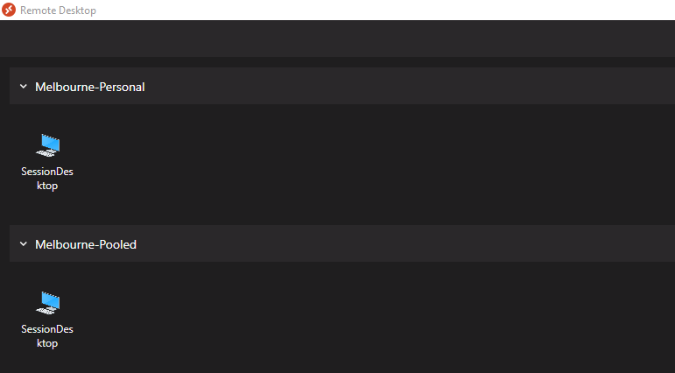

Here is an example screenshot of Workspaces that CFS Offshore Users persona end-users will see using Remote Desktop clients:

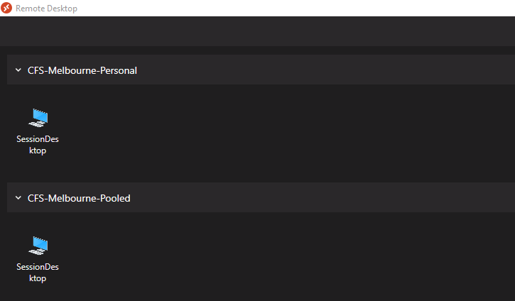

#### Deployment

Workspace are deployed as a part of Host Pools creation process. Refer the Host Pools section to refer the screenshots for more information. However, Workspaces can be created independently as required.

#### Configuration

The following is the configuration of Workspaces deployed in the environment:

##### Non-production

|  |  |  |
| --- | --- | --- |
| ID | Workspace | Associated Application Group |
| 1 | Sydney-Pooled-DEV | hp-np-edc-avd-sd-001-DAG |
| 2 | Sydney-Personal-DEV | hp-np-edc-avd-pd-001-DAG |
| 3 | Melbourne-Pooled-DEV | hp-np-sdc-avd-sd-001-DAG |
| 4 | Melbourne-Personal-DEV | hp-np-sdc-avd-pd-001-DAG |
| 5 | CFS-Sydney-Pooled-DEV | hp-np-edc-cfs-avd-sd-001-DAG |
| 6 | CFS-Sydney-Personal-DEV | hp-np-edc-cfs-avd-pd-001-DAG |
| 7 | CFS-Melbourne-Pooled-DEV | hp-np-sdc-cfs-avd-sd-001-DAG |
| 8 | CFS-Melbourne-Personal-DEV | hp-np-sdc-cfs-avd-pd-001-DAG |

##### Production

|  |  |  |
| --- | --- | --- |
| ID | Workspace | Associated Application Group |
| 1 | Sydney-Pooled | hp-prd-edc-avd-sd-001-DAG |
| 2 | Sydney-Personal | hp-prd-edc-avd-pd-001-DAG |
| 3 | Melbourne-Pooled | hp-prd-sdc-avd-sd-001-DAG |
| 4 | Melbourne-Personal | hp-prd-sdc-avd-pd-001-DAG |
| 5 | CFS-Sydney-Pooled | hp-prd-edc-cfs-avd-sd-001-DAG |
| 6 | CFS-Sydney-Personal | hp-prd-edc-cfs-avd-pd-001-DAG |
| 7 | CFS-Melbourne-Pooled | hp-prd-sdc-cfs-avd-sd-001-DAG |
| 8 | CFS-Melbourne-Personal | hp-prd-sdc-cfs-avd-pd-001-DAG |

### Application Groups

Only Application Group containing Session Desktop is deployed as a part of this build.

Application groups gets created as a part of Host Pool creation automatically. However, application groups can be created separately as required.

#### Deployment

Application groups gets created as a part of Host Pool creation automatically. However, application groups can be created separately as required.

#### Configuration

The following is the configuration of Application Groups deployed in environment:

##### Non-production

|  |  |  |  |  |
| --- | --- | --- | --- | --- |
| ID | Application Group | Application | Associated Host Pool | Assignments (AD Groups) |
| 1 | hp-np-edc-avd-sd-001-DAG | Pooled | hp-np-edc-avd-sd-001 | SG-AD-OPS-EDC-AVDSharedUsers |
| 2 | hp-np-edc-avd-pd-001-DAG | Personal | hp-np-edc-avd-pd-001 | SG-AD-OPS-EDC-AVDPersonalUsers |
| 3 | hp-np-sdc-avd-sd-001-DAG | Pooled | hp-np-sdc-avd-sd-001 | SG-AD-OPS-SDC-AVDSharedUsers |
| 4 | hp-np-sdc-avd-pd-001-DAG | Personal | hp-np-sdc-avd-pd-001 | SG-AD-OPS-SDC-AVDPersonalUsers |
| 5 | hp-np-edc-cfs-avd-sd-001-DAG | Pooled | hp-np-edc-cfs-avd-sd-001 | SG-AD-OPS-EDC-CFS-AVDSharedUsers |
| 6 | hp-np-edc-cfs-avd-pd-001-DAG | Personal | hp-np-edc-cfs-avd-pd-001 | SG-AD-OPS-EDC-CFS-AVDPersonalUsers |
| 7 | hp-np-sdc-cfs-avd-sd-001-DAG | Pooled | hp-np-sdc-cfs-avd-sd-001 | SG-AD-OPS-SDC-CFS-AVDSharedUsers |
| 8 | hp-np-sdc-cfs-avd-pd-001-DAG | Personal | hp-np-sdc-cfs-avd-pd-001 | SG-AD-OPS-SDC-CFS-AVDPersonalUsers |

##### Production

|  |  |  |  |  |
| --- | --- | --- | --- | --- |
| ID | Application Group | Application | Associated Host Pool | Assignments (AD Groups) |
| 1 | hp-prd-edc-avd-sd-001-DAG | Pooled | hp-prd-edc-avd-sd-001 | SG-AD-OPS-EDC-AVDSharedUsers |
| 2 | hp-prd-edc-avd-pd-001-DAG | Personal | hp-prd-edc-avd-pd-001 | SG-AD-OPS-EDC-AVDPersonalUsers |
| 3 | hp-prd-sdc-avd-sd-001-DAG | Pooled | hp-prd-sdc-avd-sd-001 | SG-AD-OPS-SDC-AVDSharedUsers |
| 4 | hp-prd-sdc-avd-pd-001-DAG | Personal | hp-prd-sdc-avd-pd-001 | SG-AD-OPS-SDC-AVDPersonalUsers |
| 5 | hp-prd-edc-cfs-avd-sd-001-DAG | Pooled | hp-prd-edc-cfs-avd-sd-001 | SG-AD-OPS-EDC-CFS-AVDSharedUsers |
| 6 | hp-prd-edc-cfs-avd-pd-001-DAG | Personal | hp-prd-edc-cfs-avd-pd-001 | SG-AD-OPS-EDC-CFS-AVDPersonalUsers |
| 7 | hp-prd-sdc-cfs-avd-sd-001-DAG | Pooled | hp-prd-sdc-cfs-avd-sd-001 | SG-AD-OPS-SDC-CFS-AVDSharedUsers |
| 8 | hp-prd-sdc-cfs-avd-pd-001-DAG | Personal | hp-prd-sdc-cfs-avd-pd-001 | SG-AD-OPS-SDC-CFS-AVDPersonalUsers |

|  |  |
| --- | --- |
|  | ***Note***  *DAG stands for Desktop Application Group.* |

### User Profiles

FSLogix agent is deployed to deliver the user profiles to Azure Virtual Desktop sessions and Azure Files storage accounts are used to store that user profiles data. Storage accounts in section describes the configuration of storage accounts for FSLogix.

#### Working Data

Working data of end users is configured to be stored in and synchronised with OneDrive for Business automatically. The required policies have been configured in Microsoft Intune. For more information on the configuration, refer section 6.2.10.

#### FSLogix Agent

By default, FSLogix agent software is shipped with Windows 11 Enterprise multi-session OS image from Microsoft Gallery. Hence, there is no need to deploy it separately for shared/pooled session host VMs.

For personal session host VMs, FSLogix agent software is configured to be deployed via Microsoft Intune. For more information on the configuration, refer section 6.3.9.2.

The FSLogix agent configuration is delivered by Group Policy Objects described in section 6.3.3.1.5.

#### FSLogix Configuration

The following Azure Files Storage Accounts are created and configured for use by FSLogix:

**Non-production**

|  |  |  |  |
| --- | --- | --- | --- |
| ID | Storage Account | Resource Group | Location |
| 1 | vmnpedcfs001 | rg-np-edc-oper-stor-001 | Australia East |
| 2 | vmnpsdcfs001 | rg-np-sdc-oper-stor-001 | Australia Southeast |

**Production**

|  |  |  |  |
| --- | --- | --- | --- |
| ID | Storage Account | Resource Group | Location |
| 1 | vmprdedcfs001 | rg-prd-edc-oper-stor-001 | Australia East |
| 2 | vmprdsdcfs001 | rg-prd-sdc-oper-stor-001 | Australia Southeast |

##### Permissions

The following table contains the accounts and groups and their assigned permissions:

|  |  |
| --- | --- |
|  | ***Important Note***  *These accounts and groups are created with the same names in both non-production and non-production environments. Hence, domain name suffixes are not mentioned.* |

|  |  |  |  |
| --- | --- | --- | --- |
| ID | Account | Account type | Storage Account Role Assignments |
| 1 | SG-AD-OPS-FSLogixShareContributorGroup | Security group | Storage File Data SMB Share Contributor |
| 2 | SG-AD-OPS-FSLogixShareElevatedContributorGroup | Security group | Storage File Data SMB Share Elevated Contributor |
| 3 | svcavddomainjoin | Service account | Contributor |

The following table contains the steps to assign the above permissions:

|  |  |
| --- | --- |
|  | ***Important Note***  *The steps shown in the table below are from one of the storage accounts in non-production environment. However, the steps to assign these roles for other storage accounts are similar regardless of the environment.* |

|  |  |  |
| --- | --- | --- |
| Steps | Screenshot | |
| From the Azure portal à go to **‘Storage Accounts’** à click the storage account **‘vmnpedcfs001’**  à click on ‘**Access Control (IAM)’** à click on **‘+Add’** à click on **‘Role assignments’** |  |
| Click on **‘Storage File Data SMB Share Contributor’** à and click **‘Next’** |  |
| Click on **‘Select members’** à find the group shown in the screenshot, select it and click **‘Review + assign’** twice to assign the roles. |  |
| Once done, click again on **‘+Add’** à click on **‘Role assignments’** à click on **‘Storage File Data SMB Share Elevated Contributor’** |  |
| Click on **‘Select members’** 🡪 find the group shown in the screenshot, select it and click **‘Review + assign’** twice to assign the roles. |  |
| Once done, click again on **‘+Add’** à click on **‘Role assignments’** à click on **‘Contributor’** |  |
| Click on **‘Select members’** 🡪 find ‘**svcavddomainjoin’**, select it and click **‘Review + assign’** twice to assign the role  Follow these steps to assign the roles for other storage accounts. |  |

##### File Shares

The following table contains the main configuration of file shares within the storage accounts. Two file shares have been created in each storage account, each for shared and personal desktops:

**Non-production**

|  |  |  |  |  |  |
| --- | --- | --- | --- | --- | --- |
| * ID | * Region | * Protocol | * Quota (GiB) | * File Share | Purpose |
| 1 | Australia East | SMB | 5001 | fs-dev-edc-avdsd-01 | To host the Shared Desktop user profiles |
| 2 | 1501 | fs-dev-edc-avdpd-01 | To host Dedicated Desktop user profiles |
| 3 | Australia Southeast | 5001 | fs-dev-sdc-avdsd-01 | To host Shared Desktop user profiles |
| 4 | 1501 | fs-dev-sdc-avdpd-01 | To host Dedicated Desktop user profiles |

**Non-production**

|  |  |  |  |  |  |
| --- | --- | --- | --- | --- | --- |
| * ID | * Region | * Protocol | * Quota (GiB) | * File Share | Purpose |
| 1 | Australia East | SMB | 5001 | fs-prd-edc-avdsd-01 | To host the Shared Desktop user profiles |
| 2 | 1501 | fs-prd-edc-avdpd-01 | To host Dedicated Desktop user profiles |
| 3 | Australia Southeast | 5001 | fs-prd-sdc-avdsd-01 | To host Shared Desktop user profiles |
| 4 | 1501 | fs-prd-sdc-avdpd-01 | To host Dedicated Desktop user profiles |

|  |  |
| --- | --- |
|  | ***Important Note***  *1Initial provisioned capacity in R1.*  *This capacity will be increased before releasing Azure Virtual Desktop solution to production or as needed to save costs.* |

The following table contains the steps followed to create a file share in Azure Files storage account:

|  |  |
| --- | --- |
|  | ***Important Note***  *The steps shown in the table below are from one of the storage accounts in non-production environment. However, the steps to create a file share in other storage accounts are similar regardless of the environment.* |

|  |  |
| --- | --- |
| * Steps | Screenshot |
| From Azure portal, go to **‘Storage Accounts’** à select **‘vmnpedcfs001’** from the list à click on **‘File shares’** à click on **‘+ File share’** à Enter the **name** of the file share and the **provisioned capacity**, leave everything else default, and click **‘Create’** |  |

##### Active Directory Integration

Active Directory identity-based authentication is configured for the Azure Files Storage Accounts SMB access. The following key components and sequence are used to setup this integration:

1. Kerberos Key with AE256 encryption method
2. Storage Account computer account object in Active Directory and set above Kerberos key as object’s password.
3. Service Principal Name of above computer account with a cifs service
4. Configure Azure Files Storage Account using above information

The script in this section is used to configure the above components and establish the AD integration. Note the following important information as it is critical to understand before running the script:

1. The script has following variables in it, change the variables as per the requirement. These variables are used to declare the storage account being configured, storage account’s resource group and subscription it is in:
   * $StorageAccountName = enter the storage account name being configured
   * $ResourceGroupName = enter the resource group of storage account
   * $Subscription = enter the Azure subscription of storage account
2. OU must be declared carefully using the following table: this is where the computer account object of storage account will be created:

**Non-production**

|  |  |  |
| --- | --- | --- |
| ID | OU Path | DN |
| 1 | DEVCFS > Devices > EDC > [Storage](mailto:svcavddomainjoin@dev.cfs.com.au) Account | OU=Storage Account,OU=EDC,OU=Devices,OU=DEVCFS,DC=dev,DC=cfs,DC=com,DC=au |
| 2 | DEVCFS > Devices > SDC > Storage Account | OU=Storage Account,OU=SDC,OU=Devices,OU=DEVCFS,DC=dev,DC=cfs,DC=com,DC=au |

**Production**

|  |  |  |
| --- | --- | --- |
| ID | OU Path | DN |
| 1 | CFS > Devices > EDC > [Storage](mailto:svcavddomainjoin@dev.cfs.com.au) Account | OU=Storage Account,OU=EDC,OU=Devices,OU=CFS,DC=dev,DC=cfs,DC=com,DC=au |
| 2 | CFS > Devices > SDC > Storage Account | OU=Storage Account,OU=SDC,OU=Devices,OU=CFS,DC=dev,DC=cfs,DC=com,DC=au |

1. The execution of this script requires Windows PowerShell session running with ‘**Domain Admin’** account.
2. While connecting to Azure tenant using ‘*Connect-AzAccount’*, authenticate with ‘**svcavddomainjoin’** account as this service account has *Contributor* permissions on all the storage accounts.
3. A computer this script is executed from, must:
   * be a member of domain *(dev.cfs.com.au in case of non-production and cfs.com.au in case of production)*
   * have an internet access to communicate with Azure tenant and to download the required powershell modules.
   * have RSAT tools installed.
   * have AzFilesHybrid module downloaded by referring this [document](https://docs.microsoft.com/en-us/azure/storage/files/storage-files-identity-ad-ds-enable).
4. The values of following attributes can be taken from *Get-ADDomain* powershell command:
   * *ActiveDirectoryDomainName*
   * *ActiveDirectoryDomainName*
   * *ActiveDirectoryNetBiosDomainName*
   * *ActiveDirectoryDomainGuid*
   * *ActiveDirectoryDomainsid*
5. The value of following attribute can be obtained from newly created storage account computer object by executing *Get-ADComputer* powershell command:
   * *ActiveDirectoryAzureStorageSid*

|  |  |
| --- | --- |
|  | ***Important Note***  *The current variables set in the below script are from non-production storage account. Change these variables to use this script for other storage accounts.* |

# Set the execution policy to unrestricted for the current session

Set-ExecutionPolicy -ExecutionPolicy Unrestricted -Scope CurrentUser

#Navigate to directory where AzFilesHybrid files were downloaded and execute the below command

Import-Module -Name AzFilesHybrid

#Install the required modules

Install-Module Az

#Connect to Azure Tenant

Connect-AzAccount

# Set the required variables

$StorageAccountName = 'vmnpedcfs001'

$ResourceGroupName = 'rg-np-edc-oper-stor-001'

$Subscription = 'subsc-np-operations-001'

# Set the Azure context with subscription name

Select-AzSubscription -Subscription $Subscription

# Create the Kerberos key on the storage account and get the Kerb2 key as the password for the AD identity to represent the storage account

New-AzStorageAccountKey -ResourceGroupName $ResourceGroupName -Name $StorageAccountName -KeyName kerb2

$Kerbkey = Get-AzStorageAccountKey -ResourceGroupName $ResourceGroupName -Name $StorageAccountName -ListKerbKey | where-object{$_.Keyname -contains "kerb2"}

# Create a computer account object that will represent the Storage Account in Active Directory

# Firstly, convert the kerberos key to a password secure string

$PwdSecureString = ConvertTo-SecureString -String $Kerbkey.Value -AsPlainText -Force

New-ADComputer `

-SAMAccountName $StorageAccountName `

-Path 'OU=EDC,OU=Shared,OU=Devices,OU=DEVCFS,DC=dev,DC=cfs,DC=com,DC=au' `

-Name $StorageAccountName `

-AccountPassword $PwdSecureString `

-AllowReversiblePasswordEncryption $false `

-Description "Computer account object for Azure storage account $StorageAccountName." `

-Server dev.cfs.com.au `

-Enabled $true `

-ErrorAction Stop

# Before proceeding to next step, make sure the newly created computer account has valid spn. Create spn using the command prompt and execute the following command:

setspn -s cifs/vmnpedcfs001.file.core.windows.net vmnpedcfs001

# Set the feature flag on the target storage account and provide the required AD domain information

Set-AzStorageAccount `

-ResourceGroupName "$ResourceGroupName" `

-Name "$StorageAccountName" `

-EnableActiveDirectoryDomainServicesForFile $true `

-ActiveDirectoryDomainName "dev.cfs.com.au" `

-ActiveDirectoryNetBiosDomainName "devcfs" `

-ActiveDirectoryForestName "dev.cfs.com.au" `

-ActiveDirectoryDomainGuid "fc029215-df03-4a90-8713-9cfe62f2996d" `

-ActiveDirectoryDomainsid "S-1-5-21-1170116249-2613192180-2572230752" `

-ActiveDirectoryAzureStorageSid "S-1-5-21-1170116249-2613192180-2572230752-12107"

# Follow the below steps to validate the implemented configuration:

# Get the target storage account into a variable

$storageaccount = Get-AzStorageAccount `

-ResourceGroupName "$ResourceGroupName" `

-Name "$StorageAccountName"

# To verify, list the directory service of the selected service account

$storageAccount.AzureFilesIdentityBasedAuth.DirectoryServiceOptions

# To verify, list the directory domain information if the storage account has enabled AD DS authentication for file shares

$storageAccount.AzureFilesIdentityBasedAuth.ActiveDirectoryProperties

After the execution of above script, FSLogix agent on a fully working AVD VM should be able to access the Azure Files storage account and should be Active. To verify this, go to *C:\Program files\FSLogix\Apps\frxtray.exe* on the VM and launch it by clicking its traffic signal icon near the date and time on the desktop. The icon should appear with a green traffic light and should be in Active state.

Sometimes the Kerberos key configured for the storage account does not work as expected – as it fails to use the AES256 encryption method. When this happens, the frxtray icon shows amber light with an error and the below error is logged in the System log in the event viewer on the VM:

Log Name: System

Source: Microsoft-Windows-Security-Kerberos

Date: 2/4/2022 5:36:31 PM

Event ID: 4

Task Category: None

Level: Error

Keywords: Classic

User: N/A

Computer: VMNPEDCAVDS-1.dev.cfs.com.au

Description:

The Kerberos client received a KRB_AP_ERR_MODIFIED error from the server stonpedcoper001. The target name used was cifs/stonpedcoper001.file.core.windows.net. This indicates that the target server failed to decrypt the ticket provided by the client. This can occur when the target server principal name (SPN) is registered on an account other than the account the target service is using. Ensure that the target SPN is only registered on the account used by the server. This error can also happen if the target service account password is different than what is configured on the Kerberos Key Distribution Center for that target service. Ensure that the service on the server and the KDC are both configured to use the same password. If the server name is not fully qualified, and the target domain (file.core.windows.net) is different from the client domain (DEV.CFS.COM.AU), check if there are identically named server accounts in these two domains, or use the fully-qualified name to identify the server.

In this case, storage account’s computer account object password needs to be updated using the following powershell command. In order to execute the script, keep the following things in mind:

1. The execution of this script requires Windows PowerShell session running with ‘**Domain Admin’** account.
2. While connecting to Azure tenant using ‘*Connect-AzAccount’*, authenticate with ‘**svcavddomainjoin’** account as this service account has *Contributor* permissions on all the storage accounts.
3. A computer this script is executed from, must:
   * be a member of domain *(dev.cfs.com.au in case of non-production and cfs.com.au in case of production)*
   * have an internet access to communicate with Azure tenant and to download the required powershell modules.
   * have RSAT tools installed.
   * have AzFilesHybrid module downloaded by referring this [document](https://docs.microsoft.com/en-us/azure/storage/files/storage-files-identity-ad-ds-enable).

# Set the execution policy to unrestricted for the current session

Set-ExecutionPolicy -ExecutionPolicy Unrestricted -Scope CurrentUser

#Navigate to directory where AzFilesHybrid files were downloaded and execute the below command

Import-Module -Name AzFilesHybrid

#Install the required modules

Install-Module Az

#Connect to Azure Tenant

Connect-AzAccount

# Set the required variables

$Subscription = 'subsc-np-operations-001'

# Set the Azure context with subscription name

Select-AzSubscription -Subscription $Subscription

# Update the encryption type

Update-AzStorageAccountAuthForAES256 -ResourceGroupName 'rg-np-edc-oper-stor-001' -StorageAccountName 'vmnpedcfs001'

|  |  |
| --- | --- |
|  | ***Important Note***  *AVD VMs may need a restart after executing the above script.* |

The following table contains the steps to verify the Storage Account integration with Active Directory:

**Non-production**

|  |  |
| --- | --- |
| * Steps | Screenshot |
| From Azure portal, go to **‘Storage Accounts’** à select **‘vmnpedcfs001’** from the list à click on **‘File shares’** à validate the **Active Directory** is configured. |  |
| From Azure portal, go to **‘Storage Accounts’** à select **‘vmnpsdcfs001’** from the list à click on **‘File shares’** à validate the **Active Directory** is configured. |  |

**Production**

|  |  |
| --- | --- |
| * Steps | Screenshot |
| From Azure portal, go to **‘Storage Accounts’** à select **‘vmprdedcfs001’** from the list à click on **‘File shares’** à validate the **Active Directory** is configured. |  |
| From Azure portal, go to **‘Storage Accounts’** à select **‘vmprdsdcfs001’** from the list à click on **‘File shares’** à validate the **Active Directory** is configured. |  |

##### NTFS Permissions

NTFS permissions must be setup correctly and carefully for FSLogix profile containers to work.

The following table contains the mapping of identities to their respective file shares. Follow these mappings when setting up the NTFS permissions:

**Non-production**

|  |  |  |  |  |
| --- | --- | --- | --- | --- |
| ID | Identity  (e.g., Security Group etc.) | Must Have NTFS Permissions on | | Permissions |
| **Storage Account** | **File Share** |
| 1 | SG-AD-OPS-EDC-AVDSharedUsers | vmnpedcfs001 | fs-np-edc-avdsd-01 | Modify |
| 2 | SG-AD-OPS-EDC-AVDPersonalUsers | fs-np-edc-avdpd-01 |
| 3 | SG-AD-OPS-EDC-CFS-AVDSharedUsers | fs-np-edc-avdsd-01 |
| 4 | SG-AD-OPS-EDC-CFS-AVDPersonalUsers | fs-np-edc-avdpd-01 |
| 5 | SG-AD-OPS-SDC-AVDSharedUsers | vmnpsdcfs001 | fs-np-sdc-avdsd-01 | Modify |
| 6 | SG-AD-OPS-SDC-AVDPersonalUsers | fs-np-sdc-avdpd-01 |
| 7 | SG-AD-OPS-SDC-CFS-AVDSharedUsers | fs-np-sdc-avdsd-01 |
| 8 | SG-AD-OPS-SDC-CFS-AVDPersonalUsers | fs-np-sdc-avdpd-01 |
| 9 | Creator Owner | vmnpedcfs001 | fs-np-edc-avdsd-01 | Modify |
| fs-np-edc-avdpd-01 |
| vmnpsdcfs001 | fs-np-sdc-avdsd-01 | Modify |
| fs-np-sdc-avdpd-01 |

**Production**

|  |  |  |  |  |
| --- | --- | --- | --- | --- |
| ID | Identity  (e.g., Security Group etc.) | Must Have NTFS Permissions on | | Permissions |
| **Storage Account** | **File Share** |
| 1 | SG-AD-OPS-EDC-AVDSharedUsers | vmprdedcfs001 | fs-prd-edc-avdsd-01 | Modify |
| 2 | SG-AD-OPS-EDC-AVDPersonalUsers | fs-prd-edc-avdpd-01 |
| 3 | SG-AD-OPS-EDC-CFS-AVDSharedUsers | fs-prd-edc-avdsd-01 |
| 4 | SG-AD-OPS-EDC-CFS-AVDPersonalUsers | fs-prd-edc-avdsd-01 |
| 5 | SG-AD-OPS-SDC-AVDSharedUsers | vmprdsdcfs001 | fs-prd-sdc-avdsd-01 | Modify |
| 6 | SG-AD-OPS-SDC-AVDPersonalUsers | fs-prd-sdc-avdpd-01 |
| 7 | SG-AD-OPS-SDC-CFS-AVDSharedUsers | fs-prd-sdc-avdsd-01 |
| 8 | SG-AD-OPS-SDC-CFS-AVDPersonalUsers | fs-prd-sdc-avdpd-01 |
| 5 | Creator Owner | vmprdedcfs001 | fs-prd-edc-avdsd-01 | Modify |
| fs-prd-edc-avdpd-01 |
| vmprdsdcfs001 | fs-prd-sdc-avdsd-01 | Modify |
| fs-prd-sdc-avdpd-01 |

The following steps are followed to setup the NTFS permissions for file shares in Azure Files storage accounts.

|  |  |
| --- | --- |
|  | ***Important Note***  *The following table contains the steps to setup NTFS permissions on one of the non-production storage account file shares. The sequence of steps to be followed for setting up the NTFS permissions are same regardless of environment.* |

|  |  |
| --- | --- |
| * Steps | Screenshot |
| From the same computer used for executing the scripts in the previous section, open the **command prompt** with elevated privileges 🡪 construct and execute the command above the screenshot | **Command:**  **net use <desired-drive-letter>: <UNC-path> <SA-key> /user:Azure\<SA-name>**  Here,   1. **Desired drive letter** – use ‘s:’ for mapping shared desktop file shares 2. **UNC Path** – this is the UNC path of storage accounts, can be constructed easily by using this format: \\<storage account name>.file.core.windows.net\<file share name>.   *E.g.,* *\\vmnpedcfs001.file.core.windows.net\fs-np-edc-avdsd-01*   1. **SA-key** – is an Access Key of the storage account, can be obtained by going to **storage account** from Azure portal 🡪 click on **‘Access Keys’** 🡪 click on **‘Show keys’** from the top of the blade to reveal the keys 🡪 copy the **‘Key’** value from **Key 1**. 2. **SA-name** – is the name of storage account.   Following is the screenshot for reference: |
| Execute the command mentioned in the screenshot column to assign the permissions to appropriate user group | **Command:**  **icacls <mounted-drive-letter>: /grant <user-email>:(M)**  Here,   1. **Mounted-drive-letter** – is the drive letter set in the previous step, in this case it is ‘s:’ 2. **User-email** – appropriate security group of users (refer the permissions mapping table earlier in this section. 3. **(M)** – this is to assign ‘Modify’ permissions |
| Similar to previous step, assign permissions to Creator Owner on the file shares | **Command:**  **icacls <mounted-drive-letter>: /grant "Creator Owner":(OI)(CI)(IO)(M)**  Here,   1. **Mounted-drive-letter** – is the drive letter set in the previous step, in this case it is ‘s:’ |
| Remove the permissions of other default identities or groups | **Command:**  **icacls <mounted-drive-letter>: /remove "Authenticated Users"**  **icacls <mounted-drive-letter>: /remove "Builtin\Users"**  Here,   1. **Mounted-drive-letter** – is the drive letter set in the previous step, in this case it is ‘s:’ |
| Finally, validate the permissions and they should look like the ones in the screenshot | **Command:**  **icacls s:** |
| Once verified, remove the mapped drive | **Command:**  **net use s: /DELETE** |

The following table contains the NTFS permissions on the existing file shares:

**Non-production**

| **NTFS Permissions on File Shares** | |
| --- | --- |
| \\vmnpedcfs001.file.core.windows.net\fs-np-edc-avdsd-01 |  |
| \\vmnpedcfs001.file.core.windows.net\fs-np-edc-avdpd-01 |  |
| \\vmnpsdcfs001.file.core.windows.net\fs-np-sdc-avdsd-01 |  |
| \\vmnpsdcfs001.file.core.windows.net\fs-np-sdc-avdpd-01 |  |

**Production**

| **NTFS Permissions on File Shares** | |
| --- | --- |
| \\vmprdedcfs001.file.core.windows.net\fs-prd-edc-avdsd-01 |  |
| \\vmprdedcfs001.file.core.windows.net\fs-prd-edc-avdpd-01 |  |
| \\vmprdsdcfs001.file.core.windows.net\fs-prd-sdc-avdpd-01 |  |
| \\vmprdsdcfs001.file.core.windows.net\fs-prd-sdc-avdsd-01 |  |

##### Antivirus Exclusions

The following paths and processes have been excluded from antivirus scanning. These exclusions are configured using Microsoft Defender for Endpoint, refer section 6.2.11 for more information on its configuration and steps.

###### Excluded files/ paths:

**Non-production**

%ProgramFiles%\FSLogix\Apps\frxdrv.sys

%ProgramFiles%\FSLogix\Apps\frxdrvvt.sys

%ProgramFiles%\FSLogix\Apps\frxccd.sys

%TEMP%\*.VHD

%TEMP%\*.VHDX

%Windir%\TEMP\*.VHD

%Windir%\TEMP\*.VHDX

\\vmnpedcfs001.file.core.windows.net\fs-np-edc-avdsd-01\*.VHD

\\vmnpedcfs001.file.core.windows.net\fs-np-edc-avdpd-01\*.VHD

\\vmnpedcfs001.file.core.windows.net\fs-np-edc-avdsd-01\*.VHDX

\\vmnpedcfs001.file.core.windows.net\fs-np-edc-avdpd-01\*.VHDX

\\vmnpsdcfs001.file.core.windows.net\fs-np-sdc-avdsd-01\*.VHD

\\vmnpsdcfs001.file.core.windows.net\fs-np-sdc-avdpd-01\*.VHD

\\vmnpsdcfs001.file.core.windows.net\fs-np-sdc-avdsd-01\*.VHDX

\\vmnpsdcfs001.file.core.windows.net\fs-np-sdc-avdpd-01\*.VHDX

**Production**

%ProgramFiles%\FSLogix\Apps\frxdrv.sys

%ProgramFiles%\FSLogix\Apps\frxdrvvt.sys

%ProgramFiles%\FSLogix\Apps\frxccd.sys

%TEMP%\*.VHD

%TEMP%\*.VHDX

%Windir%\TEMP\*.VHD

%Windir%\TEMP\*.VHDX

\\vmprdedcfs001.file.core.windows.net\fs-prd-edc-avdsd-01\*.VHD

\\vmprdedcfs001.file.core.windows.net\fs-prd-edc-avdpd-01\*.VHD

\\vmprdedcfs001.file.core.windows.net\fs-prd-edc-avdsd-01\*.VHDX

\\vmprdedcfs001.file.core.windows.net\fs-prd-edc-avdpd-01\*.VHDX

\\vmprdsdcfs001.file.core.windows.net\fs-prd-sdc-avdsd-01\*.VHD

\\vmprdsdcfs001.file.core.windows.net\fs-prd-sdc-avdpd-01\*.VHD

\\vmprdsdcfs001.file.core.windows.net\fs-prd-sdc-avdsd-01\*.VHDX

\\vmprdsdcfs001.file.core.windows.net\fs-prd-sdc-avdpd-01\*.VHDX

###### Excluded processes:

|  |  |
| --- | --- |
|  | ***Note***  *The process exclusions in this section are same for non-production and production environments.* |

%ProgramFiles%\FSLogix\Apps\frxccd.exe

%ProgramFiles%\FSLogix\Apps\frxccds.exe

%ProgramFiles%\FSLogix\Apps\frxsvc.exe

#### Backup

Azure Backup is configured to backup file shares containing user profile containers.

The following is the backup configuration of file shares in Azure Files storage account in both EDC and SDC regions within Recovery Services Vault.

|  |  |
| --- | --- |
|  | ***Note***  *The below table contains the steps to enable backup for an Azure Files storage account from non-production environment. However, process of setting up backup for other storage accounts in non-production and production, is same.* |

##### vmnpedcfs001

| **Steps** | **Screenshot** |
| --- | --- |
| From the Azure portal, go to **‘Storage Accounts’** 🡪 click on **‘vmnpedcfs001’** 🡪 click on **‘File shares’** 🡪 click on **‘fs-np-edc-avdsd-01’** or any of the file shares 🡪 click on **‘Backup’** 🡪 click on **‘Create a new policy’** (make sure the correct Recovery Services Vault is selected) |  |
| On the Create policy page, enter the **‘Policy name’** à entre the **backup schedule** that runs daily at 2:AM AEST -à set the **retention** for 14 days as shown in the screenshot à click ‘**Create**’ |  |
| Once the backup configuration is done, click on **‘Enable backup’** |  |
| Once enabled, initiate first backup manually. Go to **‘Backup’** in the file share à click on **‘Backup now’** |  |

### Device Management

Microsoft Endpoint Manager has been configured to deliver the following settings to AVD session host VMs:

1. Policies
   * Device compliance
   * Device restriction
   * Endpoint protection
   * Windows Updates for Business (WUfB)
2. Applications
   * FSLogix

There are additional apps that have been wrapped and deployed to AVDs using Intune, refer the Application Packaging document for more information.

1. Scripts – to deploy the following:
   * PowerShell Modules
   * Enable selected RSAT Features
   * MS Teams Optimization

#### Enrollment

Shared AVD VMs enroll into Intune via Group Policy as described in section Active Directory earlier in this document.

Intune enrollment of Shared AVD VMs begins as soon as they are AD domain joined and group policies are applied – “AVD-Automatic Intune Enrollment” policy in particular.

Personal AVD VMs enroll into Intune via Automatic Enrollment MDM scope configuration in Azure Active Directory. This MDM scope is set to All devices. Intune enrollment of Personal AVDs begins as soon as they are hybrid Azure AD joined and their device objects are created in Azure AD.

#### Policies

Intune policies settings configured in Intune are baseline settings recommended by Microsoft. Configuration of each setting is not shown in this section; however, this section contains screenshots of high-level settings. For settings with customized configuration such as Defender Firewall inbound rules etc., detailed information is provided in those respective columns.

The AVD policies configuration in Intune and steps are described in section 6.2.10. However, this section will describe Intune policies for AVDs configured in both production and non-production environment.

##### Multi-session/ Shared AVD VMs

Multi-session OS such as Shared VMs only support Intune policies that are created via Settings Catalogue.

The following are the policies created for Multi-session/ Shared VMs:

|  |  |  |  |
| --- | --- | --- | --- |
| ID | Policy and Description | Screenshot | Assignments (Device Groups) |
| 1 | **Name**: Enterprise AVD – Windows 11 Multi-session Configuration Policies  **Description**: This policy contains all the device configuration and restriction policies for multi-session OS or Shared VMs.  Refer the **‘Configuration settings’** section in the screenshot to see the list of settings deployed via this policy. |  | DG-AA-OPS-AVDSharedSessionHosts |

##### Personal AVD VMs

The following are the policies created for Personal AVD VMs:

|  |  |  |  |
| --- | --- | --- | --- |
| ID | Policy | Screenshot | Assignments (Device Groups) |
| 1 | Enterprise AVD - OneDrive folder redirection |  | DG-AA-OPS-AVDPersonalSessionHosts |
| 2 | Enterprise AVD - Time zone for AVD Personal Devices |  | DG-AA-OPS-AVDPersonalSessionHosts |
| 3 | Enterprise AVD -Config-Win10-Custom-CSP |  | DG-AA-OPS-AVDPersonalSessionHosts |
| 4 | Enterprise AVD -Config-Win10-Device-Restrictions-UI |  | DG-AA-OPS-AVDPersonalSessionHosts |
| 5 | Enterprise AVD -Config-Win10-Endpoint-Protection-UI | **NOTE**: The Microsoft Defender Firewall settings in this policy has different IP address configurations in prod and non-prod environments. Hence, refer sub-section Defender Firewall rules further in this section. | DG-AA-OPS-AVDPersonalSessionHosts |
| 6 | Enterprise AVD -Config-Win10-Identity-Protection-UI |  | DG-AA-OPS-AVDPersonalSessionHosts |

###### Defender Firewall Rules (Non-Prod)

|  |  |
| --- | --- |
|  | ***Important Note***  *Inbound Defender Firewall rules for multi-session OS/ Shared VMs are deployed via GPOs as deploying firewall rules via Intune are not supported as of July 2022.* |

|  |  |
| --- | --- |
| Rule Name | Settings Screenshot |
| Management - Remote Desktop (RDP-In) |  |
| Windows Updates Delivery Optimization |  |
| Qualys Scanner - Open TCP Ports 135 139 445 |  |
| Qualys Scanner - Open UDP Ports 135 137 |  |
| Qualys Scanner - Allow ICMP V4 Echo Requests |  |
| Qualys Scanner - Allow ICMP V6 Echo Requests |  |
| ServiceNow - Discovery 135 |  |
| Service Now - Windows Management Instrumentation (WMI-In) |  |

###### Defender Firewall Rules (Prod)

|  |  |
| --- | --- |
|  | ***Important Note***  *Inbound Defender Firewall rules for multi-session OS/ Shared VMs are deployed via GPOs as deploying firewall rules via Intune are not supported as of July 2022.* |

|  |  |
| --- | --- |
| Rule Name | Settings Screenshot |
| Management - Remote Desktop (RDP-In) |  |
| Windows Updates Delivery Optimization |  |
| Qualys Scanner - Open TCP Ports 135 139 445 |  |
| Qualys Scanner - Open UDP Ports 135 137 |  |
| Qualys Scanner - Allow ICMP V4 Echo Requests |  |
| Qualys Scanner - Allow ICMP V6 Echo Requests |  |
| ServiceNow - Discovery 135 |  |
| Service Now - Windows Management Instrumentation (WMI-In) |  |

##### Windows Updates for Business

This section contains Intune WUfB policies in accordance with the proposed patching process in the design.

Multi-session Windows OS only support policies created via Settings Catalog. Refer this Microsoft [document](https://docs.microsoft.com/en-us/mem/intune/fundamentals/azure-virtual-desktop-multi-session#create-the-device-configuration-profile) for more information.

|  |  |
| --- | --- |
|  | ***Important Note***  *As of May 2022, not all WUfB policies are supported by AVD Shared and Personal VMs. This includes feature updates and quality updates policies.*  *Feature updates installations upon their release cannot be delayed or managed for shared and Pooled AVD VMs.* |

The following table lists the WUfB policies and its assignments configured in the environment:

|  |  |  |  |
| --- | --- | --- | --- |
| ID | WUfB Policy | Description | Assignments (Device Groups) |
| **Multi-session OS policies created via Settings Catalog** | | | |
| 1 | Enterprise AVD – Windows 11 Multi-session Updates Policy [BLUE] | Windows Updates for Business policy for AVD Blue Shared VMs | DG-AA-OPS-AVDSharedBlueSessionHosts |
| 2 | Enterprise AVD – Windows 11 Multi-session Updates Policy [GREEN] | Windows Updates for Business policy for AVD Green Shared VMs | DG-AA-OPS-AVDSharedGreenSessionHosts |
| **Update Rings policies** | | | |
| 3 | Enterprise AVD – Windows Updates Policy [BLUE] | Update rings for AVD Blue Personal VMs | DG-AA-OPS-AVDPersonalBlueSessionHosts |
| 4 | Enterprise AVD – Windows Updates Policy [GREEN] | Update rings for AVD Green Personal VMs | DG-AA-OPS-AVDPersonalGreenSessionHosts |

The following table contains the configuration of WUfB policies:

| **Policy** | **Screenshot** |
| --- | --- |
| **Enterprise AVD – Windows 11 Multi-session Updates Policy [BLUE]** |  |
| **Enterprise AVD – Windows 11 Multi-session Updates Policy [GREEN]** |  |
| **Enterprise AVD – Windows Updates Policy [BLUE]** |  |
| **Enterprise AVD – Windows Updates Policy [GREEN]** |  |

#### Apps

Steps to wrap and deploy an app using Microsoft Intune are outlined in Operations guide document. Refer that document for more information on it. There are additional apps that have been wrapped and deployed to AVDs using Intune, refer the Application Packaging document for more information.

|  |  |
| --- | --- |
|  | ***Important Note***  *This section contains the configuration of deployed application it via Microsoft Intune in non-production environment. However, the steps to wrap/ package and deploying any application is similar regardless of environment. Some apps may have different parameters, installation and detection instructions which must be carefully followed while deploying it.* |

The following table contains the configuration of application deployment:

|  |  |
| --- | --- |
| Application | Screenshot |
| FSLogix Agent |  |

Applications are deployed via Microsoft Intune on both shared and personal session host VMs.

At the time of writing this document i.e., Nov 2022, the following application(s) have been identified by CFS as baseline apps for AVDs and they are deployed via Microsoft Intune in both non-production and production environments:

|  |  |  |  |
| --- | --- | --- | --- |
| ID | Application | Type | Persona |
| 1 | FSLogix Agent  (Only for personal AVDs as this agent is already included in multi-session OS for shared AVDs) | Win32 app | Partner Operate Teams |
| 2 | M365 Apps  (Only for personal AVDs as this agent is already included in multi-session OS for shared AVDs) | Intune inbuilt Microsoft 365 apps |
| 3 | Google Chrome | Win32 app |
| 4 | Notepad++ | Win32 app |
| 5 | WinZip  (Including WinZip license files app and WinZip Command Line app) | Win32 app |
| 6 | Crowdstrike Agent | Win32 app |
| 7 | Netskope Agent | Win32 app |
| 8 | Nexthink Agent | Win 32 app |
| 9 | Citrix Workspace | Win32 app |
| 10 | Adobe Acrobat Reader | Win32 app |
| 11 | MS Teams Optimisation  (Only for personal AVDs as it is enabled by default on multi-session OS for shared AVDs) | Script |
| 12 | Windows RSAT Tools | Script |
| 13 | PowerShell Modules | Script |
| 1 | FSLogix Agent  (Only for personal AVDs as this agent is already included in multi-session OS for shared AVDs) | Win32 app | CFS Offshore Users |
| 2 | M365 Apps  (Only for personal AVDs as this agent is already included in multi-session OS for shared AVDs) | Intune inbuilt Microsoft 365 apps |
| 3 | Google Chrome | Win32 app |
| 4 | Notepad++ | Win32 app |
| 5 | WinZip  (Including WinZip license files app and WinZip Command Line app) | Win32 app |
| 6 | Crowdstrike Agent | Win32 app |
| 7 | Netskope Agent | Win32 app |
| 8 | Nexthink Agent | Win 32 app |
| 9 | Citrix Workspace | Win32 app |
| 10 | MS Teams Optimisation  (Only for personal AVDs as it is enabled by default on multi-session OS for shared AVDs) | Script |

### Scaling Plans

Azure Virtual Desktop inbuilt capability of Autoscaling has been configured in the non-production environment.

Note that autoscaling can only turn on or off the Host Pool VMs. It will not deploy/ create or destroy any VM or resource. Autoscaling is configured based on the Time of the day, Specific days of the week (weekdays and weekends) and session limits of session hosts.

Scaling plans created in R1 were located at North Europe as Australia East region was not available at that time. In

June 2022, Microsoft released Australia East region to host AVD services.

Host Pools for CFS Offshore Users persona are created in Australia East region, and existing scaling plans could not used due to being in North Europe, Hence, new scaling plans are created in the Australia East region and these new scaling plans will be consumed by CFS Offshore Users persona and will also be consumed by future personas.

|  |  |
| --- | --- |
|  | ***Important Note***  *As of Jan 2022, Azure Virtual Desktop Scaling Plans feature is in public preview that offers out of the box native autoscaling capability with the following limitations.*   * *Scaling plans can only be deployed in US and European regions.* * *Configuration can only be done through Azure Portal.* * *Scaling plans can only be configured for Session Host VMs for non-pooled desktops. Session Host VMs for pooled desktops are not supported.*   *This can be reviewed in future and the implementation can be planned accordingly.* |

Exclusion tag ‘**AVD-Maintenance’** has been configured to support the maintenance work during incidents, scheduled maintenance or change tasks. VMs assigned this exclusion tag will not be managed by Scaling Plans. For e.g., Scaling Plans will not start or stop the VMs when the exclusion tag on the VM is applied.

Four scaling plans have been created:

**Non-production**

|  |  |  |  |
| --- | --- | --- | --- |
| ID | Scaling Plan Name | Location | Purpose |
| 1 | sp-np-edc-avd-sd-001 | North Europe | Scaling plan for Australia East Host Pool for shared desktops. |
| 2 | sp-np-sdc-avd-sd-001 | Scaling plan for Australia Southeast Host Pool for shared desktops. |
| 3 | sp-np-edc-cfs-avd-sd-001 | Australia East | Scaling plan for Australia East Host Pool for shared desktops. |
| 4 | sp-np-sdc-cfs-avd-sd-001 | Scaling plan for Australia Southeast Host Pool for shared desktops. |

**Production**

|  |  |  |  |
| --- | --- | --- | --- |
| ID | Scaling Plan Name | Location | Purpose |
| 1 | sp-prd-edc-avd-sd-001 | North Europe | Scaling plan for Australia East Host Pool for shared desktops. |
| 2 | sp-prd-sdc-avd-sd-001 | Scaling plan for Australia Southeast Host Pool for shared desktops. |
| 3 | sp-prd-edc-cfs-avd-sd-001 | Australia East | Scaling plan for Australia East Host Pool for shared desktops. |
| 4 | sp-prd-sdc-cfs-avd-sd-001 | Scaling plan for Australia Southeast Host Pool for shared desktops. |

#### Deployment

|  |  |
| --- | --- |
|  | ***Important Note***  *The deployment steps mentioned this section are taken from non-production environment. However, the steps to deploy the Scaling Plans in production are same except the ‘minimum percentage of hosts’ setting. Refer the deployment section of one of the production scaling plans later in this section for reference.*  *Make sure the Scaling Plans are created in their designated resource groups as described in the Resource Group Mapping section.* |

##### RBAC Permissions

The following custom role has been configured to allow Azure Virtual Desktop to power manage all the Session Host VMs:

| **Steps** | **Screenshot** |
| --- | --- |
| JSON template for required permissions is taken from this MS [document](https://docs.microsoft.com/en-us/azure/virtual-desktop/autoscale-scaling-plan#create-a-custom-rbac-role-in-your-subscription). | {  "properties": {  "roleName": "Autoscale",  "description": "Friendly description.",  "assignableScopes": [  "/subscriptions/<SubscriptionID>"  ],  "permissions": [  {  "actions": [  "Microsoft.Insights/eventtypes/values/read",  "Microsoft.Compute/virtualMachines/deallocate/action",  "Microsoft.Compute/virtualMachines/restart/action",  "Microsoft.Compute/virtualMachines/powerOff/action",  "Microsoft.Compute/virtualMachines/start/action",  "Microsoft.Compute/virtualMachines/read",  "Microsoft.DesktopVirtualization/hostpools/read",  "Microsoft.DesktopVirtualization/hostpools/write",  "Microsoft.DesktopVirtualization/hostpools/sessionhosts/read",  "Microsoft.DesktopVirtualization/hostpools/sessionhosts/write",  "Microsoft.DesktopVirtualization/hostpools/sessionhosts/usersessions/delete",  "Microsoft.DesktopVirtualization/hostpools/sessionhosts/usersessions/read",  "Microsoft.DesktopVirtualization/hostpools/sessionhosts/usersessions/sendMessage/action"  ],  "notActions": [],  "dataActions": [],  "notDataActions": []  }  ]  }  } |
| From the Azure portal 🡪 go to ‘**Subscriptions’** 🡪 find and click on the ‘**subsc-np-operations-001’** 🡪 click on ‘**Access control (IAM)’** 🡪 Select the ‘**+ Add’** button in the top left-hand corner of the screen, then select ‘**Add custom role’** from the drop-down menu, as shown in the following screenshot. | A screenshot showing the drop-down menu that appears when you select the plus sign button in the Azure portal control panel. The option add custom role is selected and highlighted wtih a red border. |
| Name the custom role as **Autoscale** à add the **description** à select **‘Start from JSON’** à browse and supply the **JSON** saved in the first step above |  |
| Validate the permissions as they are picked from JSON file supplied in the previous step |  |
| Validate the **operations subscription** is selected à click on **‘Review + create’** |  |
| **Assign the Autoscale role** | |
| From the Azure portal 🡪 go to ‘**Subscriptions’** 🡪 find and click on the ‘**subsc-np-operations-001’** 🡪 click on ‘**Access control (IAM)’** 🡪 click on ‘Role Assignments’ 🡪 Select the ‘**+ Add’** button in the top left-hand corner of the screen, then select ‘**Add role assignment’** from the drop-down menu, as shown in the following screenshot. |  |
| Select the role **‘Autoscale’** |  |
| Click on **‘+ Select members’** 🡪 search for **‘Windows Virtual Desktop’** or **‘Azure Virtual Desktop’** 🡪 add **‘Windows Virtual Desktop’** or **‘Azure Virtual Desktop’** as members.  Finally, click on ‘**Review + assign**’ and finish |  |

##### sp-np-edc-avd-sd-001

|  |  |
| --- | --- |
|  | ***Important Note***  *This section describes the configuration and steps of one of the scaling plans in non-production. Steps to setup scaling plans in AVD environment non-production or production are same.* |

| **Steps** | **Screenshot** |
| --- | --- |
| From the Azure portal, go to **‘Azure Virtual Desktop’** 🡪 click on **‘Scaling plans’** and click on **‘Create’**  Enter the configuration information carefully |  |
| Add schedule for **weekdays** |  |
| Define the **Ramp-up** schedule |  |
| Enter the **Peak-hours** |  |
| Define the **Ramp-down** schedule |  |
| Enter the **Off-peak hours** |  |
| Add schedule for weekends.  Define the **Ramp-up** schedule |  |
| Enter the **Peak-hours** |  |
| Define the **Ramp-down** schedule |  |
| Enter the **Off-peak hours** |  |
| Select the ‘**Host Pool**’ for assignments |  |
| Enter the **Tags** |  |

### Load Balancing

Azure Virtual Desktop offers two load balancing methods to balance the load on Azure VMs in the host pool. Only one of the load balancing modes can be used:

* Breadth mode: Automatically spreads load across a Host Pool as user log-on to evenly distribute the count of users evenly across all VMs. This method is also known as “Round Robin” load balancing.
* Depth mode: Loads up users on one VM at a time, moving to the new VM after pre-defined thresholds such as user count, CPU utilization and Memory utilization. New VMs are only used when existing VMs have met these thresholds

Scaling plans are used to leverage above native load balancing mechanisms of Azure Virtual Desktop.

Refer Scaling Plans for more information on the load balancing configuration.

### Logging and Reporting

Centralised Azure Log Analytics workspace is provisioned to pull the logs and reporting data from Azure Virtual Desktop environment and store data in Azure Monitor which can further be used to configure monitoring of session host VMs performance such as CPU, Memory, Disk and Network etc.

Existing Log Analytics Workspace will be used:

**Non-production**

|  |  |  |  |
| --- | --- | --- | --- |
| * ID | * Workspace Name | * Location | * Resource Group |
| 1 | ws-np-edc-001 | Australia East | rg-np-edc-sec-sec-001 |

**Production**

|  |  |  |  |
| --- | --- | --- | --- |
| * ID | * Workspace Name | * Location | * Resource Group |
| 1 | ws-prd-edc-001 | Australia East | rg-prd-edc-sec-sec-001 |

AVD Insights are enabled and configured for all the host pools. Enabling and configuring Insights for host pools configure monitoring settings for VMs associated with it automatically as a part of the process.

AVD resources such as Host Pools, VMs, Scaling Plans, Workspaces and App Groups report their data to their local Log Analytics Workspace that are configured via Insights.

#### Deployment

|  |  |
| --- | --- |
|  | ***Important Note***   1. *Log Analytics Workspace name shown in the screenshots in below sections is of previously created workspace. It was later decided to use the centralised Log Analytics Workspace “ws-np-edc-001” in non-prod for easy maintenance purposes.* 2. *The steps listed below demonstrate Insights setup in AVD and are taken from non-production environment. The process of setting up the Insights in production are same.* |

| **Steps** | **Screenshot** |
| --- | --- |
| From the **Azure Virtual Desktop** in Azure Portal à Click on **‘Insights Hub’** à Click on **‘Open Configuration Workbook’** to configure the monitoring |  |
| Select the **‘Subscription’, ‘Resource Group’, ‘Host Pool’** and respective **‘Log Analytics Workspace’** and then click on **‘Configure Host Pool’**  Scroll down the page and similarly click on **‘Configure Workspace’** |  |
| Click on the **‘Session host data settings’** à Click on **‘Add hosts to workspace’** (make sure the right workspace is selected)  **Note**: the workspace shown in the screenshot is not valid anymore. Use **“ws-np-edc-001”** and click on **‘Add hosts to workspace’** |  |
| Select other **resources groups** and **host pools** in AVD and **repeat above steps** to configure the Insights to use **“ws-np-edc-001”** workspace for monitoring purposes. |  |

##### Monitoring Dashboard

The following is the Azure Monitoring Dashboard created for Azure Virtual Desktop. This data is coming from Azure Virtual Desktop Insights configured in the previous section. Additional data can be pinned to this monitor using Log Analytics Workspace.

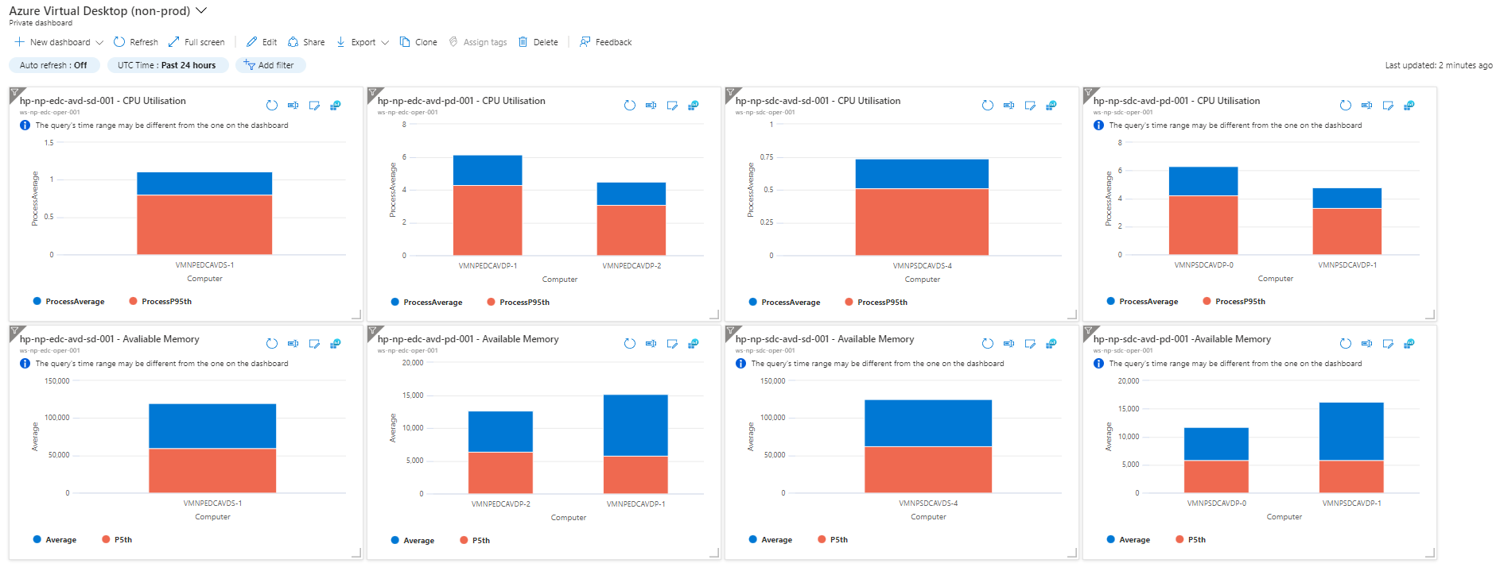

Additional monitoring data from host pools can be fetched and added to its appropriate column or can be directly accessed by navigating to Insights within the Azure Virtual Desktop portal.

The following are the steps to create a monitoring dashboard specifically for Azure Virtual Desktop:

|  |  |
| --- | --- |
|  | ***Important Note***  *The steps shown below are from non-production environment and to pin performance counters to the Azure dashboard. However, the process of creating the dashboard and steps to pin performance counters to Azure dashboard are same regardless of environment.* |

| **Steps** | **Screenshot** |
| --- | --- |
| From the Azure Portal à From the left pane, click on **‘Dashboard’** |  |
| Click on **‘+ New dashboard’** à click on **‘Blank dashboard’** |  |
| Enter the name of the dashboard **‘Azure Virtual Desktop (non-prod)’** and click **‘Save’** |  |

The following table contains the steps to pin the performance counters to the newly created Azure dashboard:

| **Steps** | **Screenshot** |
| --- | --- |
| From the **Azure Monitor** blade in Azure Portal à Click on **‘Insights Hub’** à select the appropriate AVD **resource group** and **host pool** à click on **‘Host Diagnostics’** |  |
| Scroll down the page to **‘Performance counters’** à click on **‘Log Analytics Workspace’** icon on the right hand side |  |
| Log Analytics Workspace page will appear, click on **‘Chart’** à click on **‘Pin to’** and select **‘Azure dashboard’**  In case additional VMs are created in the host pool at a later stage, make sure those VMs are added manually in the query i.e., WVDHosts query in the same format. Do this for all the performance counters added in the Monitoring Dashboard. |  |
| Select the **‘Azure Virtual Desktop (non-prod)’** from the **‘Dashboard’** drop-down menu |  |

# Workplace Security & Compliance

## Azure Active Directory

### Azure AD Groups

The following operational groups have been created to support Workplace & Mobility

|  |  |  |  |  |  |  |
| --- | --- | --- | --- | --- | --- | --- |
| Group Name | Group Type | Membership | Source | Description / Purpose | Owner | Dynamic Rule Syntax |
| DG-AA-OPS-AVDPersonalBlueSessionHosts | Security | Dynamic | Cloud | AVD Patching | Avanade Operate | (device.displayName -contains "VMPREDCVDPB") or (device.displayName -contains "VMPRSDCVDPB") |
| DG-AA-OPS-AVDPersonalGreenSessionHosts | Security | Dynamic | Cloud | AVD Patching | Avanade Operate | (device.displayName -contains "VMPREDCVDPG") or (device.displayName -contains "VMPRSDCVDPG") |
| DG-AA-OPS-AVDPersonalSessionHosts | Security | Dynamic | Cloud | AVD | Avanade Operate | (device.displayName -contains "VMPREDCVDP") or (device.displayName -contains "VMPRSDCVDP") |
| DG-AA-OPS-AVDSharedBlueSessionHosts | Security | Dynamic | Cloud | AVD Patching | Avanade Operate | (device.displayName -contains "VMPREDCVDSB") or (device.displayName -contains "VMPRSDCVDSB") |
| DG-AA-OPS-AVDSharedGreenSessionHosts | Security | Dynamic | Cloud | AVD Patching | Avanade Operate | (device.displayName -contains "VMPREDCVDSG") or (device.displayName -contains "VMPRSDCVDSG") |
| DG-AA-OPS-AVDSharedSessionHosts | Security | Dynamic | Cloud | AVD | Avanade Operate | (device.displayName -contains "VMPREDCVDS") or (device.displayName -contains "VMPRSDCVDS") |
| SG-AA-OPS-TeamRoomsStandardAccounts | Security | Dynamic | Cloud | Teams Standard Rooms Accounts for Licensing | Avanade Operate | (user.userPrincipalName -contains "AVR_A") |
| SG-AA-OPS-TeamRoomsPremiumAccounts | Security | Dynamic | Cloud | Teams Premium Rooms Accounts for Licensing | Avanade Operate | (user.userPrincipalName -contains "AVR") or (user.userPrincipalName -contains "Surface_HUB") |
| DG-AA-OPS-TeamRoomsDevices | Security | Dynamic | Cloud | Teams Room Devices for exclusion from CA rules | Avanade Operate | (device.displayName -contains "AVR MS Teams") or  (device.displayName -contains "Surface Hub") or  (device.displayName -contains "HAW Lvl G.01 Emerald AVR") or  (device.displayName -contains "HAW Lvl G.02 Opal AVR") or  (device.displayName -contains "HAW Lvl G.03 Sapphire AVR") or  (device.displayName -contains "HAW Lvl 1.01 Barramundi AVR") or  (device.displayName -contains "HAW Lvl 1.02 Conference 1 AVR") or  (device.displayName -contains "HAW Lvl 1.03 Conference 2 AVR") or  (device.displayName -contains "HAW Lvl 1.04 Conference 3 AVR") or  (device.displayName -contains "HAW Lvl 1.05 Hammerhead AVR") or  (device.displayName -contains "HAW Lvl 1.06 Marlin AVR") or  (device.displayName -contains "HAW Lvl 2.01 Bandicoot AVR") or  (device.displayName -contains "HAW Lvl 2.02 BoardRoom AVR") or  (device.displayName -contains "HAW Lvl 2.03 Kangaroo AVR") or  (device.displayName -contains "HAW Lvl 2.04 Possum AVR") or  (device.displayName -contains "HAW Lvl 3.01 Cockatoo AVR") |
| DG-AA-OPS-MMDDevices | Security | Dynamic | Cloud | Group to allow MMD devices to get a token from AD | Avanade Operate | (device.displayName -contains "MMD-") and (device.deviceOSType -contains "Windows") |
| Modern Workplace - Exclude Default Start Layout | Security | Assigned | Cloud | MMD Group provisioned/owned by Microsoft | Microsoft | n/a |
| Modern Workplace - ProcessMonitor-Install | Security | Assigned | Cloud | MMD Group provisioned/owned by Microsoft | Microsoft | n/a |
| Modern Workplace - ProcessMonitor-Uninstall | Security | Assigned | Cloud | MMD Group provisioned/owned by Microsoft | Microsoft | n/a |
| Modern Workplace - TimeTravelDebugging-Install | Security | Assigned | Cloud | MMD Group provisioned/owned by Microsoft | Microsoft | n/a |
| Modern Workplace - TimeTravelDebugging-Uninstall | Security | Assigned | Cloud | MMD Group provisioned/owned by Microsoft | Microsoft | n/a |
| Modern Workplace - Windows 11 Pre-Release Test Devices | Security | Assigned | Cloud | MMD Group provisioned/owned by Microsoft | Microsoft | n/a |
| Modern Workplace Device - Autopilot | Security | Dynamic | Cloud | MMD Group provisioned/owned by Microsoft | Microsoft | (device.devicePhysicalIds -any (_ -startsWith "[OrderID]:Microsoft365Managed_" -and _ -notMatch ".*-Shared.*" -and _ -notMatch ".*PowerUser.*")) |
| Modern Workplace Device - Autopilot Power User | Security | Dynamic | Cloud | MMD Group provisioned/owned by Microsoft | Microsoft | (device.devicePhysicalIds -any (_ -startsWith "[OrderID]:Microsoft365Managed_" -and _ -match ".*PowerUser.*")) |
| Modern Workplace Device - Autopilot Power User-Static | Security | Assigned | Cloud | MMD Group provisioned/owned by Microsoft | Microsoft | n/a |
| Modern Workplace Device - Autopilot Shared | Security | Dynamic | Cloud | MMD Group provisioned/owned by Microsoft | Microsoft | (device.devicePhysicalIds -any (_ -startsWith "[OrderID]:Microsoft365Managed_" -and _ -match ".*-Shared.*")) |
| Modern Workplace Device - Autopilot Shared-Static | Security | Assigned | Cloud | MMD Group provisioned/owned by Microsoft | Microsoft | n/a |
| Modern Workplace Device - Autopilot-Static | Security | Assigned | Cloud | MMD Group provisioned/owned by Microsoft | Microsoft | n/a |
| Modern Workplace Device Profiles - Power User | Security | Assigned | Cloud | MMD Group provisioned/owned by Microsoft | Microsoft | n/a |
| Modern Workplace Device Profiles - Sensitive Data | Security | Assigned | Cloud | MMD Group provisioned/owned by Microsoft | Microsoft | n/a |
| Modern Workplace Device Profiles - Standard | Security | Assigned | Cloud | MMD Group provisioned/owned by Microsoft | Microsoft | n/a |
| Modern Workplace Devices - Shared Device Mode | Security | Assigned | Cloud | MMD Group provisioned/owned by Microsoft | Microsoft | n/a |
| Modern Workplace Devices Dynamic - Windows 10 | Security | Dynamic | Cloud | MMD Group provisioned/owned by Microsoft | Microsoft | (device.devicePhysicalIds -any _ -startsWith "[OrderID]:Microsoft365Managed_") and (device.deviceOSVersion -notStartsWith "10.0.22000") |
| Modern Workplace Devices Dynamic - Windows 11 | Security | Dynamic | Cloud | MMD Group provisioned/owned by Microsoft | Microsoft | (device.devicePhysicalIds -any _ -startsWith "[OrderID]:Microsoft365Managed_") and (device.deviceOSVersion -startsWith "10.0.22000") |
| Modern Workplace Devices-All | Security | Assigned | Cloud | MMD Group provisioned/owned by Microsoft | Microsoft | n/a |
| Modern Workplace Devices-Broad | Security | Assigned | Cloud | MMD Group provisioned/owned by Microsoft | Microsoft | n/a |
| Modern Workplace Devices-Fast | Security | Assigned | Cloud | MMD Group provisioned/owned by Microsoft | Microsoft | n/a |
| Modern Workplace Devices-First | Security | Assigned | Cloud | MMD Group provisioned/owned by Microsoft | Microsoft | n/a |
| Modern Workplace Devices-Test | Security | Assigned | Cloud | MMD Group provisioned/owned by Microsoft | Microsoft | n/a |
| Modern Workplace Devices-Virtual Machine | Security | Assigned | Cloud | MMD Group provisioned/owned by Microsoft | Microsoft | n/a |
| Modern Workplace Roles - Security Manager | Security | Assigned | Cloud | MMD Group provisioned/owned by Microsoft | Microsoft | n/a |
| Modern Workplace Roles - Service Administrator | Security | Assigned | Cloud | MMD Group provisioned/owned by Microsoft | Microsoft | n/a |
| Modern Workplace Roles - Service Reader | Security | Assigned | Cloud | MMD Group provisioned/owned by Microsoft | Microsoft | n/a |
| Modern Workplace Roles - Support Partner | Security | Assigned | Cloud | MMD Group provisioned/owned by Microsoft | Microsoft | n/a |
| Modern Workplace Service - Intune Admin All | Security | Assigned | Cloud | MMD Group provisioned/owned by Microsoft | Microsoft | n/a |
| Modern Workplace Service - Intune Reader All | Security | Assigned | Cloud | MMD Group provisioned/owned by Microsoft | Microsoft | n/a |
| Modern Workplace Service - Intune Reader MMD | Security | Assigned | Cloud | MMD Group provisioned/owned by Microsoft | Microsoft | n/a |
| Modern Workplace Service - MDATP Admin | Security | Assigned | Cloud | MMD Group provisioned/owned by Microsoft | Microsoft | n/a |
| Modern Workplace Service - MDATP Alert Response | Security | Assigned | Cloud | MMD Group provisioned/owned by Microsoft | Microsoft | n/a |
| Modern Workplace Service Accounts | Security | Assigned | Cloud | MMD Group provisioned/owned by Microsoft | Microsoft | n/a |
| Modern Workplace-All | Security | Assigned | Cloud | MMD Group provisioned/owned by Microsoft | Microsoft | n/a |
| Modern Workplace-Broad | Security | Assigned | Cloud | MMD Group provisioned/owned by Microsoft | Microsoft | n/a |
| Modern Workplace-Fast | Security | Assigned | Cloud | MMD Group provisioned/owned by Microsoft | Microsoft | n/a |
| Modern Workplace-First | Security | Assigned | Cloud | MMD Group provisioned/owned by Microsoft | Microsoft | n/a |
| Modern Workplace-Intune Readers | Security | Assigned | Cloud | MMD Group provisioned/owned by Microsoft | Microsoft | n/a |
| Modern Workplace-Office-Language_Packs | Security | Assigned | Cloud | MMD Group provisioned/owned by Microsoft | Microsoft | n/a |
| Modern Workplace-Office-Office365_Install | Security | Assigned | Cloud | MMD Group provisioned/owned by Microsoft | Microsoft | n/a |
| Modern Workplace-Office-OneNote_Install | Security | Assigned | Cloud | MMD Group provisioned/owned by Microsoft | Microsoft | n/a |
| Modern Workplace-Office-Project_Install | Security | Assigned | Cloud | MMD Group provisioned/owned by Microsoft | Microsoft | n/a |
| Modern Workplace-Office-Visio_Install | Security | Assigned | Cloud | MMD Group provisioned/owned by Microsoft | Microsoft | n/a |
| Modern Workplace-Test | Security | Assigned | Cloud | MMD Group provisioned/owned by Microsoft | Microsoft | n/a |
| SG-AA-Build-IntuneApplicationManager | Security | Assigned | Cloud |  | Avanade Operate | n/a |
| SG-AA-Build-IntuneReadOnlyOperators | Security | Assigned | Cloud |  | Avanade Operate | n/a |
| SG-AA-build-MMD-pilot | Security | Assigned | Cloud |  | Avanade Operate | n/a |
| SG-AA-BUILD-TeamsMigrationGroup | Mail enabled security | Assigned | Cloud |  | Avanade Operate | n/a |
| SG-AA-OPS-CFS-SSPR | Security | Dynamic | Cloud | Group used for Self Service Password Reset | Avanade Operate | (user.userType -eq "Member") and (user.displayName -notContains "On-Premises") and (user.userPrincipalName -ne "svcavddomainjoin@ausupprod.onmicrosoft.com") and (user.userPrincipalName -ne "svcavdfslogix@ausupprod.onmicrosoft.com") and (user.displayName -notContains "Modern Workplace") and (user.userPrincipalName -ne "Cfs-azure-prod-service@ausupprod.onmicrosoft.com") and (user.userPrincipalName -ne "Cfs-azure-prod-admin@ausupprod.onmicrosoft.com") (user.userPrincipalName -notContains "AVR_A") and (user.userPrincipalName -notContains "AVR_MS_Teams") and (user.userPrincipalName -notContains "Surface_HUB") |
| SG-AA-OPS-IntunePolicies | Security | Dynamic | Cloud |  | Avanade Operate | (user.userType -eq "Member") and (user.displayName -notContains "On-Premises") and (user.userPrincipalName -ne "svcavddomainjoin@ausupprod.onmicrosoft.com") and (user.userPrincipalName -ne "svcavdfslogix@ausupprod.onmicrosoft.com") and (user.displayName -notContains "Modern Workplace") and (user.userPrincipalName -ne "Cfs-azure-prod-service@ausupprod.onmicrosoft.com") and (user.userPrincipalName -ne "Cfs-azure-prod-admin@ausupprod.onmicrosoft.com") |
| SG-AA-OPS-Intune-USB-ReadWrite | Security | Assigned | Cloud |  | Avanade Operate | n/a |
| SG-AD-OPS-AddComputertoDomain | Security | Assigned | Windows server AD |  | Avanade Operate | n/a |
| SG-AD-OPS-AtlassianAdminsGroup | Security | Assigned | Windows server AD |  | Avanade Operate | n/a |
| SG-AD-OPS-AVDAdministrators | Security | Assigned | Windows server AD | Contain accounts that have admin privileges on AVD. | Avanade Operate | n/a |
| SG-AD-OPS-AVDFSLogixShareContributorGroup | Security | Assigned | Windows server AD | Group for AVD users to access their FSLogix profiles. | Avanade Operate | n/a |
| SG-AD-OPS-AVDFSLogixShareElevatedContributorGroup | Security | Assigned | Windows server AD | Group for AVD administrator for NTFS permissions on FSLogix shares. | Avanade Operate | n/a |
| SG-AD-OPS-ConfluenceAdminsGroup | Security | Assigned | Windows server AD |  | Avanade Operate | n/a |
| SG-AD-OPS-ConfluenceUserGroup | Security | Assigned | Windows server AD |  | Avanade Operate | n/a |
| SG-AD-OPS-EDC-AVDPersonalUsers | Security | Assigned | Windows server AD | This group is used for assigning users to Sydney Personal host pool. | Avanade Operate | n/a |
| SG-AD-OPS-EDC-AVDSharedUsers | Security | Assigned | Windows server AD | This group is used for assigning users to Sydney Shared host pool. | Avanade Operate | n/a |
| SG-AD-OPS-IntunePilotGroup | Security | Assigned | Windows server AD |  | Avanade Operate | n/a |
| SG-AD-OPS-JiraAdminsGroup | Security | Assigned | Windows server AD | Group used for assigning admin access to Jira | Avanade Operate | n/a |
| SG-AD-OPS-JiraUserGroup | Security | Assigned | Windows server AD | Group used for assigning access to Jira | Avanade Operate | n/a |
| SG-AD-OPS-M365GroupCreators | Security | Assigned | Windows server AD | Group used to assign rights to create M365 Groups | Avanade Operate | n/a |
| SG-AD-OPS-Office365E5Assignees | Security | Assigned | Windows server AD | Group used for assigning M365 E5 licenses | Avanade Operate | n/a |
| SG-AD-OPS-MMDAssignees | Security | Assigned | Windows server AD | Group used for assigning MMD P2 E5 licenses | Avanade Operate | n/a |
| SG-AD-OPS-SharedMailboxes | Security | Assigned | Windows server AD | Group used for assigning Exch Online P2 | Avanade Operate | n/a |
| SG-AD-OPS-SDC-AVDPersonalUsers | Security | Assigned | Windows server AD | This group is used for assigning users to Melbourne Personal host pool. | Avanade Operate | n/a |
| SG-AD-OPS-SDC-AVDSharedUsers | Security | Assigned | Windows server AD | This group is used for assigning users to Melbourne Shared host pool. | Avanade Operate | n/a |
| SG-AD-OPS-AddComputertoDomain | Security | Assigned | Windows server AD |  | Avanade Operate | n/a |
| SG-AD-OPS-AtlassianAdminsGroup | Security | Assigned | Windows server AD | Group used for assigning admin access to Atlassian Cloud / Access | Avanade Operate | n/a |
| SG-AD-OPS-AVDAdministrators | Security | Assigned | Windows server AD | AVD | Avanade Operate | n/a |
| SG-AD-OPS-AVDFSLogixShareContributorGroup | Security | Assigned | Windows server AD | AVD | Avanade Operate | n/a |
| SG-AD-OPS-ConfluenceAdminsGroup | Security | Assigned | Windows server AD | Group used for assigning admin access to Confluence | Avanade Operate | n/a |
| SG-AD-OPS-ConfluenceUserGroup | Security | Assigned | Windows server AD | Group used for assigning access to Confluence | Avanade Operate | n/a |
| SG-AD-OPS-EDC-AVDPersonalUsers | Security | Assigned | Windows server AD | AVD | Avanade Operate | n/a |
| SG-AD-OPS-EDC-AVDSharedUsers | Security | Assigned | Windows server AD | AVD | Avanade Operate | n/a |

The following applications will be installed on all Windows 11 based devices using Dynamic Device Groups

|  |  |  |
| --- | --- | --- |
| Application | Version | AD Security Group |
| Netskope Agent | 94.1.1.960 | DG-AA-OPS-App-NetSkope |
| Nexthink Agent *(to be deployed)* | 22.4.1.10 (20224-Release) |  |
| Crowdstrike Agent | 6.39 (for Windows) | DG-AA-OPS-App-Crowdstrike |
| M365 Enterprise Apps | Latest | DG-AA-OPS-AVDPersonalSessionHosts |
| Microsoft Edge Browser *(only deployed to MMDs)* | Latest |  |
| Azure Information Protection Unified Labelling Client | 2.13.49 (Mar 2022) | DG-AA-OPS-App-AzureInfoProtectionAgent |
| LogMeIn | Latest | DG-AA-OPS-App-Logmein |

The following applications will be available for installation on Windows 11 user based on the persona using Static User Groups

|  |  |  |
| --- | --- | --- |
| Application | Version | AD Security Group |
| Adobe Acrobat Reader | 15.007.20033 | SG-AA-OPS-App-AdobeReader |
| Adobe Acrobat Professional | 15.007.20033 | SG-AA-OPS-App-AcrobatPRO |
| Auskey D2A | 6.0 | SG-AA-OPS-App-AuskeyD2A |
| AutoHotkey | 1.1.33.11 | SG-AA-OPS-App-AutoHotKey |
| Chrome | 101.0.4951.54 | SG-AA-OPS-App-GoogleChrome |
| Citrix Workspace | 22.4.1.62 | SG-AA-OPS-App-Citrix |
| Firefox | 100.0. | SG-AA-OPS-App-MozillaFireFox |
| IRESS IOS+ Client | 22.1.0 | SG-AA-OPS-App-IRESS |
| IRESS IPS | 22.3.211 | SG-AA-OPS-App-IRESS |
| IRESS IPS Excel Plugin *(already included in other three IRESS apps)* |  | Not applicable |
| IRESS PRO - Common Client Component |  | SG-AA-OPS-App-IRESS |
| Notepad++ | 8.4 | SG-AA-OPS-App-Notepad++ |
| Plantronics Hub Software | 3.24.53524.36336 | SG-AA-OPS-App-Plantronics |
| Putty | 0.76 | SG-AA-OPS-App-Putty |
| SnagIt | 22.0.2 | SG-AA-OPS-App-SnagIt |
| SQL 2017 Developer |  | SG-AA-OPS-App-Silverer |
| SQL Management Studio | 18.11.1 | SG-AA-OPS-App-SQLMGMT |
| Targus Dock Drivers | (v.10.2M2) – April 2022 | SG-AA-OPS-App-TargusDockDrivers |
| Microsoft Project [Shared AVD] |  | DG-AA-OPS-App-MSProject-SharedAct |
| Microsoft Project [Personal AVD] |  | SG-AA-OPS-App-MSProject |
| Microsoft Project [MMD] |  | Modern Workplace-Office-Project_Install |
| Microsoft Visio [Shared AVD] |  | DG-AA-OPS-App-Visio-SharedAct |
| Microsoft Visio [Personal AVD] |  | SG-AA-OPS-App-Visio |
| Microsoft Visio [MMD] |  | Modern Workplace-Office-Visio_Install |
| Microsoft Visio Viewer | 2016 | SG-AA-OPS-App-VisioViewer |
| Visual Studio 2019 | 16.11 | NOT PACKAGED TO LARGE FOR INTUNE |
| Visual Studio Code | 1.67 | SG-AA-OPS-App-VSCode |
| WinZip | 26.0.15033 | SG-AA-OPS-App-WinZip |
| WinZip Command Line | 6.0.13647 | SG-AA-OPS-App-WinZip |

Table Active Directory Groups

### Company Branding

|  |  |  |
| --- | --- | --- |
| Step No. | Procedure | Screenshot |
|  | Connect to Azure AD Portal | <https://aad.portal.azure.com/> |
|  | Select Azure Active Directory |  |
|  | Select Company Branding |  |
|  | Select + New Language |  |
|  | Configure the following options: | |  |  | | --- | --- | | Option | Setting | | Sign-in Page background image |  | | Banner Logo |  | | Sign-in page background colour | #192b4b | | Square logo image |  | | Square logo image, dark theme |  | |
|  | Save the settings. |  |

### Windows Hello for Business Cloud Trust

To configure Windows Hello for Business Cloud trust policies for MMD laptops, perform the steps below.

|  |  |
| --- | --- |
|  | ***Important Note***  Windows Hello for Business Cloud trust is only supported on Windows 11 with a TPM 2.0 Trust module. This negates the ability to configure Windows Hello for Business Cloud trust (WH4BCtrust) on Azure Virtual Desktops (AVD) and Privilege Access Workstations (PAWS) devices. These devices only support virtual TPM. |

#### Pre-requisites

* The machine where the script is going to be executed requires Internet access. The firewall team will need to temporarily enable internet access from this machine to *.powershellgallery.com,*.microsoft.com and *.azureredge.net
* Run the script below to enable the Azure Powershell module

# Install the Azure AD Kerberos PowerShell Module.  
Install-Module -Name AzureADHybridAuthenticationManagement -AllowClobber

#### Create Kerberos Server Object

1. Request the Active Directory Team to create the following Kerberos Server record. This step connects the Azure Tenant to the on-premise domain to allow Kerberos ticket issuance
2. Run the script below in a **domain controller with a on premise local administrator account**
3. Perform MFA when prompted using the Global administrator account for CFS Azure tenant

Specify the on-premises Active Directory domain. A new Azure AD

# Kerberos Server object will be created in this Active Directory domain.

#replace domain for PRD where required

$domain = "dev.cfs.com.au"

# Enter a UPN of an Azure Active Directory global administrator in the CFS tenant. #Replace the value for PRD where required

$userPrincipalName = "Cfs-azure-nonprod-admin@ausupnonp.onmicrosoft.com"

# Create the new Azure AD Kerberos Server object in Active Directory

# and then publish it to Azure Active Directory.

# Open an interactive sign-in prompt with given username to access the Azure AD.

Set-AzureADKerberosServer -Domain $domain -UserPrincipalName $userPrincipalName

1. You can verify the command run successfully by getting the Azure Kerberos server object

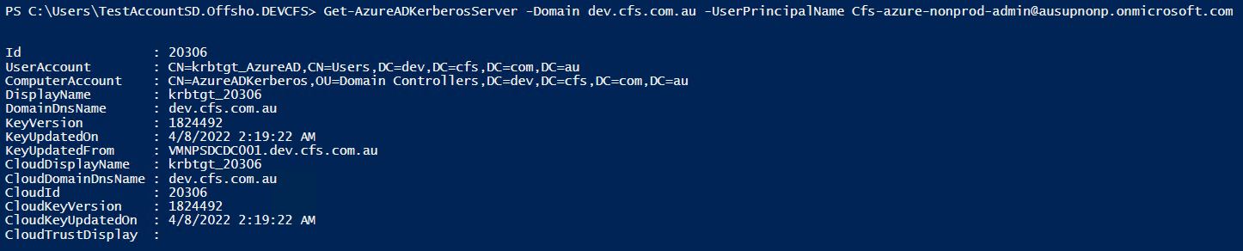

#### Intune Cloud Trust Policy

1. Once the Kerberos Server record has been associated to the tenant, create a dynamic group which will contain all the Microsoft Managed Desktop devices. This group will be used to target all the Windows Hello for Business Cloud Trust settings.
2. Open Azure Portal, Active Directory, Groups, create a new group
3. Provide the details below and create the group
   1. Name: **DG-AA-OPS-MMDDevices**
   2. Description: Dynamic group that contains all MMD laptops to target Windows Hello for Business Cloud trust policies
   3. Membership type: **Dynamic devices**
   4. Dynamic query criteria:

(device.displayName -contains "MMD-") and (device.deviceOSType -contains "Windows")

1. Wait for the device group to populate and proceed to create the custom policies in Intune to integrate with Cloud Trust
2. 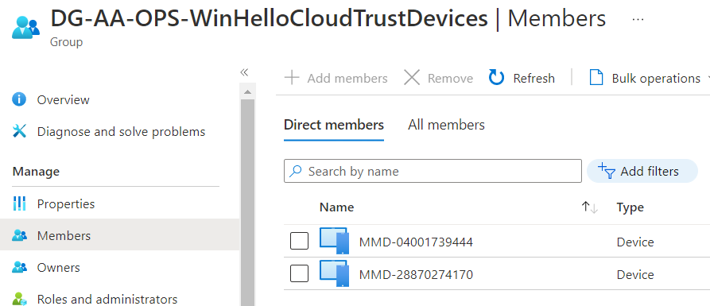
3. Open Endpoint Manager (Intune) and locate Devices, Windows, Configuration Profiles. Create a new custom policy for Windows 10/11
4. Provide the details below
   1. Name: Windows Hello for Business Cloud trust Integration
   2. Description: custom CSP policy to configure Windows Hello for Business Cloud trust integration for all MMD laptops. This policy sets the require parameters to integrate Cloud trust SSO with Windows Hello PIN
5. Under Configuration Settings, click on ADD
6. Provide the details for the policy
   1. Name: Windows Hello for Business cloud trust
   2. Description: Enable Windows Hello for Business cloud trust for sign-in and on-premises SSO.
   3. OMA-URI:

./Device/Vendor/MSFT/PassportForWork/574e14fe-5558-4211-a6a4-818ba8303014/Policies/UseCloudTrustForOnPremAuth

* 1. Replace the tenant ID for each environment respectively
  2. Data Type: Boolean
  3. Value: True

|  |  |
| --- | --- |
|  | ***Important Note***  Tenant ID for TST environment: 574e14fe-5558-4211-a6a4-818ba8303014  Tenant ID for PRD environment: 7384b0a5-f18a-43f4-8d60-f71b7ba245b5 |

1. Under assignments, assign this policy to the dynamic group **DG-AA-OPS-MMDDevices.** Note this policy can’t be assigned to user groups
2. Save the policy and trigger a SYNC on the MMD laptops on the TST environment

#### Rotate Kerberos Server Key

To maintain the Kerberos Server key object, perform the steps below on a 6 monthly basis

# Specify the on-premises Active Directory domain. A new Azure AD

# Kerberos Server object will be created in this Active Directory domain.

#Replace with PRD where applicable

$domain = "dev.cfs.com.au"

# Enter a domain administrator username and password in the local on-premise active directory

$domainCred = Get-Credential

# Enter an Azure Active Directory global administrator username and password for the CFS environment (TST or PRD).

$cloudCred = Get-Credential

Set-AzureADKerberosServer -Domain $domain -CloudCredential $cloudCred -DomainCredential $domainCred -RotateServerKey

## Azure Multi-Factor Authentication (MFA)

Refer to the WP1 IDAM As-Built Guide

## Azure Active Directory Conditional Access

Once the iOS and Android Policies have been created, perform these steps to create Conditional Access Policies which will enforce the MAM polices created for iOS and Android mobile devices.

### Require app protection policies and managed apps

1. Open Azure Portal, Locate Conditional Access Policies
2. Click on New Policy, Create New policy
3. Provide the details below
   1. **Policy Name:** CA011: Enforce Mobile MDM Policies
   2. **Under Assignments,** select the **Test Account Onshore 1**
   3. The assignments will later be changed to **ALL USERS**

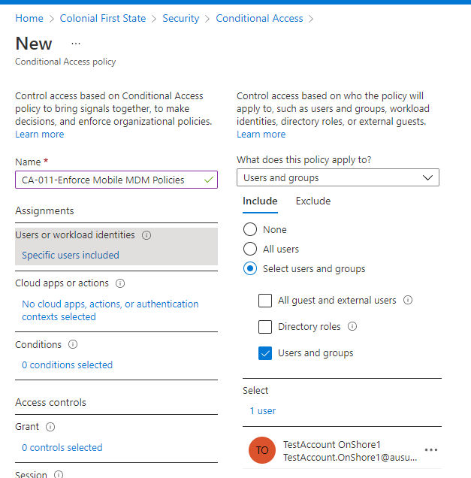

1. Under Exclusions, select the accounts
   1. **CFS AD Connect**
   2. **CFS Break Class**

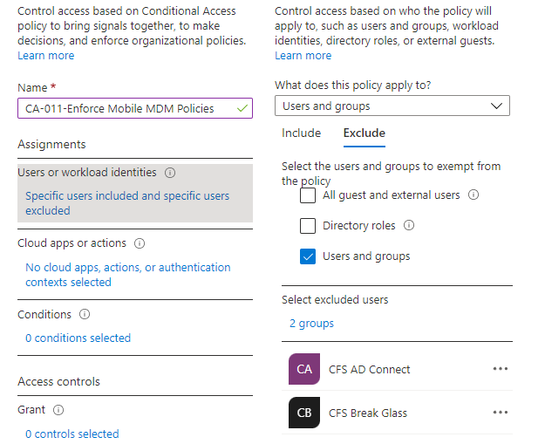

1. Under Cloud apps or Actions, select **Office 365**

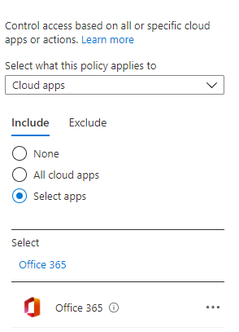

* 1. Under Conditions, Device Platforms, select **iOS, Android and Windows Phone**

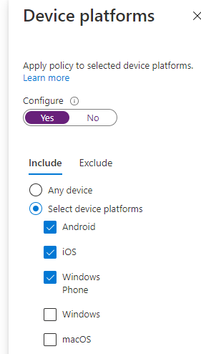

1. Under Grant, select the two options below
   1. **Require approved client app**
   2. **Require app protection policy**

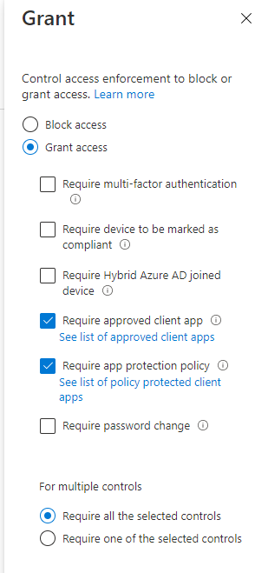

1. Create the policy

### Require Compliance Devices

To create the compliance device policy in Conditional Access, perform these steps

1. Create a new Conditional Access policy
2. Open Azure Portal, Locate Conditional Access Policies
3. Click on New Policy, Create New policy
4. Provide the details below
   1. **Policy Name:** CA012: Enforce Device Compliance
   2. **Under Assignments,** select the **Test Account Onshore 1**
   3. The assignments will later be changed to **ALL USERS**

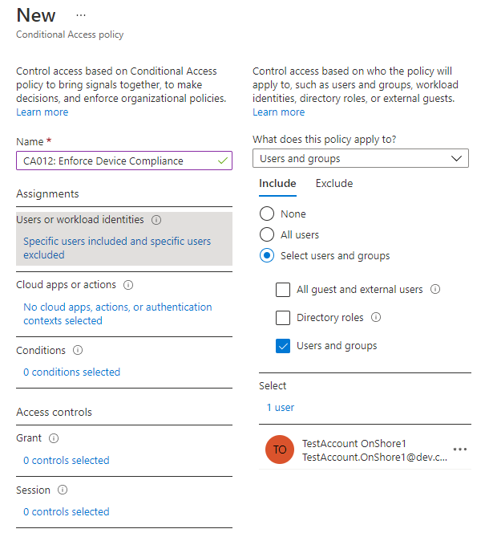

1. Under Exclusions, select the accounts
   1. **CFS AD Connect**
   2. **CFS Break Class**
   3. **All Modern Workplace Service Accounts**

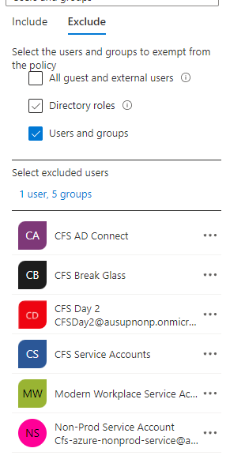

1. Under Cloud apps or Actions, select **Office 365**



1. Under **Conditions,** select
   1. Device Platforms: **Windows, MacOS and Linux (Preview)**
   2. Client apps: **Browser and Mobile apps and desktop clients**
2. Under **Grant,** select **Require device to be marked as compliant**
3. Save the policy

## Microsoft Information Protection (MIP)

### Tenant Configuration for Microsoft Information Protection

*\*\*NOTE: The following Steps have been executed in the tenant and no further action is required. They have been recorded in this Build Guide for reference only.*

#### Activate Sensitivity Labels for Microsoft 365 Groups

The following steps were executed to enable Sensitivity Labels for Microsoft 365 groups.

<https://docs.microsoft.com/en-us/azure/active-directory/enterprise-users/groups-assign-sensitivity-labels>

|  |  |  |
| --- | --- | --- |
| Step No. | Procedure | Screenshot |
|  | With the Azure AD PowerShell module installed, Connect to the Azure AD | Connect-AzureAD |
|  | Run the following to obtain the current group settings for the Azure AD organization. | $grpUnifiedSetting = (Get-AzureADDirectorySetting | where -Property DisplayName -Value "Group.Unified" -EQ)  $template = Get-AzureADDirectorySettingTemplate -Id 62375ab9-6b52-47ed-826b-58e47e0e304b  $setting = $template.CreateDirectorySetting() |
|  | Run the following and view the current configuration for the EnableMIPLabels setting, if False, run through the remaining steps. | $Setting.Values |
|  | Enable the feature by running: | $Setting["EnableMIPLabels"] = "True" |
|  | Check the new setting has been applied by running the following and reviewing the value for EnableMIPLabels to ensure the setting is set to True | $Setting.Values |
|  | Save the changes and apply the setting by running the following: | Set-AzureADDirectorySetting -Id $grpUnifiedSetting.Id -DirectorySetting $setting |

#### Enable Co- Authoring for files encrypted with Sensitivity Labels

|  |  |  |
| --- | --- | --- |
| Step No. | Procedure | Screenshot |
|  | Activate PIM roles as per Section Activate PIM Roles |  |
|  | Log into the Microsoft 365 Compliance | [Microsoft 365 Compliance](https://compliance.microsoft.com/homepage) |
|  | Select to Settings |  |
|  | Select Co-authoring for files with sensitivity labels |  |
|  | Check the box to enable ‘Turn on co-authoring for files with sensitivity labels’ |  |
|  | Click Apply |  |

#### Enable Unified Logging

Unified Logged has been enabled as per Enable Unified Logging section

### Microsoft Information Protection Deployment

#### Connect via PowerShell

This is a step by step guide on how to use PowerShell with Azure Information Protection.

**Note, if these PowerShell cmdlets are missing then the Azure PIM Roles need to be enabled and the PowerShell connection needs to be re-established.

|  |  |  |
| --- | --- | --- |
| Step No. | Procedure | Screenshot |
|  | Launch PowerShell or PowerShell ISE |  |
|  | Run the following to install the Exchange Online v2 Module | Install-Module -Name ExchangeOnlineManagement |
|  | Import the Exchange Online v2 Module | Import-Module ExchangeOnlineManagement; Get-ExchangeOnlineManagement |
|  | Update the Module | Update-Module -Name ExchangeOnlineManagement |
|  | Run the following to connect to the Security & Compliance centre | Connect-IPPSSession |

### Create a new Label

This is a step by step guide on how to create a new sensitivity labels in Microsoft 365.

All Label information can be found here: Microsoft Information Protection Labels

#### Label - Public

|  |  |  |
| --- | --- | --- |
| Step No. | Procedure | Screenshot |
|  | Log into the Microsoft 365 Compliance - Information Protection centre | [Microsoft 365 Compliance - Information Protection centre](https://compliance.microsoft.com/informationprotection?viewid=overview) |
|  | Select Labels |  |
|  | Select Create a label |  |
|  | Enter the following details when creating a PUBLIC label and then click Next | **Name:** **PUBLIC**  **Description for users:** Intended and approved for unrestricted publication; and / or information which is obtained from a public source (but does not contain Personal Information as defined by Privacy legislation). This information includes but is not limited to: Company website; and Public announcements. |
|  | Select Next |  |
|  | Select the required options: |  |
|  | Select Next |  |
|  | Check the **Mark the content of files** |  |
|  | Select Next |  |
|  | Enable the toggle to turn on Content Marking, check the required options and Customize the text | Graphical user interface, text, application  Description automatically generated  Watermark - No  Header - None  Footer - PUBLIC  Font Size – 10  Align Text - Center |
|  | Select Save |  |
|  | Select Next |  |
|  | Check both **Privacy and external user access settings** and **External sharing and conditional access settings** |  |
|  | Select Next |  |
|  | Under **Privacy** select **Public** |  |
|  | Under **External user access** check the option |  |
|  | Select Next |  |
|  | Under **Control external sharing from labeled SharePoint Sites** select **New and existing Guests** |  |
|  | Under **Use Azure AD Conditional Access to protect labeled SharePoint sites** select **Allow full access** |  |
|  | Select Next |  |
|  | Select Next |  |
|  | Review the Settings and select Create Label |  |
|  | View message that states Label was created |  |

#### Label - CFS Use Only

|  |  |  |
| --- | --- | --- |
| Step No. | Procedure | Screenshot |
|  | Log into the Microsoft 365 Compliance - Information Protection centre | [Microsoft 365 Compliance - Information Protection centre](https://compliance.microsoft.com/informationprotection?viewid=overview) |
|  | Select Labels |  |
|  | Select Create a label |  |
|  | Enter the following details when creating a PUBLIC label and then click Next | **Name:** CFS USE ONLY  **Description for users:** Proprietary to CFS and suitable for access by all CFS staff and authorised Business Partners. This information includes but is not limited to: -  Corporate directory; and  Information published on the intranet |
|  | Select Next |  |
|  | Select the required options: |  |
|  | Select Next |  |
|  | Check the **Mark the content of files** |  |
|  | Select Next |  |
|  | Enable the toggle to turn on **Content Marking**, check the required options and Customize the text | Graphical user interface, text, application  Description automatically generated  Watermark - No  Header - None  Footer – INTERNAL  Font Size – 10  Align Text - Center |
|  | Select Save |  |
|  | Select Next |  |
|  | Leave **Auto-labeling for files and emails** turned off |  |
|  | Select Next |  |
|  | Check both **Privacy and external user access settings** and **External sharing and conditional access settings** |  |
|  | Select Next |  |
|  | Under **Privacy** select **Public** |  |
|  | Under **External user access** ensure the option is unchecked |  |
|  | Select Next |  |
|  | Under **Control external sharing from labeled SharePoint Sites** select **Only people in your organization** |  |
|  | Under **Use Azure AD Conditional Access to protect labeled SharePoint sites** select **Block access** |  |
|  | Select Next |  |
|  | Select Next |  |
|  | Review the Settings and select Create Label |  |
|  | View message that states Label was created |  |

#### Label – Confidential

|  |  |  |
| --- | --- | --- |
| Step No. | Procedure | Screenshot |
|  | Log into the Microsoft 365 Compliance - Information Protection centre | [Microsoft 365 Compliance - Information Protection centre](https://compliance.microsoft.com/informationprotection?viewid=overview) |
|  | Select Labels |  |
|  | Select Create a label |  |
|  | Enter the following details when creating a PUBLIC label and then click Next | **Name:** CONFIDENTIAL  **Description for users:** Proprietary to CFS, or which is shared with CFS under a Non-Disclosure Agreement, AND which is only intended for access by a subset of CFS staff or authorised Business Partners. This information includes but is not limited to: -  Strategic business documents; and  Assurance / compliance records. |
|  | Select Next |  |
|  | Select the required options: |  |
|  | Select Next |  |
|  | Check the **Mark the content of files** |  |
|  | Select Next |  |
|  | Enable the toggle to turn on **Content Marking**, check the required options and Customize the text | Graphical user interface, text, application  Description automatically generated  Watermark - No  Font Size – 10  Text layout - Diagonal  Header - None  Footer – No  Classification – CONFIDENTIAL  Font Size – 10  Align Text - Center |
|  | Select Save |  |
|  | Select Next |  |
|  | Turn on **Auto-labeling for files and emails** |  |
|  | Under **Detect content that matches these conditions** select **+ Add condition** and then **Content Contains** |  |
|  | Leave the group name as **Default** and change the drop down to be **Any of these** |  |
|  | Click **Add** and **Sensitive info types** |  |
|  | Search and select the following types: | SWIFT code  Credit card number  Australia bank account number  Australia business number  Australia company number  Australia driver's license number  Australia medical account number  Australia passport number  Australia tax file number |
|  | Set the **When content matches these conditions** to be **Recommend that user apply the label** |  |
|  | Select Next |  |
|  | Check both **Privacy and external user access settings** and **External sharing and conditional access settings** |  |
|  | Select Next |  |
|  | Under **Privacy** select **Private** |  |
|  | Under **External user access** ensure the option is unchecked |  |
|  | Select Next |  |
|  | Under **Control external sharing from labeled SharePoint Sites** select **Only people in your organization** |  |
|  | Under **Use Azure AD Conditional Access to protect labeled SharePoint sites** select **Block access** |  |
|  | Select Next |  |
|  | Select Next |  |
|  | Review the Settings and select Create Label |  |
|  | View message that states Label was created |  |

#### Label – Customer and Personal

|  |  |  |
| --- | --- | --- |
| Step No. | Procedure | Screenshot |
|  | Log into the Microsoft 365 Compliance - Information Protection centre | [Microsoft 365 Compliance - Information Protection centre](https://compliance.microsoft.com/informationprotection?viewid=overview) |
|  | Select Labels |  |
|  | Select Create a label |  |
|  | Enter the following details when creating a label and then click Next | **Name:** CUSTOMER AND PERSONAL  **Description for users:** Personal Information about an individual as defined by privacy legislation. This information includes but is not limited to: -  Customer, prospect, or contractor information.  Information which is personal about an employee (excluding their name and work-related identifiers);  Payment Card Industry (PCI) impacting information; and  Information about a non-personal / corporate customer. |
|  | Select Next |  |
|  | Select the required options: |  |
|  | Select Next |  |
|  | Check the **Mark the content of files** |  |
|  | Select Next |  |
|  | Enable the toggle to turn on **Content Marking**, check the required options and Customize the text | Graphical user interface, text, application  Description automatically generated  Watermark - No  Font Size – 10  Text layout - Diagonal  Header - None  Footer – No  Classification – CUSTOMER AND PERSONAL  Font Size – 10  Align Text - Center |
|  | Select Save |  |
|  | Select Next |  |
|  | Leave **Auto-labeling for files and emails** turned off |  |
|  | Select Next |  |
|  | Check both **Privacy and external user access settings** and **External sharing and conditional access settings** |  |
|  | Select Next |  |
|  | Under **Privacy** select **Private** |  |
|  | Under **External user access** ensure the option is unchecked |  |
|  | Select Next |  |
|  | Under **Control external sharing from labeled SharePoint Sites** select **New and existing guests** |  |
|  | Under **Use Azure AD Conditional Access to protect labeled SharePoint sites** select **Block access** |  |
|  | Select Next |  |
|  | Select Next |  |
|  | Review the Settings and select Create Label |  |
|  | View message that states Label was created |  |

#### Label – Highly Protected

|  |  |  |
| --- | --- | --- |
| Step No. | Procedure | Screenshot |
|  | Log into the Microsoft 365 Compliance - Information Protection centre | [Microsoft 365 Compliance - Information Protection centre](https://compliance.microsoft.com/informationprotection?viewid=overview) |
|  | Select Labels |  |
|  | Select Create a label |  |
|  | Enter the following details when creating a label and then click Next | **Name:** HIGHLY PROTECTED  **Description for users:** Information which if disclosed, either intentionally or unintentionally, could result in a severe impact to CFS (refer to the 5X5 Risk Assessment Matrix). This information includes but is not limited to:  Authentication credentials including passwords, any secret, tokens etc.  Customer Credentials.  Employee Credentials.  Market Sensitive Information.  Encryption keys attached to Highly Protected information assets; and  Information which is subject to Legal Professional Privilege, law enforcement matters, and legal investigations / proceedings.Information which is personal about an employee (excluding their name and work-related identifiers);  Payment Card Industry (PCI) impacting information; and  Information about a non-personal / corporate customer. |
|  | Select Next |  |
|  | Select the required options: |  |
|  | Select Next |  |
|  | Check the **Mark the content of files** |  |
|  | Select Next |  |
|  | Enable the toggle to turn on **Content Marking**, check the required options and Customize the text | Graphical user interface, text, application  Description automatically generated  Watermark - No  Font Size – 10  Text layout - Diagonal  Header - None  Footer – HIGHLY PROTECTED  Font Size – 10  Align Text - Center |
|  | Select Save |  |
|  | Select Next |  |
|  | Leave **Auto-labeling for files and emails** turned off |  |
|  | Select Next |  |
|  | Check both **Privacy and external user access settings** and **External sharing and conditional access settings** |  |
|  | Select Next |  |
|  | Under **Privacy** select **Private** |  |
|  | Under **External user access** ensure the option is unchecked |  |
|  | Select Next |  |
|  | Under **Control external sharing from labeled SharePoint Sites** select **Only people in your organization** |  |
|  | Under **Use Azure AD Conditional Access to protect labeled SharePoint sites** select **Block access** |  |
|  | Select Next |  |
|  | Select Next |  |
|  | Review the Settings and select Create Label |  |
|  | View message that states Label was created |  |

#### Update Label Colour

This is a step by step guide on how to update the colour associated with labels

This is for the colour that appears to the Sensitivity Toolbar within Microsoft Office

e.g. 

|  |  |  |
| --- | --- | --- |
| Step No. | Procedure | Screenshot |
|  | Connect to Security and Compliance Centre via PowerShell | Connect via PowerShell |
|  | For each Parent label to be updated run the following PowerShell cmdlet | |  |  | | --- | --- | | Parent Label | PowerShell CMD | | PUBLIC | Set-Label -Identity “PUBLIC” -AdvancedSettings @{color="#808080"} | | CFS USE ONLY | Set-Label -Identity “CFS USE ONLY” -AdvancedSettings @{color="#329932"} | | CONFIDENTIAL | Set-Label -Identity “CONFIDENTIAL” -AdvancedSettings @{color="#0066ff "} | | CUSTOMER AND PERSONAL | Set-Label -Identity “CUSTOMER AND PERSONAL” -AdvancedSettings @{color="#ff9900"} | | HIGHLY PROTECTED | Set-Label -Identity “HIGHLY PROTECTED” -AdvancedSettings @{color="#ff0000"} | |
|  | Confirm colour has been applied by running | (get-label -Identity '<Label Name>').Settings   |  |  | | --- | --- | | Parent Label | PowerShell CMD | | PUBLIC | (get-label -Identity "PUBLIC").Settings | | CFS USE ONLY | (get-label -Identity "CFS USE ONLY").Settings | | CONFIDENTIAL | (get-label -Identity "CONFIDENTIAL ").Settings | | CUSTOMER AND PERSONAL | (get-label -Identity "CUSTOMER AND PERSONAL").Settings | | HIGHLY PROTECTED | (get-label -Identity "HIGHLY PROTECTED").Settings | |

### Create Label Policies

This is a step by step guide on how to create Azure Information Protect Label Policies

New Label Policy – All Users

This is a step by step guide on how to create the policy required for Non-Protect Users

|  |  |  |
| --- | --- | --- |
| Step No. | Procedure | Screenshot |
|  | Log into the Microsoft 365 Security & Compliance centre | [Microsoft 365 Security & Compliance centre](https://protection.office.com) |
|  | Select Label Policies |  |
|  | Select Publish Labels |  |
|  | Select Choose sensitivity labels to publish |  |
|  | Select all the labels to be published in the policy and click Add |  |
|  | Click Next |  |
|  | Leave Users and Groups set to All |  |
|  | Click Next |  |
|  | Under Policy Settings, select **“Users must provide a justification to remove a label”, “Require users to apply a label to their emails and documents”** and **“Require users to apply a label to their Power BI content”** and click Next |  |
|  | For Apply a default label to. Select **Confidential** for Documents, Emails, Sites and Groups, and Power BI |  |
|  | Click Next |  |
|  | Enter the following Name and Description  Name: CFS Default Labeling Policy  Description: Prod Labeling Policy for All CFS Users |  |
|  | Click Next |  |
|  | Review the settings and click Submit |  |
|  | Once created you should receive a message like the following Screenshot |  |
|  | Click Done |  |

### Additional Label Policy Settings

This is a step by step guide on how to apply additional Label Policy settings when using the Unified Labeling client. These settings have not been applied at the time of writing.

Additional settings that can be configured can be found [here](https://docs.microsoft.com/en-us/azure/information-protection/rms-client/clientv2-admin-guide-customizations#label-policy-advanced-setting-reference)

#### Enable Sensitivity Toolbar Bar by Default for all Users

This is a step by step guide on how to enable the Sensitivity bar by default for users

|  |  |  |
| --- | --- | --- |
| Step No. | Procedure | Screenshot |
|  | Connect to Security and Compliance Centre via PowerShell | Connect via PowerShell |
|  | Run the following to obtain the Label Policy Identity  The result should only display all policies that have been configured | Get-LabelPolicy | ft Name |
|  | To enable the setting to Show the bar for users, run the following for each policy listed from Step 3:  **Note:  False means the bar will be displayed.  True means the bar will not be displayed (default) | set-LabelPolicy -Identity  "<Name from Step 3>" -AdvancedSettings @{HideBarByDefault="False"} |
|  | To check the setting is being applied, by running the following: | (Get-LabelPolicy -Identity "<Name from Step 3>").settings |

#### Enable Removal of Container Protection

Enable the ability to remove protection to Container items.

By default, the remove protection capability is disabled and must be turned on to remove protection on ZIP, RAR, 7z, MSG and PST files. This is a step by step guide on how to enable the ability to remove protection on these file types

|  |  |  |
| --- | --- | --- |
| Step No. | Procedure | Screenshot |
|  | Connect to Security and Compliance Centre via PowerShell | Connect via PowerShell |
|  | Run the following to obtain the Label Policy Identity  The result should only display all policies that have been configured | Get-LabelPolicy | ft Name |
|  | To enable the setting to remove protection from container files, run the following for all policies configured:  **Note:  False means that removal of protection on container items is disabled (default) | set-LabelPolicy -Identity "<Name from Step 3>" -AdvancedSettings @{EnableContainerSupport="True"} |
|  | To check the setting is being applied, by running the following: | (Get-LabelPolicy -Identity "<Name from Step 4>").settings     |

### Deploy Unified Labelling client

The Azure Information Protection Unified Labelling client will be deployed to extend the ability of classifying and protecting content to Windows Explorer which allows for files other than Office to be protected.

An Intune app for all Windows Managed Desktop and AVD devices will be deployed to ALL devices. This app has been wrapped using the Intune Wrapping tool, describe on the Workplace & Mobility Ops Guide – P.WP5.DL6

Target: all MMD devices, all AVD device hosts.

Excepted: Multi-session Azure Virtual Desktop

App name: Microsoft Azure Information Protection

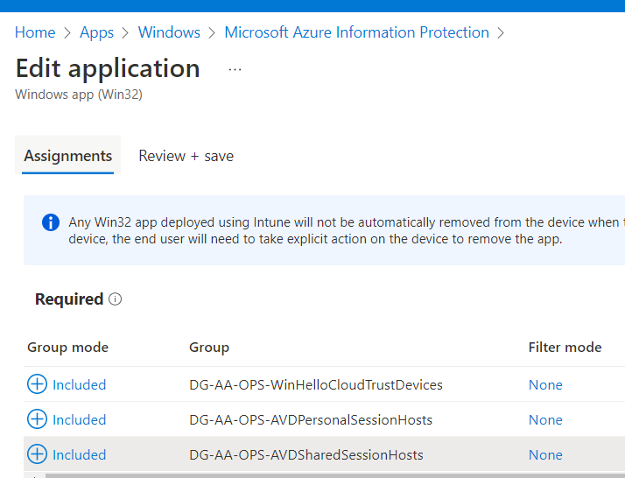

Detection rule: Manually configure detection rule

Value:

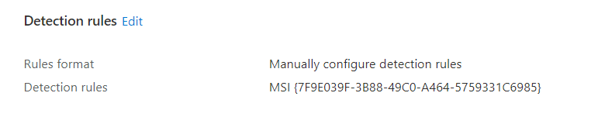

#### Disable Unified Labelling add-in for MS Office application

The UL client will be disabled for Office application to limit any potential impact to performance

M365 Apps Policy Management

### Additional One-time steps

This is a step by step guide on how to configure additional components used with AIP

#### Enable MIP for MCAS

|  |  |  |
| --- | --- | --- |
| Step No. | Procedure | Screenshot |
|  | Open MCAS Portal | [Dashboard - Microsoft Defender for Cloud Apps (cloudappsecurity.com)](https://ausupprod.portal.cloudappsecurity.com/#/dashboard) |
|  | In Defender for Cloud Apps, under the settings cog, select the Settings page under the System heading. |  |
|  | Under Microsoft Information Protection, select Automatically scan new files for Microsoft Information Protection sensitivity labels and content inspection warnings. |  |
|  | Save the settings |  |

## Microsoft 365 Data Loss Protection (DLP)

### CFS Default DLP Policy - Devices

|  |  |  |
| --- | --- | --- |
| Step No. | Procedure | Screenshot |
|  | Log into the Microsoft 365 Compliance – Data Loss Prevention | [Data loss prevention - Microsoft 365 compliance](https://compliance.microsoft.com/datalossprevention?viewid=overview) |
|  | Select Policies |  |
|  | Select Create Policy |  |
|  | Select a template to start building the policy. Select Custom > Custom Policy and click Next |  |
|  | Enter a name for the policy and a description | Name: **CFS Default DLP Policy – Devices**  Description: |
|  | Select Exchange Email, SharePoint Sites, OneDrive Accounts and Devices as the location and click Next |  |
|  | Select Create or customise advanced DLP rules and click Next |  |
|  | Select Create Rule |  |
|  | Provide a name for the Rule | **Device Content Restrictions**   |
|  | Under Conditions, select Add condition and Content Contains |  |
|  | Select Add and Sensitive Info Types |  |
|  | Search for the following and select:   * Australia Bank Account Number * Australia Drivers Licence Number * Australia Medical Account Number * Australia Passport Number * Australia Physical Address * Australia Tax File Number * Australian Business Number * Australian Company Number * SWIFT Code * Credit Card Number |  |
|  | Select Add and select Sensitivity Labels |  |
|  | Select CUSTOMER AND PERSONAL and HIGHLY PROTECTED and click Add |  |
|  | Under Actions, delete the **Restrict access or encrypt the content in Microsoft 365 Locations** |  |
|  | Under Actions, select Audit or Restrict activities on devices |  |
|  | Set the following options as shown |  |
|  | Under User notifications, turn the toggle on |  |
|  | Check the box for Show users a policy tip notification when an activity is restricted |  |
|  | Under Microsoft 365 services, select **Notify users in Office 365 service with a policy tip**,    Select Notify this people and select all options,  Select Customise the email text  Select Customise the policy tip text |  |
|  | Under **User Overrides,** select **Copy to a USB removable media** |  |
|  | Under Incident reports, sent the severity level to High and turn on the toggle to Send an alert to admins when a rule match occurs |  |
|  | Select Save |  |
|  | Click Next |  |
|  | Select Turn it on right away and click Next |  |
|  | Review the settings and select Submit |  |

### CFS Default DLP Policy – Teams Chat and Channel

|  |  |  |
| --- | --- | --- |
| Step No. | Procedure | Screenshot |
|  | Log into the Microsoft 365 Compliance – Data Loss Prevention | [Data loss prevention - Microsoft 365 compliance](https://compliance.microsoft.com/datalossprevention?viewid=overview) |
|  | Select Policies |  |
|  | Select Create Policy |  |
|  | Select a template to start building the policy. Select Custom > Custom Policy and click Next |  |
|  | Enter a Name and Description for the Policy click Next | Name: **CFS Default DLP Policy – Teams Chat and Channel**  Description: |
|  | Under Locations, Select Teams Chat and Channel Messages location and click Next |  |
|  | Select Create or customise advanced DLP rules and click Next |  |
|  | Select Create Rule |  |
|  | Select Add > Sensitive info types |  |
|  | Provide a name for the Rule | **Teams Message Rule**   |
|  | Under Conditions, select Add condition and Content Contains |  |
|  | Select Add and Sensitive Info Types |  |
|  | Search for the following and select:   * Australia Bank Account Number * Australia Drivers Licence Number * Australia Medical Account Number * Australia Passport Number * Australia Physical Address * Australia Tax File Number * Australian Business Number * Australian Company Number * SWIFT Code * Credit Card Number   Click Save |  |
|  | Under Conditions, Select **+ Add condition** and then select **Content is shared from Microsoft 365** |  |
|  | Change the option to be, **With people outside my organization** |  |
|  | Under Actions, Check the box for **Restrict access or encrypt the content in Microsoft 365 locations,** Change the option to be **Block only people outside you organization** |  |
|  | Turn on **User Notification**, check **Notify users in Office 365 service with a policy tip** |  |
|  | Under **Incident reports,** set the level to medium and toggle on to send an alert to admins when a rule match occurs |  |
|  | Select Turn it on right away and click Next |  |
|  | Review the settings and select Submit |  |

### CFS Default DLP Policy – External Sharing

|  |  |  |
| --- | --- | --- |
| Step No. | Procedure | Screenshot |
|  | Log into the Microsoft 365 Compliance – Data Loss Prevention | [Data loss prevention - Microsoft 365 compliance](https://compliance.microsoft.com/datalossprevention?viewid=overview) |
|  | Select Policies |  |
|  | Select Create Policy |  |
|  | Select a template to start building the policy. Select Custom > Custom Policy and click Next |  |
|  | Enter a Name and Description for the Policy click Next | Name: **CFS Default DLP Policy – External Sharing**  Description: |
|  | Under Locations, Select Exchange email, SharePoint sites and OneDrive accounts locations and click Next |  |
|  | Select Create or customise advanced DLP rules and click Next |  |
|  | Select Create Rule | Graphical user interface  Description automatically generated with medium confidence  External Sharing Rule |
|  | Select Add > Sensitive info types |  |
|  | Provide a name for the Rule | **External Sharing Rule** |
|  | Under Conditions, select Add condition and Content Contains |  |
|  | Select Add and Sensitive Info Types |  |
|  | Search for the following and select:   * Australia Bank Account Number * Australia Drivers Licence Number * Australia Medical Account Number * Australia Passport Number * Australia Physical Address * Australia Tax File Number * Australian Business Number * Australian Company Number * SWIFT Code * Credit Card Number   Click Add |  |
|  | Select Add and select Sensitivity Labels |  |
|  | Select CUSTOMER AND PERSONAL and HIGHLY PROTECTED and click Add |  |
|  | Under Conditions, Select **+ Add condition** and then select **Content is shared from Microsoft 365** |  |
|  | Change the option to be, **With people outside my organization** |  |
|  | Under Actions, Check the box for **Restrict access or encrypt the content in Microsoft 365 locations,** Change the option to be **Block only people outside you organization** |  |
|  | Turn on **User Notifications**, check **Notify users in Office 365 service with a policy tip** |  |
|  | Under **Email notifications,** select **Notify these people:** and check all the options |  |
|  | Under **Incident reports,** set the level to medium and toggle on to send an alert to admins when a rule match occurs |  |
|  | Select Turn it on right away and click Next |  |
|  | Review the settings and select Submit |  |

## Microsoft Endpoint Data Loss Prevention (Endpoint DLP)

Once all MDM policies have been created (does not have to be in any order), perform the steps below to create the Endpoint DLP policies

|  |  |
| --- | --- |
|  | ***Important Note***  *Before proceeding, make sure all DLP policies have been configured to target* ***Devices***. See image below |

### Pre-requisites

All DLP policies must be configured to target devices. This will guarantee all Data Loss Prevention policies trigger on endpoint devices onboarded onto Defender for Endpoint. To verify all devices are covered by any existing DLP policy, perform these checks

1. Open the Compliance Centre
2. Under Solutions, select **Data Loss prevention**

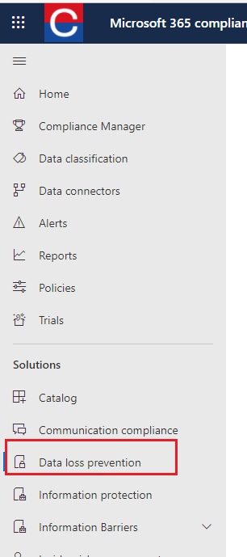

1. Click on Policies and verify the policy (ies) contain devices

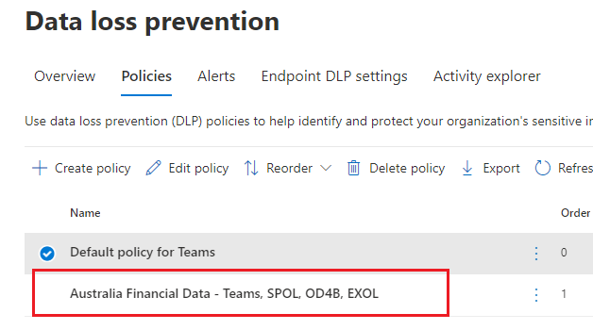

1. Click on the policy then Edit Policy, click NEXT then check devices has been marked to ON

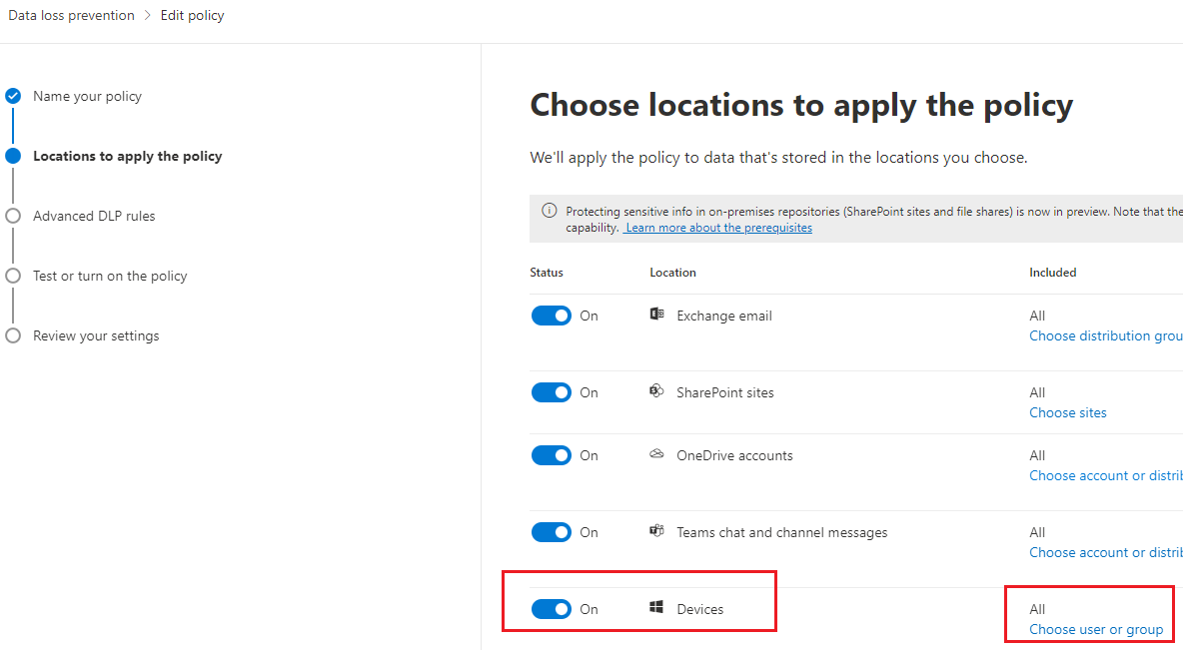

1. Once Devices are included in all DLP policies, click on **Endpoint DLP Settings** on the top menu and configure the options below
   1. Set **Advance classification scanning and protection (preview)** to ON and limit bandwidth usage to 1000 MB
   2. Set File path exclusions for Mac to **ON**
   3. Set Auto-quarantine settings to **ON**
   4. Under Browser and domain restrictions, add all the 11 default browsers then delete Google Chrome

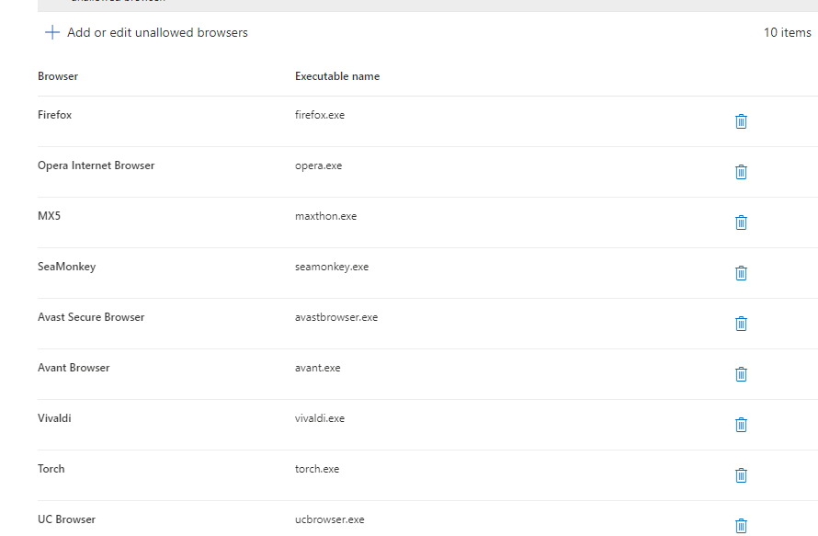

1. Under **Service Domains**, add dev.cfs.com.au and set the option to **ALLOW (Non-Prod)**

Under **Service Domains**, add cfs.com.au, my.cfs.com.au, tech.cfs.com.au & ausupprod.onmicrosoft.com and set the option to **ALLOW (Prod)**

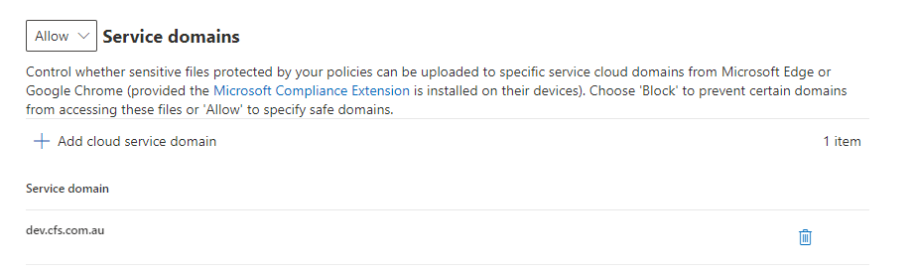

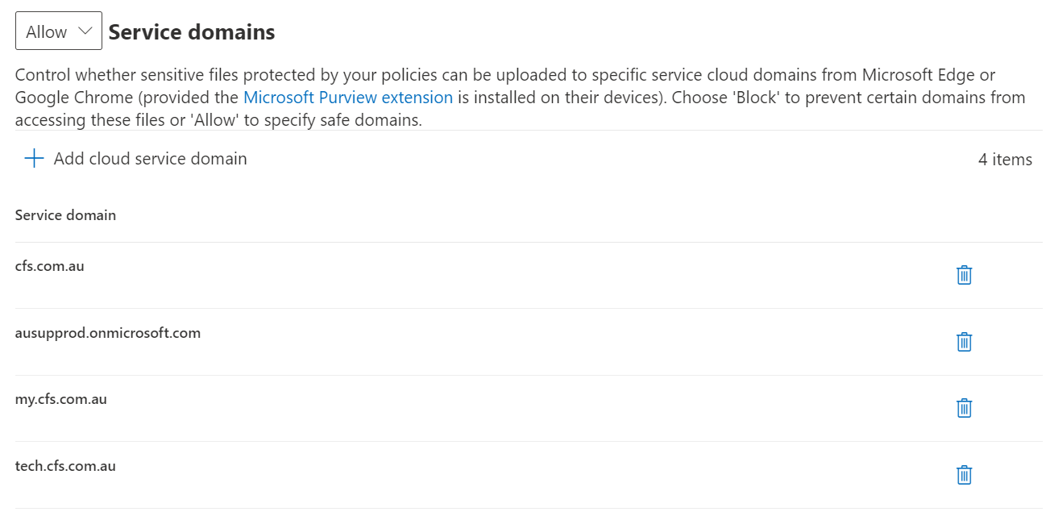

### Onboard devices to Compliance DLP

To onboard all devices to Compliance Centre, perform these steps

|  |  |
| --- | --- |
|  | ***Important Note***  *You can do this only after the devices have been onboarded onto Defender for Endpoint so you can select the devices* |

1. Open Compliance Centre [Device onboarding - Microsoft 365 compliance](https://compliance.microsoft.com/compliancesettings/deviceonboarding)
2. Click on Turn on **Device Onboarding**

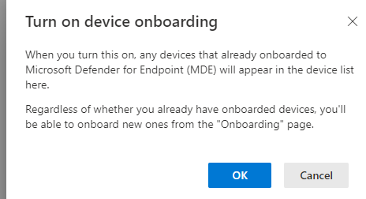

1. Wait for the devices to onboard on Compliance Centre

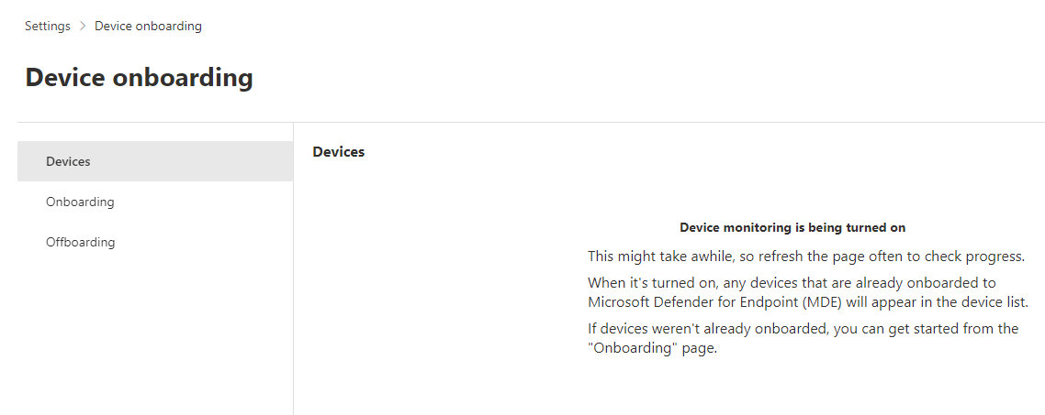

1. Verify all onboarded devices appear on the list

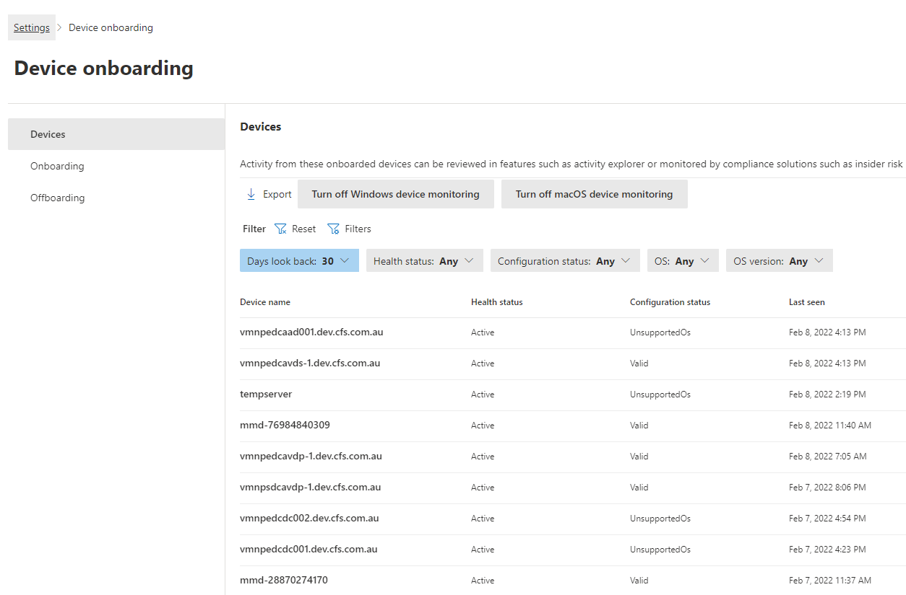

## Microsoft 365 Retention Policies

### CFS EXOL, SPOL, OD4B & M365 Group Retention Policy

|  |  |  |
| --- | --- | --- |
| Step No. | Procedure | Screenshot |
|  | Open the Microsoft 365 Compliance – Information Governance portal | [Information governance - Microsoft 365 compliance](https://compliance.microsoft.com/informationgovernance?viewid=retention) |
|  | Select Retention Policies |  |
|  | Create a new Policy |  |
|  | Enter a Name for the policy  **CFS Retention Policy - EXOL, SPOL, OD4B, M365 Groups** |  |
|  | Under Type, select Static |  |
|  | Select the following Locations to apply the policy:   * Exchange Email * SharePoint Sites * OnDrive Accounts * Microsoft 365 Groups * Exchange Public Folder |  |
|  | Select **Retain items forever** |  |
|  | Review the settings and select Submit |  |

### CFS Retention Policy - MS Teams Chats and Channels

|  |  |  |
| --- | --- | --- |
| Step No. | Procedure | Screenshot |
|  | Open the Microsoft 365 Compliance – Information Governance portal | [Information governance - Microsoft 365 compliance](https://compliance.microsoft.com/informationgovernance?viewid=retention) |
|  | Select Retention Policies |  |
|  | Create a new Policy |  |
|  | Enter a Name for the policy  **CFS Retention Policy - MS Teams Chats and Channels** |  |
|  | Under Type, select Static |  |
|  | Select the following Locations to apply the policy:   * Exchange Email * SharePoint Sites * OnDrive Accounts * Microsoft 365 Groups * Exchange Public Folder |  |
|  | Select **Retain items forever** |  |
|  | Review the settings and select Submit |  |

### CFS Retention Policy - MS Teams Private Channel Messages

|  |  |  |
| --- | --- | --- |
| Step No. | Procedure | Screenshot |
|  | Open the Microsoft 365 Compliance – Information Governance portal | [Information governance - Microsoft 365 compliance](https://compliance.microsoft.com/informationgovernance?viewid=retention) |
|  | Select Retention Policies |  |
|  | Create a new Policy |  |
|  | Enter a Name for the policy  **CFS Retention Policy - MS Teams Private Channel Messages** |  |
|  | Under Type, select Static |  |
|  | Select the following Locations to apply the policy:   * Exchange Email * SharePoint Sites * OnDrive Accounts * Microsoft 365 Groups * Exchange Public Folder |  |
|  | Select **Retain items forever** |  |
|  | Review the settings and select Submit |  |

## Microsoft 365 Records Management

At this time, the default Out of the Box experience has been implemented and no configuration change has been made.

## Microsoft 365 eDiscovery

At this time, the default Out of the Box experience has been implemented and no configuration change has been made.

## Audit and Logging

### Audit Log Retention Policy

|  |  |  |
| --- | --- | --- |
| Step No. | Procedure | Screenshot |
|  | Open the M365 Compliance Center – Audit page | [Audit - Microsoft 365 compliance](https://compliance.microsoft.com/auditlogsearch) |
|  | Select **Audit retention policies** |  |
|  | Select **Create audit retention policy** |  |
|  | Enter a name for the policy |  |
|  | Select all Record Types |  |
|  | Set Duration to be 1 Year |  |
|  | Leave Priority as 1 |  |
|  | Save the Policy |  |

### Enable Unified Logging

|  |  |  |
| --- | --- | --- |
| Step No. | Procedure | Screenshot |
|  | Connect to Exchange Online via PowerShell with the following cmdlet | Connect-ExchangeOnline -UserPrincipalName <##UPN##> |
|  | Once connected, run the following to review the status | Get-AdminAuditLogConfig | FL UnifiedAuditLogIngestionEnabled |
|  | If **FALSE**, run the following | Set-AdminAuditLogConfig -UnifiedAuditLogIngestionEnabled $true |
|  | NOTE: if you receive the following message around OrganizationCustomization, go to section Enable OrganizationCustomization. Once completed re-run step 3 | The command you tried to run isn't currently allowed in your organization. To run this command, you first  need to run the command: Enable-OrganizationCustomization. |

#### Enable OrganizationCustomization

|  |  |  |
| --- | --- | --- |
| Step No. | Procedure | Screenshot |
|  | Connect to Exchange Online via PowerShell with the following cmdlet | Connect-ExchangeOnline -UserPrincipalName <##UPN##> |
|  | Once connected, run the following to review the status | Get-OrganizationConfig | fl isdehydrated |
|  | If Status is TRUE, run the following. | Enable-OrganizationCustomization |
|  | Once run, re-run the following and ensure the result is FALSE, it may take 5-10mins for the setting to update | Get-OrganizationConfig | fl isdehydrated |

# Appendix